Assignment 7

1.Write a query that counts all orders for October 3.

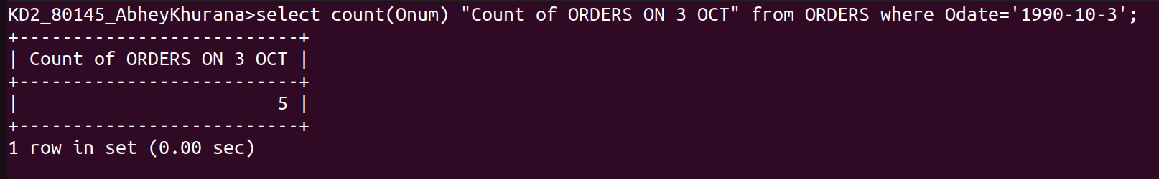
2.Write a query that counts the number of different non-NULL city values in the Customers table;

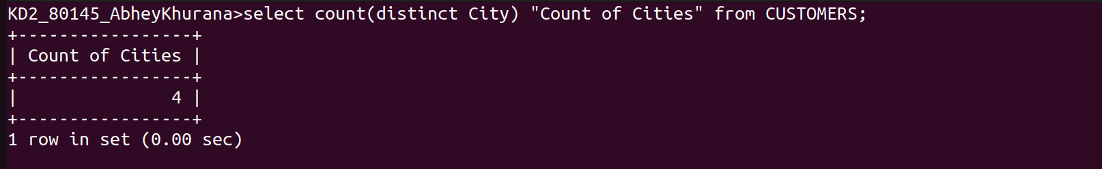
3.Write a query that selects each customer’s smallers order.

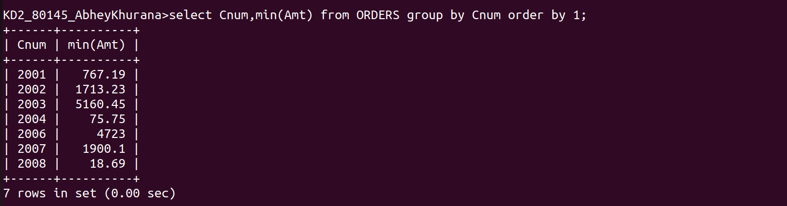
This command works as
first Cnum and amt columns are retrieved from Server DB and then it is grouped in 2D array in regard of Cnum
2004-> 10,20,30
and then group functions is applied on each such array and output is computed.

4. Write a query that selects the first customer in alphabatical order, whose name begins with ‘G’.

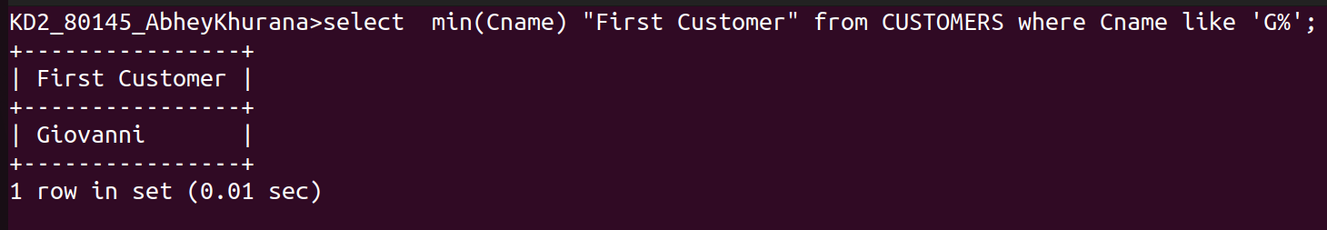

5.Write a query that selects the highest rating in each city
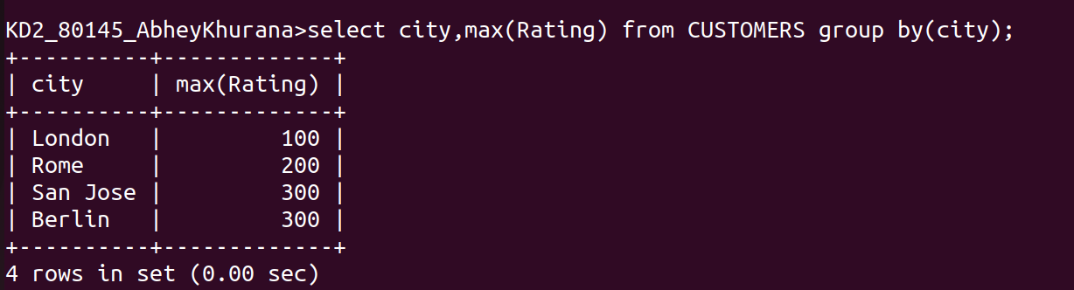
6.Write a query that counts the number of salespeople registering orders for each day.(If a salesperson has more than one order on a given day, he or she should be counted only once.)

