MONGO DB Solutions
1,2,3

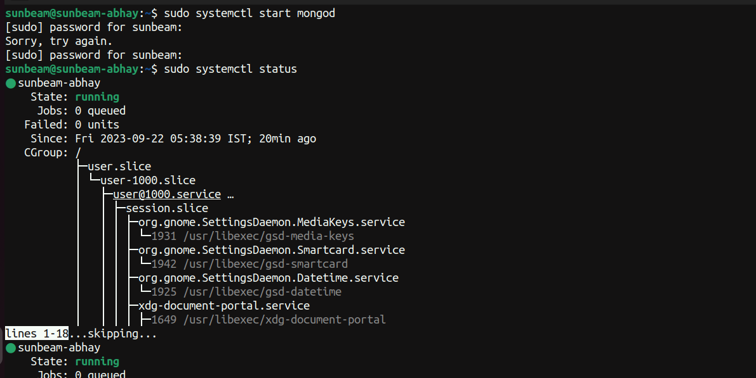
4,5

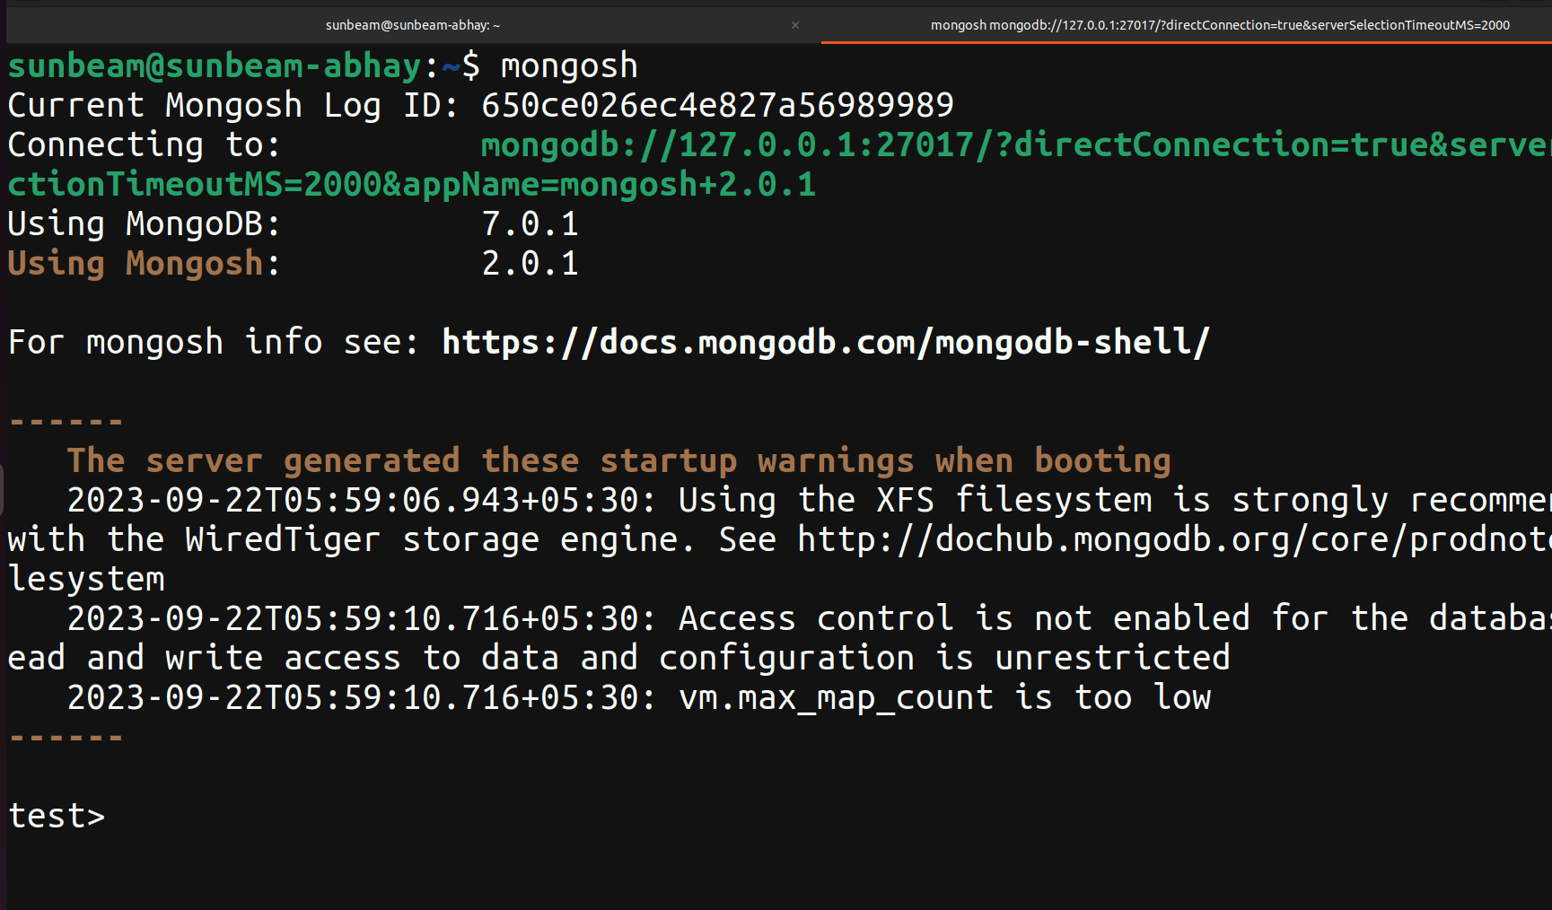

6. show dbs

7. use CDAC

8. show collections

9. db.createCollection(“LIBRARY”)

10. db.LIBRARY.insert({title:'MongoDB programming', author:'Sameer', likes:100})

11. db.LIBRARY.find()
_id: ObjectId("650c361a8b42a6b3308cb71d")

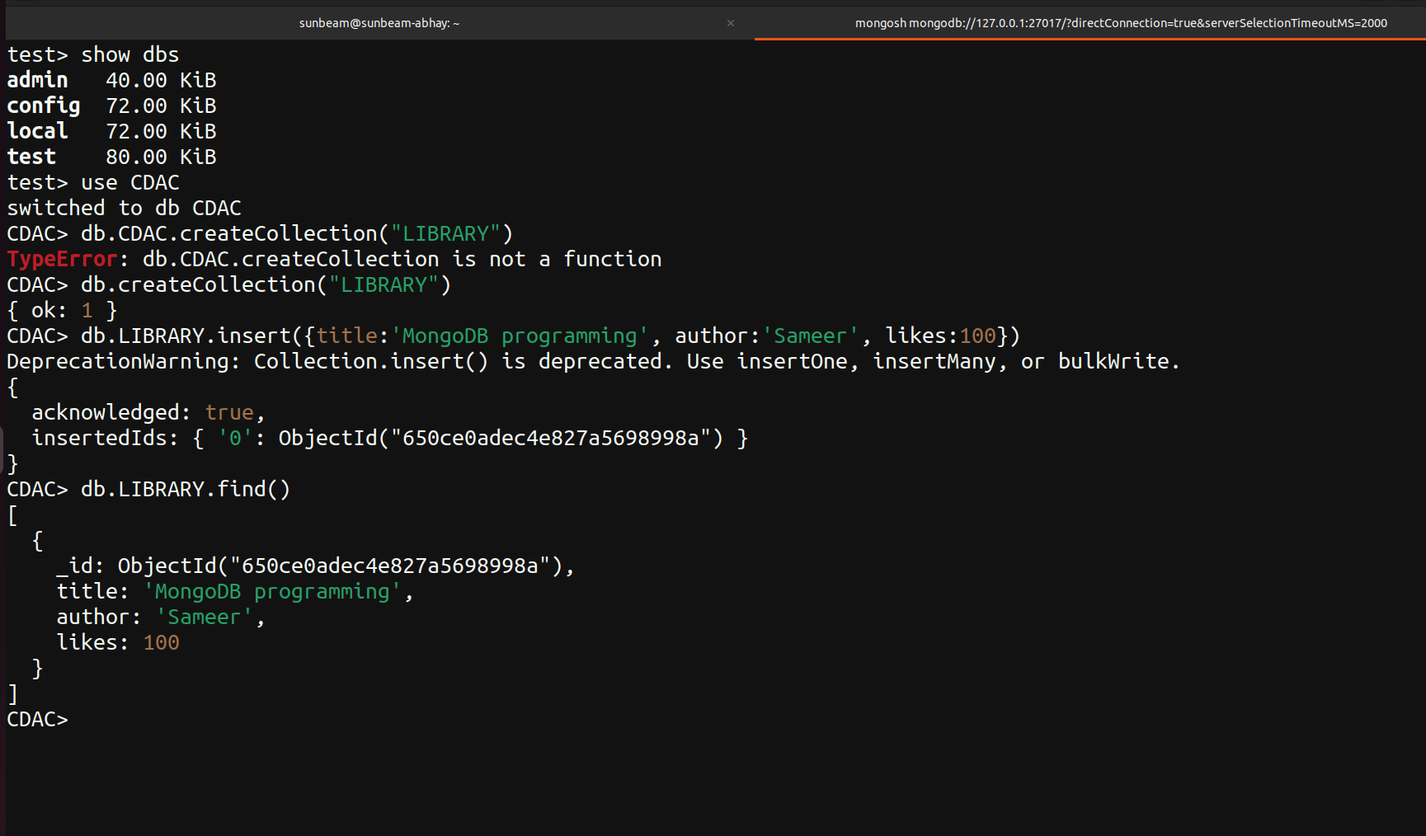

12. db.LIBRARY.insert({title:'MySQL programming',authors:['Jack','Jill'],likes:200})

13. db.LIBRARY.find()

14. db.LIBRARY.findOne()

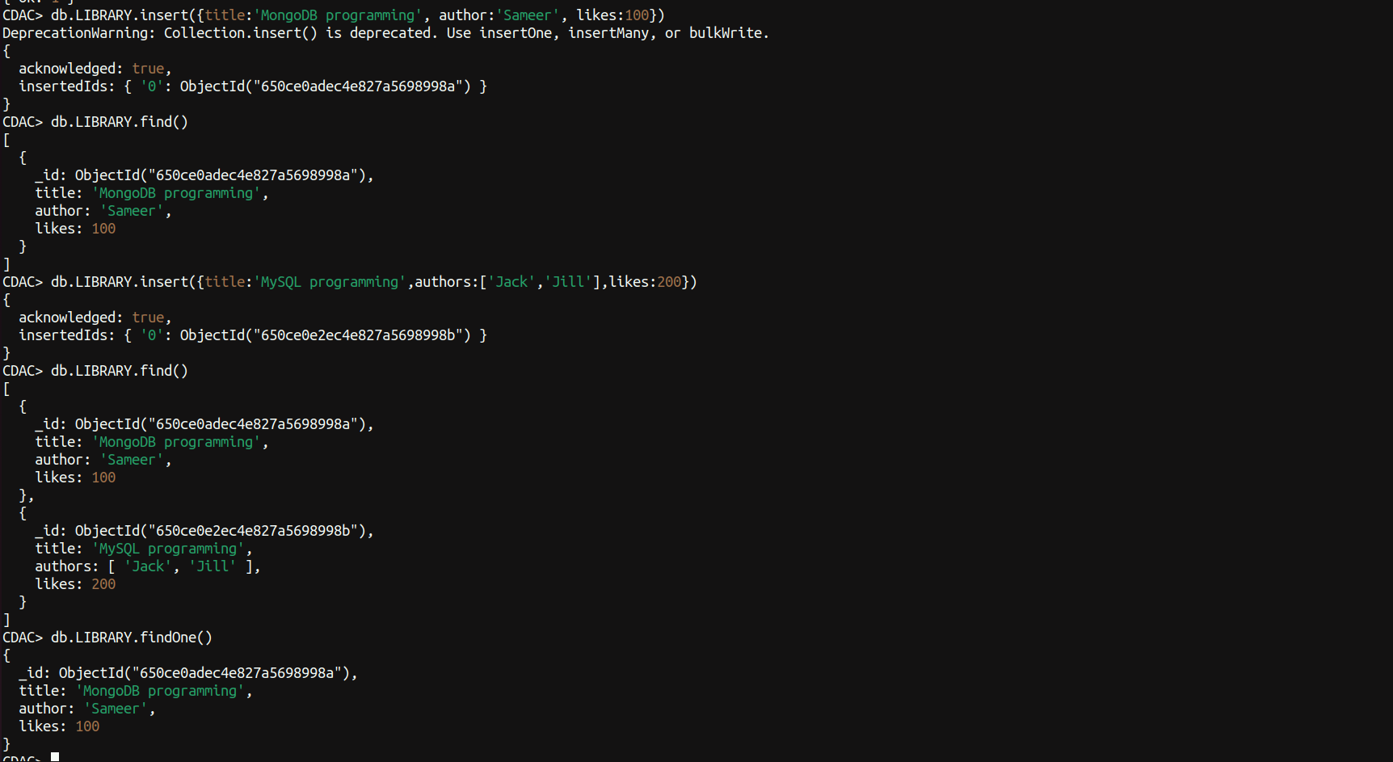

15. db.LIBRARY.find().pretty()

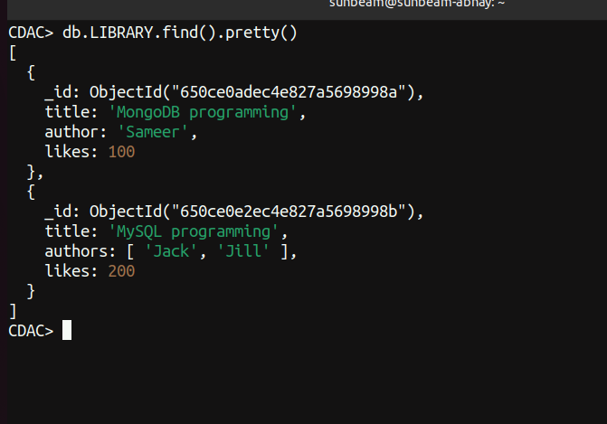

16. db.LIBRARY.update({author:’Sameer’},{$set{author:’Sameer Dehadrai’}})

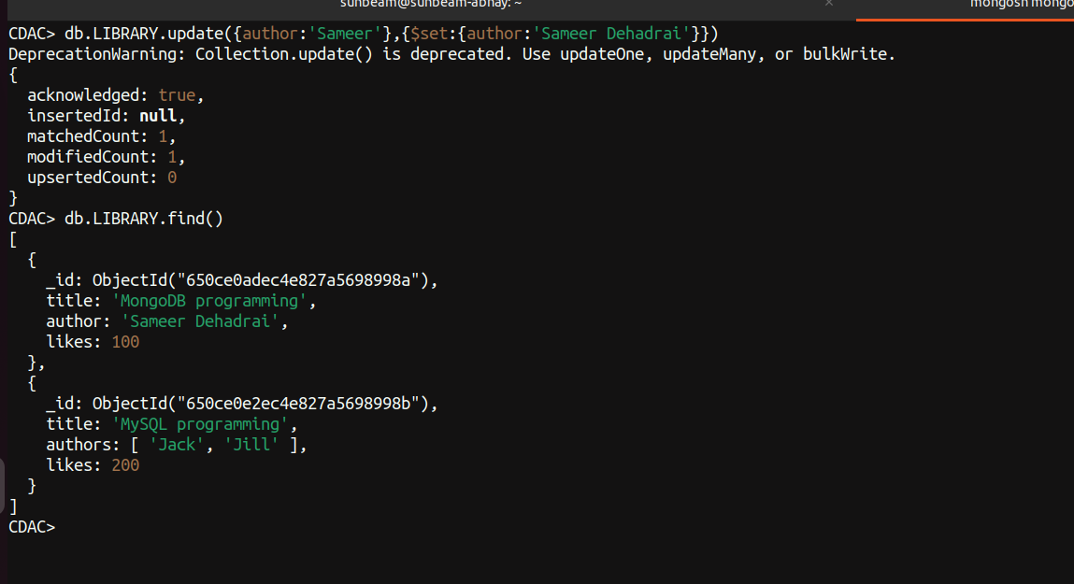

17. db.LIBRARY.remove({likes:100})

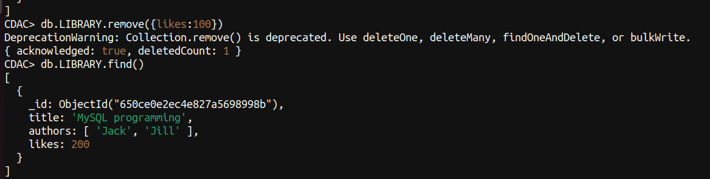

18. db.LIBRARY.drop()

19. use CDAC db.dropDatabase()
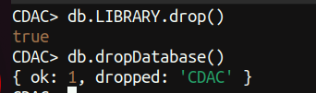

20. sudo systemctl stop mongod

