ASSIGNMENT 10

1. Write a query that produces all pairs of salespeople who are living in the same city.Exclude combinations of salespeople with themselves as well as duplicate rows with the order reversed.

Select a.Sname , b.Sname, a.City from SALESPEOPLE a,SALESPEOPLE b
where a.City=b.City and a.Snum!=b.Snum order by 1 desc;

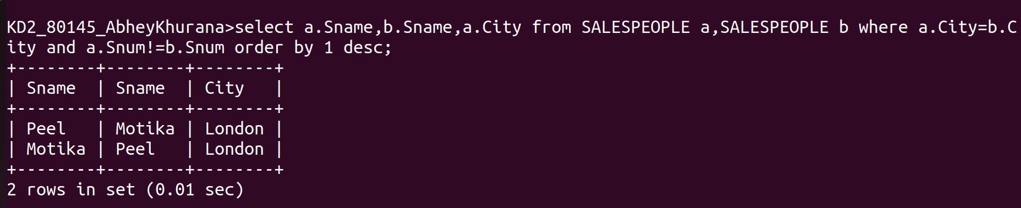

2.Write a query that produces the names and cities of all customers with the same rating as Hoffman.

