Assignment 8

1. Assume each salesperson has 12% commision. Write a query on the orders table that will produce the order number,the salesperson number, and the amount of the salesperson’s commision for that order.

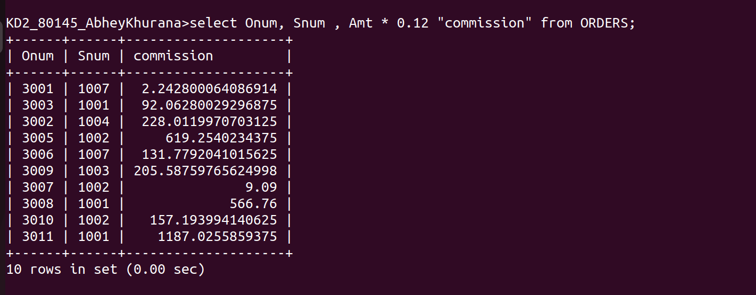
2. Write a query on customers table that will find the highest rating in each city. Put the output int this form:

For the city (city), the highest rating is: (rating).

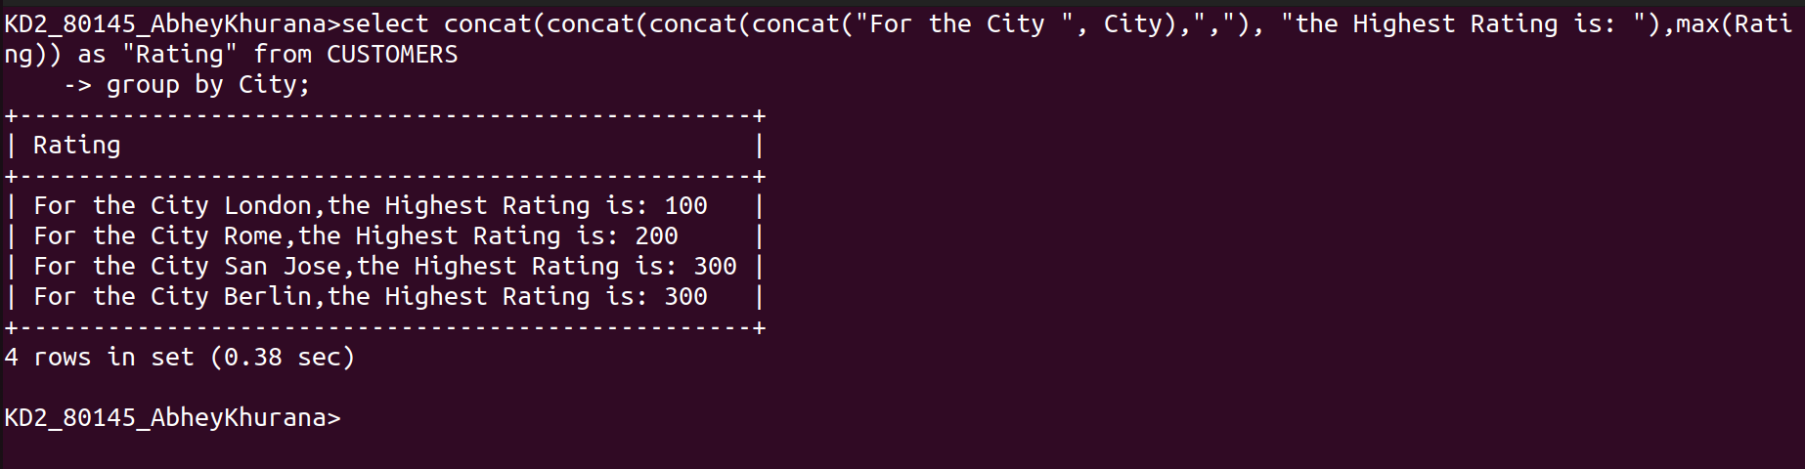
3.Write a query that lists customers in descending order of rating. Output the rating field first, followed by the customer’s name and number.


4.Write a query that totals the orders for each day and places the results in descending order.

