ASSIGNMENT 4

1. Write a select command that produces the order number, amount, and date for all the rows in the Orders table.

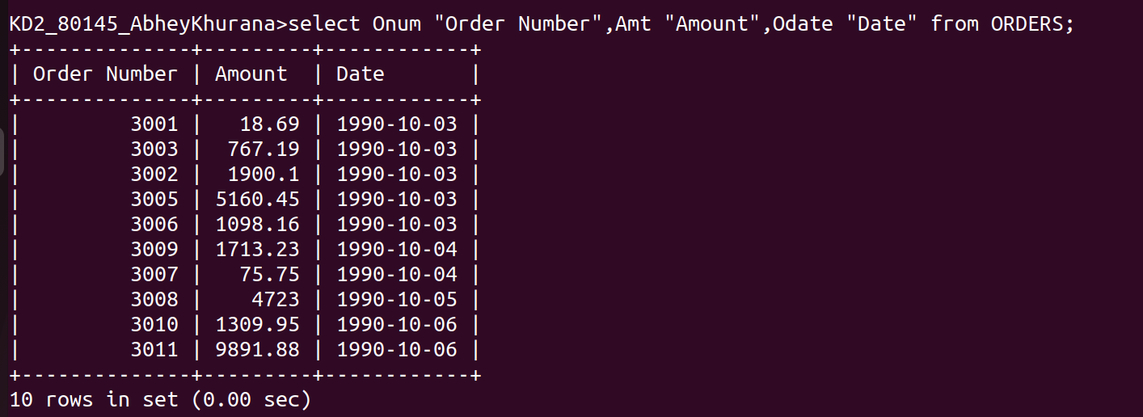
KD2_80145_AbheyKhurana>select Onum "Order Number",Amt "Amount",Odate "Date" from ORDERS;

2. Write a Query that produces all rows from the Customer table for which the salesperson’s number is 1001.
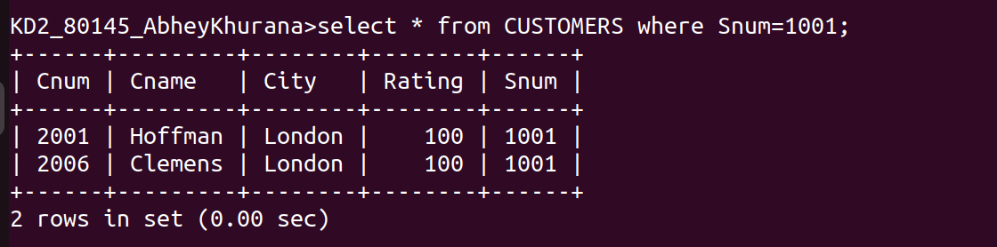

3. Write a query that displays the Salespeople table with the columns in the following order: city , sname , snum , comm.

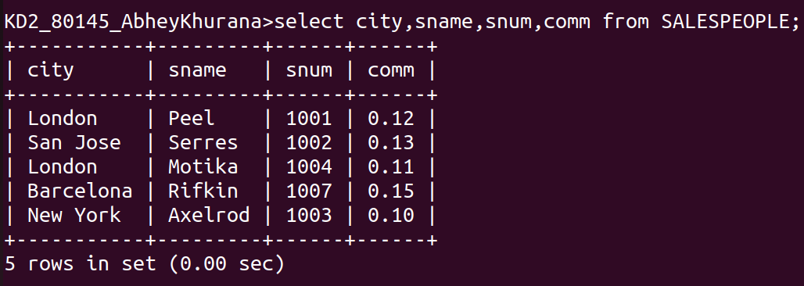

4. Write a select command that produces the rating followed by the name of each customer in San Jose.
