**Q1**

Code:

package Q_01;  
  
import javax.swing.*;  
  
public class Q_01 {  
 public static void main(String[] args) {  
 JFrame frame = new JFrame();  
 frame.setSize(800, 600);  
 frame.setTitle("Welcome to Java");  
 frame.setVisible(true);  
 }  
}

Output:

**Q2**

Code:

package Q_02;  
  
import java.util.Scanner;  
import javax.swing.*;  
  
public class Q_02 {  
 public static void main(String[] args) {  
 Scanner scan = new Scanner(System.*in*);  
 System.*out*.print("Enter your First Name: ");  
 String firstName = scan.nextLine();  
  
 System.*out*.print("Enter your Last Name: ");  
 String lastName = scan.nextLine();  
  
 //System.out.println(firstName + " " + lastName);  
  
 JFrame window = new JFrame();  
 window.setSize(800,600);  
 window.setTitle(firstName + " " + lastName);  
 window.setVisible(true);  
  
 }  
}

Output:

**Q3**

Code:

package Q_03;  
  
import java.util.Scanner;  
import javax.swing.*;  
  
public class Q_03 {  
 public static void main(String[] args) {  
 Scanner scan = new Scanner(System.*in*);  
 System.*out*.print("Enter Your First Name: ");  
 String fName = scan.nextLine();  
  
 System.*out*.print("Enter Your Middle Name: ");  
 String mName = scan.nextLine();  
  
 System.*out*.print("Enter Your LAst Name: ");  
 String lName = scan.nextLine();  
  
 //System.out.print(fName + " " + mName + " " + lName);  
  
 String initial = mName.substring(0,1);  
 //System.out.print(initial);  
  
  
 JFrame frame = new JFrame();  
 frame.setSize(800,600);  
 frame.setTitle(fName + " " + initial + ". " + lName);  
 frame.setVisible(true);  
  
  
 }  
}

Output:

**Q4**

Code:

package Q_04;  
  
import java.text.SimpleDateFormat;  
import java.util.*;  
  
public class Q_04 {  
 public static void main(String[] args) {  
 Date today = new Date();  
 //System.out.println(today);  
  
 SimpleDateFormat sdf = new SimpleDateFormat("dd MMM yyyy");  
 System.*out*.println(sdf.format(today));  
  
 }  
}

Output:

**Q5**

Code:

package Q_05;  
  
import java.text.SimpleDateFormat;  
import java.util.Date;  
  
public class Q_05 {  
 public static void main(String[] args) {  
 Date today = new Date();  
 SimpleDateFormat df = new SimpleDateFormat("EEEE, MMMM dd, yyyy");  
 System.*out*.print(df.format(today));  
  
 }  
}

Output:

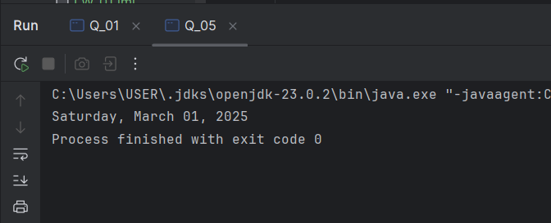

**Q6**

Code:

package Q_06;  
  
import java.util.*;  
import javax.swing.*;  
  
public class Q_06 {  
 public static void main(String[] args) {  
  
 Scanner sizein = new Scanner(System.*in*);  
 System.*out*.print("Enter The Width of The Window: ");  
 int W = sizein.nextInt();  
  
 System.*out*.print("Enter The Height of The Window: ");  
 int H = sizein.nextInt();  
  
 Scanner titlein = new Scanner(System.*in*);  
 System.*out*.print("Enter The Title of The Window: ");  
 String title = titlein.nextLine();  
   
 JFrame window = new JFrame();  
 window.setSize(W,H);  
 window.setTitle(title);  
 window.setVisible(true);  
 }  
}

Output:

**Q7**

Code:

package Q_07;  
  
import javax.swing.*;  
import java.text.SimpleDateFormat;  
import java.util.Date;  
  
public class Q_07 {  
 public static void main(String[] args) {  
 Date time = new Date();  
 SimpleDateFormat sdf = new SimpleDateFormat("HH:mm:ss a");  
 //System.out.print(sdf.format(time));  
  
 JFrame frame = new JFrame();  
 frame.setSize(600,300);  
 frame.setTitle(sdf.format(time));  
 frame.setVisible(true);  
  
 }  
}

Output:

**Q8**

Code:

package Q_08;  
  
import java.util.Scanner;  
  
public class Q_08 {  
 public static void main(String[] args) {  
 Scanner input = new Scanner(System.*in*);  
 System.*out*.print("Enter your Text: ");  
 String text = input.nextLine();  
  
 int place , size;  
 place = text.indexOf("!");  
 //System.out.println(place);  
  
 size = text.length();  
 //System.out.println(size);  
  
 String part01 , part02 ;  
 part01 = text.substring(0,place);  
 part02 = text.substring(++place,size);  
 System.*out*.println(part01);  
 System.*out*.println(part02.trim());  
  
 }  
}

Output:

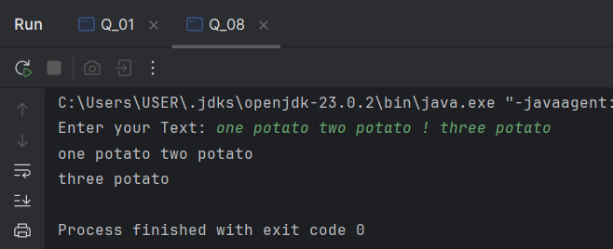

**09**

Code:

package Q_09;  
  
import java.util.Scanner;  
  
public class Q_09 {  
 public static void main(String[] args) {  
 Scanner input = new Scanner(System.*in*);  
 System.*out*.print("Enter Your Input Text : ");  
 String text = input.nextLine();  
  
 int size;  
 size = text.length();  
 System.*out*.println(size);  
  
 System.*out*.println(text.charAt(0));  
 System.*out*.println(text.charAt(size-1));  
  
 }  
}

Output:

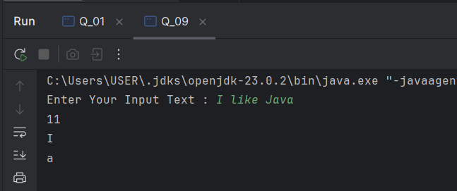

**Q_10**

Code:

package Q_10;  
  
import java.util.Scanner;  
  
public class Q_10 {  
 public static void main(String[] args) {  
 Scanner input = new Scanner(System.*in*);  
 System.*out*.print("Enter Your Input Text : ");  
 String text = input.nextLine();  
  
 int length , place;  
 length = text.length();  
 //System.out.println(length);  
  
 if (length % 2 == 1) {  
 place = ((length + 1) / 2);  
 //System.out.println(place);  
 System.*out*.println(text.charAt(--place));  
  
 }  
 else {  
 System.*out*.println("Not Acceptable. The Input Word must have an odd length");  
 }  
 }  
}

Output:

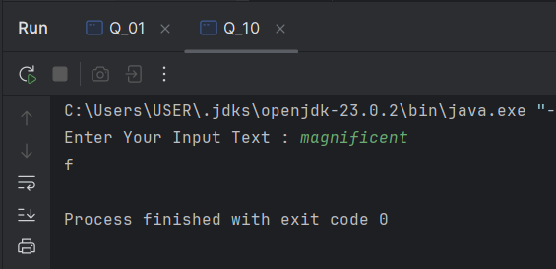

**Q_11**

Code:

package Q_11;  
  
import java.util.Scanner;  
  
public class Q_11 {  
 public static void main(String[] args) {  
 Scanner scan = new Scanner(System.*in*);  
 System.*out*.println("Enter Your Full Name (Format - FirstName MiddleName LastName) : ");  
 String fullName = scan.nextLine();  
  
 String fName, mName, mInitial, lName, remain;  
 int f_Space, s_Space, length;  
  
 // First Name -------------------------------------------------------------------------------------------------  
 f_Space = fullName.indexOf(" ");  
 fName = fullName.substring(0, f_Space);  
 //System.out.println(fName);  
  
 length = fullName.length();  
 remain = fullName.substring(f_Space, length);  
 remain = remain.trim();  
 //System.out.println(remain);  
  
 // Middle Name -------------------------------------------------------------------------------------------------  
 s_Space = remain.indexOf(" ");  
 mName = remain.substring(0, s_Space);  
 //System.out.println(mName);  
  
 length = remain.length();  
 mInitial = mName.substring(0,1);  
 //System.out.println(mInitial);  
  
 // Last Name ---------------------------------------------------------------------------------------------------  
 lName = remain.substring(s_Space, length);  
 lName = lName.trim();  
 //System.out.println(lName);  
  
 // Output ------------------------------------------------------------------------------------------------------  
 System.*out*.println(lName + "," + fName + " " + mInitial + ".");  
 }  
}

Output:

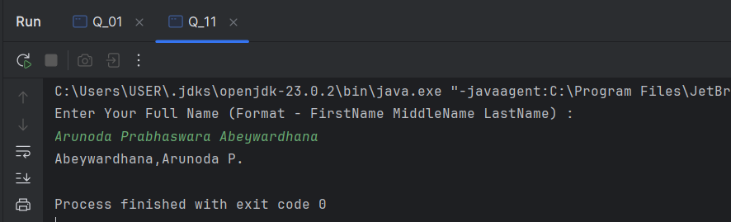

**Q_12**

Code:

package Q_12;  
  
import javax.swing.*;  
  
public class Q_12 {  
 public static void main(String[] args) {  
 JFrame frame = new JFrame();  
 frame.setVisible(true);  
 frame.setSize(300,200);  
 frame.setTitle("My First Frame");  
 frame.setLocation( 100, 50 );  
   
 }  
}

Output:

**Q_13**

Code:

package Q_13;  
  
import javax.swing.*;  
  
public class Q_13 {  
 public static void main(String[] args) {  
 JFrame myWindow;  
 myWindow = new JFrame();  
 myWindow.setSize(500, 250);  
 myWindow.setTitle("UOK");  
 myWindow.setVisible(true);  
 try {Thread.*sleep*(500);} catch(Exception e) { }  
 myWindow.setVisible(false);  
 try {Thread.*sleep*(500);} catch(Exception e) { }  
 myWindow.setVisible(true);  
 }  
}

Output:

