**Q1**

Code:

package Q_01;  
  
public class Q_01 {  
 public static void main(String[] args) {  
  
 // part a  
 int A = 10;  
 int B = 20;  
 int C = 30;  
  
 double answer_a = Math.*sqrt*( Math.*pow*(B,2) + (4 * A * C) );  
 System.*out*.println(answer_a);  
  
 // part b  
  
 int X = 400;  
 int Y = 5;  
  
 double answer_b = Math.*sqrt*( (X + (4 * Math.*pow*(Y,3)) ) );  
 System.*out*.println(answer_b);  
  
 //part c  
  
 double answer_c = Math.*cbrt*(X * Y);  
 System.*out*.println(answer_c);  
  
 // part d  
  
 int r = 7;  
 double answer_d_area = Math.*PI* * Math.*pow*(r,2);  
 System.*out*.println(answer_d_area);   
 }  
}

Output:

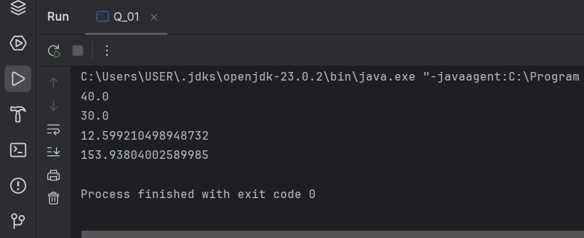

**Q2**

Code:

package Q_02;  
  
import java.util.Scanner;  
  
public class Q_02 {  
 public static void main(String[] args) {  
  
 Scanner scan = new Scanner(System.*in*);  
 System.*out*.print("Enter the length in centimeters (cm): ");  
  
 double cm = scan.nextDouble();  
  
 // 1 foot (ft) = 30.48 cm  
 // 1 inch = 2.54 cm  
  
 double ft, inch , remainder ;  
  
 ft = (int) (cm / 30.48);  
 remainder = cm % 30.48;  
 inch = remainder / 2.54;  
  
 System.*out*.printf("Entered length in feet(ft) and inches(inch): %.1f ft and %.2f inch%n", ft, inch);  
 }  
}

Output:

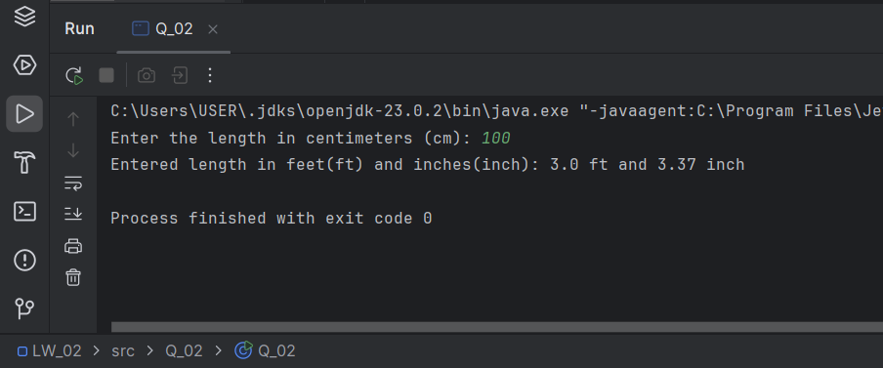

**Q3**

Code:

package Q_03;  
  
import java.util.Scanner;  
  
public class Q_03 {  
 public static void main(String[] args) {  
  
 Scanner input= new Scanner(System.*in*);  
 System.*out*.print("Enter the temperature in degrees of Celsius: ");  
  
 double cD = input.nextDouble();  
 double fD = (1.8 * cD) + 32;  
  
 System.*out*.printf("Temperature in degrees of Fahrenheit: %.2f" ,fD );  
 }  
}

Output:

**Q4**

Code:

package Q_04;  
  
import java.util.Scanner;  
  
public class Q_04 {  
 public static void main(String[] args) {  
  
 double lb = 0;  
  
 Scanner input = new Scanner(System.*in*);  
 System.*out*.println("***** Choose the weight input unit *****");  
 System.*out*.print("Enter ( 1 -> weight in Kilograms(Kg) , 2 -> weight in Pounds(lb) ): ");  
  
 int option = input.nextInt();  
  
 if (option == 1) {  
 System.*out*.print("Enter your weight in kilograms: ");  
 double kg = input.nextDouble();  
 // 1Kg = 2.20462 lb  
 lb = kg * 2.20462;  
  
 } else if (option == 2) {  
 System.*out*.print("Enter your weight in pounds: ");  
 lb = input.nextDouble();  
  
 }  
 if (option == 1 || option == 2) {  
 double calories = lb * 19;  
 System.*out*.printf("Number of calories that you need in one day: %.2f" , calories);  
  
 } else {  
 System.*out*.println("***** The value that you Entered is not an option. Try again. *****");  
 }  
 }  
}

Output:

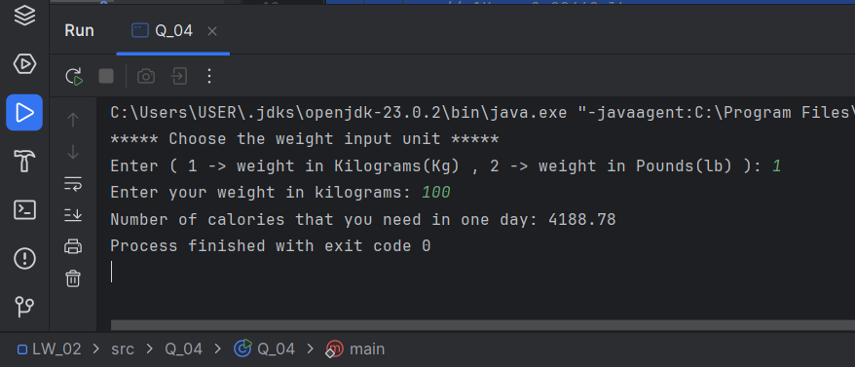

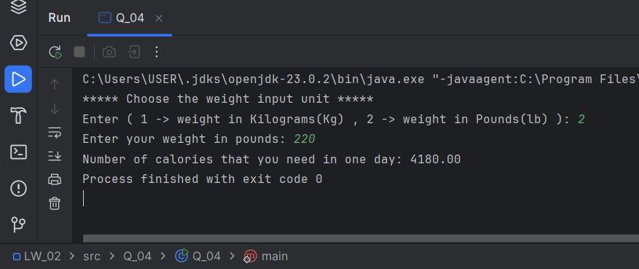

**Q5**

Code:

package Q_05;  
  
import java.util.Scanner;  
  
public class Q_05 {  
 public static void main(String[] args) {  
  
 Scanner input= new Scanner(System.*in*);  
 System.*out*.print("Enter the temperature in degrees of Fahrenheit: ");  
  
 double fD = input.nextDouble();  
 double cD = (5.0 / 9.0) * ( fD - 32) ;  
  
 System.*out*.printf("Temperature in degrees of Celsius: %.2f" ,cD );  
 }  
}

Output:

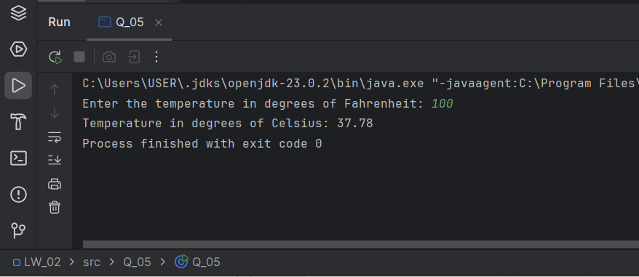

**Q6**

Code:

package Q_06;  
  
import java.util.GregorianCalendar;  
import java.util.Scanner;  
  
public class Q_06 {  
 public static void main(String[] args) {  
  
 Scanner input = new Scanner(System.*in*);  
 System.*out*.print("Enter your birth year: ");  
 int b_year = input.nextInt();  
  
 GregorianCalendar cal = new GregorianCalendar();  
 int current_year = cal.get(GregorianCalendar.*YEAR*);  
 //System.out.print(current_year);  
 int age = current_year - b_year;  
  
 System.*out*.printf("You were born in %d and will be %d years old this year", b_year, age);  
 }  
}

Output:

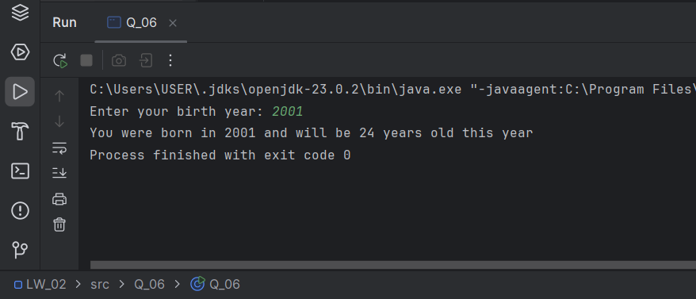

**Q7**

Code:

package Q_07;  
  
import java.util.Scanner;  
  
public class Q_07 {  
 public static void main(String[] args) {  
  
 Scanner input = new Scanner(System.*in*);  
 System.*out*.print("Enter Your Height(cm): ");  
 int height = input.nextInt();  
  
 System.*out*.print("Enter Your Weight(Kg): ");  
 int weight = input.nextInt();  
  
 double BMI = weight / (Math.*pow*( (height / 100.0), 2));  
 System.*out*.printf("Your BMI value is: %.3f%n" ,BMI);  
  
 if (BMI >= 20 && BMI <= 25) {  
 System.*out*.println("Your BMI value is normal");

} else  
 System.*out*.println("Your BMI value is not in the healthy range");

}  
}

Output:

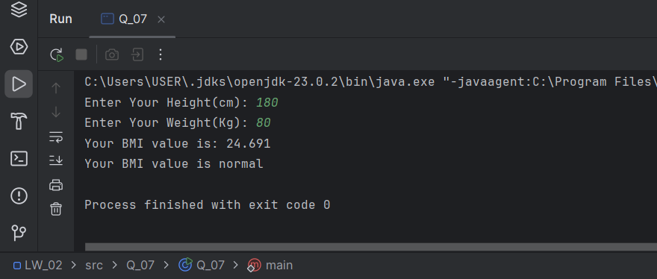

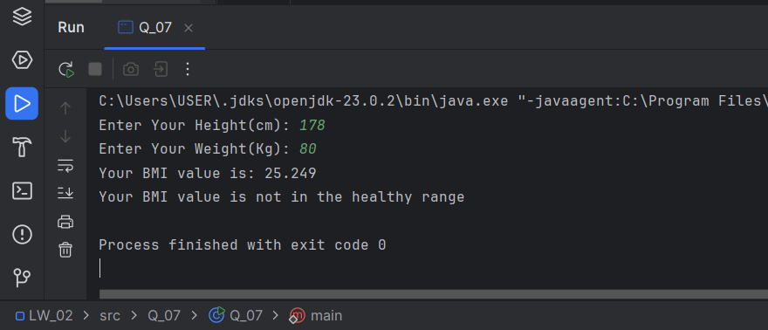

Q8

Code:

package Q_08;  
  
import java.util.Scanner;  
  
public class Q_08 {  
 public static void main(String[] args) {  
  
 Scanner input = new Scanner(System.*in*);  
 System.*out*.print("Enter the radius of the sphere: ");  
 double r = input.nextDouble();  
  
 double PI = 3.14;  
 double v = (4.0 / 3.0) * (PI * Math.*pow*(r, 3));  
 System.*out*.printf("Volume of the sphere is: %.3f%n" ,v);  
 }  
}

Output:

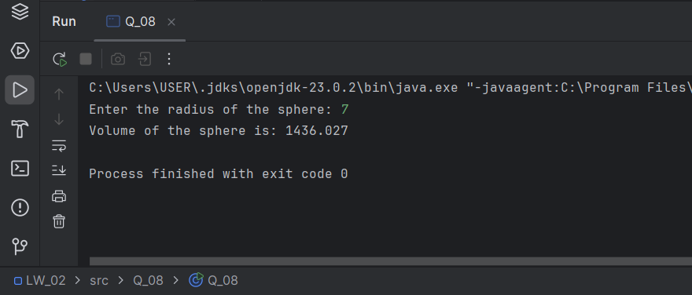

**Q9**

Code:

package Q_09;  
  
import java.util.Scanner;  
  
public class Q_09 {  
 public static void main(String[] args) {  
  
 Scanner input = new Scanner(System.*in*);  
 System.*out*.print("Enter the amount of investment: ");  
 double P = input.nextDouble();  
  
 System.*out*.print("Enter the annual interest rate(%): ");  
 double R = input.nextDouble();  
  
 System.*out*.print("Enter the number of years for the investment: ");  
 double N = input.nextDouble();  
  
 double grow = P * (Math.*pow* ( (1 + (R / 100)), N));  
   
 System.*out*.printf("The amount of money you will earn after %.0f years is: $ %.2f" , N, grow);  
 }  
}

Output:

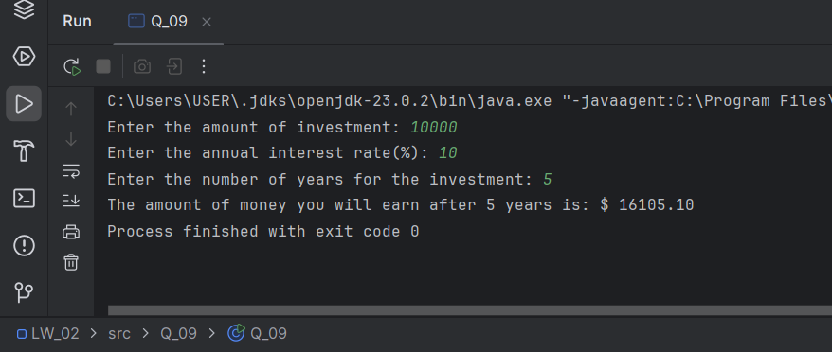

**Q10**

Code:

package Q_10;  
  
import java.util.Scanner;  
  
public class Q_10 {  
 public static void main(String[] args) {  
  
 Scanner input = new Scanner(System.*in*);  
 System.*out*.print("Enter the loan amount: ");  
 double l_amount = input.nextDouble();  
  
 System.*out*.print("Enter the annual interest rate(%): ");  
 double a_i_rate = input.nextDouble();  
  
 System.*out*.print("Enter the loan period(in years): ");  
 double l_period = input.nextDouble();  
 double months = 12.0;  
  
 System.*out*.println("* * * * * * * * * * * * * * * * * * * * * * * * * * * * * * * * * * * * * * * * * * * * * *");  
  
 double m_i_rate = (a_i_rate / 100.0 / months) ;  
 System.*out*.printf("The monthly interest rate for the loan: %.6f%%%n", m_i_rate);  
  
 double no_payments = (l_period * months);  
 System.*out*.printf("Number of payments: %.0f%n", no_payments);  
  
 double m_payment = (l_amount * m_i_rate) / (1 - Math.*pow*( (1 / (1 + m_i_rate)), no_payments));  
 System.*out*.printf("The monthly payment amount: $ %.2f%n", m_payment);  
  
 double t_payment = m_payment * no_payments;  
 System.*out*.printf("The total payment amount: $ %.2f%n", t_payment);  
  
 System.*out*.println("* * * * * * * * * * * * * * * * * * * * * * * * * * * * * * * * * * * * * * * * * * * * * *");  
 }  
}

Output:

