**Q1**

Code: Temperature.java

package Q_01;  
  
public class Temperature {  
 private double celsius;  
  
 //NO-Arg Constructor  
 public Temperature () {  
  
 this.celsius = 0.0;  
 }  
  
 // Parameterized Constructor  
 public Temperature(double celsius) {  
  
 this.celsius = celsius;  
 }  
  
 //Getter for Celsius  
 public double toCelsius() {  
  
 return this.celsius;  
 }  
  
 //Getter for Fahrenheit  
 public double toFahrenheit() {  
  
 return this.celsius * 9 / 5 + 32;  
 }  
  
 // Setter for Celsius  
 public void setCelsius(double celsius) {  
  
 this.celsius = celsius;  
 }  
  
 // Setter for Fahrenheit  
 public void setFahrenheit(double fahrenheit) {  
  
 this.celsius = (fahrenheit - 32) * 5 / 9;  
 }  
}

Main.java

package Q_01;  
  
import java.util.Scanner;  
  
public class Main {  
 public static void main(String[] args) {  
  
 Scanner input = new Scanner(System.*in*);  
  
 System.*out*.print("Enter temperature in Celsius: ");  
 double celsius = input.nextDouble();  
  
 Temperature temp = new Temperature(celsius);  
 temp.setCelsius(celsius);  
  
 System.*out*.println("Temperature in Fahrenheit: " + temp.toFahrenheit());  
 }  
}

**Output:**

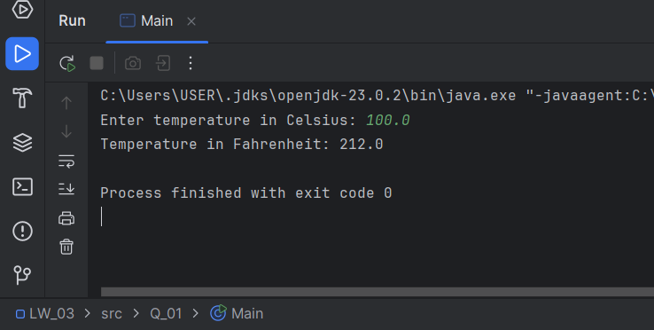

**Q2**

Code: Main.java

package Q_02;  
  
import Q_01.Temperature;  
  
import java.util.Scanner;  
  
public class Main {  
 public static void main(String[] args) {  
  
 Scanner input = new Scanner(System.*in*);  
  
 System.*out*.print("Enter temperature in Fahrenheit: ");  
 double fahrenheit = input.nextDouble();  
  
 Temperature temp = new Temperature();  
 temp.setFahrenheit(fahrenheit);  
  
 System.*out*.println("Temperature in Celsius: " + temp.toCelsius());  
 }  
}

**Output:**

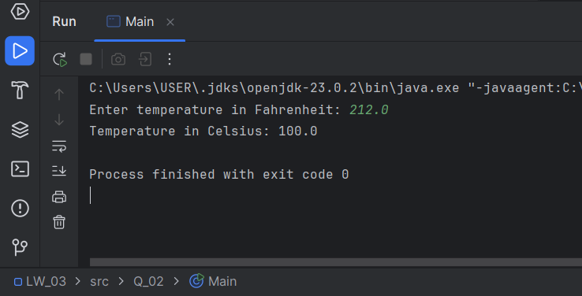

**Q3**

Code: Circle.java

package Q_03;  
  
public class Circle {  
 private double ri;  
 private double ro;  
  
 //NO-Arg Constructor  
 public Circle() {  
  
 this.ri = 0.0;  
 this.ro = 0.0;  
 }  
  
 //setter for set the circle's radius  
 public void setRadius(double ro, double ri) {  
  
 this.ro = ro;  
 this.ri = ri;  
 }  
  
 public double computeArea () {  
  
 return ( (Math.*PI* * Math.*pow*(ro, 2)) - (Math.*PI* * Math.*pow*(ri, 2)) );  
 }  
  
 public void computeCircumference() {  
  
 double C_ro = 2 * Math.*PI* * ro;  
 double C_ri = 2 * Math.*PI* * ri;  
 System.*out*.printf("Circumference of the outer circle: %.2f units\n", C_ro);  
 System.*out*.printf("Circumference of the inner circle: %.2f units", C_ri);  
 }  
}

Main.java

package Q_03;  
  
import java.util.Scanner;  
  
public class Main {  
 public static void main(String[] args) {  
  
 Scanner input = new Scanner(System.*in*);  
  
 System.*out*.print("Radius of the outer circle: ");  
 double ro = input.nextDouble();  
  
 System.*out*.print("Radius of the inner circle: ");  
 double ri = input.nextDouble();  
  
 Circle tempCircle = new Circle();  
  
 tempCircle.setRadius(ro,ri);  
  
 System.*out*.printf("Area of the circular region: %.2f square unit\n" ,tempCircle.computeArea());  
  
 tempCircle.computeCircumference();  
  
 }  
}

**Output:**

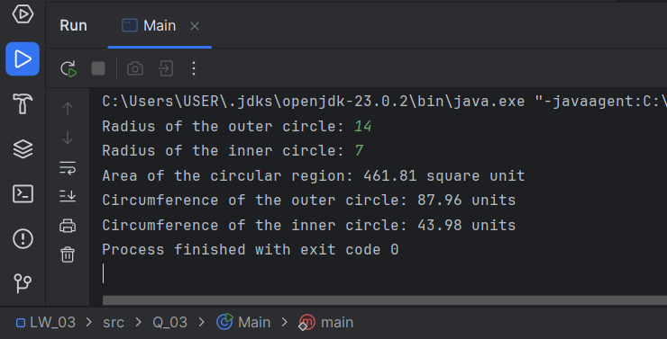

**Q4**

Code: Owner.java

package Q_04;  
  
public class Owner {  
  
 private String ownerName;  
 private String phoneNo;  
  
 //Constructor: Initializes the data member  
 public Owner() {  
  
 ownerName = "Unknown";  
 phoneNo = "Not Assigned";  
 }  
  
 public Owner (String ownerName, String phoneNo) {  
 this.ownerName = ownerName;  
 this.phoneNo = phoneNo;  
 }  
  
 //Assigns the name of this bicycle's owner  
 public void setOwnerName(String ownerName) {  
  
 this.ownerName = ownerName;  
 }  
  
 //Returns the name of this bicycle's owner  
 public String getOwnerName() {  
  
 return ownerName;  
 }  
  
 //Assigns the phone number of this bicycle's owner  
 public void setPhoneNo(String phoneNo) {  
  
 this.phoneNo = phoneNo;  
 }  
  
 //Returns the phone number of this bicycle's owner  
 public String getPhoneNo() {  
  
 return phoneNo;  
 }  
}

Bicycle.java

package Q_04;  
  
public class Bicycle {  
  
 private final Owner owner;  
  
 public Bicycle(String ownerName, String phoneNo) {  
  
 owner = new Owner(ownerName,phoneNo);  
  
 }  
  
 //Assigns the name of this bicycle's owner  
 public void set_OwnerName(String ownerName) {  
  
 owner.setOwnerName(ownerName);  
 }  
  
  
 //Returns the name of this bicycle's owner  
 public String get_OwnerName() {  
  
 return owner.getOwnerName();  
 }  
  
  
 //Assigns the phone number of this bicycle's owner  
 public void set_PhoneNo(String phoneNo) {  
  
 this.owner.setPhoneNo(phoneNo);  
 }  
  
  
 //Returns the phone number of this bicycle's owner  
 public String get_PhoneNo() {  
  
 return owner.getPhoneNo();  
 }  
}

Main.java

package Q_04;  
  
import java.util.Scanner;  
  
public class Main {  
 public static void main(String[] args) {  
  
 Scanner input = new Scanner(System.*in*);  
  
 System.*out*.print("Enter the Bicycle name: ");  
 String B_name = input.next();  
  
 System.*out*.print("Enter the Owner name: ");  
 String ownerName = input.next();  
  
 System.*out*.print("Enter the Phone number: ");  
 String phoneNo = input.next();  
  
 Bicycle bikes = new Bicycle(ownerName, phoneNo);  
 bikes.set_OwnerName(ownerName);  
 bikes.set_PhoneNo(phoneNo);  
  
 System.*out*.println("\n*** Details of the bike ***");  
 System.*out*.println("Bicycle name: " + B_name);  
 System.*out*.println("Name of the owner: " + bikes.get_OwnerName());  
 System.*out*.println("Phone number of the owner: " + bikes.get_PhoneNo());  
  
 }  
}

**Output:**

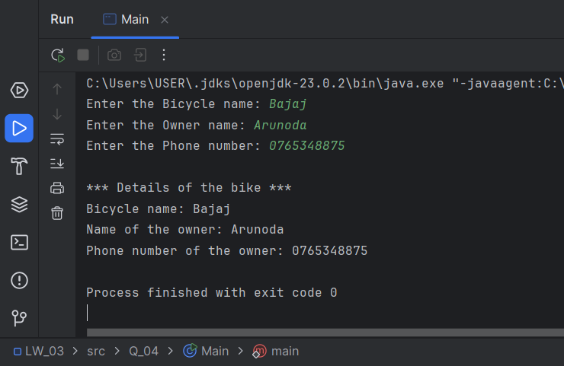

**Q5**

Code: Course.java

package Q_05;  
  
public class Course {  
 private String courseName;  
 private String courseCode;  
 private Lecturer lecturer;  
  
 // Constructor  
 public Course(String courseName, String courseCode) {  
 this.courseName = courseName;  
 this.courseCode = courseCode;  
 }  
  
 // Getters for Course Name  
 public String getCourseName() {  
  
 return courseName;  
 }  
  
 // Setters for Course Name  
 public void setCourseName(String courseName) {  
  
 this.courseName = courseName;  
 }  
  
 // Getters for Course Code  
 public String getCourseCode() {  
  
 return courseCode;  
 }  
  
 // Setters for Course Code  
 public void setCourseCode(String courseCode) {  
  
 this.courseCode = courseCode;  
 }  
  
 // Setters for Lecturer  
 public void setLecturer(Lecturer lecturer) {  
  
 this.lecturer = lecturer;  
 }  
  
 // Getters for Lecturer  
 public Lecturer getLecturer() {  
  
 return lecturer;  
 }  
}

Lecturer.java

package Q_05;  
  
public class Lecturer {  
 private String lecturerName;  
 private String courseTeaching;  
  
 // Constructor  
 public Lecturer(String lecturerName, String courseTeaching) {  
 this.lecturerName = lecturerName;  
 this.courseTeaching = courseTeaching;  
 }  
  
 // Setter for Lecturer Name  
 public void setLecturerName(String lecturerName) {  
  
 this.lecturerName = lecturerName;  
 }  
  
 // Getter for Lecturer Name  
 public String getLecturerName() {  
  
 return this.lecturerName;  
 }  
  
 // Setter for Course Teaching  
 public void setCourseTeaching(String courseTeaching) {  
  
 this.courseTeaching = courseTeaching;  
 }  
  
 // Getter for Course Teaching  
 public String getCourseTeaching() {  
  
 return courseTeaching;  
 }  
}

Student.java

package Q_05;  
  
public class Student {  
 private String studentName;  
 private String degreeName;  
 private String courseFollowing;  
  
 // Constructor  
 public Student(String studentName, String degreeName, String courseFollowing) {  
 this.studentName = studentName;  
 this.degreeName = degreeName;  
 this.courseFollowing = courseFollowing;  
 }  
  
 // Setter for Student Name  
 public void setStudentName(String studentName) {  
  
 this.studentName = studentName;  
 }  
  
 // Getter for Student Name  
 public String getStudentName() {  
  
 return studentName;  
 }  
  
 // Setter for Degree Name  
 public void setDegreeName(String degreeName) {  
  
 this.degreeName = degreeName;  
 }  
  
 // Getter for Degree Name  
 public String getDegreeName() {  
  
 return degreeName;  
 }  
  
 // Setter for Course Following  
 public void setCourseFollowing(String courseFollowing) {  
  
 this.courseFollowing = courseFollowing;  
 }  
  
 // Getter for Course Following  
 public String getCourseFollowing() {  
  
 return courseFollowing;  
 }  
}

Main.java

package Q_05;  
  
import java.util.Scanner;  
  
public class Main {  
 public static void main(String[] args) {  
  
 // Course information  
 Scanner courseInfo = new Scanner(System.*in*);  
  
 System.*out*.print("Name of the Course: ");  
 String courseName = courseInfo.next();  
  
 System.*out*.print("Code of the Course: ");  
 String courseCode = courseInfo.next();  
  
 Course course = new Course(courseName, courseCode);  
 course.setCourseName(courseName);  
 course.setCourseCode(courseCode);  
  
 // Lecturer information  
 Scanner lecturerInfo = new Scanner(System.*in*);  
  
 System.*out*.print("Name of the Lecturer: ");  
 String lecturerName = lecturerInfo.next();  
  
 System.*out*.print("Teaching Course: ");  
 String courseTeaching = lecturerInfo.next();  
  
 Lecturer prof = new Lecturer(lecturerName, courseTeaching);  
 prof.setLecturerName(lecturerName);  
 prof.setCourseTeaching(courseTeaching);  
 course.setLecturer(prof);  
  
 // Student information  
 Scanner studentInfo = new Scanner(System.*in*);  
  
 System.*out*.print("Name of the Student: ");  
 String studentName = studentInfo.next();  
  
 System.*out*.print("Name of the Degree: ");  
 String degreeName = studentInfo.next();  
  
 System.*out*.print("Course Following: ");  
 String courseFollowing = studentInfo.next();  
  
 Student std = new Student(studentName, degreeName, courseFollowing);  
 std.setStudentName(studentName);  
 std.setDegreeName(degreeName);  
 std.setCourseFollowing(courseFollowing);

// Display all information  
 System.*out*.println("\n");  
 System.*out*.println(" ----- LECTURER INFORMATION -----");  
 System.*out*.println("* Lecturer Name: " + prof.getLecturerName());  
 System.*out*.println("* Teaching Course: " + prof.getCourseTeaching());  
  
 System.*out*.println("\n");  
 System.*out*.println(" ----- COURSE INFORMATION -----");  
 System.*out*.println("* Course Name: " + course.getCourseName());  
 System.*out*.println("* Course Code: " + course.getCourseCode());  
 System.*out*.println("* Assigned Lecturer: " + course.getLecturer().getLecturerName());  
  
 System.*out*.println("\n");  
 System.*out*.println(" ----- STUDENT INFORMATION -----");  
 System.*out*.println("* Student Name: " + std.getStudentName());  
 System.*out*.println("* Degree Name: " + std.getDegreeName());  
 System.*out*.println("* Course Following: " + std.getCourseFollowing());  
 }  
}

Output:

