**Q1**

Code: Approach 1 - Main

package Q_01;  
  
import java.util.Scanner;  
  
public class Main {  
 public static void main(String[] args) {  
  
 Scanner input = new Scanner(System.*in*);  
  
 System.*out*.print("Enter an integer: ");  
 int num1 = input.nextInt();  
  
 System.*out*.print("Enter an integer: ");  
 int num2 = input.nextInt();  
  
 System.*out*.print("Enter an integer: ");  
 int num3 = input.nextInt();  
  
 if (num1 >= num2) {  
 if (num3 >= num2) {  
 System.*out*.print(num2 + " is the smallest integer");  
   
 } else {  
 System.*out*.print(num3 + " is the smallest integer");  
   
 }  
   
 } else if (num1 >= num3) {  
 System.*out*.print(num3 + " is the smallest integer");  
   
 } else {  
 System.*out*.print(num1 + " is the smallest integer");  
   
 }  
 }  
}

Code: Approach 2 – Main2

package Q_01;  
  
import java.util.Scanner;  
  
public class Main2 {  
 public static void main(String[] args) {  
  
 Scanner input = new Scanner(System.*in*);  
  
 System.*out*.print("Enter an integer: ");  
 int num1 = input.nextInt();  
  
 System.*out*.print("Enter an integer: ");  
 int num2 = input.nextInt();  
  
 System.*out*.print("Enter an integer: ");  
 int num3 = input.nextInt();  
  
 if (num1 >= num2 && num3 >= num2) {  
 System.*out*.print(num2 + " is the smallest integer");  
   
 } else if (num2 >= num1 && num3 >= num1) {  
 System.*out*.print(num1 + " is the smallest integer");  
   
 } else {  
 System.*out*.print(num3 + " is the smallest integer");  
   
 }  
 }  
}

Code: Approach 3 – Main3

package Q_01;  
  
import java.util.Scanner;  
  
public class Main3 {  
 public static void main(String[] args) {  
  
 Scanner input = new Scanner(System.*in*);  
  
 System.*out*.print("Enter an integer: ");  
 int num1 = input.nextInt();  
  
 System.*out*.print("Enter an integer: ");  
 int num2 = input.nextInt();  
  
 System.*out*.print("Enter an integer: ");  
 int num3 = input.nextInt();  
  
 int sInt = num1;  
  
 if (sInt >= num2) {  
 sInt = num2;  
 }  
 if (sInt >= num3) {  
 sInt = num3;  
 }  
 System.*out*.print(sInt + " is the smallest integer");  
 }  
}

Output:

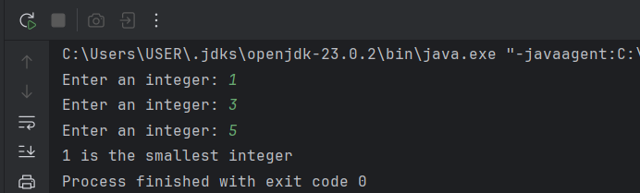

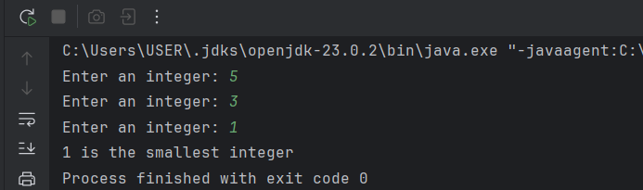

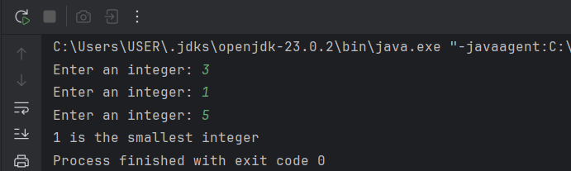

**Q2**

Code:

package Q_02;  
  
import java.util.Scanner;  
  
public class Main {  
 public static void main(String[] args) {  
  
 Scanner scanner = new Scanner(System.*in*);  
  
 System.*out*.println("0.Magenta");  
 System.*out*.println("1.Cyan");  
 System.*out*.println("2.Red");  
 System.*out*.println("3.Blue");  
 System.*out*.println("4.Green\n");  
 System.*out*.print("Select one color from the above list: ");  
  
 int selection = scanner.nextInt();  
  
 switch (selection) {  
 case 0:  
 System.*out*.println("\n* You selected Magenta");  
 break;  
  
 case 1:  
 System.*out*.println("\n* You selected Cyan");  
 break;  
  
 case 2:  
 System.*out*.println("\n* You selected Red");  
 break;  
  
 case 3:  
 System.*out*.println("\n* You selected Blue");  
 break;  
  
 case 4:  
 System.*out*.println("\n* You selected Green");  
 break;  
  
 default:  
 System.*out*.println("\n* Invalid selection");  
 }  
 }  
}

Output:

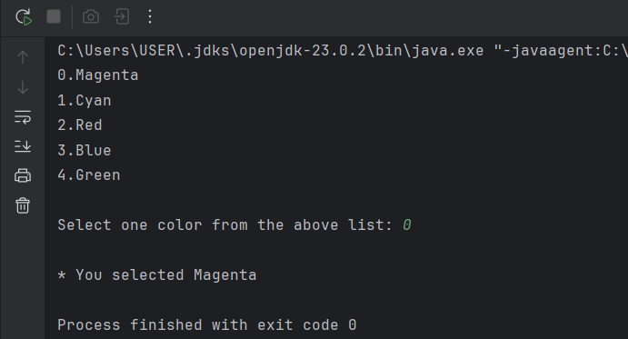

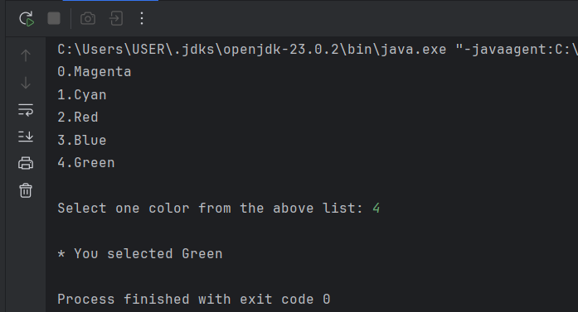

**Q3**

Code:

package Q_03;  
  
import java.util.Scanner;  
  
public class Main {  
  
 public static void main(String[] args) {  
  
 Scanner input = new Scanner(System.*in*);  
  
 System.*out*.print("Enter a power of 10: ");  
 int power = input.nextInt();  
  
 switch (power) {  
 case 6:  
 System.*out*.println("Million");  
 break;  
  
 case 9:  
 System.*out*.println("Billion");  
 break;  
  
 case 12:  
 System.*out*.println("Trillion");  
 break;  
  
 case 15:  
 System.*out*.println("Quadrillion");  
 break;  
  
 case 18:  
 System.*out*.println("Quintillion");  
 break;  
  
 case 21:  
 System.*out*.println("Sextillion");  
 break;  
  
 case 30:  
 System.*out*.println("Nonillion");  
 break;  
  
 case 100:  
 System.*out*.println("Googol");  
 break;  
  
 default:  
 System.*out*.println("No standard name for 10^" + power);  
 System.*out*.println("Enter a power of 10 (example: 6, 9, 12, etc.)");  
 break;  
 }  
 }  
}

Output:

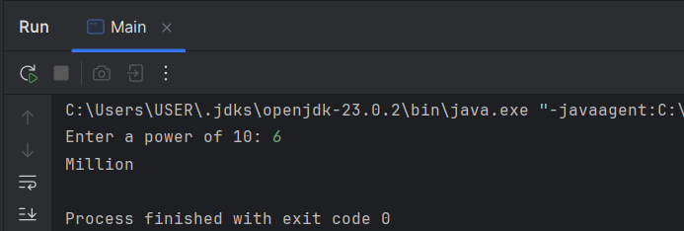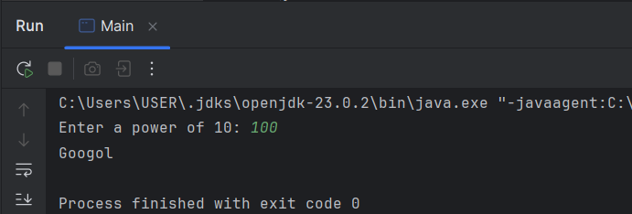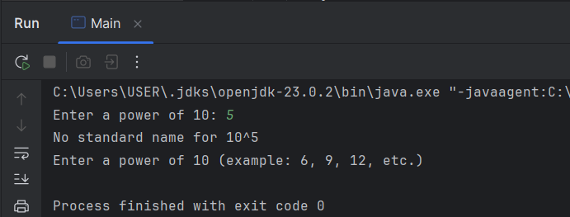

**Q4**

Code:

package Q_04;  
  
import java.util.Scanner;  
  
public class Main {  
 public static void main(String[] args) {  
  
 Scanner input = new Scanner(System.*in*);  
  
 System.*out*.print("Enter a year: ");  
 int year = input.nextInt();  
  
 if (year % 4 == 0) {  
 if (year % 100 == 0 && year % 400 == 0)  
 System.*out*.print("* This year is a leap year *");  
  
 else if (year % 100 != 0)  
 System.*out*.print("* This year is a leap year *");  
  
 else  
 System.*out*.print("* This year is not a leap year *");  
  
 } else  
 System.*out*.print("* This year is not a leap year * ");  
 }  
}

Output:

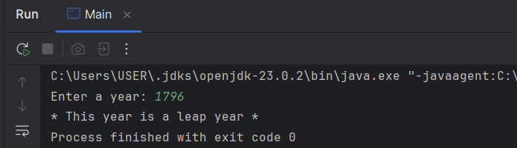

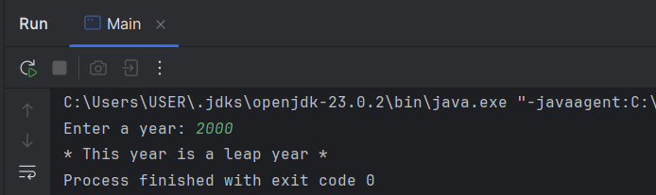

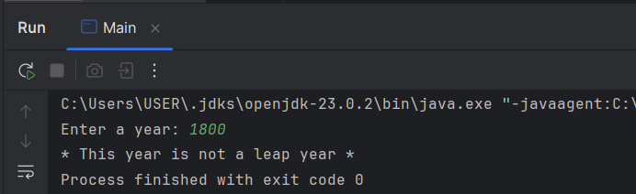

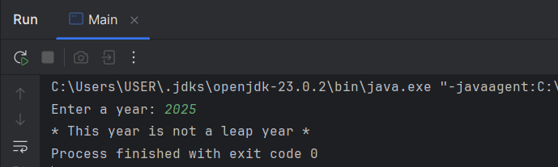

**Q5**

Code:

package Q_05;  
  
import java.util.Scanner;  
  
public class Main {  
 public static void main(String[] args) {  
  
 double eCost, sdCost, dCost;  
 int qtyE = 0, qtySD = 0, qtyD = 0;  
 int Entree, sDish, Drink;  
 // Assume that the maximum quantity allowed per item is 10 at a time  
  
 Scanner input = new Scanner(System.*in*);  
  
 System.*out*.println("*** Welcome to MyJava Lo-Fat Burgers ***");  
  
 System.*out*.println("\n**** Entree Menu ****");  
 System.*out*.println("1 -> Tofu Burger $3.49");  
 System.*out*.println("2 -> Cajun Chicken $4.59");  
 System.*out*.println("3 -> Buffalo Wings $3.99");  
 System.*out*.println("4 -> Rainbow Fillet $2.99");  
  
 System.*out*.println("\n*** Side Dish Menu ***");  
 System.*out*.println("1. Rice Cracker $0.79");  
 System.*out*.println("2. No-Salt Fries $0.69");  
 System.*out*.println("3. Zucchini $1.09");  
 System.*out*.println("4. Brown Rice $0.59");  
  
 System.*out*.println("\n*** Drink Menu ***");  
 System.*out*.println("1. Cafe Mocha $1.99");  
 System.*out*.println("2. Cafe Latte $1.90");  
 System.*out*.println("3. Espresso $2.49");  
 System.*out*.println("4. Oolong Tea $0.99");

// Entree  
System.*out*.print("\nEntree item (Enter 0 to skip): ");  
Entree = input.nextInt();  
while (Entree < 0 || Entree > 4) {  
 System.*out*.println("Invalid Entree choice. Please enter again");  
 System.*out*.print("\nEntree item (Enter 0 to skip): ");  
 Entree = input.nextInt();  
}  
  
if (Entree == 1)  
 eCost = 3.49;  
else if (Entree == 2)  
 eCost = 4.59;  
else if (Entree == 3)  
 eCost = 3.99;  
else if (Entree == 4)  
 eCost = 2.99;  
else  
 eCost = 0.00;  
  
if (Entree != 0) {  
 System.*out*.print("Quantity: ");  
 qtyE = input.nextInt();  
 while (qtyE < 1 || qtyE > 10) {  
 System.*out*.println("Invalid quantity. Please enter again");  
 System.*out*.print("Quantity: ");  
 qtyE = input.nextInt();  
 }  
}

// Side Dish  
System.*out*.print("\nSide Dish item (Enter 0 to skip): ");  
sDish = input.nextInt();  
while (sDish < 0 || sDish > 4) {  
 System.*out*.println("Invalid Side Dish choice. Please enter again");  
 System.*out*.print("\nSide Dish item (Enter 0 to skip): ");  
 sDish = input.nextInt();  
}

if (sDish == 1)  
 sdCost = 0.79;  
else if (sDish == 2)  
 sdCost = 0.69;  
else if (sDish == 3)  
 sdCost = 1.09;  
else if (sDish == 4)  
 sdCost = 0.59;  
else  
 sdCost = 0.00;  
  
if (sDish != 0) {  
 System.*out*.print("Quantity: ");  
 qtySD = input.nextInt();  
 while (qtySD < 1 || qtySD > 10) {  
 System.*out*.println("Invalid quantity. Please enter again");  
 System.*out*.print("Quantity: ");  
 qtySD = input.nextInt();  
 }  
}

// Drink  
System.*out*.print("\nDrink item (Enter 0 to skip): ");  
Drink = input.nextInt();  
while (Drink < 0 || Drink > 4) {  
 System.*out*.println("Invalid Drink choice. Please enter again");  
 System.*out*.print("\nDrink item (Enter 0 to skip): ");  
 Drink = input.nextInt();  
}

if (Drink == 1)  
 dCost = 1.99;  
else if (Drink == 2)  
 dCost = 1.90;  
else if (Drink == 3)  
 dCost = 2.49;  
else if (Drink == 4)  
 dCost = 0.99;  
else  
 dCost = 0.00;

if (Drink != 0) {  
 System.*out*.print("Quantity: ");  
 qtyD = input.nextInt();  
 while (qtyD < 1 || qtyD > 10) {  
 System.*out*.println("Invalid quantity. Please enter again");  
 System.*out*.print("Quantity: ");  
 qtyD = input.nextInt();  
 }  
}

if (Entree == 0 && sDish == 0 && Drink == 0) {  
 System.*out*.println("\nNo items selected");  
 } else {  
 double total = (eCost * qtyE) + (sdCost * qtySD) + (dCost * qtyD);  
 System.*out*.println("\n*** Your Order ***");  
 System.*out*.println("\nCategory Price Qty Amount");  
 System.*out*.println("-----------------------------------");  
 System.*out*.printf("Entree: $%.2f %d $%.2f", eCost, qtyE, (eCost * qtyE));  
 System.*out*.printf("\nSide Dish: $%.2f %d $%.2f", sdCost, qtySD, (sdCost * qtySD));  
 System.*out*.printf("\nDrink: $%.2f %d $%.2f", dCost, qtyD, (dCost * qtyD));  
 System.*out*.println("\n-----------------------------------");  
 System.*out*.printf("Total: $%.2f", total);  
 System.*out*.println("\n-----------------------------------");  
 }  
  
 }  
}

Output:

