**Q1**

Code:

package Q_01;  
  
public class Main {  
 public static void main(String[] args) {  
 int i =10;  
 int count = 0;  
  
 while (i <= 49) {  
 if (count % 10 == 0 && count != 0) {  
 System.*out*.print("\n");  
 }  
 System.*out*.printf("%d ",i);  
 count++;  
 i++;  
 }  
 }  
}

Output:

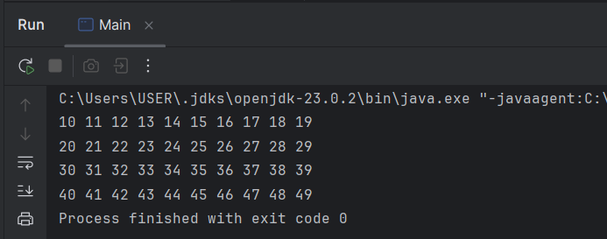

**Q2**

Code:

package Q_02;  
  
import java.util.Scanner;  
  
public class Main {  
  
 public static int digitCount(int number) {  
  
 int dCount = 0;  
  
 if (number == 0)  
 dCount = 1;  
  
 while (number > 0) {  
 number = number / 10;  
 dCount++;  
 }  
 return dCount;  
 }  
 public static void main(String[] args) {  
  
 Scanner input = new Scanner(System.*in*);  
 int num;  
  
 while(true) {  
 System.*out*.print("Enter an integer: ");  
 num = input.nextInt();  
  
 if (num < 0) {  
 System.*out*.println("you have entered a negative integer");  
 System.*out*.println("Exited");  
 break;  
   
 } else {  
 System.*out*.printf("%d has %d digits", num, *digitCount*(num));  
 System.*out*.println("\n");  
  
 }  
 }  
 }  
}

Output:

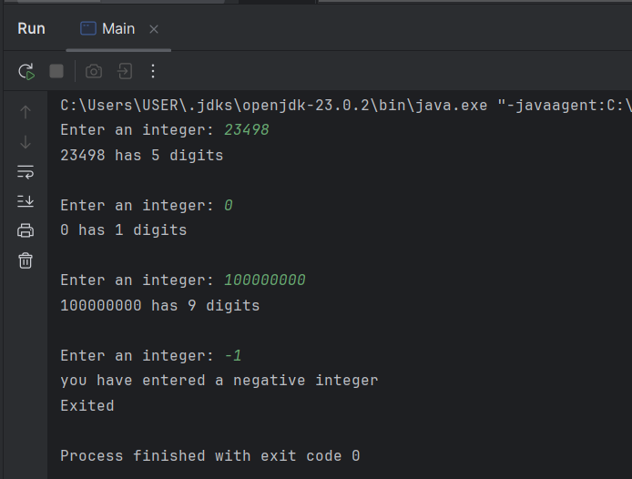

**Q3**

Code:

package Q_03;  
  
import java.util.Scanner;  
  
public class Main {  
 public static void main(String[] args) {  
  
 Scanner input = new Scanner(System.*in*);  
  
 System.*out*.print("Enter a Number: ");  
 int N = input.nextInt();  
  
 System.*out*.printf("\n------ Multiplication Table of %d ------\n", N);  
  
 for (int i = 1; i <= 10; i++ ) {  
 if (i == 10) // if selection used for better formatted output  
 System.*out*.printf("\t\t\t%d * %d = %d\n", N, i, (N * i));  
 else  
 System.*out*.printf("\t\t\t%d * %d = %d\n", N, i, (N * i));  
 }  
 }  
}

Output:

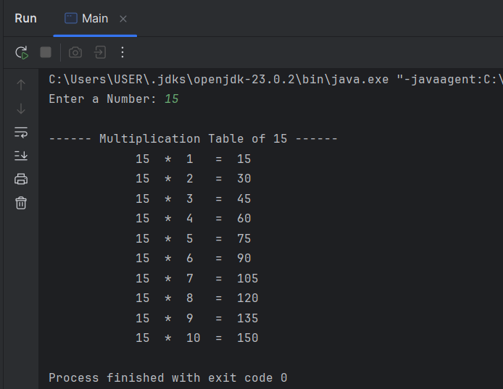

**Q4**

Code:

package Q_04;  
  
import java.util.Scanner;  
  
public class Main {  
 public static void main(String[] args) {  
  
 Scanner input = new Scanner(System.*in*);  
  
 System.*out*.print("Enter the number of rows: ");  
 int rows = input.nextInt();  
  
 System.*out*.print("\n");  
  
 for (int i = 1; i <= rows; i++) {  
 for (int m = 1; m <= (rows + 1 - i); m++) {  
 System.*out*.print(" ");  
   
 }  
 for (int j = 1; j <= (2 * i - 1); j++ ) {  
 System.*out*.print("* ");  
   
 }  
 System.*out*.print("\n");  
   
 }  
 }  
}

Output:

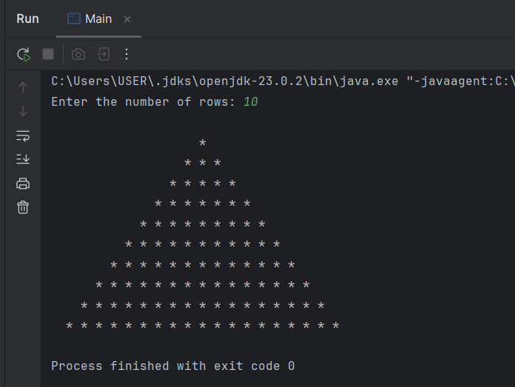

**Q5**

Code:

package Q_05;  
  
import java.util.Scanner;  
  
public class Main {  
 public static void main(String[] args) {  
  
 Scanner input = new Scanner(System.*in*);  
  
 System.*out*.print("Enter a word or phrase: ");  
 String text = input.nextLine();  
  
 String temp = text.toLowerCase();  
 String word = temp.replaceAll("[^a-zA-Z0-9]", "");  
  
 int size = word.length();  
 int start;  
 int end = size - 1;  
 int status = 0;  
  
 if (size ==0)  
 System.*out*.println("-- No valid characters were entered");  
 else if (size == 1)  
 System.*out*.println("-- Only one valid character has been entered");  
 else {  
 for (start = 0; start <= end; start++) {  
 if (word.charAt(start) == word.charAt(end)) {  
 status = 1;  
 end--;  
  
 } else {  
 status = 0;  
 break;  
 }  
 }  
  
 if (status == 1)  
 System.*out*.printf("-- The entered data, \"%s\" is a palindrome", text);  
 else  
 System.*out*.printf("-- The entered data, \"%s\" is not a palindrome", text);  
  
 }  
 }  
}

Output:

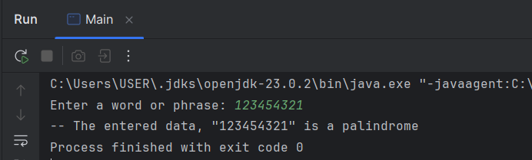

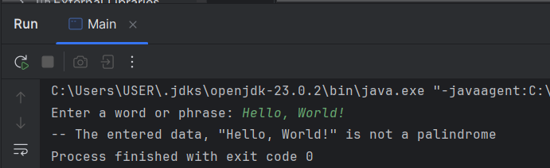

**Q6**

Code:

package Q_06;  
import java.util.Scanner;  
import java.util.Random;  
  
public class Main {  
 public static void main(String[] args) {  
  
 Random random = new Random();  
 int randomNum = random.nextInt(100) + 1;  
  
 Scanner input = new Scanner(System.*in*);  
 int num = 0;  
  
 System.*out*.println("I've generated a random number. It's between 1 and 100.");  
 System.*out*.println("Can you guess it?");  
  
 while (num != randomNum) {  
 System.*out*.print("\nEnter your guessed number: ");  
 num = input.nextInt();  
  
 if (num <= randomNum - 20)  
 System.*out*.println("too low");  
 else if (num <= randomNum - 10)  
 System.*out*.println("lower");  
 else if (num <= randomNum - 5)  
 System.*out*.println("close, but low");  
 else if (num < randomNum)  
 System.*out*.println("very close, little bit low");  
 else if (num >= randomNum + 20)  
 System.*out*.println("too high");  
 else if (num >= randomNum + 10)  
 System.*out*.println("higher");  
 else if (num >= randomNum + 5)  
 System.*out*.println("close, but high");  
 else if (num > randomNum)  
 System.*out*.println("very close, little bit higher");  
 }  
 System.*out*.println("Correct! The number was " + randomNum);  
 }  
}

Output:

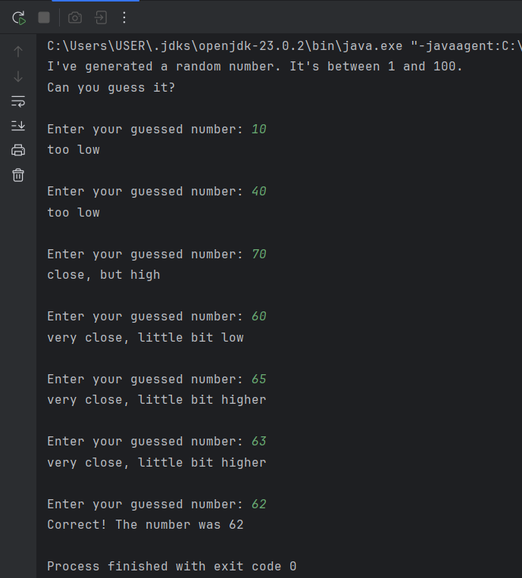

**Q7**

Code: Approach 1 – Main (Perform non-case-sensitive replacements, including words withsymbols)

package Q_07;  
  
import java.util.Scanner;  
  
public class Main {  
 public static void main(String[] args) {

//If we want to do non-case-sensitive replacements including symbols

Scanner input = new Scanner(System.*in*);  
  
 System.*out*.print("Enter a sentence: ");  
 String sentence = input.nextLine().trim();  
  
 System.*out*.print("Enter the word to replace: ");  
 String wReplace = input.nextLine().trim();  
  
 System.*out*.print("Enter the replacement word: ");  
 String rWord = input.nextLine().trim();  
  
 String[] text = sentence.split("(?=\\W)|(?<=\\W)|(?=\\b)|(?<=\\b)|(?=_)|(?<=_)");  
  
 int textSize = text.length;  
 boolean wordFound = false;  
  
 StringBuilder updatedText = new StringBuilder();  
  
 for (int i = 0; i < textSize; i++) {  
 if (text[i].equalsIgnoreCase(wReplace)) {  
 updatedText.append(rWord);  
 wordFound = true;  
  
 } else  
 updatedText.append(text[i]);  
  
 }

if (!wordFound) {  
 System.*out*.println("\nThe word \"" + wReplace + "\" was not found in the sentence.");  
 System.*out*.println("sentence: " + updatedText);  
 System.*out*.println("No replacements were made.");  
  
 } else  
 System.*out*.println("\nUpdated sentence: " + updatedText);  
  
 }  
}

Output: Approach 1

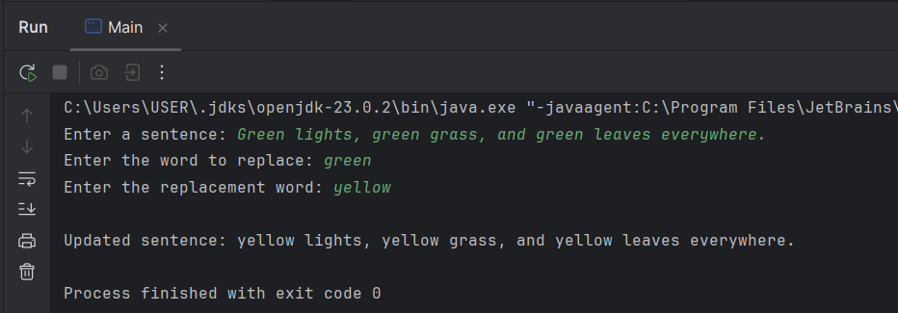

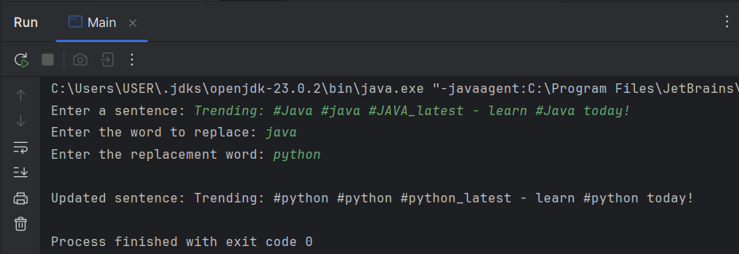

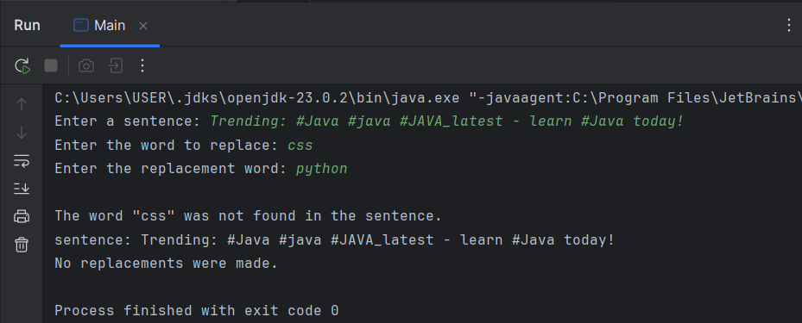

Code: Approach 2 – Main2 (Perform case-sensitive replacements, including words withsymbols)

package Q_07;  
  
import java.util.Scanner;  
  
public class Main2 {  
 public static void main(String[] args) {  
 //If we want to do replacements of case-sensitive words with symbols  
 Scanner input = new Scanner(System.*in*);  
  
 System.*out*.print("Enter a sentence: ");  
 String sentence = input.nextLine().trim();  
  
 System.*out*.print("Enter the word to replace: ");  
 String wReplace = input.nextLine().trim();  
  
 System.*out*.print("Enter the replacement word: ");  
 String rWord = input.nextLine().trim();  
  
 String[] text = sentence.split("(?=\\W)|(?<=\\W)|(?=\\b)|(?<=\\b)|(?=_)|(?<=_)");  
  
 int textSize = text.length;  
 boolean wordFound = false;

StringBuilder updatedText = new StringBuilder();  
  
 for (int i = 0; i < textSize; i++) {  
 if (text[i].equals(wReplace)) {  
 updatedText.append(rWord);  
 wordFound = true;  
  
 } else  
 updatedText.append(text[i]);  
  
 }  
  
 if (!wordFound) {  
 System.*out*.println("\nThe word \"" + wReplace + "\" was not found in the sentence.");  
 System.*out*.println("sentence: " + updatedText);  
 System.*out*.println("No replacements were made.");  
  
 } else  
 System.*out*.println("\nUpdated sentence: " + updatedText);  
  
 }  
}

Output: Approach 2

