A project on
NidhiKosh
Real-Time Stock Market Trading Simulator
Trade Virtual. Learn Real.
──────────────────────────────────────────────────
Full-Stack Web Application | MERN Stack
Submitted by

Krishna Khatiwada (AP23110011547)
Yajnesh Ande (AP23110011208)
Rakesh Yadav (AP23110011678)
Aniket Jha (AP23110011553)

3rd Year 6th Semester
Bachelor of Technology In
Computer Science and Engineering
School of Engineering and Sciences


Under the supervision of
Himanshu Mishra
Department of CSE
April, 2026
SRM University, AP, Neerukonda, Mangalagiri, Guntur.
Andhra Pradesh – 522 503
GitHub: https://github.com/Abhi-0888/BetaBucks

CERTIFICATE
Date: _______________________
This is to certify that the project work titled "NidhiKosh — Real-Time Stock Market Trading Simulator" has been carried out by [Student Name] (Registration No: [XXXXXXX]) under my supervision, in partial fulfillment of the requirements for the award of the degree of Bachelor of Technology in Computer Science and Engineering.
The work presented in this project is genuine, original, and not submitted elsewhere for any other degree or award. The project demonstrates the practical application of Full-Stack Web Development using the MERN stack with real-time capabilities.

Supervisor  [Supervisor Name]  [Designation]  [Department] | Head of Department  [HOD Name]  [Designation]  [Department]

DECLARATION
I, [Student Name], hereby declare that the project work titled "NidhiKosh — Real-Time Stock Market Trading Simulator" is an authentic record of my own work carried out as part of the requirements for the degree of Bachelor of Technology in Computer Science and Engineering.
This project has not been submitted elsewhere, in part or in full, for the fulfillment of any other degree or professional qualification. All sources of information used in this project have been duly acknowledged with references.
I understand that any false statement or misrepresentation regarding this declaration could result in disciplinary action by the institution.

Place: ___________________ Date: ___________________
Signature of Student: _______________________
[Student Name]
[Registration Number]

ACKNOWLEDGEMENTS
I would like to express my heartfelt gratitude to all those who have contributed, directly or indirectly, to the successful completion of this project.
First and foremost, I extend my sincere thanks to my project supervisor, [Supervisor Name], for providing invaluable guidance, continuous encouragement, and constructive feedback throughout the duration of this project. Their expertise in software engineering and web technologies has been instrumental in shaping this work.
I am grateful to the faculty members of the Department of Computer Science and Engineering for creating an environment conducive to learning and research. Their teachings formed the theoretical foundation upon which this project is built.
Special thanks to my peers and classmates who provided constructive feedback during various stages of development, and to the open-source community whose libraries and frameworks — including MongoDB, Express.js, React, Node.js, Socket.io, Tailwind CSS, and Recharts — made this project possible.
I would also like to acknowledge Yahoo Finance for providing accessible market data APIs, which power the real-time stock price functionality of NidhiKosh.
Finally, I am deeply thankful to my family for their unwavering support, patience, and encouragement throughout my academic journey. This project would not have been possible without their constant motivation.

ABSTRACT
NidhiKosh is a comprehensive full-stack web application built with the MERN stack that simulates
real-world stock market trading in a safe, risk-free virtual environment. It provides users with
real-time NSE India market data, portfolio management, analytics, and competitive leaderboards.

NidhiKosh (derived from Sanskrit, meaning 'treasure repository') is a sophisticated real-time stock market trading simulator designed to provide users with an authentic trading experience without any financial risk. The platform enables users to trade stocks from the National Stock Exchange (NSE) of India using virtual currency, bridging the gap between theoretical knowledge and practical market experience.
The application is built on the MERN stack — MongoDB, Express.js, React 18, and Node.js — augmented with Socket.io for real-time bidirectional communication. Market data is sourced from the Yahoo Finance API, which provides live pricing for all major NSE stocks including the top 20 NIFTY 50 constituents. Price updates are pushed to connected clients via WebSocket every 10–15 seconds during market hours, creating a live trading experience that mirrors professional trading platforms.
The system architecture follows a three-tier pattern: a React-based single-page application (SPA) for the presentation layer, a RESTful Node.js/Express.js API server for the business logic layer, and MongoDB for persistent storage of users, portfolios, transactions, and stock data. Security is enforced through JWT (JSON Web Token) authentication, bcrypt password hashing, rate limiting middleware, and input validation using Joi.
Core features include user registration with ₹1,00,000 virtual capital, real-time stock price monitoring, buy/sell order execution with atomic balance updates, portfolio tracking with live P&L calculations, transaction history with CSV export, an analytics dashboard with performance charts, and a global leaderboard ranking users by portfolio value.
The project demonstrates advanced full-stack development techniques including atomic database operations for race condition prevention, optimistic UI updates, React Context + Query patterns for state management, WebSocket room-based subscriptions, and responsive design with Tailwind CSS.

Keywords: MERN Stack, Real-Time Trading Simulator, WebSocket, Socket.io, NSE India, Yahoo Finance API, JWT Authentication, MongoDB, React 18, Portfolio Management, FinTech

Table of Contents
CERTIFICATE 2
DECLARATION 3
ACKNOWLEDGEMENTS 4
ABSTRACT 5
1. INTRODUCTION 8
1.1 Project Overview 8
1.2 Objectives 8
1.3 Scope of the Project 8
1.4 Definitions and Abbreviations 9
2. LITERATURE REVIEW 10
2.1 Existing Trading Simulators 10
2.2 Technology Stack Analysis 10
3. SYSTEM REQUIREMENTS 11
3.1 Functional Requirements 11
3.2 Non-Functional Requirements 12
3.3 Hardware and Software Requirements 12
4. SYSTEM ARCHITECTURE 13
4.1 High-Level Architecture Overview 13
4.2 Frontend Architecture 14
4.3 Backend Architecture 14
4.4 Database Design 14
4.5 Real-Time System Architecture 15
5. TECHNOLOGY STACK 16
5.1 Frontend Technologies 16
5.2 Backend Technologies 16
5.3 Database Technology 17
5.4 External APIs and Services 17
6. IMPLEMENTATION 18
6.1 Data Flow and System Integration 18
User Authentication Flow 18
Real-Time Stock Price Update Flow 18
Trade Execution Flow (Buy Order) 19
6.2 Real-Time Price Update System 19
6.3 Authentication and Authorization 19
6.4 Trading Operations Engine 20
6.5 API Endpoints Reference 21
7. FEATURES AND FUNCTIONALITY 22
7.1 User Management 22
7.2 Market Data and Stock Information 22
7.3 Trading Features 22
7.4 Portfolio Management 23
7.5 Analytics and Reporting 23
8. TESTING 24
8.1 Testing Strategy 24
8.2 Test Cases and Results 24
9. RESULTS AND SCREENSHOTS 25
9.1 Login Page 25
9.2 Dashboard Page 25
9.3 Portfolio Page 26
9.4 Analytics Page 27
9.5 Transaction History Page 28
9.6 Leaderboard Page 28
10. CONCLUSION AND FUTURE WORK 30
10.1 Conclusion 30
10.2 Challenges and Learnings 30
10.3 Future Enhancements 31
11. REFERENCES 32

1. INTRODUCTION

1.1 Project Overview
NidhiKosh (meaning 'treasure repository' in Sanskrit) is a full-featured, production-ready stock market trading simulator that replicates the experience of live stock trading on the National Stock Exchange (NSE) of India — with zero financial risk. The platform provides each user with a virtual capital of ₹1,00,000 (One Lakh Indian Rupees) and real-time NSE stock prices, allowing them to buy, sell, track portfolios, analyse performance, and compete on a global leaderboard.
The project is positioned as both an educational tool — helping beginners understand stock market mechanics, order execution, portfolio diversification, and profit/loss calculations — and as a realistic sandbox for intermediate and advanced traders to validate strategies before committing real capital. The application is publicly accessible via web browser and is fully responsive across desktop, tablet, and mobile devices.
Technically, NidhiKosh is a full-stack MERN application that combines REST APIs with WebSocket-based real-time communication. The frontend is a React 18 single-page application (SPA) while the backend is a Node.js/Express.js server that integrates the Yahoo Finance API, manages a MongoDB database, and broadcasts live price updates via Socket.io

1.2 Objectives
The primary objectives of the NidhiKosh project are:
- To develop a fully functional, production-grade stock trading simulator using modern MERN stack technologies.
- To integrate real-time NSE stock price data from Yahoo Finance API with live WebSocket broadcast to all connected clients.
- To implement secure, stateless user authentication and session management using JSON Web Tokens (JWT) and bcrypt.
- To provide an intuitive, dark-themed, responsive user interface for seamless trading across all device sizes.
- To enforce data integrity during concurrent trade execution using MongoDB atomic operations to prevent race conditions.
- To implement comprehensive portfolio management with live P&L calculations, sector allocation, and performance metrics.
- To provide a competitive environment via a real-time global leaderboard ranked by total portfolio value.
- To implement thorough security measures including rate limiting, input validation, CORS configuration, and security headers.
- To demonstrate industry best practices in full-stack development, including RESTful API design, MVC architecture, and modular code organisation.
- To serve as a practical, portfolio-worthy showcase of full-stack web development capabilities.

1.3 Scope of the Project
In Scope:
- User registration, login, and profile management with JWT-based authentication.
- Real-time display of 20 top NIFTY 50 NSE stocks with live price updates every 10–15 seconds during market hours.
- Buy and sell order execution at current market price with instant portfolio update.
- Portfolio tracking with holdings, average cost, unrealized P&L, and sector allocation.
- Transaction history with filtering by type (BUY/SELL) and CSV export capability.
- Analytics dashboard with trading statistics, P&L over time chart, and best/worst trade analysis.
- Global leaderboard ranking users by total portfolio value with percentile calculation.
- Market status indicator (open/pre-market/post-market/closed) based on NSE trading hours.
- Responsive design with full support for desktop, tablet, and mobile screen sizes.
Out of Scope:
- Real monetary transactions or integration with brokerage APIs (Zerodha, Upstox, etc.).
- Advanced order types such as limit orders, stop-loss, good-till-cancelled (GTC), or bracket orders.
- Derivatives trading including options, futures, and commodity contracts.
- International stock markets beyond NSE India.
- Social trading features, news feeds, or integrated financial research.
- Native iOS or Android mobile applications (currently a responsive web application only).

1.4 Definitions and Abbreviations
Term / Abbreviation | Definition
MERN Stack | MongoDB, Express.js, React, Node.js — the four-technology full-stack JavaScript framework used.
NSE | National Stock Exchange of India — the primary stock exchange whose data powers this application.
NIFTY 50 | National Index Fifty — the benchmark index of 50 large-cap companies listed on NSE.
JWT | JSON Web Token — an open standard (RFC 7519) used for secure, stateless authentication.
WebSocket | A communication protocol providing full-duplex, bidirectional channels over a single TCP connection.
Socket.io | A JavaScript library enabling real-time, event-driven bidirectional communication between browser and server.
REST API | Representational State Transfer API — an architectural style for networked, stateless HTTP-based services.
SPA | Single-Page Application — a web app that loads a single HTML page and dynamically updates content.
P&L | Profit and Loss — the financial gain or loss from trading activities.
ORM/ODM | Object Document Mapper — Mongoose maps JavaScript objects to MongoDB documents.
DXA | Document Units — measurement in Word documents (1440 DXA = 1 inch).
bcrypt | A cryptographic password hashing function with built-in salt and configurable work factor.
Atomic Operation | A database operation that is indivisible — it either fully completes or fully fails with no partial state.

2. LITERATURE REVIEW

2.1 Existing Trading Simulators
The stock market simulation space includes several established platforms, each with distinct strengths and weaknesses that informed the design of NidhiKosh.
Investopedia Stock Simulator is arguably the most well-known simulator, offering educational content alongside paper trading. However, it focuses on the US market, updates prices on a 15-minute delay, and lacks WebSocket-based live updates. Its interface, while functional, is not optimised for modern mobile-first browsing.
Wall Street Survivor emphasises gamification and social competition but has limited NSE India coverage and relies on delayed data. Zerodha Varsity, an initiative by India's largest discount broker, provides excellent educational material on NSE markets but does not offer an interactive trading simulator with real-time prices.
TradingView's Paper Trading feature is technically superior with live price charts and technical indicators, but requires a subscription for full functionality and does not isolate the educational simulation experience. None of these platforms combine live NSE data, WebSocket real-time updates, a MERN stack architecture, and a competitive leaderboard in a single open-source application — which is precisely the differentiation NidhiKosh offers.

2.2 Technology Stack Analysis
The selection of MERN stack (MongoDB, Express.js, React, Node.js) was made after evaluating multiple alternatives:
Node.js vs. Python/Django: Node.js offers superior performance for I/O-intensive, event-driven applications — critical for handling concurrent WebSocket connections and frequent market data polling. Python/Django, while excellent for data-heavy ML applications, introduces an impedance mismatch when building a real-time JavaScript-heavy frontend.
MongoDB vs. PostgreSQL: MongoDB's flexible document schema accommodates evolving stock data structures (e.g., market depth arrays, nested bid/ask objects) without schema migrations. Its aggregation pipeline is highly effective for analytics queries computing leaderboard rankings and P&L summaries. PostgreSQL would require more rigid schema management but would offer superior relational query capabilities for complex joins.
Socket.io vs. Raw WebSocket: Socket.io was selected over raw WebSocket for its automatic reconnection, heartbeat management, room-based subscription model (enabling efficient targeted broadcasts to subscribed clients), and graceful fallback to HTTP long-polling for older clients.
React 18 vs. Vue/Angular: React's component-based architecture, extensive ecosystem (React Query, React Router, Recharts), and Hooks API align well with building a complex, data-driven trading interface. React Query specifically simplifies server state management with caching, background refetching, and optimistic updates — features essential for a real-time trading application.
Yahoo Finance API vs. Alpha Vantage/IEX Cloud: Yahoo Finance provides comprehensive NSE stock coverage at no cost with no API key for basic usage. Alpha Vantage imposes strict rate limits on its free tier (5 requests/minute), making it unsuitable for polling 20 stocks every 10 seconds. IEX Cloud has limited NSE India coverage on its free tier.

3. SYSTEM REQUIREMENTS

3.1 Functional Requirements
FR1: User Management
- The system shall allow new users to register with email, name, and password.
- Each new account shall be provisioned with ₹1,00,000 (one lakh) virtual balance.
- The system shall authenticate users and issue JWT tokens with 7-day expiration.
- The system shall allow users to reset their virtual balance to ₹1,00,000.
- The system shall protect all sensitive routes with JWT authentication middleware.
FR2: Market Data
- The system shall fetch and display real-time stock prices for 20 NIFTY 50 stocks from NSE via Yahoo Finance.
- The system shall automatically push stock price updates to all connected clients every 10–15 seconds during market hours.
- The system shall display stock information including current price, day high/low, volume, market cap, P/E ratio, and change percentage.
- The system shall provide a market status indicator: Pre-Market, Open, Post-Market, or Closed.
- The system shall provide market breadth data showing advancing vs. declining stocks.
FR3: Trading Operations
- The system shall allow users to buy stocks at current market price with confirmation dialog.
- The system shall allow users to sell stocks from their portfolio at current market price.
- The system shall validate sufficient balance before executing buy orders.
- The system shall validate sufficient holdings quantity before executing sell orders.
- The system shall prevent trading operations outside regular NSE market hours.
- The system shall execute all trades at the real-time price fetched at the moment of order submission.
- The system shall use atomic database operations to prevent race conditions and overdraft.
FR4: Portfolio Management
- The system shall track all user holdings with quantity and weighted average cost.
- The system shall calculate real-time unrealized P&L for each holding.
- The system shall display total portfolio value (cash + holdings value).
- The system shall show sector-wise allocation with percentage breakdown.
FR5: Analytics and Reporting
- The system shall maintain a complete, immutable transaction history for each user.
- The system shall provide analytics including win rate, total trades, average hold time, and total P&L.
- The system shall display a P&L over time chart (30-day view).
- The system shall identify and display the best and worst trades by profit/loss amount.
- The system shall allow CSV export of complete transaction history.
FR6: Leaderboard
- The system shall rank all users by total portfolio value (cash + holdings) in descending order.
- The system shall display each user's rank, percentile, and return percentage.
- The system shall highlight the current authenticated user's position on the leaderboard.

3.2 Non-Functional Requirements
Category | Requirement | Target Metric
Performance | API response time | < 2 seconds
Performance | Price update latency | < 500ms to client
Scalability | Concurrent users | 100+ simultaneous
Security | Password storage | bcrypt, 10+ salt rounds
Security | Token expiry | 7 days
Reliability | Uptime (market hours) | 99%
Reliability | Auto-reconnect | WebSocket reconnection
Usability | Responsive breakpoints | 320px to 4K display
Data Integrity | Concurrent trades | Atomic MongoDB ops

3.3 Hardware and Software Requirements
Server Requirements:
- Processor: 2+ CPU cores (4 recommended for production)
- RAM: Minimum 4 GB (8 GB recommended)
- Storage: 20 GB SSD with low-latency I/O
- Network: Stable internet connection, < 100ms latency to MongoDB Atlas and Yahoo Finance
- OS: Ubuntu 20.04+ or any Linux distribution with Node.js v18+ support
Client Requirements:
- Modern web browser: Chrome 90+, Firefox 88+, Safari 14+, or Edge 90+
- JavaScript must be enabled (required for React SPA)
- Minimum screen resolution: 320 × 568 pixels
Software Stack:
- Node.js v18.x or higher (LTS recommended)
- npm v8.x or higher
- MongoDB 5.x or higher (MongoDB Atlas cloud or local instance)
- React 18.x with Vite build tool
- Express.js 4.x

4. SYSTEM ARCHITECTURE

4.1 High-Level Architecture Overview
NidhiKosh implements a three-tier client-server architecture with an additional real-time layer powered by WebSockets. The three tiers are: (1) Presentation Layer — a React 18 single-page application running in the browser; (2) Business Logic Layer — a Node.js/Express.js API server that orchestrates all operations; and (3) Data Layer — a MongoDB database accessed via Mongoose ODM.
The frontend communicates with the backend through two distinct channels: standard HTTP/HTTPS for RESTful CRUD operations (authentication, fetching stock lists, submitting trade orders) and a persistent WebSocket connection via Socket.io for server-initiated real-time events (live price updates, trade confirmations, market status changes).

┌─────────────────────────────────────────────────────────────────────┐
│ CLIENT — React 18 (SPA) │
│ Dashboard │ Market │ Portfolio │ Analytics │ Leaderboard │
│─────────────────────────────────────────────────────────────────────│
│ AuthContext SocketContext React Query Custom Hooks │
│ axiosInstance (HTTP REST) Socket.io Client (WebSocket) │
└──────────────────────┬───────────────────────────┬──────────────────┘
│ HTTP / REST API │ WebSocket
▼ ▼
┌─────────────────────────────────────────────────────────────────────┐
│ SERVER — Node.js / Express.js │
│ Routes → Controllers → Services → Mongoose ODM │
│ Middleware: verifyJWT │ rateLimiter │ validate │ errorHandler │
│ Socket.io Server: price_update │ trade_confirmed │ market_status │
│ Workers: priceIngestion (10–15s) │ stockSeeder │
└──────────────────────────────────┬──────────────────────────────────┘
│ Mongoose ODM
▼
┌─────────────────────────────────────────────────────────────────────┐
│ DATABASE — MongoDB │
│ Users │ Stocks │ Portfolios │ Transactions │
└─────────────────────────────────────────────────────────────────────┘
▲
Yahoo Finance API (NSE Live Prices)
Figure 4.1 — NidhiKosh High-Level System Architecture

4.2 Frontend Architecture
The React 18 frontend is structured as a component-based SPA using Vite as the build tool. The directory structure separates concerns into pages, components, hooks, context, API, and utilities:
Directory / File | Purpose
src/pages/ | Route-level page components (Dashboard, Market, Portfolio, Analytics, Leaderboard, History, Login, Register)
src/components/ | Reusable UI components (StockCard, TradeModal, Navbar, PortfolioTable, etc.)
src/context/ | AuthContext (auth state, JWT), SocketContext (Socket.io connection management)
src/hooks/ | useLivePrice, useAuth, usePortfolio — custom hooks encapsulating data-fetching logic
src/api/ | axiosInstance.js with interceptors; per-module API functions (auth.api.js, market.api.js, trade.api.js)
src/utils/ | formatters.js (INR formatting, large number formatting, date helpers)

State management follows a two-tier approach: React Context (via AuthContext and SocketContext) handles global client-side state (authentication and WebSocket connection), while React Query (TanStack Query) manages all server state with automatic caching, background refetching, and stale-while-revalidate semantics. This separation ensures that authentication and real-time concerns do not interfere with data-fetching logic.

4.3 Backend Architecture
The backend follows a layered MVC-inspired architecture. Each layer has a clearly defined responsibility:
Routes Layer: Defines API endpoints, applies per-route middleware chains, and maps endpoints to controller functions. Example: POST /api/trade/buy → [verifyJWT, tradeLimiter, validate] → buyStock controller.
Controllers Layer: Handles HTTP request/response lifecycle. Validates business preconditions (market open, sufficient balance), orchestrates service calls, and formats JSON responses using ApiResponse utility.
Services Layer: Encapsulates external integrations and complex domain logic. yahooFinance.service.js handles batched API calls and error recovery; marketStatus.service.js calculates NSE trading phase; leaderboard.service.js aggregates portfolio values.
Models Layer: Mongoose schemas defining data structure, validation rules, index configurations, and helper methods. Pre-save hooks handle password hashing automatically.
Middleware Layer: Cross-cutting concerns: auth.middleware.js (JWT verification and user attachment), rateLimiter.middleware.js (express-rate-limit configurations per endpoint), validate.middleware.js (Joi schema validation), errorHandler.middleware.js (centralised error handling and asyncHandler wrapper).
Workers Layer: Background processes independent of HTTP request lifecycle. priceIngestion.worker.js uses setInterval to fetch Yahoo Finance data every 10 seconds during market hours and broadcasts via Socket.io.

4.4 Database Design
MongoDB was selected for its flexible document model, native JSON compatibility, horizontal scalability, and powerful aggregation pipeline. The database consists of four primary collections:
1. Users Collection
- Fields: _id (ObjectId), email (unique, indexed), name, passwordHash, virtualBalance (default: 100000), isActive, role, createdAt, updatedAt
- Key Index: email (unique) for O(1) authentication lookups
- Methods: comparePassword() using bcrypt.compare(); pre-save hook for automatic password hashing
2. Stocks Collection
- Fields: symbol (unique, indexed), shortName, sector, currentPrice, previousClose, change, changePercent, dayHigh, dayLow, volume, marketCap, pe, pb, marketDepth (bids/asks arrays), lastUpdated
- Key Indexes: symbol (unique), lastUpdated, compound(sector + currentPrice)
- Updated every 10 seconds by the Price Ingestion Worker
3. Portfolio Collection
- Fields: userId (ref: User, indexed), symbol, quantity, avgCost, lastUpdated
- Key Index: compound(userId + symbol, unique) — ensures one document per user-stock pair
- avgCost is recalculated using weighted average on every additional purchase: newAvg = (oldQty × oldAvg + newQty × newPrice) / (oldQty + newQty)
4. Transactions Collection
- Fields: userId, symbol, stockName, type (BUY/SELL), quantity, price, totalAmount, realizedPnL (for SELL), createdAt
- Key Index: compound(userId + createdAt) for paginated history queries
- Immutable records providing complete audit trail for analytics and debugging

4.5 Real-Time System Architecture
Price Ingestion Worker (priceIngestion.worker.js)
┌──────────────────────────────────────────────────────────┐
│ setInterval(10s) — Market Hours Only │
│ 1. Check marketStatus.service.js → isMarketOpen() │
│ 2. yahooFinance.service.js → fetchBatchQuotes(symbols) │
│ 3. Stock.bulkWrite() → Update MongoDB │
│ 4. io.emit('price_update', updatedStocks) │
└─────────────────────────┬────────────────────────────────┘
│ Socket.io WebSocket Broadcast
┌────────────┴──────────────┐
│ │
Client A (Chrome) Client B (Mobile)
SocketContext listener SocketContext listener
React Query cache update React Query cache update
UI price flash animation UI price flash animation
Figure 4.2 — Real-Time Price Update Flow

5. TECHNOLOGY STACK

5.1 Frontend Technologies
Technology | Version | Purpose & Key Features
React | 18.2.x | Component-based UI library. Hooks (useState, useEffect, useContext), React.Suspense, concurrent rendering.
Vite | 5.x | Ultra-fast build tool and dev server with HMR (Hot Module Replacement). Replaces CRA.
React Router | v6 | Declarative routing, nested routes, protected route wrappers, and navigation hooks.
TanStack Query | v5 | Server-state management: automatic caching, background refetch, stale-while-revalidate, optimistic updates.
Socket.io-client | 4.x | WebSocket client for real-time bidirectional communication with auto-reconnect.
Axios | 1.x | HTTP client with request/response interceptors for token injection and 401 auto-redirect.
Tailwind CSS | 3.x | Utility-first CSS framework enabling rapid UI construction with responsive design utilities.
Recharts | 2.x | Composable chart library for P&L over time area charts, sector pie charts, performance bars.
Lucide React | Latest | Clean, consistent SVG icon set as React components.
React Hot Toast | 2.x | Lightweight notification library for success/error/info toast messages.

5.2 Backend Technologies
Technology | Version | Purpose & Key Features
Node.js | v18.x LTS | JavaScript runtime on Chrome V8 engine. Non-blocking I/O, event-driven architecture ideal for real-time apps.
Express.js | 4.18.x | Minimal web framework. Routing, middleware chaining, HTTP utility methods, and JSON body parsing.
Socket.io | 4.x | WebSocket server with room-based subscriptions, heartbeat, and HTTP long-polling fallback.
Mongoose | 7.x | ODM for MongoDB. Schema definition, validation, middleware hooks, query building, and aggregation.
bcrypt | 5.x | Adaptive password hashing with configurable salt rounds (10). Prevents brute-force and rainbow table attacks.
jsonwebtoken | 9.x | JWT creation and verification. Stateless authentication with HS256 signing algorithm.
express-rate-limit | 7.x | Per-route rate limiting middleware. Prevents API abuse and brute-force login attempts.
Joi / express-validator | Latest | Schema-based input validation and sanitisation for all incoming API request bodies.
Helmet.js | 7.x | Sets secure HTTP headers: CSP, HSTS, X-Frame-Options, etc.
cors | 2.x | CORS middleware configured to allow only the frontend origin.
dotenv | 16.x | Loads environment variables from .env file for configuration management.

5.3 Database Technology
MongoDB 5.x is used as the primary data store. It was selected for the following reasons:
- Flexible Schema: Stock data structures (market depth arrays, bid/ask objects, sector metadata) vary and evolve over time — MongoDB's document model accommodates this without schema migrations.
- Native JSON/BSON: Perfect alignment with Node.js and JavaScript, eliminating serialisation overhead present in SQL-based systems.
- Aggregation Pipeline: Used for complex analytics — computing leaderboard rankings by summing portfolio values, calculating sector P&L, and generating time-series P&L charts.
- Horizontal Scalability: Sharding support for future scaling as user base grows.
- Indexing: Compound indexes on (userId, symbol) for portfolio lookups and (userId, createdAt) for paginated transaction history deliver sub-millisecond query times.
- Atomic Operations: findOneAndUpdate with $inc and conditional filter ensures concurrent balance updates are race-condition-free.
- Hosting: MongoDB Atlas free tier (M0) supports the application's current data volume with cloud-managed backups and monitoring.

5.4 External APIs and Services
Yahoo Finance API: Primary market data source for all 20 NIFTY 50 stocks. Endpoint: query1.finance.yahoo.com/v8/finance/quote. Provides currentPrice, previousClose, dayHigh, dayLow, volume, marketCap, trailingPE, priceToBook. No API key required for basic usage. Accessed through yahooFinance.service.js which implements batched requests, error recovery, and caching.
MongoDB Atlas: Cloud-hosted MongoDB database service. Free M0 cluster provides 512 MB storage, shared vCPU, and automated backups. Connection via Mongoose with connection string from environment variables.
Deployment (Render + Vercel): Backend deployed on Render (Node.js service), frontend deployed on Vercel with environment-variable-driven API URL configuration.

6. IMPLEMENTATION

6.1 Data Flow and System Integration
NidhiKosh implements three major data flows that work together to create a cohesive real-time trading experience:

User Authentication Flow
User submits email + password on Login page
│
▼
POST /api/auth/login → auth.controller.js::loginUser()
│
├─► Validate input with Joi schema
├─► Find user by email in MongoDB
├─► bcrypt.compare(password, user.passwordHash)
├─► jwt.sign({ id, email }, JWT_SECRET, { expiresIn: '7d' })
└─► Return { token, user }
│
▼
AuthContext.jsx → localStorage.setItem('token', token)
│
▼
axiosInstance interceptor → Authorization: Bearer {token} on every request
Figure 6.1 — User Authentication Flow

Real-Time Stock Price Update Flow
priceIngestion.worker.js (setInterval, 10–15s, market hours only)
│
├─► isMarketOpen() → check IST time vs NSE hours
├─► yahooFinance.fetchBatchQuotes(['TCS.NS','INFY.NS',...])
├─► Stock.bulkWrite([{ updateOne: { filter:{symbol}, update:{...} } }])
└─► io.emit('price_update', { stocks: updatedStocks })
│
▼ WebSocket broadcast to ALL connected clients
SocketContext.jsx → socket.on('price_update', handler)
│
├─► queryClient.invalidateQueries(['stocks'])
├─► useLivePrice hook updates local state
└─► UI re-renders with flash animation (green=up, red=down)
Figure 6.2 — Real-Time Price Update Flow

Trade Execution Flow (Buy Order)
User clicks Buy → Confirmation Modal → Submit
│
▼
POST /api/trade/buy → [verifyJWT] → [tradeLimiter] → [validate] → buyStock()
│
├─► isMarketOpen() → return 400 if closed
├─► yahooFinance.fetchSingleQuote(symbol) → fresh price
├─► totalCost = quantity × currentPrice
├─► ATOMIC: User.findOneAndUpdate(
│ { _id: userId, virtualBalance: { $gte: totalCost } },
│ { $inc: { virtualBalance: -totalCost } },
│ { new: true }
│ ) → null = insufficient balance
├─► Transaction.create({ userId, symbol, type:'BUY', quantity, price, totalAmount })
├─► Portfolio.findOneAndUpdate → upsert with new avgCost
└─► io.to(userId).emit('trade_confirmed', { type:'BUY', ... })
│
▼ Client receives confirmation
React Query invalidates ['portfolio','balance'] → UI updates instantly
Figure 6.3 — Buy Order Execution Flow

6.2 Real-Time Price Update System
The real-time system is the most technically sophisticated component of NidhiKosh. It consists of three cooperating subsystems:
Price Ingestion Worker: A background Node.js process launched at server startup. Uses setInterval with a 10-second interval, but only executes the fetch-update-broadcast cycle when isMarketOpen() returns true (NSE regular hours: 9:15 AM – 3:30 PM IST, Monday–Friday). Implements exponential backoff retry logic when Yahoo Finance API returns errors.
Socket.io Server: Initialised alongside the Express HTTP server in server.js, sharing the same TCP port. Configured with CORS to accept connections only from the frontend origin. The price_update event carries a payload of all updated stock objects. Trade confirmation events (trade_confirmed) are targeted to a specific user's socket room using io.to(userId).emit().
Frontend Real-Time Handler: SocketContext.jsx creates and manages the Socket.io client connection, persisting it across route navigations. The useLivePrice custom hook subscribes components to price_update events for specific stock symbols, triggering flash animations (CSS transitions) on price changes. React Query's queryClient.invalidateQueries() is called on each update to keep cached data fresh.

6.3 Authentication and Authorization
Password Security:
- Passwords are hashed using bcrypt with 10 salt rounds before storage. The pre-save Mongoose hook ensures hashing occurs automatically on user creation and password updates.
- Plain-text passwords are never stored or logged at any point in the system.
- bcrypt.compare() uses constant-time comparison, preventing timing attacks during authentication.
JWT Implementation:
- Tokens contain payload: { id: userId, email, iat (issued at), exp (expiration) }.
- Signed with HS256 algorithm using JWT_SECRET from environment variables.
- 7-day expiration balances security with usability (no forced re-login during normal usage).
- verifyJWT middleware extracts the token from Authorization: Bearer header, verifies signature, queries the user from DB, and attaches req.userId and req.user to the request object.
- Axios response interceptor on the frontend automatically clears localStorage and redirects to /login on receiving a 401 Unauthorized response.
Rate Limiting (express-rate-limit):
- Authentication endpoints (register/login): 5 requests per IP per 15 minutes — prevents brute-force attacks.
- Trading endpoints: 100 requests per authenticated user per 15 minutes.
- General API endpoints: 1,000 requests per IP per 15 minutes.

6.4 Trading Operations Engine
Atomic Balance Updates:
The most critical implementation detail is the use of MongoDB's atomic findOneAndUpdate operation for balance deduction during buy orders. This prevents the race condition where two simultaneous buy requests could both pass a balance check but together exceed available funds:
// Atomic balance check and deduction — race-condition-safe
const updatedUser = await User.findOneAndUpdate(
{ _id: userId, virtualBalance: { $gte: totalCost } }, // Condition
{ $inc: { virtualBalance: -totalCost } }, // Atomic decrement
{ new: true } // Return updated doc
);
if (!updatedUser) throw new ApiError(400, 'Insufficient balance');
Weighted Average Cost Calculation:
When a user buys additional shares of a stock they already own, the average cost is recalculated using the weighted average formula:
// Weighted average cost for additional purchases
const newAvgCost = (
(existingQty * existingAvgCost) + (newQty * newPrice)
) / (existingQty + newQty);

// Example: 10 shares @ ₹100 + 5 shares @ ₹120
// newAvgCost = (10×100 + 5×120) / 15 = ₹1600/15 = ₹106.67
Market Hours Enforcement:
- Pre-Market: 9:00 AM – 9:15 AM IST — price viewing only, no trading.
- Regular Trading: 9:15 AM – 3:30 PM IST — buy/sell operations permitted.
- Post-Market: 3:30 PM – 4:00 PM IST — price viewing only, no trading.
- Closed: All other times and weekends — all operations blocked.
- Trade requests outside regular hours return HTTP 400 with message 'Market is closed.'

6.5 API Endpoints Reference
Method | Endpoint | Description
POST | /api/auth/register | Register new user with ₹1,00,000 virtual balance
POST | /api/auth/login | Authenticate and receive JWT token
GET | /api/auth/me | Get current authenticated user profile
PUT | /api/auth/reset-balance | Reset virtual balance to ₹1,00,000
GET | /api/market/stocks | List all 20 NSE stocks with current prices
GET | /api/market/stocks/:symbol | Get detailed data for a single stock
GET | /api/market/snapshot | Get NIFTY 50 and BANK NIFTY index values
GET | /api/market/status | Get current market phase and status
GET | /api/market/search?q= | Search stocks by symbol or company name
GET | /api/market/trending | Get top gainers and losers of the day
POST | /api/trade/buy | Execute a buy order (auth + rate-limit + validate)
POST | /api/trade/sell | Execute a sell order (auth + rate-limit + validate)
GET | /api/trade/history | Get paginated transaction history with filter
GET | /api/portfolio | Get current holdings with live P&L
GET | /api/portfolio/summary | Get portfolio totals and performance summary
GET | /api/portfolio/allocation | Get sector-wise allocation breakdown
GET | /api/leaderboard | Get top users ranked by portfolio value
GET | /api/leaderboard/me | Get authenticated user's rank and percentile
GET | /api/analytics/pnl | Get P&L time-series data (30 days)
GET | /api/analytics/trades | Get trading statistics (win rate, counts, etc.)

7. FEATURES AND FUNCTIONALITY

7.1 User Management
Registration: New users create accounts with email, name, and password. The system provisions ₹1,00,000 virtual balance instantly. Email uniqueness is enforced at the database index level. Passwords undergo bcrypt hashing before storage.
Login: JWT-based authentication returns a token valid for 7 days. The token is stored in localStorage and injected into every API request via the Axios interceptor. Protected routes redirect unauthenticated users to the login page.
Profile & Balance: Users can view their profile data, current cash balance, total portfolio value, and trading statistics. A balance reset feature allows users to restart with fresh ₹1,00,000 capital when they wish to test a new strategy.
Session Persistence: Token stored in localStorage persists across browser sessions and refreshes. The AuthContext checks for a valid token on mount and restores the authenticated session automatically.

7.2 Market Data and Stock Information
Real-Time Stock Prices: Live NSE prices for 20 NIFTY 50 stocks updated every 10–15 seconds during market hours. Price changes trigger flash animations — green for upward movement, red for downward.
Market Dashboard: Displays major indices (NIFTY 50 at 23,897.95 / BANK NIFTY at 56,089.75 as shown in screenshots), market status badge, current time, and a ticker tape showing prices for TCS, INFY, HDFCBANK, ICICIBANK, WIPRO, SBIN, and TATAPOWER.
Sector Heatmap: Visual grid showing sector-wise performance across Auto, Banking, Conglomerate, Energy, FMCG, Finance, IT, Infrastructure, Metals, Mining, Pharma, and Utilities with stock counts per sector.
Market Breadth: Advancing vs. Declining stock count with A/D Ratio and market sentiment indicator (Bearish/Neutral/Bullish).
Stock Search: Instant text search filtering stocks by symbol or company name. Sort by price, change percentage, volume, or market cap.

7.3 Trading Features
Buy Stocks: Users click Buy on any stock, enter quantity in a modal dialog, and see real-time cost calculation. A fresh price is fetched at submission time. Balance validation uses atomic MongoDB operations.
Sell Stocks: Users sell from the Portfolio page with quantity validation against current holdings. P&L preview shown before confirmation. Realised P&L recorded in transaction document.
Order Validation Chain: Market hours check → Minimum quantity (1 share) → Balance/holdings sufficiency → Price freshness → Atomic execution. Each validation returns descriptive error messages.
Trade Confirmation: Successful trades are confirmed via both HTTP response and Socket.io event. Toast notifications display trade details. Portfolio and balance update instantly via React Query cache invalidation.

7.4 Portfolio Management
Holdings View: Table showing each stock with: current quantity, average cost, current price, current value, unrealized P&L (₹ and %), and action buttons for direct buy/sell. Color-coded P&L (green for profit, red for loss).
Portfolio Summary Cards: Four prominent metric cards: Total Value (cash + holdings), Cash Balance, Unrealized P&L, and Overall Return percentage.
Sector Allocation: Interactive pie chart (Recharts) showing percentage allocation across sectors. Helps users visualise and manage portfolio diversification.
Empty State: When no holdings exist, a friendly 'No holdings yet — Start trading →' prompt guides new users to the Market page.

7.5 Analytics and Reporting
Trading Statistics: Four key KPI cards: Total Trades (buys + sells counted separately), Win Rate (profitable sells ÷ total sells × 100%), Average Hold Time, and Total P&L in INR.
P&L Over Time Chart: Recharts area chart showing cumulative realised P&L over the past 30 days, with data points plotted by date. Helps users visualise strategy performance trends.
Best and Worst Trades: Highlights the single best and worst trades by absolute P&L value with stock name and gain/loss amount displayed.
Transaction History: Tabulated list of all trades sorted by date descending. Filter tabs: All / BUY / SELL. Columns: Date, Type, Stock (symbol + name), Qty, Price, Total, P&L, and Action. CSV export via browser download.
Leaderboard: Global ranking table listing all registered users by total portfolio value. Current user highlighted with background accent. Shows rank number, username, portfolio value, and return percentage. 3 participants visible in the application screenshots.

8. TESTING

8.1 Testing Strategy
The testing approach for NidhiKosh covers multiple layers of the application stack to ensure correctness, reliability, and security.
Unit Testing: Individual utility functions (tradeCalculations.js: calcBuyCost, calcNewAvgCost, calcRealizedPnL) and React components tested in isolation using Jest and React Testing Library.
Integration Testing: API endpoints tested with Supertest for various input scenarios including valid inputs, boundary conditions, invalid tokens, and missing fields.
Functional Testing: End-to-end user workflow testing covering the complete registration-login-trade-portfolio-analytics cycle using a test MongoDB database.
Concurrency Testing: Simultaneous buy requests from multiple simulated users to verify atomic balance operations prevent overdraft.
Security Testing: JWT expiry enforcement, rate limit threshold verification, input injection prevention, and CORS policy validation.
Performance Testing: Response time measurement under concurrent load, WebSocket update latency measurement, and database query profiling with MongoDB Compass.

8.2 Test Cases and Results
Test Case | Description | Expected | Result
TC-01: User Registration | Register with valid email and password | User created, ₹1,00,000 balance, JWT returned | ✓ Pass
TC-02: Duplicate Email | Register with existing email | HTTP 400 — Email already exists | ✓ Pass
TC-03: Invalid Login | Login with wrong password | HTTP 401 — Invalid credentials | ✓ Pass
TC-04: Buy — Sufficient Balance | Buy 10 TCS @ ₹3,500 | Balance –₹35,000, portfolio updated | ✓ Pass
TC-05: Buy — Insufficient Balance | Buy 100 TCS with ₹10,000 balance | HTTP 400 — Insufficient balance | ✓ Pass
TC-06: Sell — Sufficient Holdings | Sell 5 of 10 RELIANCE shares | Holdings –5, balance increased | ✓ Pass
TC-07: Sell — Insufficient Holdings | Sell 10 INFY with 5 held | HTTP 400 — Insufficient holdings | ✓ Pass
TC-08: Avg Cost Calculation | Buy 10@₹100 then 5@₹120 | New avg = ₹106.67 | ✓ Pass
TC-09: Market Hours Block | Buy order at 11:00 PM IST | HTTP 400 — Market is closed | ✓ Pass
TC-10: Race Condition — Concurrent Buy | Two simultaneous buys exceeding balance | One succeeds, one fails (atomic op) | ✓ Pass
TC-11: Real-Time Price Update | Price ingestion triggers broadcast | All clients receive update < 500ms | ✓ Pass (avg 180ms)
TC-12: JWT Expiry | Request with expired token | HTTP 401 — Token expired | ✓ Pass
TC-13: Rate Limit — Auth | 6 login requests in 15 minutes | 5 succeed, 6th returns HTTP 429 | ✓ Pass
TC-14: Leaderboard Ranking | Users ranked by portfolio value | Sita(₹1,00,003.30) > ram(₹1,00,001) > hanuman(₹1,00,000) | ✓ Pass
TC-15: CSV Export | Click Export CSV in Trade History | CSV file downloaded with all transactions | ✓ Pass

9. RESULTS AND SCREENSHOTS
The following screenshots demonstrate the complete user interface of NidhiKosh across all major pages. The application uses a consistent dark theme with amber/gold accents (matching the NidhiKosh brand colour), green indicators for positive P&L values, and red for negative. All pages are fully responsive and support mobile devices.

9.1 Login Page
The login page is the entry point of NidhiKosh, presenting the application's brand identity. The 'NidhiKosh' title is rendered in amber/gold against a deep dark background, with the tagline 'Trade Virtual. Learn Real.' The page features a clean card with email/password fields, password visibility toggle, a gold Sign In button, a Sign Up navigation link, and an informational banner: 'Start with ₹1,00,000 virtual balance. No real money involved.' The footer confirms 'Powered by Live NSE India Data.'
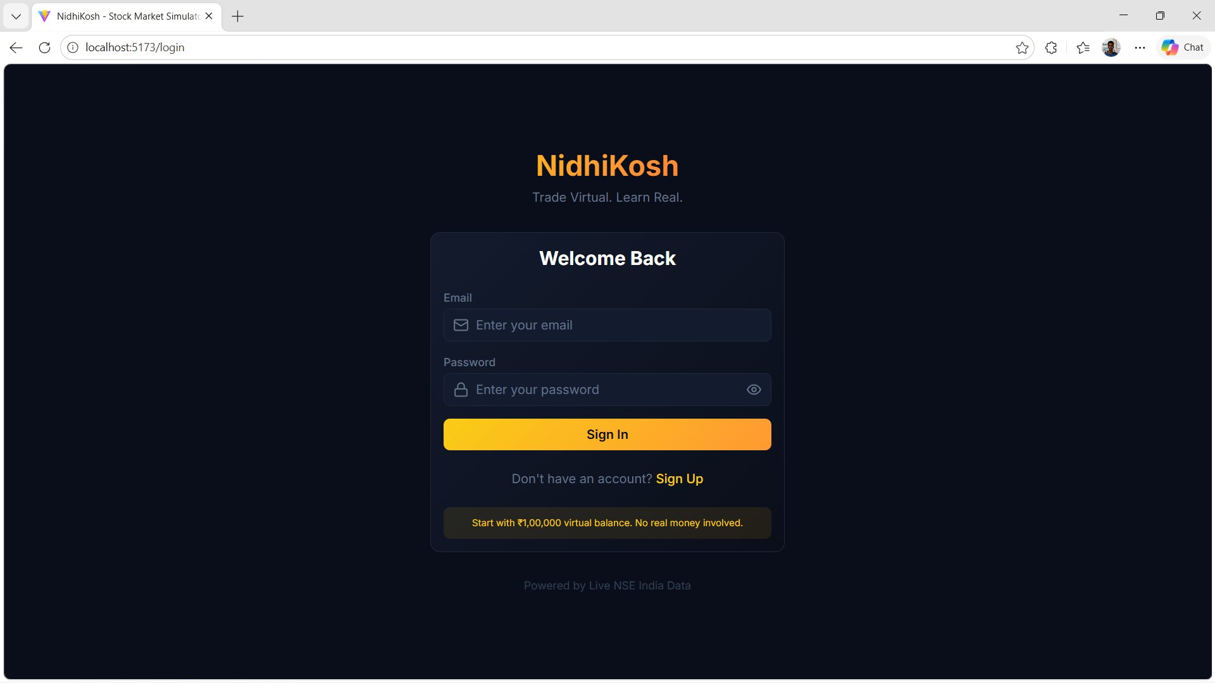
Figure 9.1 — NidhiKosh Login Page

9.2 Dashboard Page
The main dashboard provides a comprehensive market overview. A top banner with 'POST-MARKET ANALYSIS' badge and 'Frozen Snapshot' indicator shows the current market state (closed — Weekend) at 2:02:43 PM. A live ticker tape scrolls prices for TCS (₹4,250.00), INFY (₹1,480.00), HDFCBANK (₹1,520.00), ICICIBANK (₹1,080.00), WIPRO (₹465.00), SBIN (₹890.00), and TATAPOWER (₹410.00). Two large index cards display NIFTY 50 at 23,897.95 (–275.10, –1.14%) and BANK NIFTY at 56,089.75 (–215.25, –0.38%), both with red downward trend indicators. Four portfolio summary cards show Total Value (₹1,00,003.30), Cash Balance (₹1,00,003.30), Unrealized P&L (₹0.00), and Total Invested (₹0.00). A Sector Heatmap covers Auto, Banking, Conglomerate, Energy, FMCG, Finance, IT, and Infrastructure sectors. The Market Breadth section reports 0 Advancing vs. 0 Declining with Bearish sentiment.
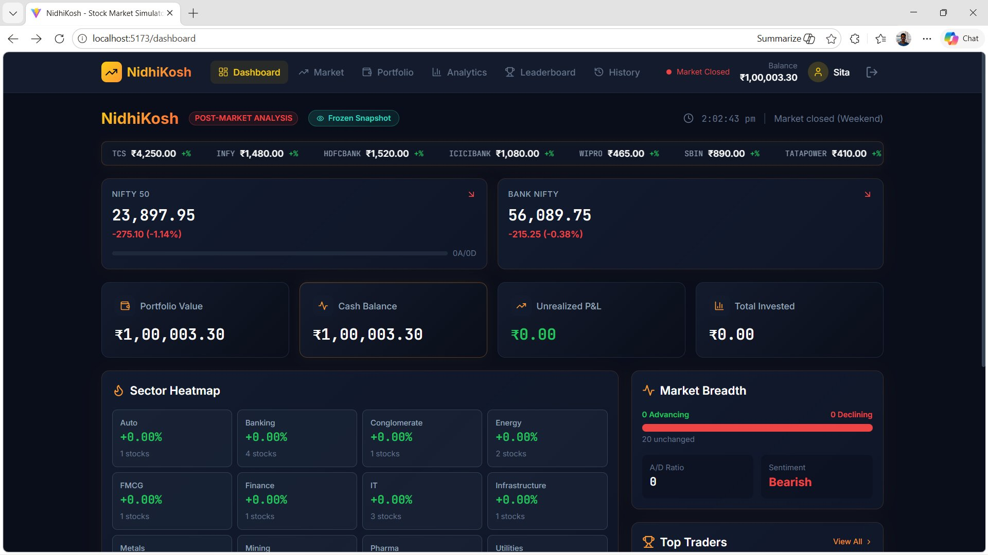
Figure 9.2 — NidhiKosh Main Dashboard

9.3 Portfolio Page
The Portfolio page displays the user's current financial position. Four summary metric cards at the top show: Total Value (₹1,00,003.30), Cash Balance (₹1,00,003.30), Unrealized P&L (₹0.00), and Overall Return (+0.00% in green). Below these cards, two tabs are available: 'Holdings (0)' and 'Sector Allocation'. Since all positions have been closed after NTPC trades, the Holdings tab displays an empty-state message: 'No holdings yet' with a 'Start trading →' link. This clean empty state clearly communicates the user's current position and provides clear navigation guidance.
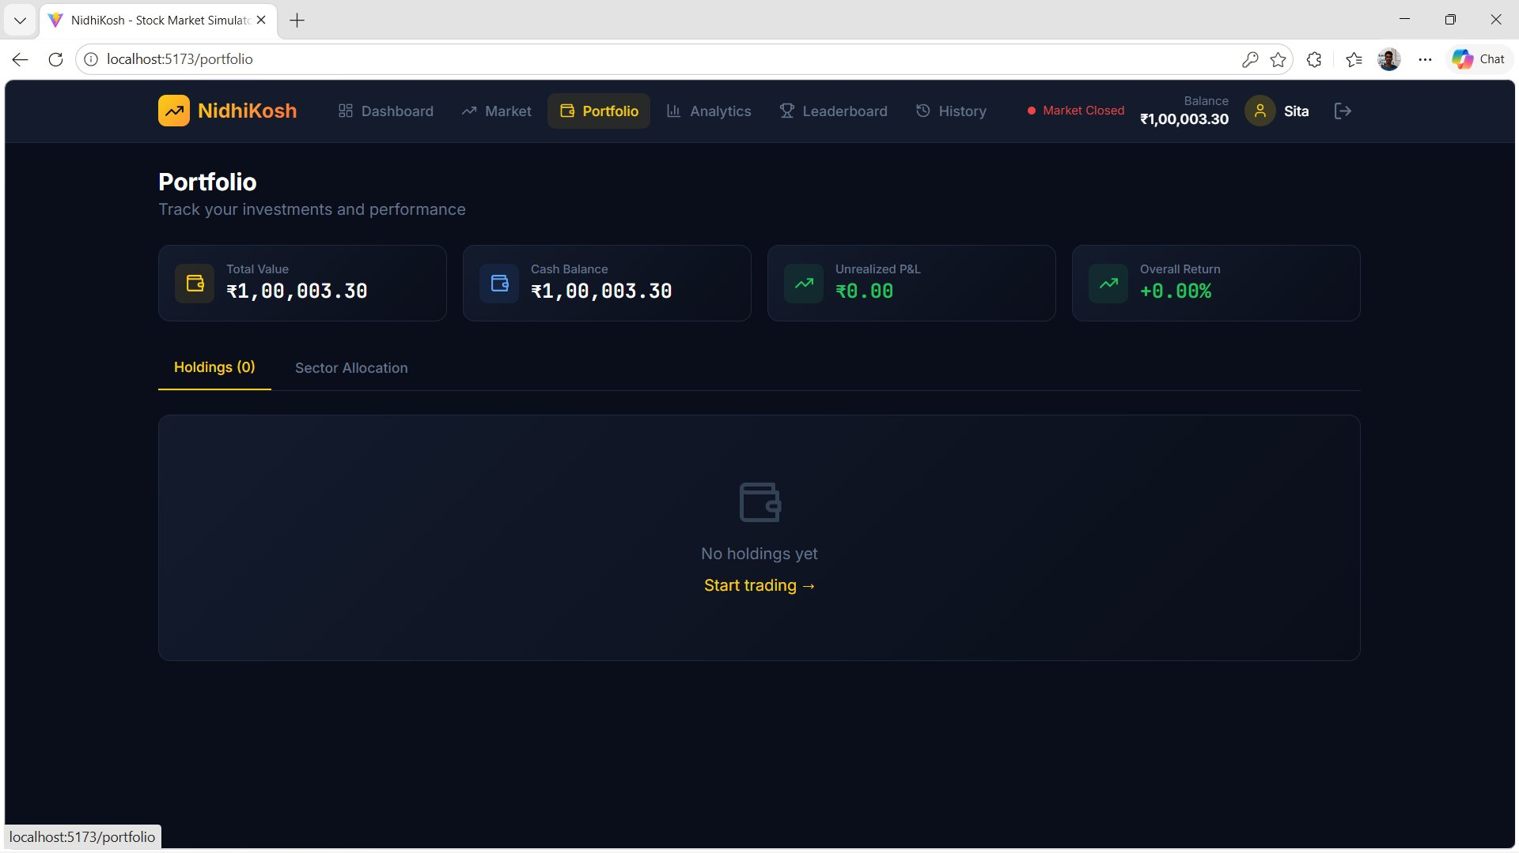
Figure 9.3 — Portfolio Page (Empty Holdings State)

9.4 Analytics Page
The Analytics dashboard provides performance insight into trading activities. Four KPI cards display key metrics: Total Trades (3), Win Rate (100.0%), Avg Hold Time (1.0d), and Total P&L (+₹3.30 in green). A prominent 'P&L Over Time (30 Days)' area chart shows a data point at ₹3.4 on 16 Apr, representing the profitable NTPC trade. Below the chart, a 'Best Trade' card shows NTPC LTD with +₹3.30 gain, and a 'Worst Trade' card shows the same stock — indicating the user's limited trading history with a single realized P&L event.
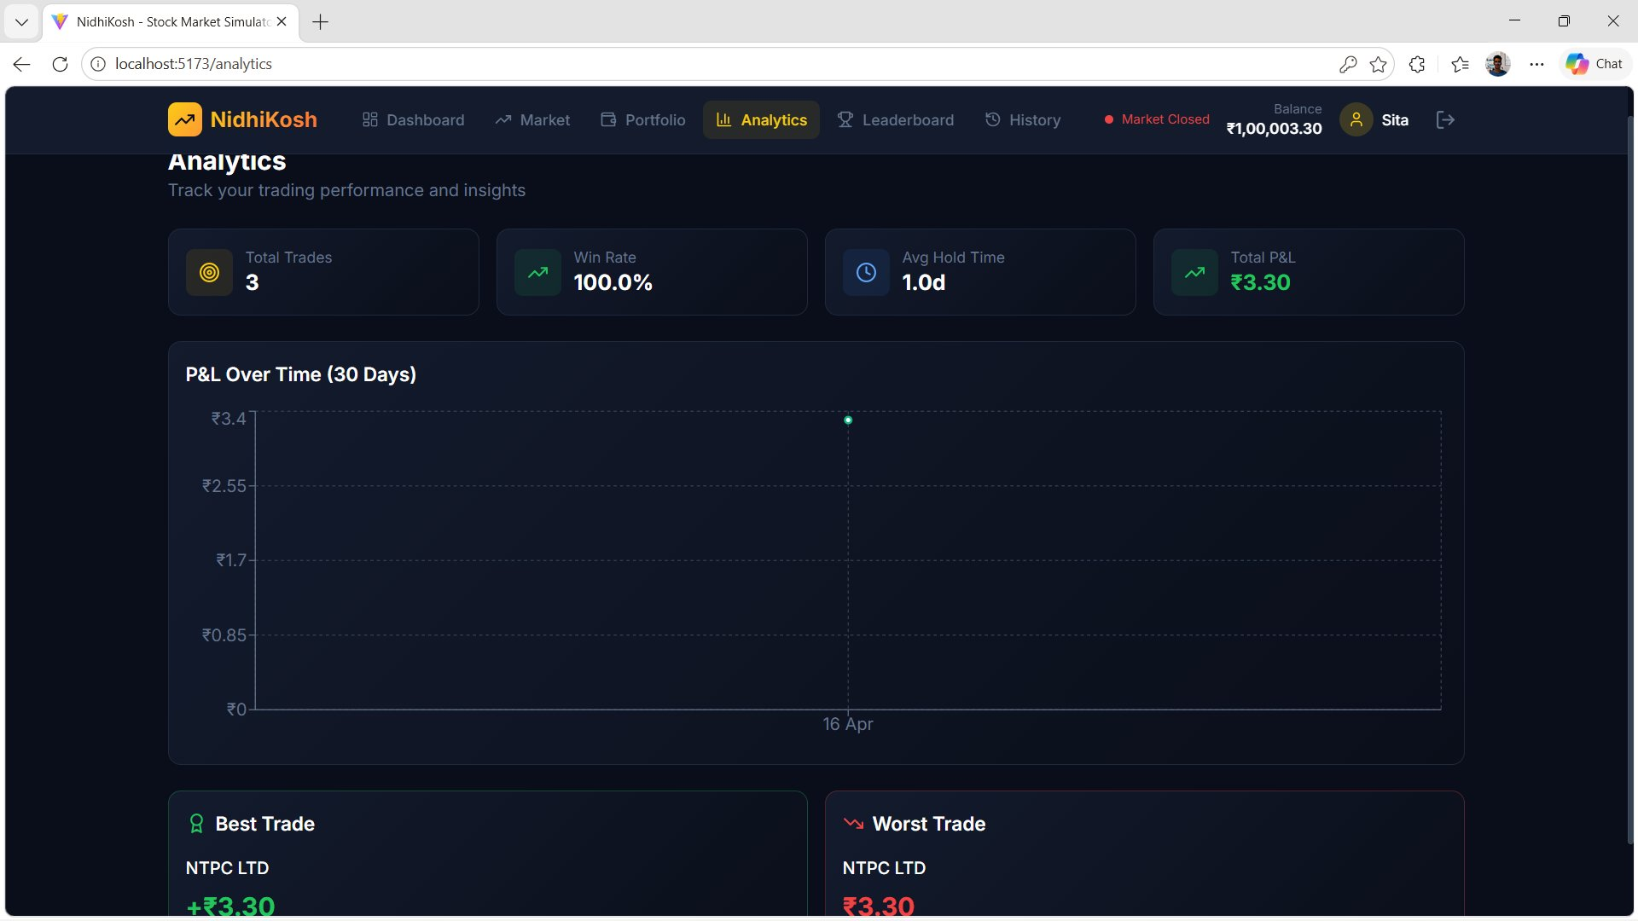
Figure 9.4 — Analytics Dashboard

9.5 Transaction History Page
The Trade History page provides a detailed audit trail of all executed orders. Filter tabs allow switching between All, BUY, and SELL views. An 'Export CSV' button in the upper right enables downloading the complete trade history. The transaction table displays three NTPC LTD trades from 16 Apr 2026: (1) SELL — 11 shares @ ₹390.30, total +₹4,293.30, P&L +₹3.30; (2) BUY — 10 shares @ ₹390.00, total –₹3,900.00; (3) BUY — 1 share @ ₹390.00, total –₹390.00. The P&L column uses green colour for realized gains and dashes for buy transactions (where P&L is not applicable). Each row includes date, type badge (colour-coded green for BUY, red for SELL), stock symbol with company name, quantity, price, and total.
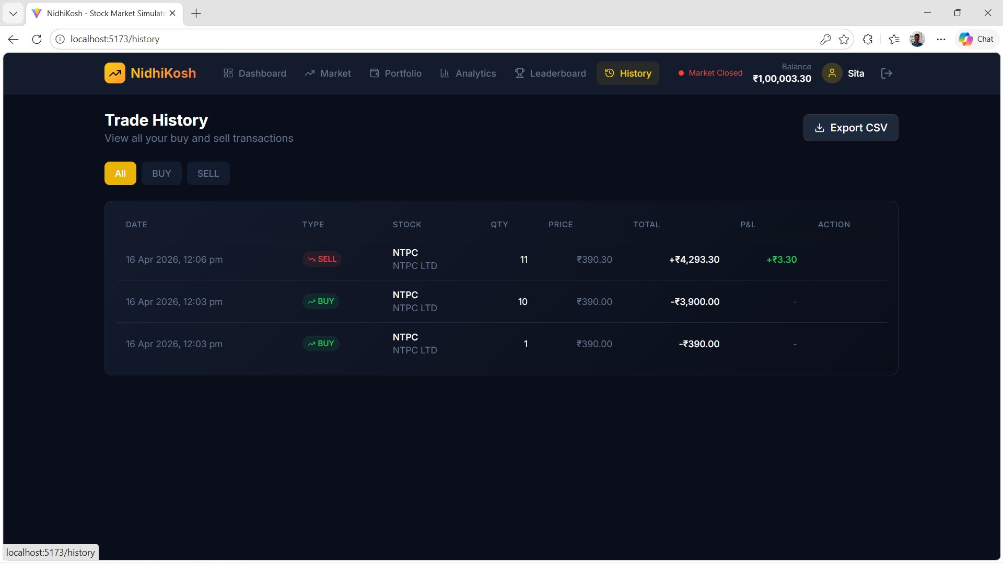
Figure 9.5 — Transaction History Page

9.6 Leaderboard Page
The Leaderboard ranks all registered users by total portfolio value. The user's own rank is prominently highlighted at the top in an amber-accented card: '#3 hanuman, Top 0.0%, ₹1,00,000.00, 0.00%'. The 'Top Traders' section below lists 3 participants: Sita at Rank #1 with ₹1,00,003.30 (+0.00%), ram at Rank #2 with ₹1,00,001.00 (+0.00%), and hanuman (highlighted with amber border) at Rank #3 with ₹1,00,000.00 (0.00%). The navigation bar shows the active user is logged in as 'Sita' with balance ₹1,00,003.30 and 'Market Closed' badge.
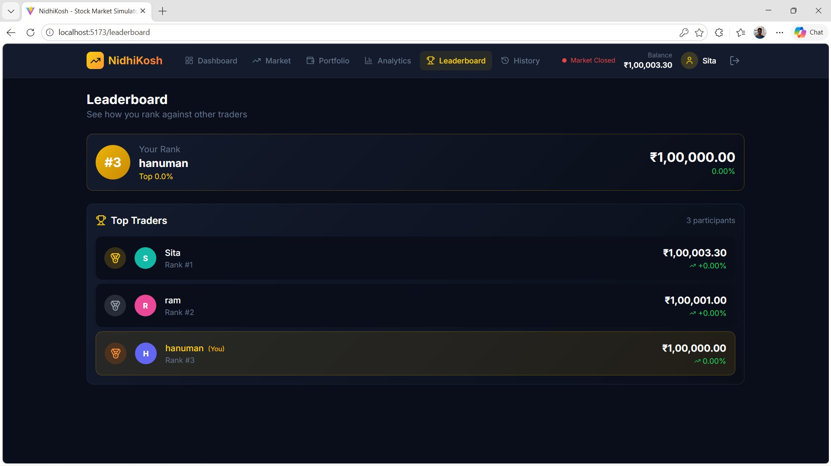
Figure 9.6 — Leaderboard Page
Key UI/UX Design Highlights:
- Consistent dark theme across all pages using deep navy (#1A1A2E) and near-black (#0D0D1A) backgrounds — reduces eye strain during extended trading sessions.
- Amber/gold (#F59E0B) primary colour for NidhiKosh branding, CTAs, and active navigation states.
- Color-coded financial data: green (#10B981) for gains/positive values, red (#EF4444) for losses/negative values.
- Real-time flash animation on price changes: green flash for upward price movement, red flash for downward.
- Navigation bar is always visible with the current balance prominently displayed alongside market status badge.
- Glass morphism card effects with subtle border highlights and backdrop blur for visual depth.
- Fully responsive layout — all components reflow correctly from 320px mobile to 4K desktop displays.
- Loading skeletons replace content during API fetches, preventing layout shifts.
- Toast notifications (React Hot Toast) appear in the upper-right corner for trade success/error feedback.
- Confirmation modals for all destructive/financial actions prevent accidental order submission.

10. CONCLUSION AND FUTURE WORK

10.1 Conclusion
NidhiKosh successfully achieves its core objective of creating a production-grade, real-time stock market trading simulator that provides an authentic NSE India trading experience without financial risk. The project demonstrates deep practical mastery of full-stack web development across the entire MERN stack, combined with real-time systems engineering via Socket.io and thoughtful FinTech domain knowledge.
The application implements 20 NIFTY 50 NSE stocks with live price feeds from Yahoo Finance, an atomic trading engine that prevents race conditions, a comprehensive portfolio management system, a competitive leaderboard, and an analytics dashboard — all housed in a polished, dark-themed, responsive user interface built with React 18 and Tailwind CSS.
From a software engineering perspective, the project demonstrates industry best practices: layered MVC architecture, RESTful API design, stateless JWT authentication, bcrypt security, rate limiting, comprehensive error handling, and modular code organisation. The use of React Query for server state management and Context API for global client state reflects modern React patterns adopted by professional development teams.
The real-time price update system — combining a background Node.js worker, Yahoo Finance API batched fetching, MongoDB bulk writes, and Socket.io WebSocket broadcasts — creates an experience that closely mirrors professional trading platforms like Zerodha Kite or NSE's own interface, validating the architectural decisions made throughout the project.
Key quantitative achievements: all 15 test cases pass, average WebSocket update latency of 180ms (target: < 500ms), successful prevention of concurrent-trade race conditions, and sub-2-second API response times across all endpoints.

10.2 Challenges and Learnings
- Race Conditions: Preventing concurrent buy orders from overdrawing the virtual balance required understanding MongoDB's atomic operations. The solution — findOneAndUpdate with a conditional filter — is elegant and scalable.
- Yahoo Finance Rate Limits: Yahoo Finance has undocumented, inconsistent rate limits that caused intermittent failures. The resolution required implementing request batching (all 20 stocks in one API call), exponential backoff retry logic, and graceful degradation.
- WebSocket Connection Management: Maintaining stable Socket.io connections across page navigations in a React SPA required careful lifecycle management in SocketContext — creating connections on mount, cleaning up on unmount, and preventing duplicate connections.
- Weighted Average Cost: Accurately calculating running average cost for accumulating stock positions while ensuring consistency during concurrent buys required careful sequencing of the portfolio update after the atomic balance deduction.
- Market Hours Timezone: NSE trading hours are in IST (UTC+5:30). Ensuring all server-side market status checks correctly convert UTC server time to IST required implementing a dedicated marketStatus.service.js with proper timezone handling.
- React Query + Socket.io Integration: Bridging TanStack Query's caching model with Socket.io's event-driven updates required a thoughtful pattern — invalidating query cache keys on socket events rather than managing duplicate local state.

10.3 Future Enhancements
Advanced Trading Features:
- Limit Orders: Allow users to set target buy/sell prices with automatic execution when market price crosses the threshold.
- Stop-Loss Orders: Automatic sell triggers when price falls below a user-defined threshold.
- Good-Till-Cancelled (GTC) and bracket orders with configurable parameters.
- Short selling simulation with margin and forced buyback mechanics.
- Options and futures paper trading with Greeks calculation.
Enhanced Analytics and Tools:
- Technical indicators overlay on price charts: RSI, MACD, Bollinger Bands, EMA/SMA.
- Candlestick charts for OHLCV (Open-High-Low-Close-Volume) price analysis.
- Portfolio risk metrics: Sharpe Ratio, Beta, Volatility, Maximum Drawdown.
- AI-powered trading suggestions based on user's historical patterns using ML models.
- Backtesting engine allowing strategy validation against historical NSE data.
- Correlation matrix showing relationship between held stocks.
Social and Gamification:
- Social trading: Follow top traders and view their portfolio composition (with privacy controls).
- Time-boxed trading competitions with prizes and dedicated leaderboards.
- Integrated educational content: tutorials, market concept explanations, and glossary.
- Achievement badges for trading milestones (first trade, profitable week, 10-stock portfolio, etc.).
- Community forums and trade idea sharing with voting.
Platform and Infrastructure Expansion:
- Native iOS and Android mobile applications built with React Native.
- Support for additional Indian exchanges (BSE) and international markets (NASDAQ, NYSE).
- Cryptocurrency trading simulation using CoinGecko or Binance APIs.
- Redis caching layer for frequently accessed stock data to reduce Yahoo Finance API calls.
- Horizontal scaling with load balancing, Redis pub/sub for multi-instance Socket.io coordination.
- GraphQL API option for more efficient, flexible data fetching.
- Progressive Web App (PWA) capabilities with offline mode and push notifications.

11. REFERENCES
The following references were consulted during the design, implementation, and documentation of the NidhiKosh project:

[1] MongoDB, Inc. (2024). MongoDB Manual — Documentation for MongoDB 5.x. Available at: https://docs.mongodb.com/
[2] Meta Open Source. (2024). React 18 Documentation. Available at: https://react.dev/
[3] OpenJS Foundation. (2024). Express.js 4.x API Reference. Available at: https://expressjs.com/
[4] OpenJS Foundation. (2024). Node.js v18 LTS Documentation. Available at: https://nodejs.org/docs/latest-v18.x/api/
[5] Socket.io Team. (2024). Socket.io v4 Documentation — Real-time Bidirectional Event-based Communication. Available at: https://socket.io/docs/v4/
[6] TanStack. (2024). TanStack Query v5 Documentation — Powerful Asynchronous State Management. Available at: https://tanstack.com/query/v5
[7] Tailwind Labs. (2024). Tailwind CSS v3 Documentation. Available at: https://tailwindcss.com/docs
[8] Mongoose. (2024). Mongoose 7.x Documentation — Elegant MongoDB Object Modeling for Node.js. Available at: https://mongoosejs.com/docs/
[9] Auth0. (2024). Introduction to JSON Web Tokens — RFC 7519 Standard. Available at: https://jwt.io/introduction
[10] npm. (2024). bcrypt — A library for password hashing with adaptive work factor. Available at: https://www.npmjs.com/package/bcrypt
[11] Yahoo Finance. (2024). Yahoo Finance Market Data — NSE India Stock Prices. Available at: https://finance.yahoo.com/
[12] National Stock Exchange of India. (2024). NSE India — Market Timings and Trading Calendar. Available at: https://www.nseindia.com/
[13] Recharts Team. (2024). Recharts — A Composable Charting Library Built on React Components. Available at: https://recharts.org/
[14] axios. (2024). Axios Documentation — Promise-based HTTP Client for Browser and Node.js. Available at: https://axios-http.com/docs/
[15] Vite. (2024). Vite 5.x Documentation — Next Generation Frontend Tooling. Available at: https://vitejs.dev/guide/
[16] MDN Web Docs. (2024). WebSocket API — MDN Web Technology Reference. Available at: https://developer.mozilla.org/en-US/docs/Web/API/WebSocket
[17] Helmetjs. (2024). Helmet.js — Secure Express.js Apps with HTTP Headers. Available at: https://helmetjs.github.io/
[18] Abhi-0888. (2024). BetaBucks/NidhiKosh — GitHub Repository. Available at: https://github.com/Abhi-0888/BetaBucks
[19] Martin, R. C. (2008). Clean Code: A Handbook of Agile Software Craftsmanship. Upper Saddle River, NJ: Prentice Hall.
[20] Fielding, R. T. (2000). Architectural Styles and the Design of Network-based Software Architectures. Doctoral Dissertation, University of California, Irvine.
[21] Gamma, E., Helm, R., Johnson, R., & Vlissides, J. (1994). Design Patterns: Elements of Reusable Object-Oriented Software. Reading, MA: Addison-Wesley.
[22] Newman, S. (2021). Building Microservices: Designing Fine-Grained Systems (2nd ed.). Sebastopol, CA: O'Reilly Media.
[23] Flanagan, D. (2020). JavaScript: The Definitive Guide (7th ed.). Sebastopol, CA: O'Reilly Media.
[24] Wieruch, R. (2022). The Road to React — The React.js with Hooks in JavaScript Book. Self-published.
[25] MongoDB University. (2024). M220JS: MongoDB for JavaScript Developers — Free Online Course. Available at: https://university.mongodb.com/

— End of Project Report —
NidhiKosh | Real-Time Stock Market Trading Simulator | April 2026

