8086_EMU Stopwatch
A project Report
Submitted By
Krishna Khatiwada (AP23110011547)
Mukhtaar Ahmed Shaik (AP23110010554)
Dikshya Pokharel (AP23110011673)
Anshu Shah (AP23110011260)

Under the Supervision of
Dr. Anirban Bhar
Department of Computer Science and Engineering SRM University-AP
In partial fulfilment for the requirements of the project
BACHELOROFTECHNOLOGYINCOMPUTERSCIENCEAND ENGINEERING

DEPARTMENTOFCOMPUTERSCIENCEANDENGINEERING
SRMUNIVERSITY-AP
NEERUKONDA
ANDHRAPRADESH, INDIA
DECEMBER-2025
Table of Contents
Abstract 2
Introduction 2
Objectives 3
System Requirements 4
Program Overview 5
Explanation of Major Components 6
1.1 Data Section 6
1.2 Initialization 6
1.3 Main Loop 7
1.4 Input Handling 7
1.5 Start/Stop Logic 7
1.6 Reset Logic 8
1.7 Timer Calculation (TIMER_SECTION) 8
1.8 Display Routines 8
1.9 TICKS_TO_TIME (Time Conversion) 9
Flow of Execution 10
Output Screen 11
Conclusion 12
References 12

Abstract
This project is about creating a simple stopwatch application using 8086 Assembly Language, designed to run in the DOS operating system. The program interacts directly with the computer’s hardware through BIOS interrupts to handle keyboard inputs, display text properly on the screen, and keep track of time based on the system clock.
The stopwatch shows time in a clear format of minutes, seconds, and hundredths of a second (MM: SS: HH). It lets the user easily start or stop the timer, reset it back to zero, and quit the program when finished. The screen updates constantly so the user can see the time counting in real-time.
This project serves as a practical example of how low-level programming works by communicating directly with hardware, managing interrupts effectively, and designing a simple text-based interface. It also demonstrates important concepts like real-time timing, user input handling, and dynamic screen updates using assembly language.

Introduction
Assembly language programming gives you a unique window into the inner workings of a computer by letting you control the processor at the most basic level. Unlike high-level languages, assembly requires managing every detail, such as registers, memory addresses, and hardware signals. This level of control helps in understanding how software really talks to the machine’s components.
In this project, a stopwatch is built purely with 8086 Assembly language for the DOS environment, demonstrating real-time programming concepts. The program uses BIOS interrupts, which are special routines provided by the system firmware, to handle essential tasks such as reading keyboard inputs and displaying information on the screen. By using these interrupts, the program communicates directly with hardware without needing complex drivers or additional software layers.
The stopwatch functions like a physical timing device, allowing the user to start, pause, reset, and quit. It shows time in minutes, seconds, and hundredths of a second using a simple text interface. Behind the scenes, the program continuously updates this display by looping through the routines that check for user input and track elapsed time based on system clock ticks.
Through this project, you gain practical experience with key assembly programming skills: manipulating registers to store and compute values, using branching to control program flow, handling interrupts for hardware communication, and designing a user-friendly interface using only basic text output. It’s a great way to learn how low-level programming enables precise control of a computer’s operations in real time.

Objectives
The main goals of this project were:
- Gain practical experience in programming with 8086 Assembly Language, focusing on its syntax and core concepts.
- Understand how BIOS interrupts work to handle hardware interactions such as keyboard input, timer functions, and screen display.
- Develop a real-time stopwatch application that functions without any high-level libraries or operating system services beyond BIOS.
- Design a simple, user-friendly text-based interface that clearly displays time and provides easy control options.
- Implement structured programming techniques in Assembly by organizing code into reusable subroutines and procedures.
- Learn how to manage registers and memory efficiently to perform timing calculations and update the display.
- Explore continuous looping and interrupt-driven programming for responsive, real-time behaviour.
- Practice handling user input with debounce logic to ensure reliable start, stop, reset, and quit commands.
- Demonstrate dynamic screen updating techniques using BIOS video interrupts in text mode.
- Build a foundation for understanding low-level hardware control that can be applied to other embedded or system programming tasks.
- Improve debugging skills by working directly at the hardware-software interface.

System Requirements
To run this stopwatch project, you will need a few specific tools and system features like:
- MASM/TASM Assembler
An assembler like MASM (Microsoft Assembler) or TASM (Turbo Assembler) is necessary to translate the 8086 Assembly source code into machine code that the processor can execute. These tools are essential for writing and building the program.
- DOS or DOSBox Emulator
Since the stopwatch application is built for the DOS operating system, you will need either a real DOS environment or an emulator such as DOSBox. DOSBox allows you to run DOS programs on modern computers by simulating the DOS system and hardware.
- Intel 8086-Compatible Architecture
The program is designed for the Intel 8086 processor or any compatible CPU that supports its instruction set and BIOS services. The hardware or emulator used must have support for this architecture to ensure correct program execution.
- Text-Mode Display (80×25)
The stopwatch interface uses a text-mode screen with a standard size of 80 columns by 25 rows. This display mode is crucial for properly showing the time and user commands in a clear, readable format without graphical elements.

Program Overview
The stopwatch application consists of:
user interface section that shows the header, status messages, and the current timer display on the screen.
At the heart of the program is a main loop that constantly checks for keyboard input from the user and updates the timer based on the system clock. The program uses separate subroutines to handle important tasks like drawing the user interface, converting the clock ticks into minutes, seconds, and hundredths of a second, and displaying the formatted time on the screen.
1. User Interface Layer
- Displays the stopwatch header, status messages, and the current timer value on the screen.
- Uses text-mode output controlled by BIOS interrupts for clear and simple visual feedback.
2. Input Handling Layer
- Continuously monitors keyboard input to detect user commands like start, stop, reset, and quit.
- Uses BIOS keyboard interrupt services to handle key presses efficiently.
3. Timing and Control Layer
- Maintains the stopwatch logic by tracking elapsed time based on system clock ticks.
- Converts raw tick counts into a human-readable format (minutes, seconds, hundredths).
- Controls the start, stop, and reset functions of the stopwatch.
4. Subroutine/Function Layer
- Contains reusable routines for drawing the UI elements, converting time, and printing formatted outputs.
- Organizes code for better readability, modularity, and maintenance.
5. Hardware Interaction Layer
- Uses BIOS interrupts as the interface to hardware and system services:
  - INT 10h for screen display and text output.
  - INT 16h for detecting keyboard input.
  - INT 1Ah for accessing real-time clock ticks.
  - INT 21h for DOS-level operations like printing and program exit.
This layered approach helps isolate responsibilities, making the program organized, easier to understand, and efficient in handling real-time stopwatch functionality using low-level assembly programming.

Explanation of Major Components

1.1 Data Section
This section declares all the static text and dynamic variables used in the program.
- UI Labels: Strings like header, title_msg, controls, status_stop, and status_run store text messages displayed on the screen.
- Variables:
  - start_tick (DW) holds the BIOS tick count when the stopwatch starts.
  - accumulated (DW) stores the total elapsed ticks accumulated during paused sessions.
  - current_tick (DW) stores the computed elapsed tick count for display.
  - is_running (DB) acts as a flag (0 or 1) indicating if the stopwatch is currently running.
  - time_str is a text buffer holding the formatted time string in MM:SS:HH format (initialized to "00:00:00").
This separates static UI text from runtime variables used to control and display the stopwatch’s state.

1.2 Initialization
Initialization happens in the MAIN procedure when the program starts:
- The data segment is loaded into the DS register with:
MOV AX, @DATA and MOV DS, AX
- Video mode 03h is set (standard 80×25 text mode) using INT 10h:
MOV AX, 0003h INT 10h
- Cursor is hidden for a cleaner user interface:
MOV AH, 01h, MOV CX, 2000h, INT 10h
- Calls DRAW_INTERFACE to print the header, title, status line (default “STOPPED”), controls, and zeroed time display on the screen.
This sets up a fixed layout and environment for the stopwatch interface.

1.3 Main Loop
The program enters an infinite loop MAIN_LOOP that:
- Checks if a key is ready using INT 16h with AH=01h (MOV AH, 01h; INT 16h).
- If a key is detected (ZF=0), it jumps to HANDLE_INPUT to process it. Otherwise, it goes to TIMER_SECTION to update time.
- A delay loop WAIT_LOOP (MOV CX, 0FFFh; LOOP DELAY) ensures the screen updates at a readable pace.
- This cycle continues endlessly to manage input and screen updating dynamically.
The main loop acts as the program’s central controller.

1.4 Input Handling
In HANDLE_INPUT:
- The key is fetched with INT 16h AH=00h (MOV AH, 00h; INT 16h), storing the ASCII code in AL.
- Input keys supported:
  - 'Q' or 'q': Quits the application (EXIT_ROUTINE).
  - Spacebar (' '): Toggles stopwatch start/stop (TOGGLE_ROUTINE).
  - 'R' or 'r': Resets stopwatch (RESET_ROUTINE).
- Case-insensitive checks use multiple compare and jump instructions (CMP AL, 'q' ...).
- If the key doesn’t match, control returns to update the timer (TIMER_SECTION).
This structure ensures responsive and flexible command input.

1.5 Start/Stop Logic
Implemented in TOGGLE_ROUTINE:
- When toggling start:
  - Reads the BIOS tick count with INT 1Ah (MOV AH, 00h; INT 1Ah), storing DX in start_tick.
  - Changes UI status to “RUNNING” by setting cursor position with INT 10h and printing with INT 21h.
- When toggling stop:
  - Again reads the BIOS tick count, calculates elapsed ticks since start by SUB DX, start_tick.
  - Adds this elapsed time to accumulated to accumulate total paused time.
  - Updates UI status to “STOPPED”.
This logic allows the stopwatch to pause and resume cleanly by adjusting accumulated ticks instead of resetting.

1.6 Reset Logic
The RESET_ROUTINE:
- Sets is_running to 0 (stop state), clears accumulated and start_tick to zero.
- Calls DRAW_ZEROS to update time display to "00:00:00" on the screen.
- Resets all runtime state so the stopwatch appears freshly started.
This routine enables an instant restart with a clear UI reset.

1.7 Timer Calculation (TIMER_SECTION)
If the stopwatch is running:
- Reads current BIOS tick count (INT 1Ah) and calculates total elapsed ticks as:
(current tick − start_tick + accumulated)
- Stores this in current_tick.
- Calls TICKS_TO_TIME to convert this tick value to minutes, seconds, and hundredths.
- Calls DRAW_TIME to display the updated formatted time string visually.
If the stopwatch is stopped, the display remains unchanged.
This section keeps the time accurate and updates the screen continuously.

1.8 Display Routines
- DRAW_INTERFACE: Prints the UI frame (header, title, separators), initial status text (“STOPPED”), controls info, and calls DRAW_ZEROS.
- DRAW_ZEROS: Specifically writes zeros (‘0’) at exact positions in time_str (characters for minutes, seconds, hundredths) and prints it. It uses BIOS interrupts to position the cursor and print strings.
- DRAW_TIME: Positions the cursor and prints the current formatted time_str to reflect running elapsed time.
These manage a clear, well-structured user interface on the text screen.

1.9 TICKS_TO_TIME (Time Conversion)
This is a key subroutine that translates raw BIOS tick counts into readable time format:
- Takes the tick value in current_tick.
- Using division and multiplication, breaks ticks into:
  - Hundredths of a second
  - Seconds
  - Minutes
- Converts each numeric value into ASCII characters by adding '0'.
- Stores these ASCII digits into exact spots in the time_str buffer arranged as "MM:SS:HH".
This makes the stopwatch display easy and familiar to read, just like a digital clock.

Flow of Execution

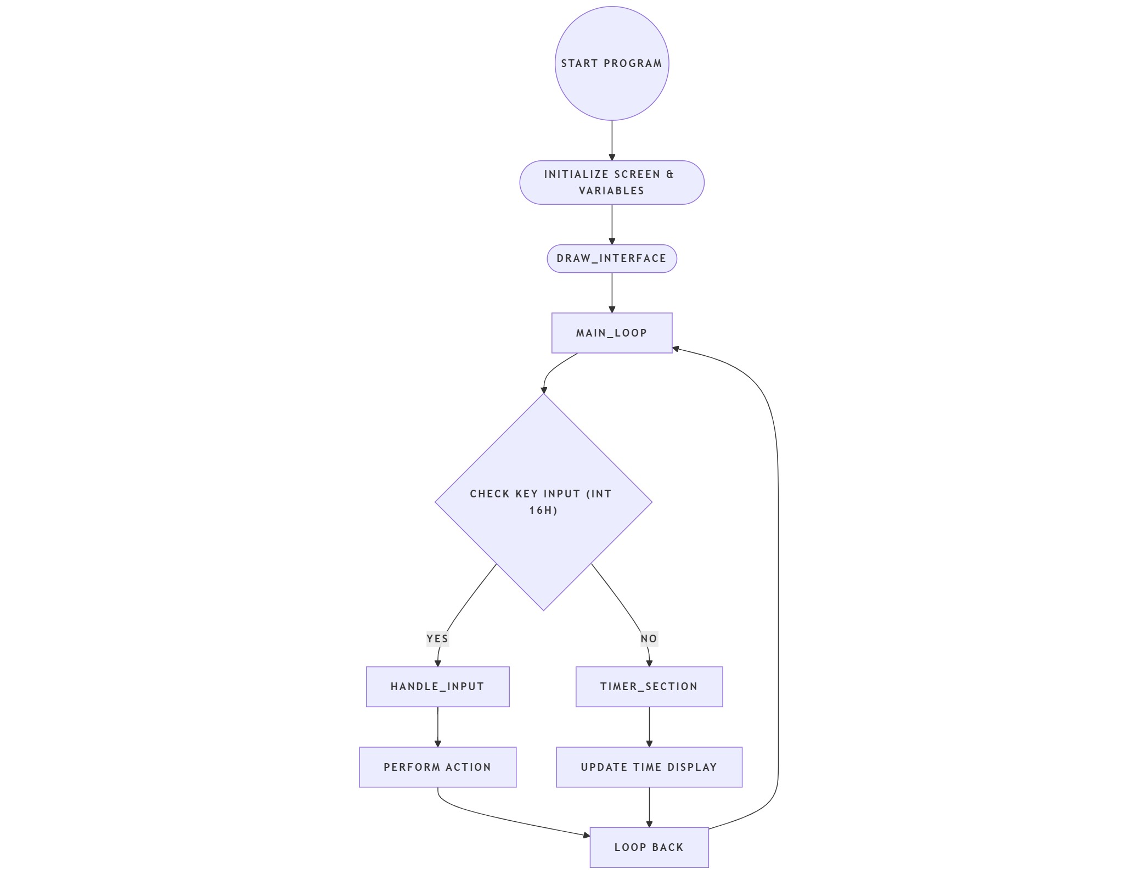

Output Screen
A typical stopwatch screen looks like this:

STATUS: STOPPED
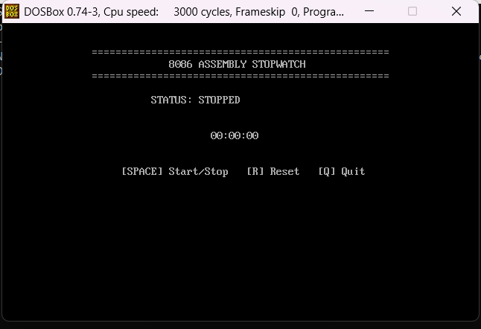
STATUS: RUNNING

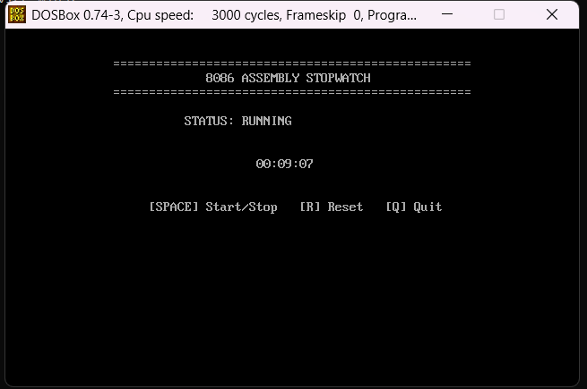

Conclusion
This 8086 Assembly stopwatch project successfully shows how to create a fully working timing application using just low-level assembly code and direct BIOS interrupt calls, without any high-level libraries or modern operating system help. It brings together key programming concepts like handling hardware interrupts for keyboard input and system timing, carefully managing CPU registers to track and calculate elapsed time, working with memory to store variables and format display strings, implementing efficient loops for real-time updates, and building a clean text-based user interface that feels responsive and professional.
The program runs smoothly in the DOS environment, instantly responding to user commands like start/stop toggling with the spacebar, quick resets with the R key, and clean exit with Q. The display updates continuously in real-time using the BIOS tick counter (about 18.2 ticks per second), converting raw hardware ticks into an easy-to-read MM:SS:HH format while providing clear status feedback like "RUNNING" or "STOPPED." This makes it not just a functional stopwatch, but an excellent hands-on learning tool for students and developers exploring assembly language, understanding how early computers handled real-time operations, hardware communication through interrupts, and creating practical applications with minimal resources.

References
- Intel 8086/8088 Architecture Documentation: Official technical manuals detailing the processor's instruction set, register usage, memory addressing modes, and hardware interfacing capabilities used throughout the program.
- BIOS Interrupt List (Ralf Brown's Interrupt List): Comprehensive reference for all BIOS services like INT 10h (video), INT 16h (keyboard), INT 1Ah (timer), and INT 21h (DOS), which form the foundation of the stopwatch's hardware interaction.
- MASM/TASM Assembly Language Manuals: Guides for Microsoft Assembler (MASM) and Turbo Assembler (TASM) covering syntax, directives like .MODEL SMALL and .STACK, segment management, and subroutine creation essential for building and debugging the code.
- DOS Programming Reference Guides: Documentation on DOS system calls, program execution model, text-mode video operations, and environment setup using tools like DOSBox for testing 8086 applications on modern systems.

