**Indian Institute of Information Technology, Allahabad**

**Object Oriented Methodology (OOM)**

**Mini Project-10**

**TAs: Mr. Ayush Sinha, Mr. Bagesh Kumar Mr. Harshit Gupta**

**Instructors: Prof. O. P. Vyas and Dr. Ranjana Vyas, Dr. Sonali Agarwal**

**OOM Mini Project # 10:** Software Drawing 2D shapes & 3 D graphics

**ABSTRACT**

In this project you have to draw 2D shapes such as Square, Circles. And there are buttons to control the rotation shapes.

Also, draw of 3D Squares/Rectangle, circles. In addition to this, keep a buttons to control the rotation in different orientations.

Abstract Images:

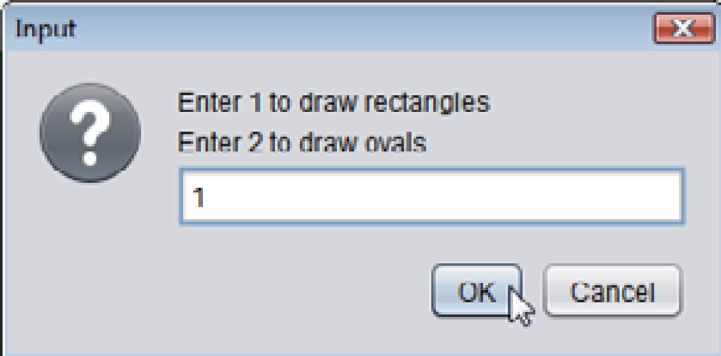

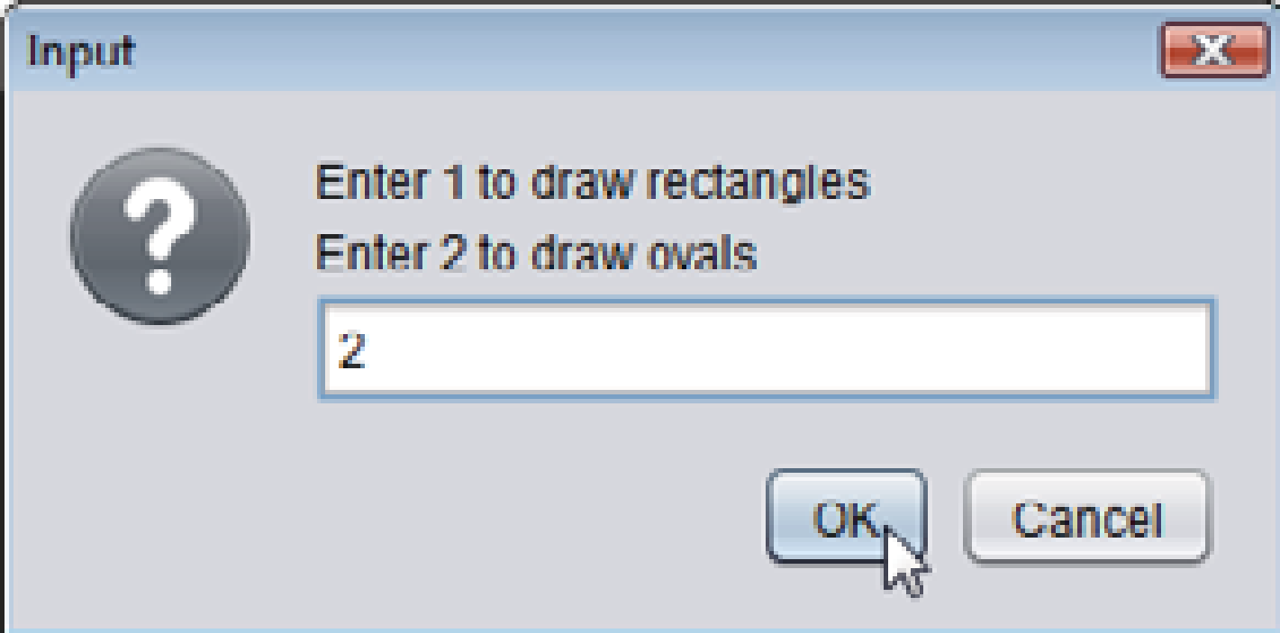

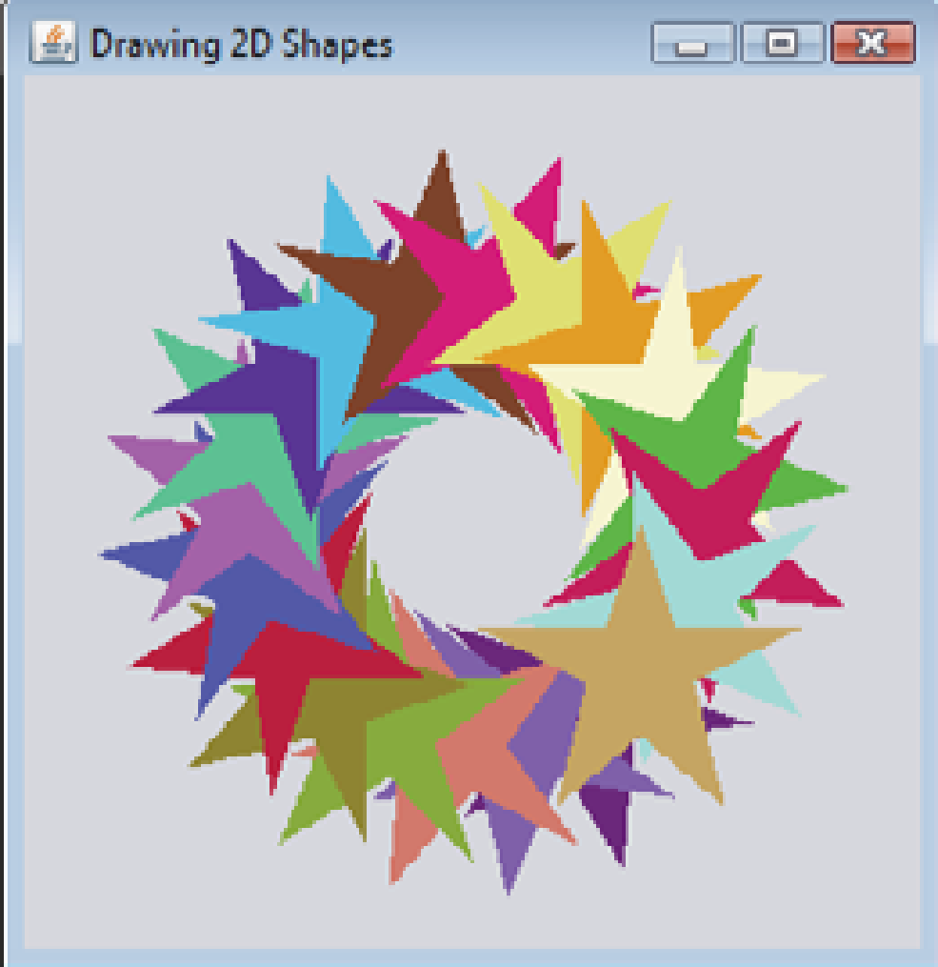

**Specific Technology**

JAVA, Swing

**Project Tasks**

Use case analysis, Design: Class Diagram, CRC and Implementation, User -Interface

**FEATURES**

1. Draw a dialog box, in which you have to enter your choice.
2. According to choice you have to draw a 2D shape.
3. There should be a component by which you can control the rotation of shape.

**Submission**

The project presentation has to be done by each member to show periodically the progress and the complete project submission should contain the following:

1. UML diagrams:-Use Case diagram, Class diagram, CRC diagram(s), illustrating the design of your program.
2. All the Java source code should necessary to compile and execute.