Name: Abhishek Gupta

Id: AF0402465

Batch: ANP-C7781

Lab 2 Submission

**1.     Write a program that takes a student's score as input and outputs the corresponding grade based on the following scale:**

**A: 90-100**

**B: 80-89**

**C: 70-79**

**D: 60-69**

**F: 0-59**

**Solution:**

**package** Lab2;

**import** java.util.*;

**public** **class** Grade {

**public** **static** **void** main(String[] args) {

// **TODO** Auto-generated method stub

Scanner sc = **new** Scanner(System.***in***);

System.***out***.print("Enter score: ");

**int** score = sc.nextInt();

**char** grade;

**if**(score >= 90 && score <= 100)

{

grade = 'A';

}

**else** **if** (score >=80)

{

grade = 'B';

}

**else** **if** (score >= 70)

{

grade = 'C';

}

**else** **if** (score >= 60)

{

grade = 'D';

}

**else**

{

grade = 'F';

}

System.***out***.println("The result is: "+grade+" grade");

}

}

**Output:**

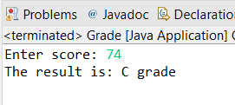

**2.  Write a program to check if a given year is a leap year. (A year is a leap year if it is divisible by 4 but not by 100, or it is divisible by 400.)**

**Solution:**

**package** Lab2;

**import** java.util.*;

**public** **class** leap_year {

**public** **static** **void** main(String[] args) {

// **TODO** Auto-generated method stub

Scanner sc = **new** Scanner(System.***in***);

System.***out***.println("Enter any year: ");

**int** year = sc.nextInt();

**if**(year % 4 == 0 || year % 400 ==0)

{

System.***out***.println(year + " is a leap year");

}

**else**

{

System.***out***.println(year + " is not a leap year");

}

}

}

**Output:**

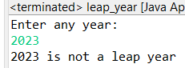 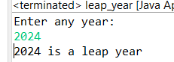

**3.     Write a program that takes an integer as input and checks if it is positive, negative, or zero.**

**Solution:**

**package** Lab2;

**import** java.util.*;

**public** **class** positive_negative {

**public** **static** **void** main(String[] args) {

// **TODO** Auto-generated method stub

Scanner scanner = **new** Scanner(System.***in***);

System.***out***.println("Enter any number: ");

**int** num = scanner.nextInt();

**if**(num > 0)

{

System.***out***.println(num + " number is positive");

}

**else** **if**(num < 0)

{

System.***out***.println(num + " number is negative");

}

**else**

{

System.***out***.println(num + " number is zero");

}

scanner.close();

}

}

**Output:**

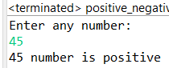 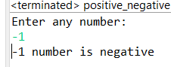 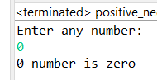

**4.     Write a program that prints numbers from 1 to 10 using a loop.**

**Solution:**

**package** Lab2;

**public** **class** numbers1_10 {

**public** **static** **void** main(String[] args) {

// **TODO** Auto-generated method stub

System.***out***.println("numbers are: ");

**for**(**int** i=1; i<=10; i++)

{

System.***out***.println(i);

}

}

}

**Output:**

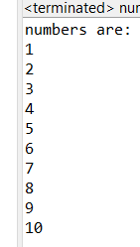

**5.     Write a program that takes an integer N as input and calculates the sum of entered numbers.**

**Solution:**

**package** Lab2;

**import** java.util.*;

**public** **class** sum {

**public** **static** **void** main(String[]args) {

Scanner sc = **new** Scanner(System.***in***);

System.***out***.println("Enter the number: ");

**int** N = sc.nextInt();

System.***out***.println("Enter " + N + " integers:");

**int** total = 0;

**for** (**int** i = 0; i < N; i++) {

**int** num = sc.nextInt();

total += num;

}

System.***out***.println("The sum of entered numbers is: " + total);

sc.close();

}

}

**Output:**

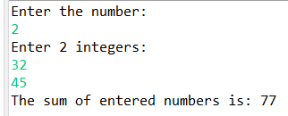

**6.     Write a program that takes an integer as input and prints its multiplication table up to 10.**

**Solution:**

**package** Lab2;

**import** java.util.*;

**public** **class** multiplication {

**public** **static** **void** main(String[] args) {

// **TODO** Auto-generated method stub

Scanner sc = **new** Scanner(System.***in***);

System.***out***.print("Enter number for its multiplication table: ");

**int** n = sc.nextInt();

**for**(**int** i=1;i<=10;i++) {

System.***out***.println(n+" * "+i+" = "+n*i);

}

sc.close();

}

}

**Output:**

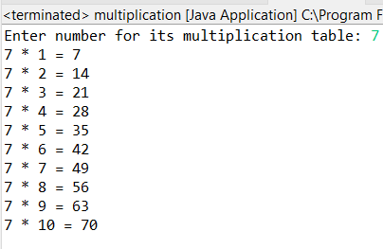

**7.     Write a program that takes a positive integer as input and prints its digits in reverse order.**

**Solution:**

**package** Lab2;

**import** java.util.*;

**public** **class** reverse {

**public** **static** **void** main(String[] args) {

// **TODO** Auto-generated method stub

Scanner sc = **new** Scanner(System.***in***);

System.***out***.println("Enter a number to reverse: ");

**int** n = sc.nextInt();

System.***out***.println("Your entered number is: "+n);

**int** rev=0;

**while**(n!=0)

{

**int** remainder = n % 10;

rev = rev * 10 + remainder;

n = n/10;

}

System.***out***.println("Reverse of your entered number is: "+rev);

sc.close();

}

}

**Output:**

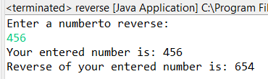

**8.     Create a class Animal with a method makeSound() that prints "Some generic animal sound". Create another class Dog that extends Animal and overrides the makeSound() method to print "Bark". Write a main method to demonstrate calling the makeSound() method on an Animal reference holding a Dog object.**

**Solution:**

**package** Lab2;

**class** Ani

{

**public** **void** makeSound()

{

System.***out***.println("Some generic animal sound");

}

}

**class** Dog **extends** Ani

{

**public** **void** makeSound()

{

System.***out***.println("Bark");

}

}

**public** **class** animal {

**public** **static** **void** main(String[] args) {

// **TODO** Auto-generated method stub

Ani mydog = **new** Dog();

mydog.makeSound();// This will print "Bark"

}

}

**Output:**

