LAB-08
BL.EN.U4AIE23021
Spectral Analysis of Speech Using DCT and MFCC Features
1. Objective
- To analyze and compare energy compaction properties of Discrete Fourier Transform (DFT) and Discrete Cosine Transform (DCT).
- To extract and analyze Mel-Frequency Cepstral Coefficients (MFCCs) from a speech signal.
- To understand how MFCCs capture phonetic variations in speech.
2. Dataset Description
- Type: Speech signal (.wav)
- Sampling Frequency: 22050 Hz
- Duration: 4s
3. Methodology
3.1 Preprocessing
- The speech signal is loaded and normalized.
- A 25 ms frame is extracted from the signal.
- A Hamming window is applied to reduce spectral leakage.
3.2 DFT and DCT Analysis
- DFT is computed using Fast Fourier Transform (FFT).
- DCT is computed using type-II cosine transform.
- Energy is calculated as:
$$E=∑∣X(k)∣^{2}$$
- Cumulative energy is used to analyze energy compaction.

3.3 MFCC Extraction
- MFCCs are computed using:
  - Framing
  - Windowing
  - FFT
  - Mel filter banks
  - Log scaling
  - DCT
- Number of coefficients: 13 MFCCs per frame

4. Results
4.1 Energy Compaction Comparison
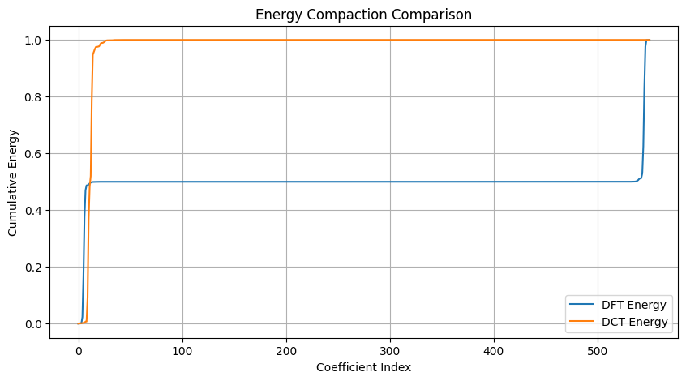
Figure 1: Energy compaction comparison between DFT and DCT.

4.2 Histogram of Coefficients
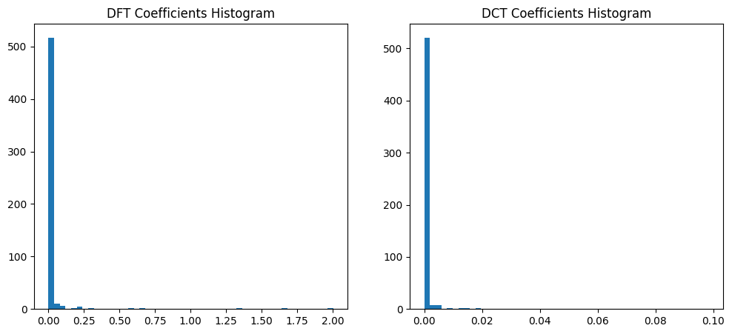
Figure 2: Histogram comparison of DFT and DCT coefficients.
4.3 MFCC Coefficients Over Time
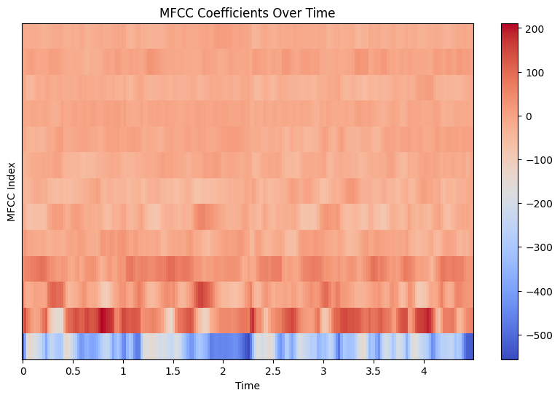
Figure 3: MFCC coefficients variation over time.

4.4 First Two Frames MFCC Comparison
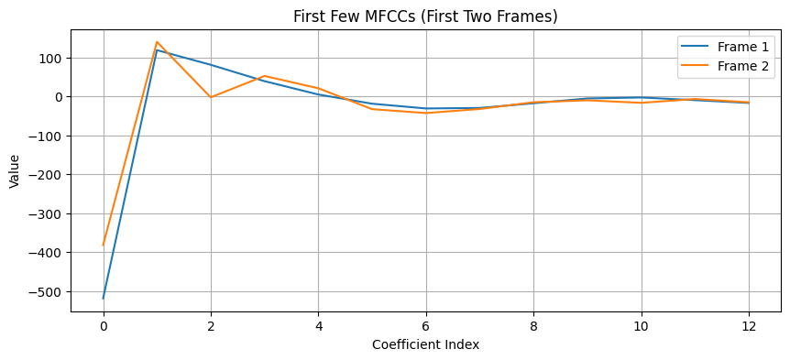
Figure 4: Comparison of MFCC coefficients for first two frames.

5. Discussion
5.1 DCT vs DFT Energy Compaction
The results clearly show that DCT achieves superior energy compaction compared to DFT. Most of the signal energy in DCT is concentrated within the first few coefficients, whereas DFT distributes energy across a larger number of coefficients.
This occurs because:
- DCT uses only cosine basis functions
- DFT includes redundant information due to symmetry
Thus, DCT provides a more efficient representation of speech signals.

5.2 Histogram Analysis
The histogram demonstrates that:
- DCT coefficients are highly concentrated near zero, indicating sparsity
- DFT coefficients are more widely distributed
This confirms that DCT is more suitable for compression and feature extraction tasks.

5.3 MFCC Analysis
The MFCC heatmap shows that coefficients vary over time, reflecting the non-stationary nature of speech.
- Lower-order MFCCs capture spectral envelope
- Higher-order MFCCs capture fine spectral details
The variation in MFCCs corresponds to changes in phonemes and articulation.

5.4 Frame-wise MFCC Comparison
The comparison of the first two frames shows:
- Significant variation in lower coefficients
- Similarity in higher coefficients
This indicates that:
- Lower coefficients carry most of the phonetic information
- Speech characteristics change even across short durations

6. Conclusion
- DCT provides better energy compaction than DFT, making it more suitable for speech processing.
- MFCCs effectively capture the perceptual and phonetic features of speech.
- The experiment validates the importance of DCT-based feature extraction in applications like speech recognition.

