External CSS PORTFILIO:

Github Repository Link: <https://github.com/Abhi-GX/FWD/tree/main/portfolio>

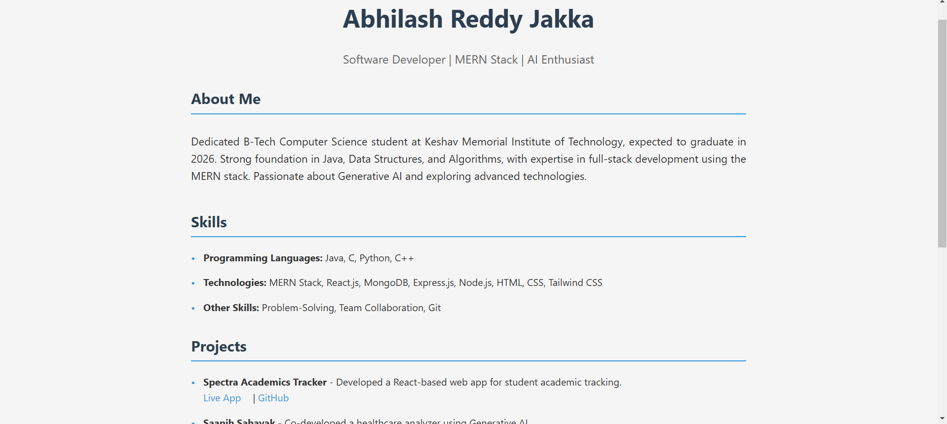

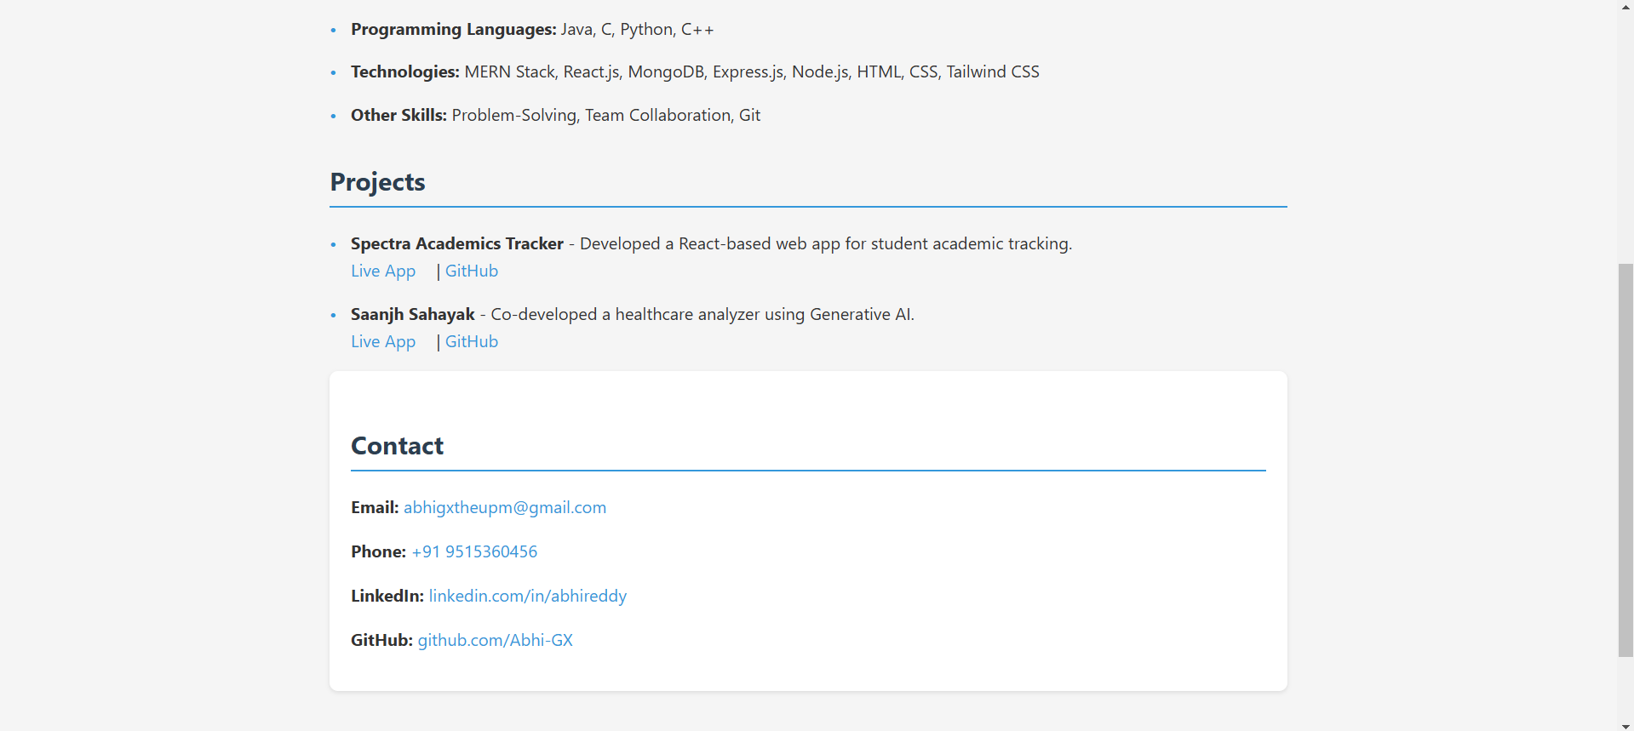

EXTERNAL CSS OF FEEDBACK:

Github Repository Link: <https://github.com/Abhi-GX/FWD/tree/main/feedback>

