SHREE BHANUDAYA MODEL SECONDARY SCHOOL
Binayi Tribini – 01, Bardaghat-Susta East,
Nawalparasi, Dumkibas

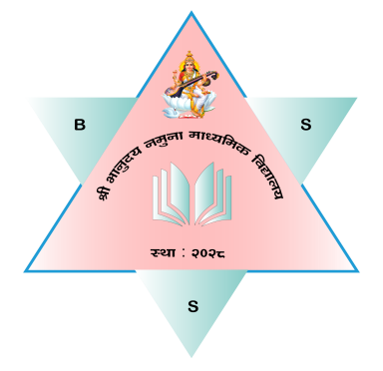

A PROJECT WORK

OF

"WEB PAGE DEVELOPMENT"
CLASS IX
of
COMPUTER ENGINEERING
For the academic year 2078 - 079
Submitted by
ABHI PARAJULI´

SYMBOL NUMBER WITH ALPHABHATE

Under the guidance of

KEWAL THANEIT

Dept. of Computer Engineering



Government of Nepal
Ministry of Education
Curriculum Development Centre
Sanothimi, Bhaktapur

SHREE BHANUDAYA MODEL SECONDARY SCHOOL
Binayi Tribini – 01, Bardaghat-Susta East,
Nawalparasi, Dumkibas



CERTIFICATE

This is to certify that the Lab report of COMPUTER REPAIR AND MAINTANCE has been carried out by ABHI PARAJULI a bonafide student of 9- Computer Engineering in SHREE BHANUDAYA MODEL SECONDARY SCHOOL of s during the academic year 2078 – 079. It is certified that all corrections/suggestions indicated for internal assessment have been incorporated while submitting this report. This report has been approved as it satisfies the academic requirements.

_________________________

KEWAL THANEIT

Dept. of Computer Engineer

__________________________

BALARAM SUBEDI

Principal

Acknowledgement

I'd want to convey my heartfelt appreciation and gratitude to my teachers as well as my supervisors for providing with the chance to work on this wonderful project ..............which also aided me in conducting extensive study and learning about a bunch of new topics.

I am quite grateful to them.

Second, I'd want to thank my friends for their assistance in completing this project in such a short period of time.

It was quite useful in terms of expanding my knowledge and abilities.

Thank You To Everyone Who Has Helped

Table of Contents

- Introduction--------------------------------------------------------1
- About webpage----------------------------------------------------1
- Design---------------------------------------------------------------3
  - Home page
  - About page
  - Contact page
  - Course page
- Coding------ --------------------------------------------------------6
  - Home page
  - About page
  - Contact page
  - Course page
- Objectives-----------------------------------------------------------2
- Advantage and limitation-----------------------------------------7
- Interface of my project -------------------------------------------9
- Reference----------------------------------------------------------10
- Conclusion---------------------------------------------------------11

Introduction

Web page hyper text document created by using different type of scripting and markup language .And it is kept in WWW and that can be accessed from the internet from everywhere. Webpage development process is very tedious and time consuming task but it is very interesting work. Because while developing the web page we got lots of practical task and have chance to experience with the output instantly.

I am a student of computer engineering class nine. I learn different type of programming langue they are Html, Css , JavaScript and little bit PHP. Now I am making a static webpage about my school. I make the webpage by the help of
Html, CSS which was I learn in class Nine. I make this web page by the help of different multimedia like w3 school, YouTube, Google etc. Many teacher also help me for writing an web page.

About webpage

My webpage is about my school. It is a static web page which was made by me by the help of many teachers. I use bracket software for making the web page. In my web page there are four pages they are-:
- Home page
- About page
- Course page
- Contact page

Design
Home page-:
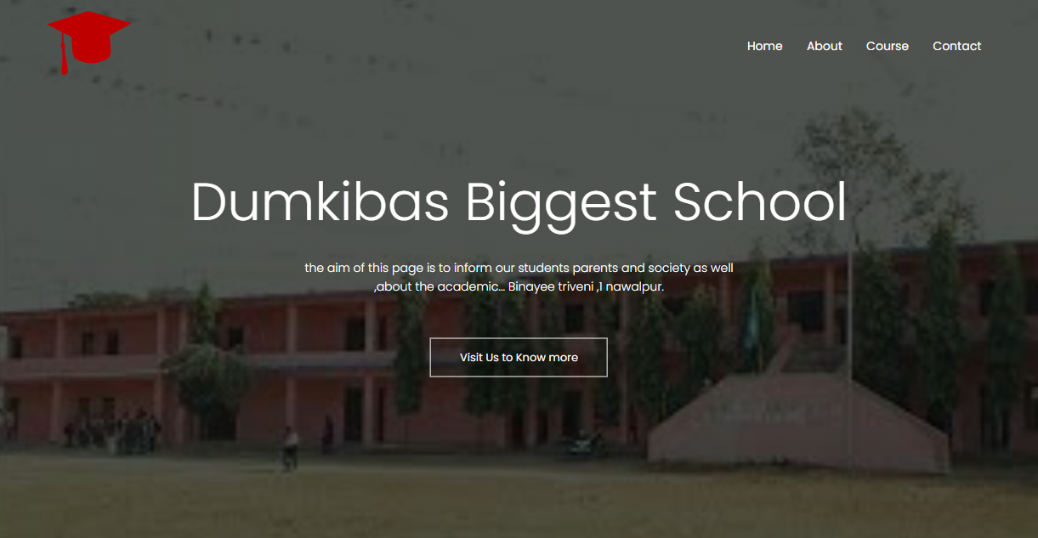

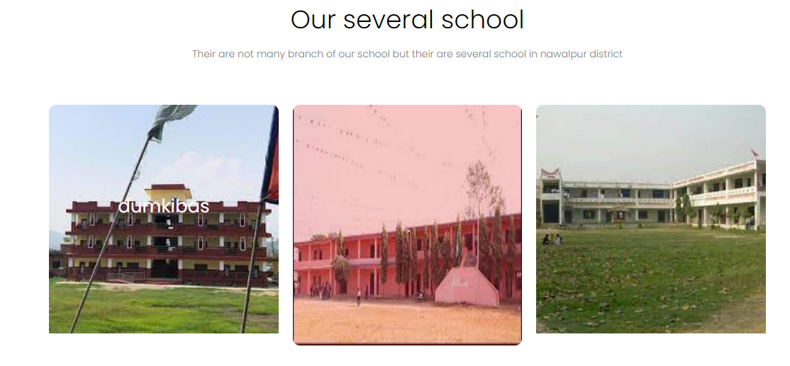

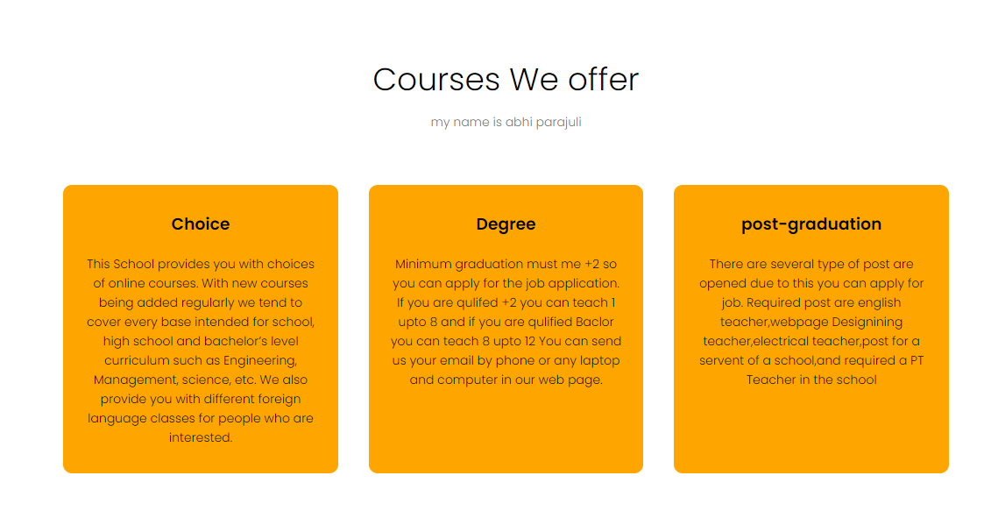

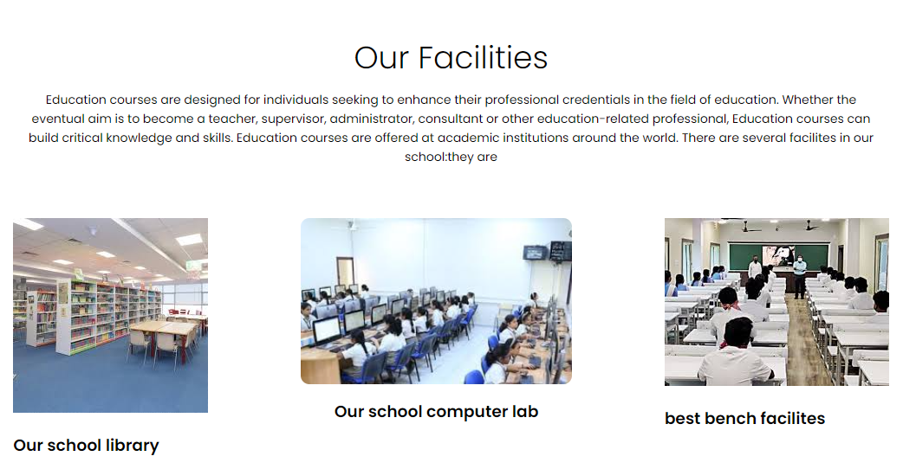

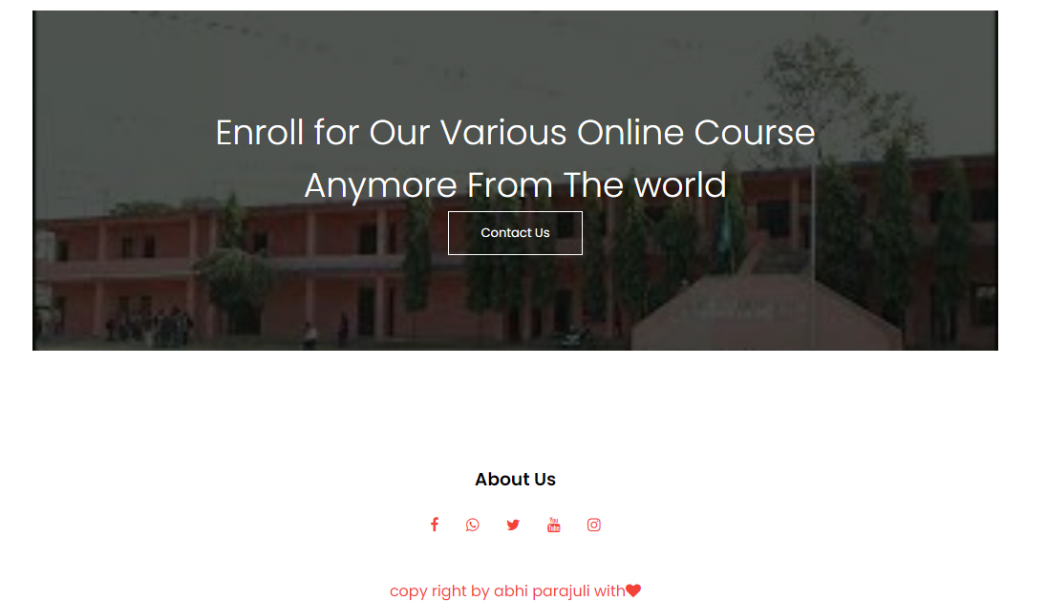

About page-:
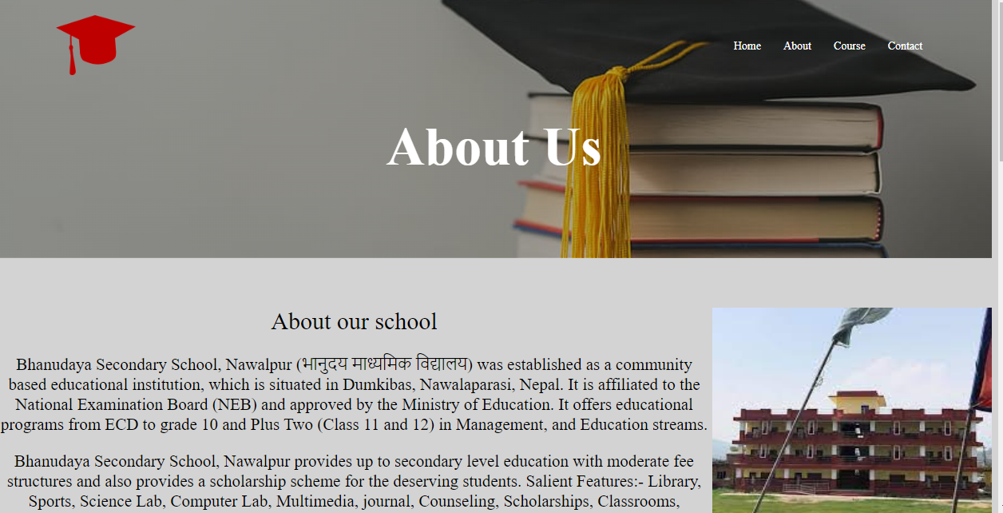





Course page-:

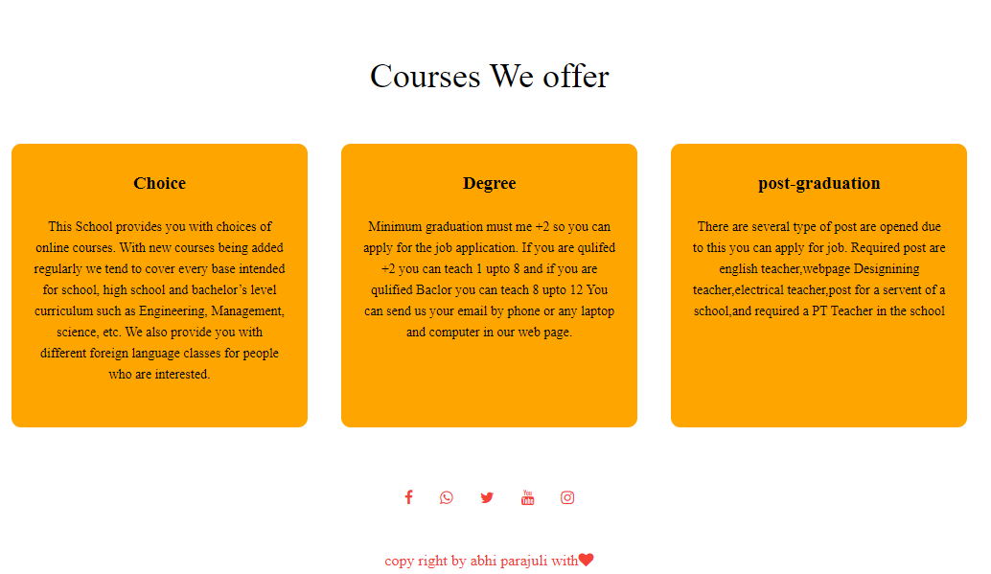
Contact page
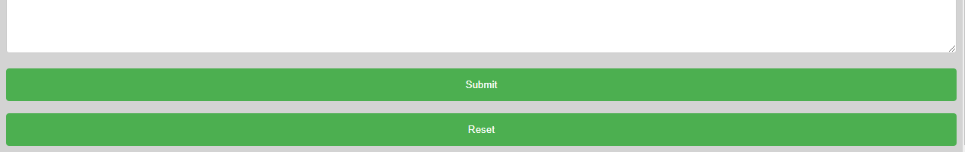
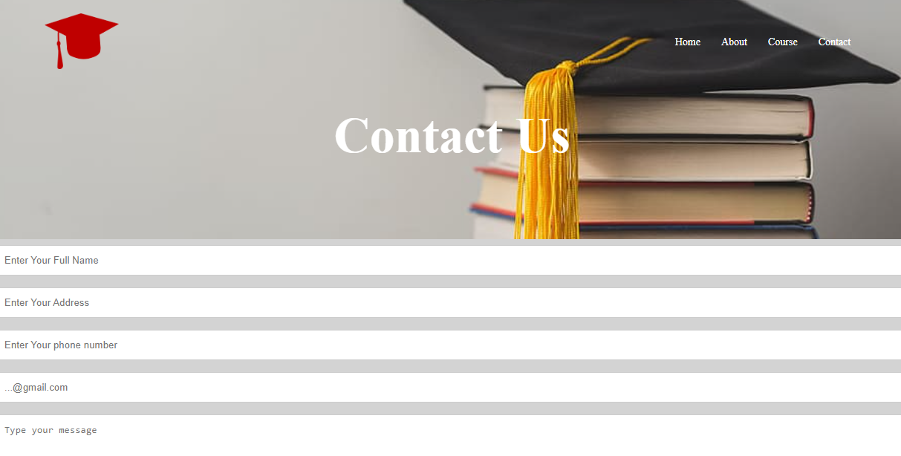

Coding

Home page-
<!DOCTYPE html>
<html>
<head>
<meta name="viewport" content="with=device-width,initial-scale=1.0">
<title>dumkibas biggest school</title>
<link rel="stylesheet" href="style.css" type="text/css">
<link rel="preconnect" href="https://fonts.googleapis.com">
<link rel="preconnect" href="https://fonts.gstatic.com">
<link rel="stylesheet" href="https://fonts.googleapis.com/css2?family=Poppins:wght@200;300;400;600;700&display=swap">
<link rel="stylesheet" href="https://stackpath.bootstrapcdn.com/font-awesome/4.7.0/css/font-awesome.min.css">
</head>
<body>
<section class="header">
<nav>
<a href="index.html"><img src="new/hat.png" > </a><div class="nav-links" id="nav-links"> <i class="fa fa-window-close" onclick="hidemenu()" ></i><ul>
<li><a href="index.html">Home</a></li>
<li><a href="about.html">About</a></li>
<li><a href="course.html">Course</a></li>
<li><a href="CONTACT.HTML">Contact</a></li>
</ul>
</div>
<i class="fa fa-bars" onclick="showmenu()"></i>
</nav>
<div class="text-box">
<h1>Dumkibas Biggest School</h1><p>the aim of this page is to inform our students parents and society as well<br>
,about the academic... Binayee triveni ,1 nawalpur.</p>
<a href="about.html" class="hero-btn">Visit Us to Know more</a>
</div>
</section>
<!----course--->
<section class="course">
<h1>Courses We offer</h1>
<p>
my name is abhi parajuli
</p>
<div class="row">
<div class="column">
<h3>Choice</h3>
<p> This School provides you with choices of online courses. With new courses being added regularly we tend to cover every base intended for school, high school and bachelor’s level curriculum such as Engineering, Management, science, etc. We also provide you with different foreign language classes for people who are interested.</p>
</div>
<div class="column">
<h3>Degree</h3>
<p>Minimum graduation must me +2 so you can apply for the job application. If you are qulifed +2 you can teach 1 upto 8 and if you are qulified Baclor you can teach 8 upto 12 You can send us your email by phone or any laptop and computer in our web page.</p>
</div>
<div class="column">
<h3>post-graduation</h3>
<p>There are several type of post are opened due to this you can apply for job. Required post are english teacher,webpage Designining teacher,electrical teacher,post for a servent of a school,and required a PT Teacher in the school </p>
</div></div>
</section>
<!------where are our school located------>
<section class="place">
<h1>Our severalschool </h1>
<p>Their are not many branch of our school but their are several school in nawalpur district </p>
<div class="row">
<div class="school-plc">
<img src="bhanudaya1.jfif">
<div class="layer">
<h3>dumkibas</h3>
</div>
</div>
<div class="school-plc1">
<img src="new/bhanudaya.jfif">
<div class="layer">
<h3>dumkibas</h3>
</div>
</div>
<div class="school-plc">
<img src="new/bhanudaya1.jfif">
<div class="layer">
<h3>Sardi,deuurali</h3>
</div>
</div>
</div>
</section>
<!--facilities-->
<section class="facilities">
<h1>Our Facilities</h1>
<p>Education courses are designed for individuals seeking to enhance their professional credentials in the field of education. Whether the eventual aim is to become a teacher, supervisor, administrator, consultant or other education-related professional, Education courses can build critical knowledge and skills. Education courses are offered at academic institutions around the world. There are several facilites in our school:they are
</p><div class="row">
<div class="facilities-col">
<img src="new/library.jfif"><h3>Our school library</h3>

</div>
<div class="facilites-col">
<img src="new/facilities.jfif"><h3>Our school computer lab</h3>
<p></p>
</div>
<div class="facilities-col">
<img src="new/bench.jfif"><h3>best bench facilites </h3>
<p></p>
</div>
</div>
</section>
<!----Call to action--->
<section class="call">
<h1>Enroll for Our Various Online Course<br>Anymore From The world</h1>
<a href="CONTACT.HTML" class="hero-btn">Contact Us</a>
</section>
<!------footer----->
<section>
<div id="footer">
<h3>About Us</h3>
<div class="icon">
<a href="https://www.facebook.com/Bhanudaya-model-secondary-school-767262433633066/"><i class="fa fa-facebook"></i></a>
<a href="https://www.whatsapp.com/"><i class="fa fa-whatsapp"></i></a>
<a href="https://twitter.com/?lang=en"><i class="fa fa-twitter"></i></a>
<a href="https://www.youtube.com/"> <i class="fa fa-youtube"></i></a>
<a href="https://www.instagram.com/"><i class="fa fa-instagram"></i></a>
</div>
<div class="last"> copy right by abhi parajuli with<i class="fa fa-heart"></i></div>
</div>
</section>
</body>
</html>
About page-:
<!DOCTYPE html>
<html lang="en">
<head>
<title>About</title>
<link rel="stylesheet" href="about.css" type="text/css"> <meta name="viewport" content="with=device-width,initial-scale=1.0">
<link rel="stylesheet" href="https://stackpath.bootstrapcdn.com/font-awesome/4.7.0/css/font-awesome.min.css">
</head>
<body>
<section class="header">
<nav>
<a href="index.html"><img src="new/hat.png" > </a>
<div class="nav-links" id="nav-links">
<ul>
<li><a href="index.html">Home</a></li>
<li><a href="#">About</a></li>
<li><a href="course.html">Course</a></li>
<li><a href="CONTACT.HTML">Contact</a></li>
</ul>
</div>
</nav>
</section>
<section class="body"></section>
<div class="text-box 1">About Us</div>
<div class="page">About our school
<img src="bhanudaya1.jfif" height=300 width=350 hspace=left align=right><p>Bhanudaya Secondary School, Nawalpur (भानुदय माध्यमिक विद्यालय) was established as a community based educational institution, which is situated in Dumkibas, Nawalaparasi, Nepal. It is affiliated to the National Examination Board (NEB) and approved by the Ministry of Education. It offers educational programs from ECD to grade 10 and Plus Two (Class 11 and 12) in Management, and Education streams.
</p><p>
Bhanudaya Secondary School, Nawalpur provides up to secondary level education with moderate fee structures and also provides a scholarship scheme for the deserving students.
Salient Features:- Library, Sports, Science Lab, Computer Lab, Multimedia, journal, Counseling, Scholarships, Classrooms, Conference Hall, Dance, Music, Tour, ECA, etc.</p>
<p></div>
<p>
<!------where are our school located------>
<section class="place">
<h1>Our severalschool </h1>
<p>Their are not many branch of our school but their are several school in nawalpur district </p>
<div class="row">
<div class="school-plc">
<img src="bhanudaya1.jfif">
<div class="layer">
<h3>dumkibas</h3>
</div>
</div>
<div class="school-plc1">
<img src="new/bhanudaya.jfif">
<div class="layer">
<h3>dumkibas</h3>
</div>
</div>
<div class="school-plc">
<img src="new/bhanudaya1.jfif">
<div class="layer">
<h3>Sardi,deuurali</h3>
</div>
</div>
</div>
</section>
<!--facilities-->
<section class="facilities">
<h1>Our Facilities</h1>
<p>Education courses are designed for individuals seeking to enhance their professional credentials in the field of education. Whether the eventual aim is to become a teacher, supervisor, administrator, consultant or other education-related professional, Education courses can build critical knowledge and skills. Education courses are offered at academic institutions around the world. There are several facilites in our school:they are
</p>
<div class="row">
<div class="facilities-col">
<img src="new/library.jfif"><h3>Our school library</h3>
<p></p>
</div>
<div class="facilites-col">
<img src="new/facilities.jfif"><h3>Our school computer lab</h3>
<p></p>
</div>
<div class="facilities-col">
<img src="new/bench.jfif"><h3>best bench facilites </h3>
<p></p>
</div>
</div>
</section>
<section>
<div id="footer">
<div class="icon">
<a href="https://www.facebook.com/Bhanudaya-model-secondary-school-767262433633066/"><i class="fa fa-facebook"></i></a>
<a href="https://www.whatsapp.com/"><i class="fa fa-whatsapp"></i></a>
<a href="https://twitter.com/?lang=en"><i class="fa fa-twitter"></i></a>
<a href="https://www.youtube.com/"> <i class="fa fa-youtube"></i></a>
<a href="https://www.instagram.com/"><i class="fa fa-instagram"></i></a>
</div>
<div class="last"> copy right by abhi parajuli with<i class="fa fa-heart"></i></div>

</div>
</section>
</body>
</html>

Contact page-:
<!DOCTYPE html>
<html lang="en">
<head>
<title>Contact~page</title>
<link rel="stylesheet" href="contanct.css" type="text/css">
<meta name="viewport" content="with=device-width,initial-scale=1.0">
</head>
<body>
<section class="header">
<nav>
<a href="index.html"><img src="new/hat.png" > </a>
<div class="nav-links" id="nav-links">
<ul>
<li><a href="index.html">Home</a></li>
<li><a href="about.html">About</a></li>
<li><a href="course.html">Course</a></li>
<li><a href="CONTACT.HTML">Contact</a></li>
</ul>
</div>
</nav>
</section>
<div class="text-box">Contact Us</div>
<div class="main">
<form method="post" action="">
<input type="text" name="name" id="name" placeholder="Enter Your Full Name">
<input type="text" name="add" id="add"placeholder="Enter Your Address">
<input type="text" name="phone" id="phone" placeholder="Enter Your phone number">
<input type="email" name="name" id="email" placeholder="...@gmail.com">
<br>
<textarea cols="40" rows="10" placeholder="Type your message"></textarea>
<input type="submit" value="Submit">
<input type="reset" value="Reset">
</form>
</div>
</body>
</html>

Course page-:

<!DOCTYPE html>
<html lang="en">
<head>
<title>About</title>
<link rel="stylesheet" href="course.css" type="text/css">
<meta name="viewport" content="with=device-width,initial-scale=1.0">
<link rel="stylesheet" href="https://stackpath.bootstrapcdn.com/font-awesome/4.7.0/css/font-awesome.min.css">
</head>
<body>
<section class="header">
<nav>
<a href="index.html"><img src="new/hat.png" > </a>
<div class="nav-links" id="nav-links">
<ul>
<li><a href="index.html">Home</a></li>
<li><a href="about.html">About</a></li>
<li><a href="course.html">Course</a></li>
<li><a href="CONTACT.HTML">Contact</a></li>
</ul>
</div>
</nav>
</section>
<div class="text-box 1">our courses</div>
<section class="course">
<h1>Courses We offer</h1>
<div class="row">
<div class="column">
<h3>Choice</h3>
<p> This School provides you with choices of online courses. With new courses being added regularly we tend to cover every base intended for school, high school and bachelor’s level curriculum such as Engineering, Management, science, etc. We also provide you with different foreign language classes for people who are interested.</p>
</div>
<div class="column">
<h3>Degree</h3>
<p>Minimum graduation must me +2 so you can apply for the job application. If you are qulifed +2 you can teach 1 upto 8 and if you are qulified Baclor you can teach 8 upto 12 You can send us your email by phone or any laptop and computer in our web page.</p>
</div>
<div class="column">
<h3>post-graduation</h3>
<p>There are several type of post are opened due to this you can apply for job. Required post are english teacher,webpage Designining teacher,electrical teacher,post for a servent of a school,and required a PT Teacher in the school </p>
</div></div>
</section>
<div class="icon">
<a href="https://www.facebook.com/Bhanudaya-model-secondary-school-767262433633066/"><i class="fa fa-facebook"></i></a>
<a href="https://www.whatsapp.com/"><i class="fa fa-whatsapp"></i></a>
<a href="https://twitter.com/?lang=en"><i class="fa fa-twitter"></i></a>
<a href="https://www.youtube.com/"> <i class="fa fa-youtube"></i></a>
<a href="https://www.instagram.com/"><i class="fa fa-instagram"></i></a>
</div>
<div class="last"> copy right by abhi parajuli with<i class="fa fa-heart"></i></div>
</body>
</html>

CSS code
Home page-:
*{
margin: 0;
padding: 0;
font-family: 'Poppins', sans-serif;
}
.header{
min-height:100vh;
width: 100%;
background-image: linear-gradient(rgba(4,9,3,0.7),rgba(4,9,3,0.7)),url(new/bhanudaya.jfif);
background-position: center;
background-size: cover;
position: relative;

}
nav{
display: flex;
padding: 2% 6%;
justify-content: space-between;
align-items: center;
}
nav img{
width: 100px;
}
.nav-links{
flex: 1;
text-align: right;
}
.nav-links ul li{
list-style: none;
display: inline-block;
padding: 8px 12px;
position: relative;

}
.nav-links ul li a{
color: white;
text-decoration: none;
font-size: 14px;
}

.nav-links ul li:after{
content:'';
width: 0%;
height: 2px;
background: #f44336;
display: block;
margin: auto;
transition: 0.5s;
}
.nav-links ul li:hover:after{
width: 100%;

}
.text-box{
width: 90%;
color: white;
position: absolute;
top: 50%;
left: 50%;
transform: translate(-50%,-50%);
text-align: center;
}
.text-box h1{
font-size: 62px;

}
.text-box p{
margin: 10px 0 40px;
font-size: 14px;
color:white;
}
.hero-btn{
display: inline-block;
text-decoration: none;
color: white;
border: 1px solid white;
padding: 12px 34px;
font-size: 13px;
background: transparent;
position: relative;
cursor: pointer;
}
.hero-btn:hover{
border:1px solid #f44336;
background: #f44336;
transition: 1s;
}
nav .fa{
display: none;
}

/*---course---*/
.course{
width: 80%;
margin: auto;
text-align:center;
padding-top:100px;
}
h1{
font-size: 36px;
font-weight: 300;
}
p{
color: #777;
font-size: 14px;
font-weight: 300;
line-height:22px;
padding: 10px;
}
.row{
margin-top: 5%;
display: flex;
justify-content: space-between;
}
.column{
flex-basis: 31%;
background: orange;
border-radius: 10px;
margin-bottom: 5%;
padding: 20px 12px;
box-sizing: border-box;
transition: 0.1s;

}
.column p{
color: black;
}
h3{
text-align: center;
font-weight:600;
margin: 10px 0;
}
.column:hover{
box-shadow: 10px 10px 10px 10px rgba(0,0,0,0.3);
}
/*----place*/
.place{
width: 80%;
margin: auto;
text-align: center;
padding-top: 50px;

}
.school-plc{
flex-basis: 32%;
border-radius:10px;
margin-bottom:30px;
position:relative;
overflow: hidden;
}
.school-plc img{
width:100%;
display: block;

}
.school-plc1{
flex-basis: 32%;
border-radius:10px;
margin-bottom:30px;
position:relative;
overflow: hidden;
}
.school-plc1 img{
width:100%;
background-size: cover;
display: block;
height: 340px;
}

.layer{
background: transparent;
height:100%;
width: 100%;
position: absolute;
top: 0;
left: 0;
transition: 1s;
}
.layer:hover{
background:rgba(226,0,0,0.7);
}
.layer h3{
width: 100%;
font-weight: 500;
color: white;
font-size: 26px;
bottom: 0;
left: 50%;
transform:translateX(-50%);
opacity: 0;
position: absolute;
}
.layer:hover h3{
bottom: 49%;
opacity: 1;
}

.facilities{
width: 80%;
margin: auto;
text-align: center;
padding-top:100px;

}
.facilities p{
color: black;
font-weight:500;
}
.facilites-col{
flex-basis: 31%;
border-radius: 10px;
margin-bottom: 5%;
text-align: center;
}
.facilites-col img{
width: 100%;
border-radius:10px;
}
.facilities-col p{
padding: 0;
}
.facilities-col h3{
margin-top: 16px;
margin-bottom: 15px;
text-align: left;
}
/*----call---*/
.call{
margin: 100px auto;
width:80%;
background-image: linear-gradient(rgba(4,9,3,0.7),rgba(4,9,3,0.7)),url(new/bhanudaya.jfif);
background-size: cover;
background-position: center;
text-align: center;
padding: 100px 0;
color: white;
}
#footer {
width: 100%;
text-align: center;

padding: 10px 0;
}
.footer h3{
margin-bottom: 25px;
margin-top: 20;
font-weight: 600;

}
.icon {
flex-basis: 31%;
color: #f44336;
margin-bottom: 12px;
padding: 5px 12px;

}
.icon .fa{
color: #f44336;
margin-bottom: 12px;
padding: 10px 12px;
cursor: pointer;
}
.last{

color: #f44336;
padding: 10px 10px;
}

About page-:

body{
background-color: lightgray;

}

#main{
background-image:lightgray;
background-repeat: no-repeat;
background-size: cover;
height: auto;
width: 80%;
margin: auto;
border-radius: 10px;
}
{
margin: 0;
padding: 0;
font-family: 'Poppins', sans-serif;
}
.header{
min-height:50vh;
width: 100%;
background-image:linear-gradient(rgba(4,9,3,0.3),rgba(4,9,3,0.3)),url(image1.jpg);
background-position: center;
background-size: cover;
position: relative;

}
nav{
display: flex;
padding: 2% 6%;
justify-content: space-between;
align-items: center;
background-image: url(../image.jpg);
}
nav img{
width: 100px;
}
.nav-links{
flex: 1;
text-align: right;
}
.nav-links ul li{
list-style: none;
display: inline-block;
padding: 8px 12px;
position: relative;

}
.nav-links ul li a{
color: white;
text-decoration: none;
font-size: 14px;
}

.nav-links ul li:after{
content:'';
width: 0%;
height: 2px;
background: #f44336;
display: block;
margin: auto;
transition: 0.5s;
}
.nav-links ul li:hover:after{
width: 100%;

}
.text-box{
width: 90%;
color: white;
position: absolute;
top: 30%;
left: 50%;
font-style: normal;
font-size: 67px;
transform: translate(-50%,-50%);
text-align: center;
font-weight: 900;

}
.body{
margin-top: 5%;
}
.page p{
font-size: 21px;
font-weight: 200;
color:black;

}
.page {
font-size: 30px;
font-weight: 300;
text-align: center;
color: black;
}
p{
font-size: 20px;
font-weight: 200;
color: black;
}

.row{
margin-top: 5%;
display: flex;
justify-content: space-between;
}
.column{
flex-basis: 31%;
background: orange;
border-radius: 10px;
margin-bottom: 5%;
padding: 20px 12px;
box-sizing: border-box;
transition: 0.1s;

}
.column p{
color: black;
}
h3{
text-align: center;
font-weight:600;
margin: 10px 0;
}
.column:hover{
box-shadow: 10px 10px 10px 10px rgba(0,0,0,0.3);
}
/*----place*/
.place{
width: 80%;
margin: auto;
text-align: center;
padding-top: 50px;

}
.school-plc{
flex-basis: 32%;
border-radius:10px;
margin-bottom:30px;
position:relative;
overflow: hidden;
}
.school-plc img{
width:100%;
display: block;

}
.school-plc1{
flex-basis: 32%;
border-radius:10px;
margin-bottom:30px;
position:relative;
overflow: hidden;
}
.school-plc1 img{
width:100%;
background-size: cover;
display: block;
height: 350px;
}

.layer{
background: transparent;
height:100%;
width: 100%;
position: absolute;
top: 0;
left: 0;
transition: 1s;
}
.layer:hover{
background:rgba(226,0,0,0.7);
}
.layer h3{
width: 100%;
font-weight: 500;
color: white;
font-size: 26px;
bottom: 0;
left: 50%;
transform:translateX(-50%);
opacity: 0;
position: absolute;
}
.layer:hover h3{
bottom: 49%;
opacity: 1;
}

.facilities{
width: 80%;
margin: auto;
text-align: center;
padding-top:100px;

}
.facilities p{
color: black;
font-weight:500;
}
.facilites-col{
flex-basis: 31%;
border-radius: 10px;
margin-bottom: 5%;
text-align: center;
}
.facilites-col img{
width: 100%;
border-radius:10px;
}
.facilities-col p{
padding: 0;
}
.facilities-col h3{
margin-top: 16px;
margin-bottom: 15px;
text-align: left;
}

#footer {
width: 100%;
text-align: center;

padding: 10px 0;
}

.icon {
flex-basis: 31%;
color: #f44336;
margin-bottom: 12px;
padding: 5px 12px;

}
.icon .fa{
color: #f44336;
margin-bottom: 12px;
padding: 10px 12px;
cursor: pointer;
}
.last{

color: #f44336;
padding: 10px 10px;
}

Contact-:
body{
background:lightgray;
}

#main{
background-image:lightgray;
background-repeat: no-repeat;
background-size: cover;
height: auto;
width: 80%;
margin: auto;
border-radius: 10px;
}
{
margin: 0;
padding: 0;
font-family: 'Poppins', sans-serif;
}
.header{
min-height:50vh;
width: 100%;
background-image:url(image1.jpg);
background-position: center;
background-size: cover;
position: relative;

}
nav{
display: flex;
padding: 2% 6%;
justify-content: space-between;
align-items: center;
background-image: url(../image.jpg);
}
nav img{
width: 100px;
}
.nav-links{
flex: 1;
text-align: right;
}
.nav-links ul li{
list-style: none;
display: inline-block;
padding: 8px 12px;
position: relative;

}
.nav-links ul li a{
color: white;
text-decoration: none;
font-size: 14px;
}

.nav-links ul li:after{
content:'';
width: 0%;
height: 2px;
background: #f44336;
display: block;
margin: auto;
transition: 0.5s;
}
.nav-links ul li:hover:after{
width: 100%;

}
.text-box{
width: 100%;
color: white;
position: absolute;
top: 30%;
left: 50%;
font-style: normal;
font-size: 67px;
transform: translate(-50%,-50%);
text-align: center;
font-weight: 900;
}

.main{
width: 100%;
}

form {
display: block;
}
input[type=text]{
width: 100%;
padding: 12px 20px;
margin: 8px 0;
display: inline-block;
border: 1px solid #ccc;
border-radius: 4px;
box-sizing: border-box;
}
input[type=email]{
width: 100%;
padding: 12px 20px;
margin: 8px 0;
display: inline-block;
border: 1px solid #ccc;
border-radius: 4px;
box-sizing: border-box;
}
textarea{
width: 100%;
padding: 12px 20px;
margin: 8px 0;
display: inline-block;
border: 1px solid #ccc;
border-radius: 4px;
box-sizing: border-box;
}
input[type=Submit]{
width: 100%;
background-color: #4CAF50;
color: white;
padding: 14px 20px;
margin: 8px 0;
border: none;
border-radius: 4px;
cursor: pointer;
}
input[type=Submit]:hover{
background: red;
}
input[type=reset] {
width: 100%;
background-color: #4CAF50;
color: white;
padding: 14px 20px;
margin: 8px 0;
border: none;
border-radius: 4px;
cursor: pointer;
}
input[type=reset]:hover {
background: red;

}

Course offered
body{
background-color: white;
}
#main{
background-image:lightgray;
background-repeat: no-repeat;
background-size: cover;
height: auto;
width: 80%;
margin: auto;
border-radius: 10px;
}
{
margin: 0;
padding: 0;
font-family: 'Poppins', sans-serif;
}
.header{
min-height:50vh;
width: 100%;
background-image:linear-gradient(rgba(4,9,3,0.3),rgba(4,9,3,0.3)),url(image1.jpg);
background-position: center;
background-size: cover;
position: relative;
}
nav{
display: flex;
padding: 2% 6%;
justify-content: space-between;
align-items: center;
background-image: url(../image.jpg);
}
nav img{
width: 100px;
}
.nav-links{
flex: 1;
text-align: right;
}
.nav-links ul li{
list-style: none;
display: inline-block;
padding: 8px 12px;
position: relative;

}
.nav-links ul li a{
color: white;
text-decoration: none;
font-size: 14px;
}

.nav-links ul li:after{
content:'';
width: 0%;
height: 2px;
background: #f44336;
display: block;
margin: auto;
transition: 0.5s;
}
.nav-links ul li:hover:after{
width: 100%;

}
.text-box{
width: 90%;
color: white;
position: absolute;
top: 30%;
left: 50%;
font-style: normal;
font-size: 67px;
transform: translate(-50%,-50%);
text-align: center;
font-weight: 900;

}

/*---course---*/
.course{
width: 80%;
margin: auto;
text-align:center;
padding-top:100px;
}
.course h1{
font-size: 36px;
font-weight: 300;
}
p{
color: #777;
font-size: 14px;
font-weight: 300;
line-height:22px;
padding: 10px;
}
.row{
margin-top: 5%;
display: flex;
justify-content: space-between;
}
.column{
flex-basis: 31%;
background: orange;
border-radius: 10px;
margin-bottom: 5%;
padding: 20px 12px;
box-sizing: border-box;
transition: 0.1s;

}
.column p{
color: black;
}
h3{
text-align: center;
font-weight:600;
margin: 10px 0;
}
.column:hover{
box-shadow: 10px 10px 10px 10px rgba(0,0,0,0.3);
}
.icon {
flex-basis: 31%;
color: #f44336;
margin-bottom: 12px;
padding: 5px 12px;
text-align: center;
}
.icon .fa{
color: #f44336;
margin-bottom: 12px;
padding: 10px 12px;
cursor: pointer;
}
.last{
text-align: center;
color: #f44336;
padding: 10px 10px;
}

