- Creational Design Patterns
  - Singleton Pattern >>
  - Factory Pattern >>
  - Abstract Factory Pattern >>
  - Builder Pattern
  - Prototype Pattern >>
- Structural Design Patterns
  - Adapter Pattern >>
  - Composite Pattern
  - Proxy Pattern >>
  - Flyweight Pattern
  - Facade Pattern >>
  - Bridge Pattern
  - Decorator Pattern >>Car Parking System
- Behavioral Design Patterns
  - Template Method Pattern
  - Mediator Pattern
  - Chain of Responsibility Pattern
  - Observer Pattern
  - Strategy Pattern
  - Command Pattern
  - State Pattern
  - Visitor Pattern
  - Interpreter Pattern
  - Iterator Pattern >>
  - Memento Pattern
Difference between Factory pattern and Abstract Factory pattern
Factory: A factory that creates objects that derive from a particular base class.
Abstract factory: A factory that creates other factories, and these factories in turn create objects derived from base classes. You do this because you often don't just want to create a single object (as with Factory method) - rather, you want to create a collection of related objects.
Factory Pattern:
1. Create object through inheritance
2. Produce only one product
3. Implements code in the abstract creator that make use of the concrete type that sub class produces.
Abstract Factory Pattern:
1. Create object through composition
2. Produce families of products
3. Concrete factories implements factory method to create product
With the Factory pattern, you produce implementations (Apple, Banana, Cherry, etc.) of a particular interface -- say, IFruit.
With the Abstract Factory pattern, you produce implementations of a particular Factory interface -- e.g., IFruitFactory. Each of those knows how to create different kinds of fruit.

Real Life Example. (Easy to remember)
Factory
Imagine you are constructing a house and you approach a carpenter for a door. You give the measurement for the door and your requirements, and he will construct a door for you. In this case, the carpenter is a factory of doors. Your specifications are inputs for the factory, and the door is the output or product from the factory.
Abstract Factory
Now, consider the same example of the door. You can go to a carpenter, or you can go to a plastic door shop or a PVC shop. All of them are door factories. Based on the situation, you decide what kind of factory you need to approach. This is like an Abstract Factory.
Basic difference:
Factory: Creates objects without exposing the instantiation logic to the client.0
Factory Method: Define an interface for creating an object, but let the subclasses decide0 which class to instantiate. The Factory method lets a class defer instantiation to subclasses
Abstract Factory: Provides an interface for creating families of related or dependent objects without specifying their concrete classes.
AbstractFactory pattern uses composition to delegate responsibility of creating object to another class while Factory method design pattern uses inheritance and relies on derived class or sub class to create object
From oodesign articles:
Factory class diagram:
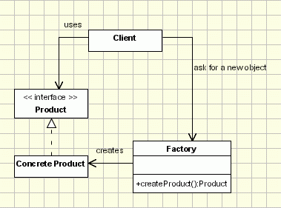
Example:
public class ShapeFactory {

//use getShape method to get object of type shape
public Shape getShape(String shapeType){
if(shapeType == null){
return null;
}
if(shapeType.equalsIgnoreCase("CIRCLE")){
return new Circle();

} else if(shapeType.equalsIgnoreCase("RECTANGLE")){
return new Rectangle();

} else if(shapeType.equalsIgnoreCase("SQUARE")){
return new Square();
}

return null;
}
}
When to use: Client just need a class and does not care about which concrete implementation it is getting.
Factory Method class digaram:
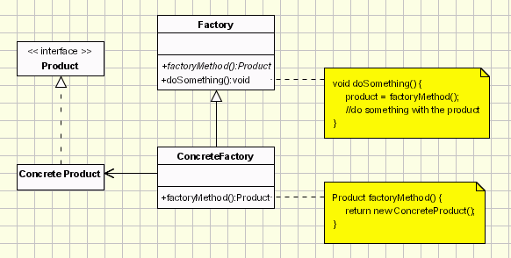
When to use: Client doesn't know what concrete classes it will be required to create at runtime, but just wants to get a class that will do the job.
Abstract Factory class diagram from dzone

Decorator design pattern
Decorator design pattern is used to modify the functionality of an object at runtime. At the same time other instances of the same class will not be affected by this, so individual object gets the modified behavior. Decorator design pattern is one of the structural design pattern (such as Adapter Pattern, Bridge Pattern,Composite Pattern) and uses abstract classes or interface with composition to implement.

Decorator Design Pattern
We use inheritance or composition to extend the behavior of an object but this is done at compile time and its applicable to all the instances of the class. We can’t add any new functionality of remove any existing behavior at runtime – this is when Decorator pattern comes into picture.
Suppose we want to implement different kinds of cars – we can create interface Car to define the assemble method and then we can have a Basic car, further more we can extend it to Sports car and Luxury Car. The implementation hierarchy will look like below image.
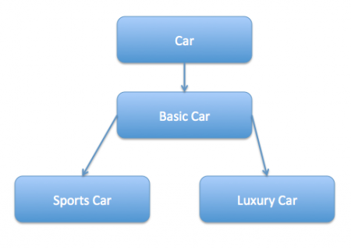
But if we want to get a car at runtime that has both the features of sports car and luxury car, then the implementation gets complex and if further more we want to specify which features should be added first, it gets even more complex. Now imagine if we have ten different kind of cars, the implementation logic using inheritance and composition will be impossible to manage. To solve this kind of programming situation, we apply decorator pattern in java.
We need to have following types to implement decorator design pattern.
- Component Interface – The interface or abstract class defining the methods that will be implemented. In our case Car will be the component interface.
- package com.journaldev.design.decorator;

- public interface Car {

- public void assemble();
}
- Component Implementation – The basic implementation of the component interface. We can haveBasicCar class as our component implementation.
- package com.journaldev.design.decorator;

- public class BasicCar implements Car {

- @Override
- public void assemble() {
- System.out.print("Basic Car.");
- }

}
- Decorator – Decorator class implements the component interface and it has a HAS-A relationship with the component interface. The component variable should be accessible to the child decorator classes, so we will make this variable protected.
- package com.journaldev.design.decorator;

- public class CarDecorator implements Car {

- protected Car car;

- public CarDecorator(Car c){
- this.car=c;
- }

- @Override
- public void assemble() {
- this.car.assemble();
- }

}
- Concrete Decorators – Extending the base decorator functionality and modifying the component behavior accordingly. We can have concrete decorator classes as LuxuryCar and SportsCar.
- package com.journaldev.design.decorator;

- public class SportsCar extends CarDecorator {

- public SportsCar(Car c) {
- super(c);
- }

- @Override
- public void assemble(){
- super.assemble();
- System.out.print(" Adding features of Sports Car.");
- }
}
package com.journaldev.design.decorator;

public class LuxuryCar extends CarDecorator {

public LuxuryCar(Car c) {
super(c);
}

@Override
public void assemble(){
super.assemble();
System.out.print(" Adding features of Luxury Car.");
}
}

Decorator Design Pattern – Class Diagram
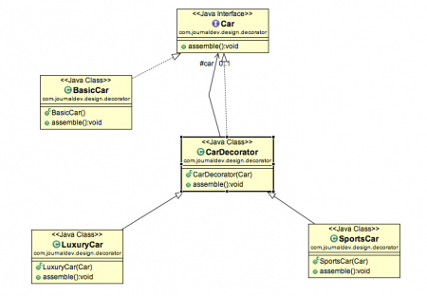

Decorator Design Pattern Test Program
package com.journaldev.design.test;

import com.journaldev.design.decorator.BasicCar;
import com.journaldev.design.decorator.Car;
import com.journaldev.design.decorator.LuxuryCar;
import com.journaldev.design.decorator.SportsCar;

public class DecoratorPatternTest {

public static void main(String[] args) {
Car sportsCar = new SportsCar(new BasicCar());
sportsCar.assemble();
System.out.println("\n*****");

Car sportsLuxuryCar = new SportsCar(new LuxuryCar(new BasicCar()));
sportsLuxuryCar.assemble();
}

}
Notice that client program can create different kinds of Object at runtime and they can specify the order of execution too.
Output of above test program is:
Basic Car. Adding features of Sports Car.
*****
Basic Car. Adding features of Luxury Car. Adding features of Sports Car.

Decorator Design Pattern – Important Points
- Decorator design pattern is helpful in providing runtime modification abilities and hence more flexible. Its easy to maintain and extend when the number of choices are more.
- The disadvantage of decorator design pattern is that it uses a lot of similar kind of objects (decorators).
- Decorator pattern is used a lot in Java IO classes, such as FileReader, BufferedReader etc.

- Create a Vehicle Class where
- Define all properties and methods for it.
- Define a default Constructor
- Define a constructor with Arguments
- Define getters and setters for all properties
- Define methods
1  2  3  4  5  6  7  8  9  10  11  12  13  14  15  16  17  18  19  20  21  22  23  24  25  26  27  28  29  30  31  32  33  34  35  36  37  38  39  40  41  42  43  44  45  46  47  48  49  50  51  52  53  54  55  56  57  58  59  60  61  62  63  64  65 | // super class  public class Vehicle {  private String model;  private String color;  private int numOfWheels;  private String transmission;  // default constructor  public Vehicle(){  }  // constructor  public Vehicle(String model, String color, int numOfWheels, String transmission){  this.model = model;  this.color = color;  this.numOfWheels = numOfWheels;  this.transmission = transmission;  }  //getters  public String getModel(){  return model;  }  public String getColor(){  return color;  }  public int NumOfWheels(){  return numOfWheels;  }  public String transmission(){  return transmission;  }  //setters  public void setNumOfWheels (int numOfWheels){  this.numOfWheels = numOfWheels;  }  public void setModel(String model){  this.model = model;  }  public void setColor(String color){  this.color = color;  }  public void setTransmission(String transmission){  this.transmission = transmission;  }  // Print Method  public void printDetails(){  System.out.println("The color of this vehicle is " + this.color);  System.out.println("The model of this vehicle is " + this.model);  System.out.println("The transmission for this vehicle is " + this.transmission);  System.out.println("The number of wheels in this vehicle is "+ this.numOfWheels);  }  }
- Define sub classes like car, truck and bike which will inherit from the super class Vehicle.
- In each class, try to include a new property (not inherited from Vehicle class)
- Define a Constructor which calls superclass constructor
- Define another constructor which has arguments.
- Define getters and setters for the child class new property.
- Define method for the child class if any.
Bike.java
1  2  3  4  5  6  7  8  9  10  11  12  13  14  15  16  17  18  19  20  21  22  23  24  25  26  27  28  29 | public class Bike extends Vehicle {  private boolean suspension;  public Bike(){  super();  }  public Bike(String model, String color, int numOfWheels, boolean suspension){  super( model, color, numOfWheels, "na"); // na for transmission as Bike class does not need a suspension property  this.suspension = suspension;  }  //getter  public boolean getSuspension(){  return suspension;  }  //setter  public void setSuspension(){  this.suspension = suspension;  }  //method  public void printBikeDetails(){  super.printDetails();  System.out.println("Does this bike have suspension ?? " + this.suspension);  }  }
Car.java
1  2  3  4  5  6  7  8  9  10  11  12  13  14  15  16  17  18  19  20  21  22  23  24  25  26  27  28  29  30  31  32 | public class Car extends Vehicle{  private Boolean roof;  // Constructors  public Car(){  super();  }  public Car(String model, String color, int numOfWheels, String transmission, Boolean roof){  super(model, color, numOfWheels, transmission);  this.roof = roof;  }  //getter  public boolean getRoof(){  return roof;  }  // setter  public void setRoof(boolean roof){  this.roof=roof;  }  // Methods  public void printdetailscar(){  super.printDetails(); // Calling superclass method  System.out.println(" does this car has a roof: " + this.roof);  }  }
Truck.java
1  2  3  4  5  6  7  8  9  10  11  12  13  14  15  16  17  18  19  20  21  22  23  24  25  26  27  28  29  30 | public class Truck extends Vehicle{  private int numOfContainers;  public Truck(){  super();  }  public Truck(String model, String color, int numOfWheels, String transmission, int numOfContainers){  super ( model, color, numOfWheels, transmission) ;  this.numOfContainers = numOfContainers;  }  //getters  public int getnumOfContainers(){  return numOfContainers;  }  //setter  public void setnumOfContainers(){  this.numOfContainers = numOfContainers;  }  //Method  public void printTruckdetails(){  super.printDetails();  System.out.println(" Number of Containers in this Truck are: " + this.numOfContainers);  }
- Define a class Car Park
- Define capacity of Car Park here and create an arraylist to hold the value of parked cars
- Define Constructor
- Define all the methods for calculating available spots, occupied spots, to add vehicles and to print details of the vehicles
1  2  3  4  5  6  7  8  9  10  11  12  13  14  15  16  17  18  19  20  21  22  23  24  25  26  27  28  29  30  31  32  33  34  35  36  37  38  39  40  41  42  43  44  45  46  47  48  49  50  51  52  53  54  55  56 | <strong></strong>  import java.util.ArrayList;  public class CarPark {  private static final int maxCapacity = 3;  private ArrayList <Vehicle>carParkArray; // Every member of carParkArray will be of type Vehicle  //constructor  public CarPark(){  this.carParkArray = new ArrayList<Vehicle>(maxCapacity);  //This ensures car PArk has three vehicles max  }  // Method to find maximum capacity of the car park  public static int getMaxCapacity(){  return maxCapacity;  }  // Method to find available spots in the carpark  public int numOfAvailableSpots(){  return this.maxCapacity - this.carParkArray.size();  }  // Method to find number of occupied spaces in the carpark  public int numOfOccupiedSpots(){  return this.carParkArray.size();  }  //Method to add vehicles to the carpark  public void addVehicles(Vehicle vehicle){  if(this.numOfAvailableSpots() > 0){  this.carParkArray.add(vehicle);  vehicle.printDetails();  System.out.println("++++++++++++ \n");  }else {  System.out.println("Car Park is full");  }  }  //Method to print parked vehicle details  public void printParkedVehicleDetails(){  // For every vehicle in array carParkArray, do blah blah  for(Vehicle vehicle: this.carParkArray){  vehicle.printDetails();  System.out.println("++++++++++++++++ \n");  }  }  }
- Define a CarParkManagement Class
- Instantiate your classes here for vehicles
- Instantiate carPark
- Add vehicles
- Call methods to print information
1  2  3  4  5  6  7  8  9  10  11  12  13  14  15  16  17  18  19  20  21  22  23  24  25  26  27  28  29  30  31  32  33  34  35 | public class CarParkManagement {  public static void main(String[] args) {  Car BMW = new Car("Z4", "red",4, "Auto",false);  Bike Superfly = new Bike("XTR", "Black",2,true );  Truck Mercedes = new Truck("8X4", "Blue", 12,"Manual", 4 );  Car Hyundai = new Car("i30","Light Blue",4,"Auto",true);  CarPark myCarPark = new CarPark();  //Parking Vehicles  myCarPark.addVehicles(BMW);  myCarPark.addVehicles(Hyundai);  myCarPark.addVehicles(Mercedes);  myCarPark.addVehicles(Superfly);  // Comment some of the above to see if it works  System.out.println(" No. of Parked vehicles: " + myCarPark.numOfOccupiedSpots());  System.out.println("No. of Available Spots: "+ myCarPark.numOfAvailableSpots());  // Printing details  System.out.println("====================\n");  System.out.println("List of All Parked Vehicles is as folows: ");  myCarPark.printParkedVehicleDetails();  }  }
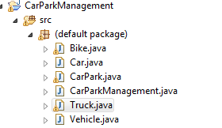

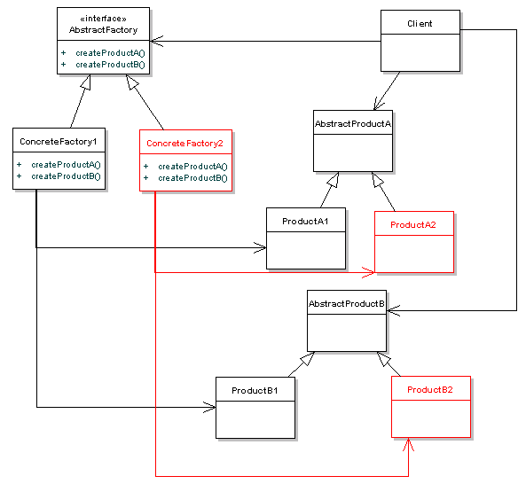
When to use: When your system has to create multiple families of products or you want to provide a library of products without exposing the implementation details.
Source code examples in above articles are very good to understand the concepts clearly.
Related SE question with code example:
Factory Pattern. When to use factory methods?
Differences:
- Abstract Factory classes are often implemented with Factory Methods, but they can also be implemented using Prototype
- Designs start out using Factory Method (less complicated, more customizable, subclasses proliferate) and evolve toward other creational patterns (more flexible, more complex) where more flexibility is needed.
- Factory Methods are usually called within Template Methods.
http://www.oodesign.com/creational-patterns/
http://www.java67.com/2012/09/top-10-java-design-pattern-interview-question-answer.html
http://www.tutorialspoint.com/design_pattern/design_pattern_interview_questions.htm
http://www.journaldev.com/12086/composition-vs-inheritance

