**Q. Moving files –**

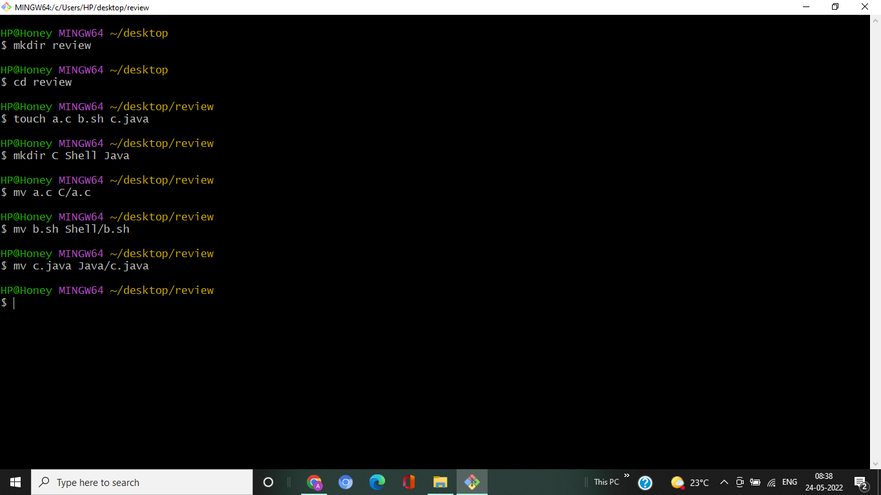

**Q. Appending files –**

HP@HONEY MINGW64 ~/desktop/CIC526/Day3

$ touch abc.log.1 def.log.1 ghi.log.1 jkl.log.1

HP@HONEY MINGW64 ~/desktop/CIC526/Day3

$ ls *.log.1 abc.log.1 def.log.1 ghi.log.1 jkl.log.1

HP@HONEY MINGW64~/desktop/CIC526/Day3

$ date "+%D" 05/28/22

HP@HONEY MINGW64~/desktop/CIC526/Day3

$ mv abc.log.1 abc-28052022.log

HP@HONEY MINGW64~/desktop/CIC526/Day3

$ mv def.log.1 def-28052022.log

HP@HONEY MINGW64~/desktop/CIC526/Day3

$ mv ghi.log.1 ghi-28052022.log

HP@HONEY MINGW64~/desktop/CIC526/Day3

$ mv jkl.log.1 jkl-28052022.log

HP@HONEY MINGW64~/desktop/CIC526/Day3

$ ls *.log

abc-28052022.log def-28052022.log ghi-28052022.log jkl-28052022.log

Q. Difference between original and updated

HP@HONEY MINGW64~/desktop/CIC526/Day3

$ mkdir original updated

HP@HONEY MINGW64~/desktop/CIC526/Day3

$ touch original-file.sh updated-file.sh

HP@HONEY MINGW64~/desktop/CIC526/Day3

$ cp original-file.sh original

HP@HONEY MINGW64~/desktop/CIC526/Day3

$ cp updated-file.sh updated

HP@HONEY MINGW64~/desktop/CIC526/Day3

$ diff original updated

Only in original: original-file.sh

Only in updated: updated-file.sh

HP@HONEY MINGW64~/desktop/CIC526/Day3

$ cp -r original updated/original-backup

Q. Last frequent urls –

HP@HONEY MINGW64 ~/desktop/CIC526/Day3

$ cat access.log

.

.

.

HP@HONEY MINGW64 ~/desktop/cic526/day3

$ cat access.log | awk '{print ($ (NF-1) ) }' | sort | uniq -c |head -4

2 "Go-http-client/1.1"

1 "python-requests/2.22.0"

74 +http://www.google.com/bot.html)"

2 +info@netcraft.com)"

**Q. List of web response codes**

HP@HONEY MINGW64 ~/desktop/CIC526/Day3

$ cat access.log | awk '{print $9, $9 }' | sort | uniq –c

3176 200 200

8 206 206

26 304 304

Q. Employee table –

HP@HONEY MINGW64 ~/desktop/CIC526/Day3

$ cat dataanalysis.csv

Id EmployeeName JobTitle BasePay OvertimePay OtherPay TotalPay TotalPay Benefits

1 NATHANIEL GM 167411 0 400184 567595 567595

2 GARY CAPTAIN 155966 245131 137811 538909 538909

3 ALBERT CAPTAIN 212739 106088 16452 335279 335279

4 CHRISTOPHER MECHANIC 77916 56120 198306 332343 332343

5 PATRICK DEPUTYCHIEF 134401 9737 182234 326373 326373

6 DAVID ASST DEPUTY 118602 8601 189082 316285 316285

7 ALSON BATTALION CHIEF 92492 89062 134426 315981 315981

8 DAVID DEPUTYDIRECTOR 256576 0 51322 307899 307899

10 JOANNE CHIEF 285262 0 17115 302377 302377

12 PATRICIA CAPTAIN 99722 87082 110804 297608 297608

13 EDWARD EXECUTIVE 294580 0 0 294580 294580

HP@HONEY MINGW64 ~/desktop/CIC526/Day3

$ cat dataanalysis.csv | awk '{ if ( $4 >= 10000) print $2, $7 }'

EmployeeName TotalPay

NATHANIEL 567595

GARY 538909

ALBERT 335279

CHRISTOPHER 332343

PATRICK 326373

DAVID 316285

ALSON 315981

DAVID 307899

JOANNE 302377

PATRICIA 297608

EDWARD 294580

HP@HONEY MINGW64 ~/desktop/CIC526/Day3

$ cat dataanalysis.csv | grep -i captain | awk '{ total += $7; count ++} END { print total/count}'

390599

HP@HONEY MINGW64 ~/desktop/CIC526/Day3

$ cat dataanalysis.csv | awk '{ if ( $5 < 10000 && $5 > 7000 ) print $3, $5}'

DEPUTYCHIEF 9737

ASSTDEPUTY 8601

HP@HONEY MINGW64 ~/desktop/CIC526/Day3

$ cat dataanalysis.csv | awk '{ t += $4; c++ } END { print t/c }'

157972