Transforming EDA Projects to Dashboards
Airbnb Listings: Chicago vs New Orleans
Comparative analysis using Python (Google Colab) and a Power BI dashboard
GitHub Link -

Prepared by: Abhishek Sarvaiya
DataViz Challenge submission

1. Project Overview
This project turns an exploratory data analysis (EDA) of Airbnb listings into an interactive Power BI dashboard that compares two American cities, Chicago and New Orleans. The dashboard is built on the same dataset that was cleaned and explored in Python.
Business question: how does Airbnb's presence differ between Chicago and New Orleans, in what is offered, what it costs, and who runs it, and what could a host, an investor or a platform team do with that knowledge?
The analysis is organised around the four problem areas from the brief:
- Which neighbourhoods are popular, and what are their average prices and numbers of listings?
- What share of listings does each room type account for?
- How does price vary with location, room type and reviews?
- How does the type of host relate to price and review activity?
The findings are presented on four dashboard pages: Overview, Property analysis, Pricing analysis and Host analysis.

2. Dataset
The data is the Airbnb listings data for the two cities. Each row is one listing. The two raw files contain 15,958 listings (Chicago 8,704 and New Orleans 7,254). After cleaning, 14,126 listings remain (Chicago 7,645 and New Orleans 6,481), stored in a single file with 23 columns and a city column that identifies the market.
Attribute | Meaning
id, name | Unique listing identifier and listing title
host_id, host_name | Identifier and name of the host
neighbourhood | Neighbourhood where the listing is located
latitude, longitude | Coordinates of the listing (used for the map)
room_type | Entire home/apt, Private room, Hotel room or Shared room
price | Price per night
minimum_nights | Minimum number of nights a guest must book
number_of_reviews, last_review, reviews_per_month | Review count, date of the last review, and average reviews per month
availability_365 | Number of days in the year the listing is open for booking

Limitation: this is listing data, not booking data. Availability and reviews are indirect signals of demand. They do not show how many nights were actually booked or what hosts earned, so the conclusions in this report are read with that in mind.

3. Tools Used
- Python in Google Colab: Pandas and NumPy for cleaning and transformation; Matplotlib and Seaborn for the EDA charts.
- Power BI Desktop: Power Query for loading and checking the data, DAX for a few helper columns, and report pages with slicers and visuals for the dashboard.

4. Data Cleaning and Transformation

4.1 Cleaning steps
The two files were loaded separately and tagged with their city before being merged, so every row is labelled correctly. Each decision below was made case by case.
Issue | What was done and why | Result
Empty column | neighbourhood_group was completely empty in both files, so it was dropped. | 1 column removed
Duplicates | Checked for repeated listing ids. | 0 duplicates found
Missing price | Price is the central measure, and a missing price cannot be estimated honestly, so these rows were removed. | 1,832 rows removed (Chicago 1,059, New Orleans 773)
Empty reviews_per_month | A blank value for a listing with no reviews really means a rate of zero, so it was filled with 0. | No rows lost
Blank licence | A blank licence means no licence on file, so it was kept as information and turned into a Licensed / Unlicensed label. | license_status column added
Extreme prices | Price was capped at the 99th percentile within each city (each city has its own price ceiling). A flag column keeps the original information. | 140 listings capped
Inconsistent text | Neighbourhood names were trimmed and given consistent capitalisation. | Consistent labels
Line breaks in names | Some listing names contain line breaks, which split one listing into several rows in Power BI. They were replaced with spaces before export (see section 8). | 50 names fixed

4.2 New columns created
Column | Definition
price_capped, price_outlier_flag | Price limited to the 99th percentile of each city, and a flag for the listings that were capped
price_band | Budget (under $75), Mid ($75-150), High ($150-300), Luxury ($300+)
availability_band | Never available, Low (1-90 days), Moderate (91-180), High (181-365)
host_type | Single-listing host (1 listing), Small multi-host (2-5), Professional host (6+), based on the number of listings per host_id
is_active | True if the listing has a review within 12 months of the latest review in the data
license_status | Licensed or Unlicensed
log_price, revenue_proxy | Log of price for skewed data, and an illustrative revenue estimate (not used for conclusions)
Min Nights Bucket, Availability Bucket, Host Type Label (Power BI) | DAX helper columns with number prefixes so that categories sort in a sensible order in charts

The final dataset has 14,126 rows and 23 columns and is the only file loaded into Power BI.

5. Exploratory Data Analysis in Python
The analysis moves from univariate to bivariate to multivariate. Univariate charts show what is typical, bivariate charts show relationships between two variables, and multivariate charts show whether those relationships change with a third factor.

5.1 Univariate analysis
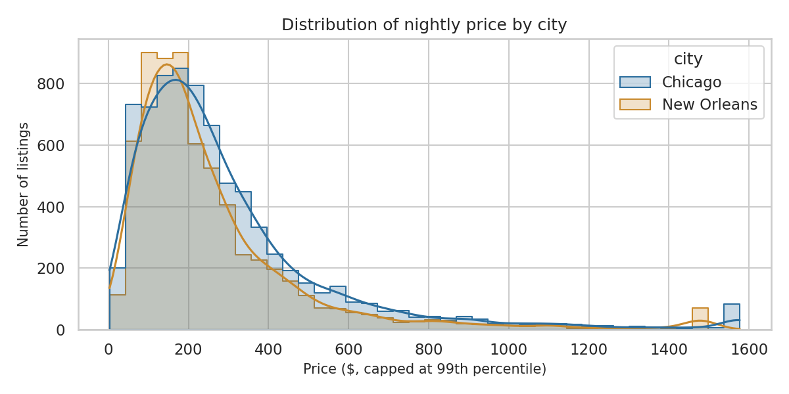
Figure 1: Distribution of nightly price by city
Prices are skewed: most listings are at lower prices, with a long tail of expensive ones. The average is well above the median in both cities (Chicago $296 against $223, New Orleans $262 against $192). The small spike at the far right is the capped listings.
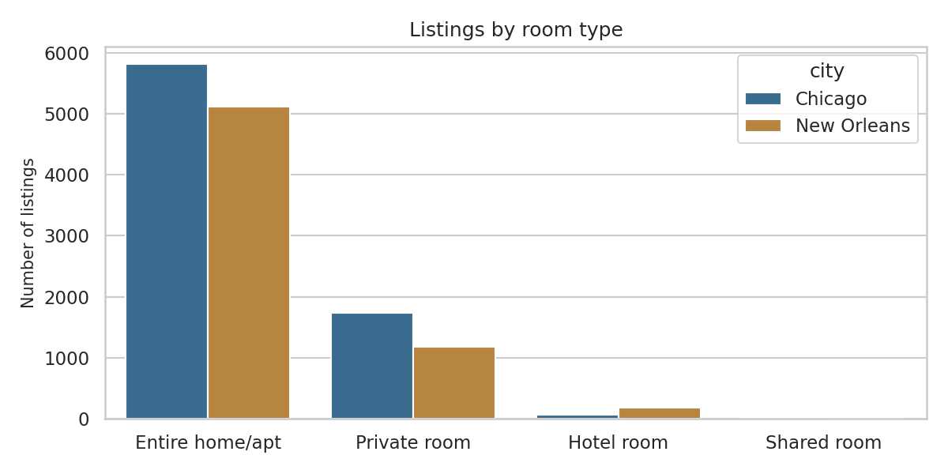
Figure 2: Listings by room type
Entire homes dominate in both cities, at about 76% of listings in Chicago and 79% in New Orleans. Private rooms follow, while hotel rooms and shared rooms are rare.
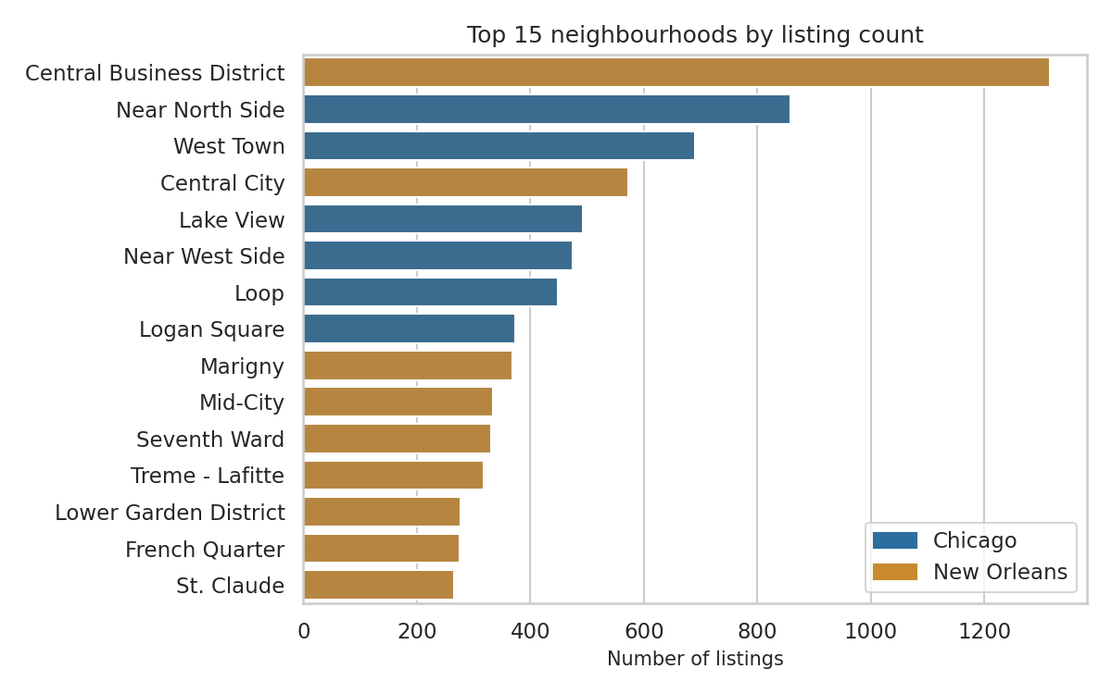
Figure 3: Top 15 neighbourhoods by listing count
The Central Business District in New Orleans has the most listings (1,315), followed by the Near North Side in Chicago (859). Both cities are well represented among the busiest neighbourhoods.
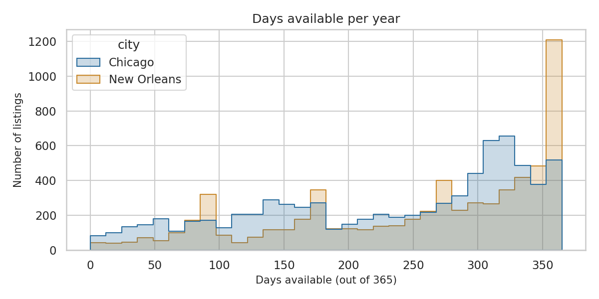
Figure 4: Days available per year
Most listings are open for a large part of the year. A large group, especially in New Orleans, is available almost every day.

5.2 Bivariate analysis
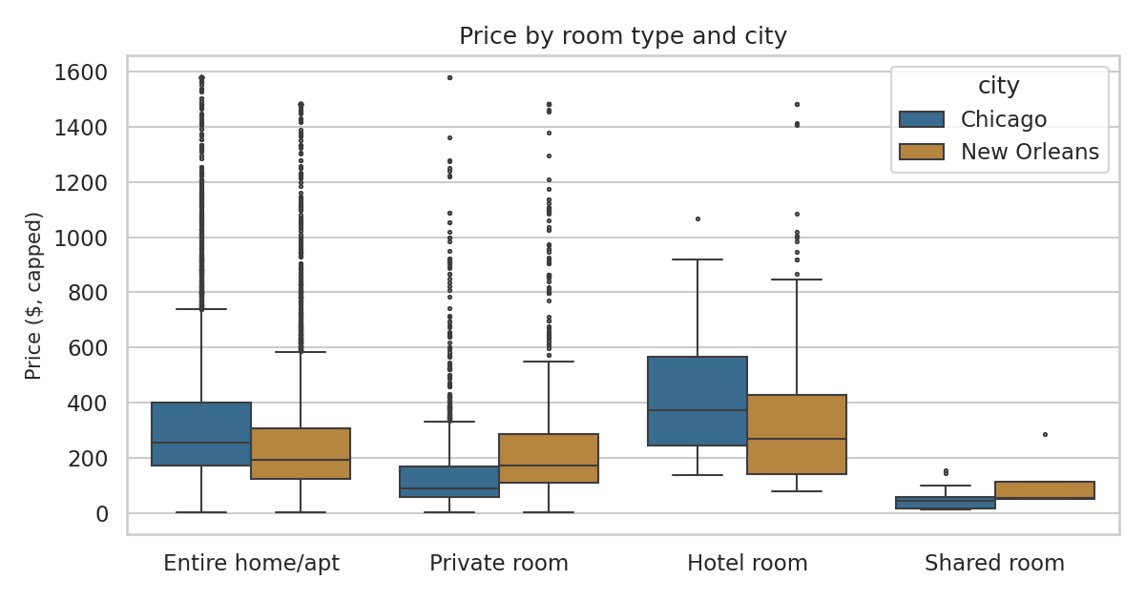
Figure 5: Price by room type and city
Hotel rooms are the most expensive room type in both cities, with average prices of about $425 in Chicago and $361 in New Orleans. Private rooms differ sharply: about $150 in Chicago but about $248 in New Orleans. Small groups, such as 65 hotel rooms in Chicago, should be read with care.

5.3 Multivariate analysis
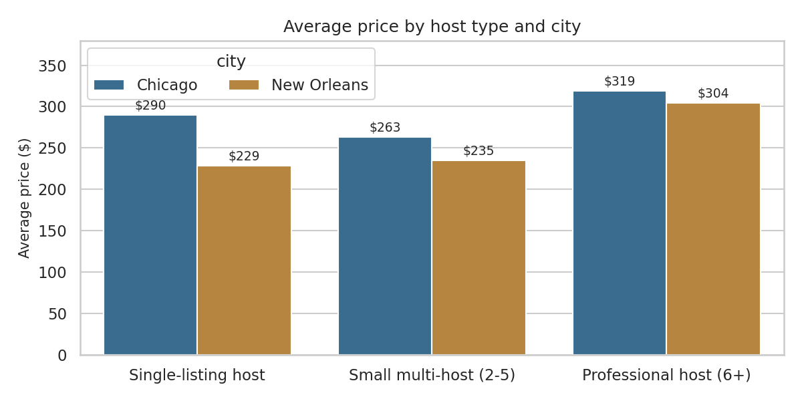
Figure 6: Average price by host type and city
Looking at price, host type and city together reveals the main finding of the project. Professional hosts (6+ listings) charge more than single-listing hosts in both cities, but the gap is about $29 in Chicago and about $75 in New Orleans.
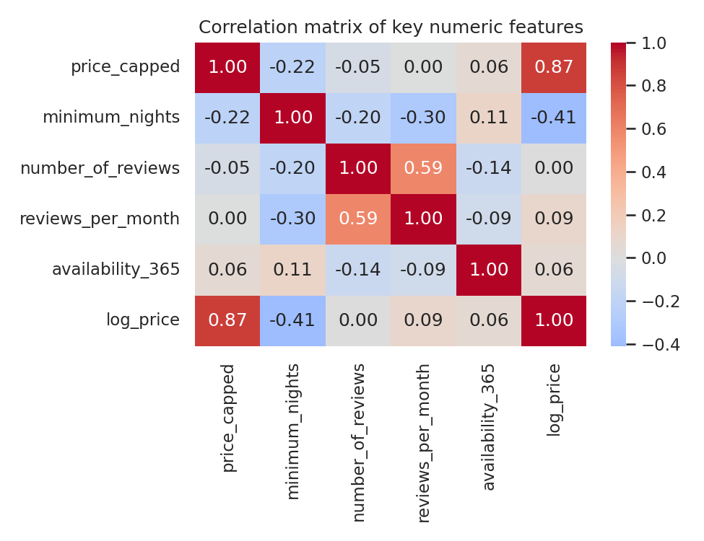
Figure 7: Correlation matrix of key numeric features
No numeric variable is strongly correlated with price. The strongest is minimum nights (about -0.22), and the correlation between price and reviews per month is essentially zero. Price is therefore explained more by location, room type and host behaviour than by review activity.

6. Power BI Dashboard

6.1 Design and interactivity
- Four pages map to the four problem areas: Overview, Property analysis, Pricing analysis and Host analysis. The page tabs at the bottom of the report are used to move between them.
- Consistent colour coding: Chicago is blue and New Orleans is gold wherever a chart is split by city, so the eye learns the code once.
- Filters: city and room type slicers sit at the top of the pages. They are synchronised, so a selection made on one page applies to every page. Selecting a bar or point in a chart also highlights related data in the other visuals on the page.
- Clear labels: every chart has a plain-English title, and each page carries a one-sentence takeaway.
- Host page filter: 105 listings with no host id (44 in Chicago and 61 in New Orleans) are excluded from the Host page, because they cannot be assigned a host type.

6.2 Overview page
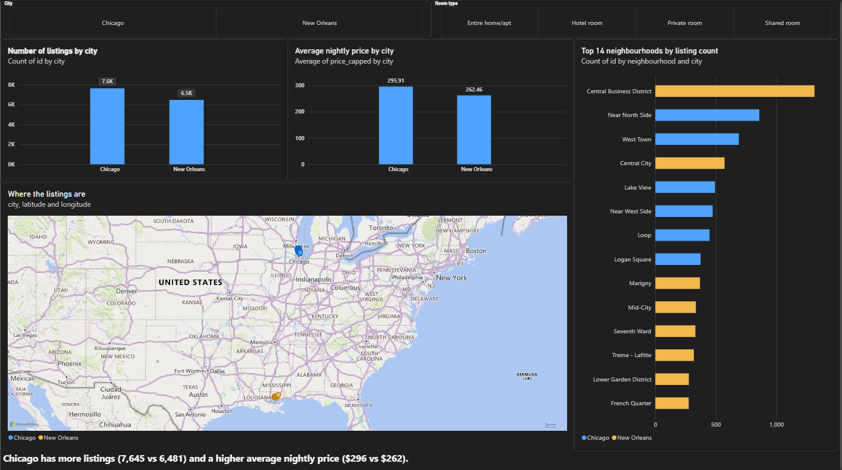
Figure 8: Overview page of the Power BI dashboard
The Overview page orients the viewer: how big each market is, how much it costs, where the listings are, and which neighbourhoods are busiest.
Visual | Why this visual | What it shows
City and Room type slicers | Let any viewer filter every chart and every page | Filters all visuals; the selection carries across the four pages
Number of listings by city (column chart) | Columns compare a count across two categories at a glance | Chicago has 7,645 listings and New Orleans has 6,481
Average nightly price by city (column chart) | Same layout, so the two charts read together | Average price is $295.91 in Chicago and $262.46 in New Orleans (medians $223 and $192)
Where the listings are (map) | Shows geography, which no other chart can | Two separate clusters, one per city; selecting a city in the slicer zooms the map in
Top 14 neighbourhoods by listing count (stacked bar) | Horizontal bars suit long neighbourhood names and ranking | The Central Business District (New Orleans) has the most listings at 1,315, followed by the Near North Side (Chicago) at 859

Takeaway: Chicago has more listings (7,645 vs 6,481) and a higher average nightly price ($296 vs $262).

6.3 Property analysis page
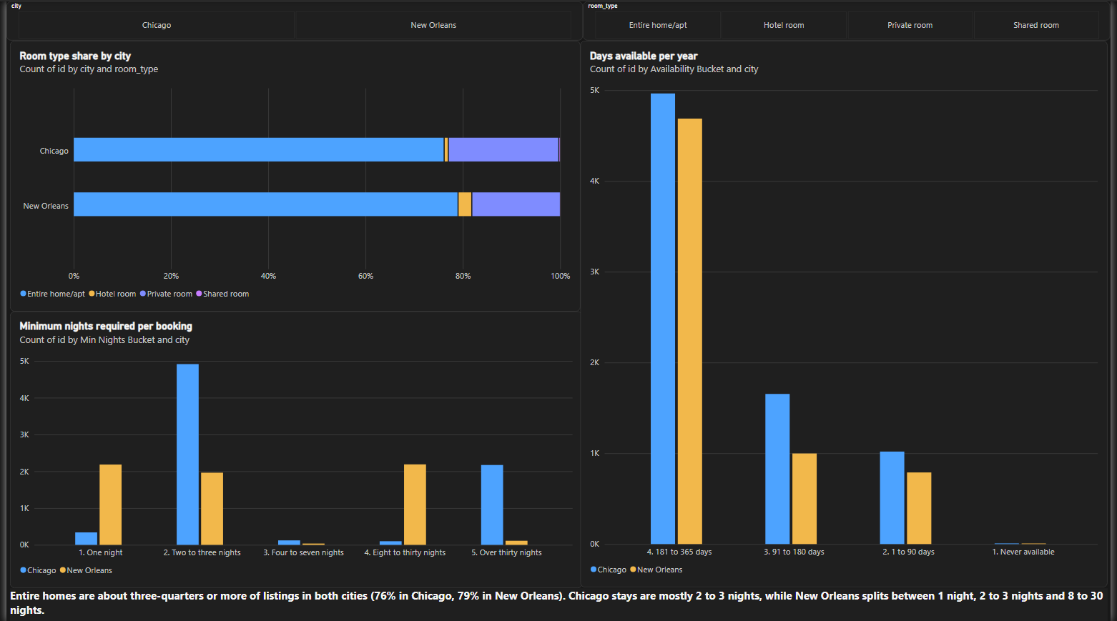
Figure 9: Property analysis page of the Power BI dashboard
This page describes what is on offer: the type of space, how long guests must stay, and how open the inventory is.
Visual | Why this visual | What it shows
Room type share by city (100% stacked bar) | Both cities stretch to 100%, so the comparison is about composition, not size. A pie chart would make the two cities hard to compare | Entire homes are about 76% of listings in Chicago and 79% in New Orleans; private rooms are about 23% and 18%; hotel and shared rooms are each under 3%
Minimum nights required per booking (column chart) | Bucketed into five groups to make a skewed number readable | Chicago: 64% require 2-3 nights and 28% require more than 30. New Orleans: roughly a third each require 1 night, 2-3 nights and 8-30 nights, and under 2% require more than 30
Days available per year (column chart) | Four availability groups, from never available to nearly always open | About 65% of Chicago listings and 72% of New Orleans listings are open for more than 180 days; almost none are never available

Takeaway: the cities look alike in room type and availability, but differ clearly in minimum-stay rules. Chicago has a large block of 30+ night listings that New Orleans almost lacks. The data cannot say why, and local rules may play a part.

6.4 Pricing analysis page
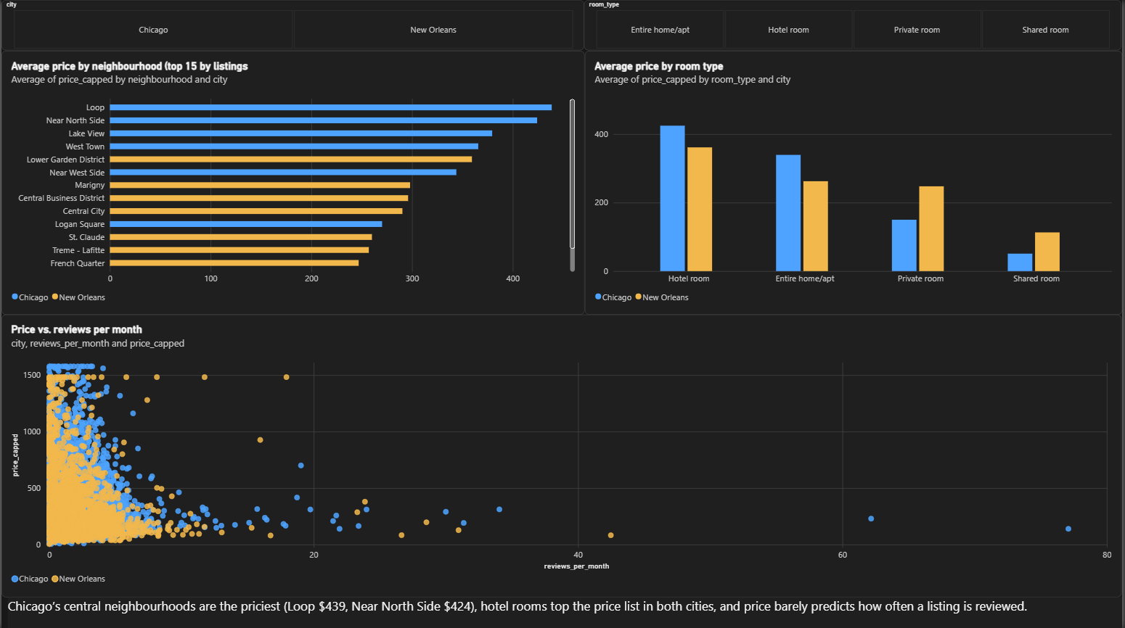
Figure 10: Pricing analysis page of the Power BI dashboard
This page shows how price varies with location, room type and review activity.
Visual | Why this visual | What it shows
Average price by neighbourhood (sorted bar chart, top 15 neighbourhoods by listings) | Limiting to the busiest neighbourhoods avoids averages based on a handful of listings | Chicago's central areas are the most expensive: the Loop at about $439 and the Near North Side at about $424. The most expensive New Orleans area here is the Lower Garden District at about $359; the French Quarter is about $247
Average price by room type (column chart) | Grouped columns compare the two cities within each room type | Hotel rooms are the most expensive in both cities (about $425 and $361). Private rooms cost about $150 in Chicago but about $248 in New Orleans
Price vs reviews per month (scatter chart) | One dot per listing shows the full spread and any relationship | No clear trend: price barely predicts how often a listing is reviewed. The few listings with more than 20 reviews a month are all at modest prices

Takeaway: location and room type explain price far better than review activity does.

6.5 Host analysis page
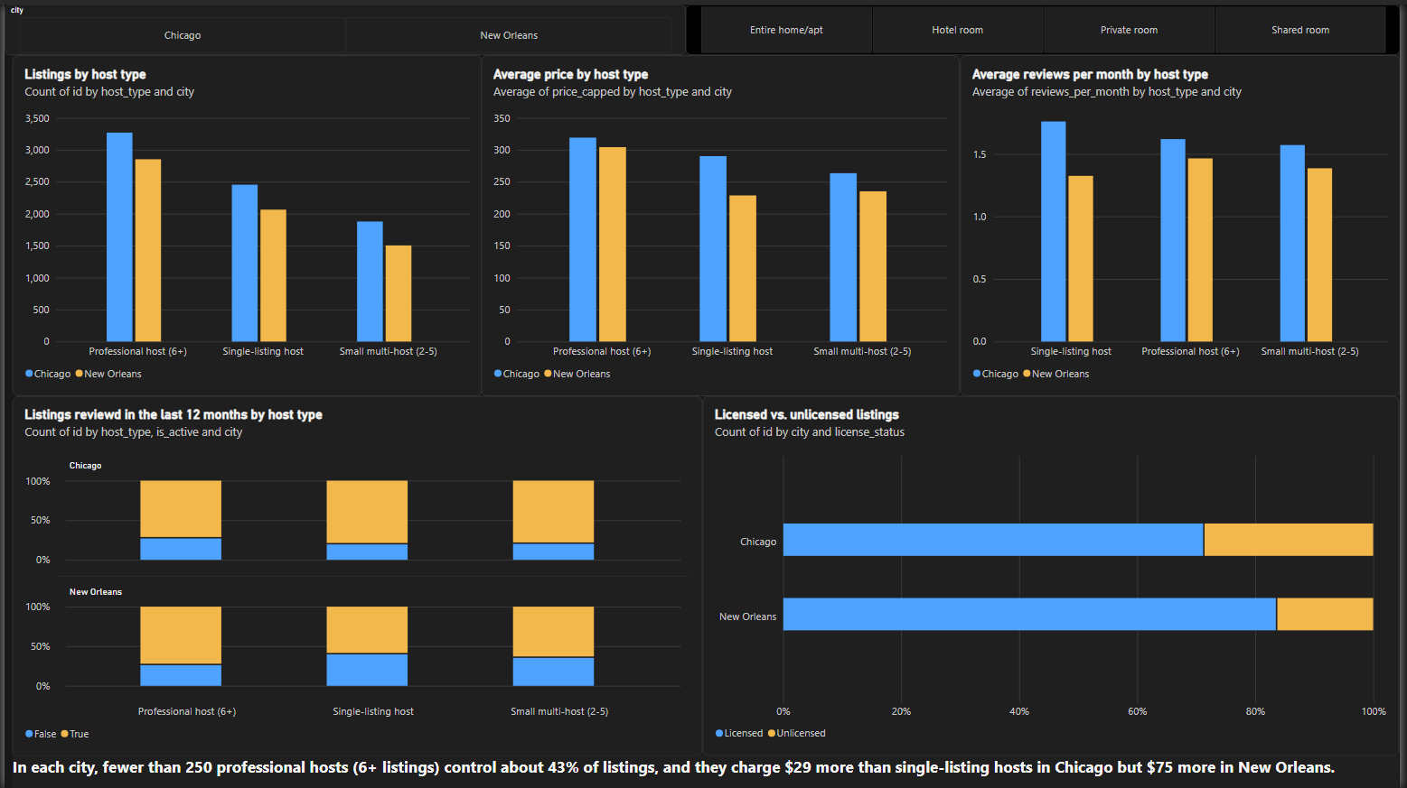
Figure 11: Host analysis page of the Power BI dashboard
This page looks at who operates the listings. Hosts are grouped by how many listings they run: single-listing, small multi-host (2-5) and professional (6+).
Visual | Why this visual | What it shows
Listings by host type (column chart) | Counts per host type, split by city | Professional hosts run about 43% of listings in Chicago (3,269 listings from 239 hosts) and about 44% in New Orleans (2,852 listings from 168 hosts)
Average price by host type (column chart) | Directly tests whether running more listings means pricing differently | Professional hosts charge about $319 in Chicago against $290 for single-listing hosts (+$29). In New Orleans it is about $304 against $229 (+$75)
Average reviews per month by host type (column chart) | Review rate as an indirect signal of activity | Differences are small: in Chicago single-listing hosts are highest (1.76), in New Orleans professional hosts are highest (1.46)
Listings reviewed in the last 12 months, by host type (100% stacked columns, one panel per city) | Percentages make the three host types comparable, and separate panels keep the cities apart | Chicago: single-listing 81%, small multi-host 80%, professional 73%. New Orleans: professional 74%, small multi-host 65%, single-listing 60%
Licensed vs unlicensed listings (100% stacked bar) | Shows the share of listings with no licence on file | About 29% of Chicago listings and about 17% of New Orleans listings have no licence on file

Takeaway: fewer than 250 professional hosts control about 43% of listings in each city, and they charge $29 more than single-listing hosts in Chicago but $75 more in New Orleans.
Key Findings and Business Interpretation
Measure | Chicago | New Orleans
Listings after cleaning | 7,645 | 6,481
Average / median nightly price | $296 / $223 | $262 / $192
Entire homes share of listings | 76% | 79%
Listings requiring 2-3 nights / over 30 nights | 64% / 28% | 30% / under 2%
Listings open for more than 180 days a year | 65% | 72%
Listings run by professional hosts (6+) | 43% (239 hosts) | 44% (168 hosts)
Price gap: professional vs single-listing hosts | +$29 | +$75
Listings with a recent review: professional / single-listing | 73% / 81% | 74% / 60%
Listings with no licence on file | About 29% | About 17%

What stakeholders can learn
- Two different market structures. Chicago is the more expensive market, and its pricing is fairly compressed across host types. New Orleans is more stratified, with a much larger premium for professional hosts.
- Concentration. In both cities a small group of professional hosts runs more than 40% of the listings, so their behaviour moves a large part of each market.
- Possible opportunity for casual hosts in New Orleans. The larger price gap suggests single-listing hosts there may have room to test higher prices. This is a hypothesis to test, not a guarantee.
- Possible dormant listings. Single-listing hosts in New Orleans have fewer recent reviews than professional hosts, which may point to listings that are barely used. A missing recent review does not prove a listing is inactive.
- Mid-term rentals in Chicago. About 28% of Chicago listings require more than 30 nights, suggesting a segment that behaves differently from ordinary short stays.
- Regulatory exposure. The share of listings with no licence on file is higher in Chicago and is worth a closer look by anyone concerned with compliance.
The data shows what differs between the cities, not why. Reasons such as local regulation are possible explanations to investigate, not conclusions.

8. Challenges and How They Were Solved

Row count inflated when loading into Power BI
When the cleaned file was first loaded, Power BI showed 14,184 rows instead of the real 14,126. The Power Query errors below show the cause: listing names that contain line breaks were split into several broken rows, with text fragments such as the end of a name appearing in the wrong columns. The fix was to replace line breaks with spaces in the notebook, export the file again, and confirm that the file has exactly one line per listing.
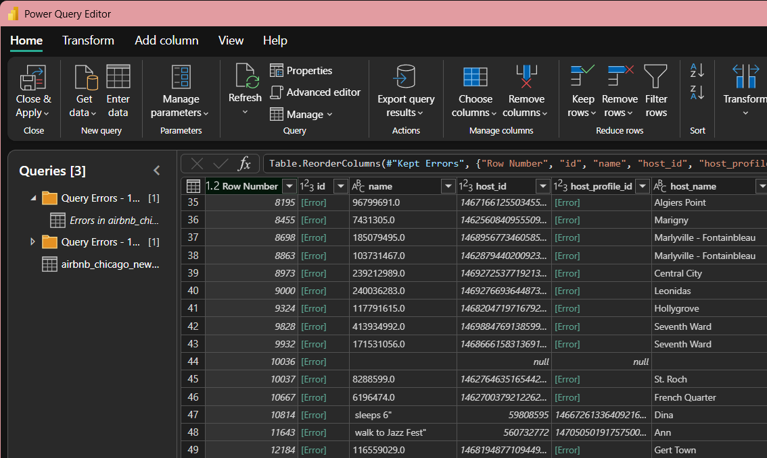
Figure 12: Power Query errors caused by line breaks inside listing names
- Dirty and missing data: missing prices, an empty column, outliers, and blank values that carry meaning (reviews and licences). Each was handled by a separate, documented decision instead of one blanket rule.
- Sorting of categories: Power BI sorts text alphabetically, which scrambles groups such as minimum nights and availability. Helper columns with number prefixes keep them in the right order.
- Map and scatter set-up: latitude, longitude, price and reviews had to be set to "Don't summarize" so that every listing is drawn as its own point instead of one averaged point per city.
- Chart choice: stacked bars were used instead of pie charts for room type, because the comparison between two cities is the point.
- Checking the numbers: key dashboard values were recalculated in Pandas and compared with Power BI before being used.

9. Conclusion and Future Improvements
Chicago and New Orleans differ in more than size. Chicago is the more expensive market with compressed pricing across host types, while New Orleans is more stratified. The most important insight is the combination of two facts: in both cities a small group of professional hosts controls more than 40% of listings, and the price premium they charge is more than twice as large in New Orleans as in Chicago.
The project also showed how much each cleaning decision matters. Capping outliers instead of deleting them, calculating percentiles per city, and treating a blank licence as information all change what the charts show.
Future improvements:
- Deeper analysis: examine the mix of host types inside each neighbourhood.
- Predictive modelling: estimate a listing's price from its room type, location and host type, and predict which listings are likely to stay active.
- Dashboarding: add drill-through pages for each neighbourhood, and bring in real booking data so demand does not have to be inferred from reviews.

