Project Name :

Suggestion Bot for Interview Skills Management

Name : B . Abhinay
Roll No. : 1602 – 21 – 737 – 002
Branch : I.T -A

ABSTRACT :

In today's competitive job market, having strong interview skills is crucial for job seekers. However, many people struggle with effectively showcasing their qualifications and experience during the interview process. To address this issue, a suggestion bot for interview skills management can be developed.
The suggestion bot would be a web-based platform that provides personalized feedback and recommendations to users based on their interview performance. The bot would use natural language processing (NLP) and machine learning (ML) algorithms to analyze the user's responses to common interview questions and provide feedback on areas of improvement.
The bot would also provide users with resources and training materials to help them prepare for their interviews. These resources could include mock interview sessions, tips on body language and communication skills, and best practices for answering common interview questions.
Additionally, the bot would keep track of the user's progress over time and provide them with performance metrics to help them gauge their improvement. This would enable users to track their progress and make adjustments to their interview strategies as needed.
Overall, the suggestion bot for interview skills management would be an invaluable tool for job seekers looking to improve their interview skills and increase their chances of landing their dream job.

Requirements :
- Number Tables : 5
- Table Names
→ User
→ Profession
→ Guide
→ Exam
→ Business
- User Attributes :
1) name varchar2(10) (primary key)
2) number int(10) (not null)
3) place varchar2(10)
4) id long(3)
- Profession : joins with users table
1) prof varchar2(10)
2)profid long(3)
- Guide Attributes : joins profession table
1) suggestion varchar2(10)
3) id long(3) suggestion

- Exam Attribute: foreign key from user
1) examlinks varchar2(20)
2) result float
3) id long(3)
- Business Attributes : foreign key from user
1) suggest varchar2(10)
2) tips varchar2(20)
3) profid long(3)

ER Model :

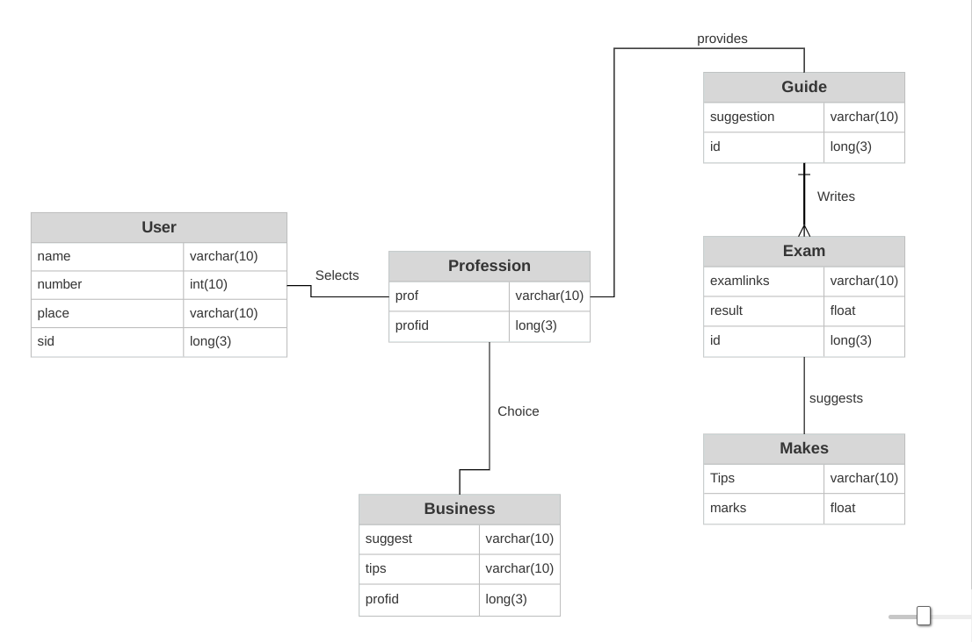

SQL COMMANDS:
create table User(
name VARCHAR(10),
num int(10),
place VARCHAR(10),
sid long(3),PRIMARY KEY(SID)
);

create table Profession(
prof VARCHAR(10),
sid long(3),
place VARCHAR(10),
FOREIGN key(sid) REFERENCES User,PRIMARY KEY(sid)
);

create table Guide(
suggestion VARCHAR(10),
sid long(3),
FOREIGN key(sid) REFERENCES Profession,PRIMARY KEY(sid)
);

create table Exam(
examlink VARCHAR(10),
sid long(3),
result float,
FOREIGN key(sid) REFERENCES Guide,PRIMARY KEY(sid)
);
create table Makes(
tips VARCHAR(10),
result float
);

create table Business(
suggest varchar(10),
tip varchar(10),
sid long(3),
FOREIGN key(sid) REFERENCES Profession,PRIMARY key(sid)
);

INSERTING VALUES:
INSERT INTO User VALUES("johnwick",9550710377,"us",11);
INSERT into User VALUES("sia",9551710377,"uk",12);
INSERT into User VALUES("chris",9552710377,"canada",13);
INSERT into User VALUES("stones",9553710377,"dubai",14);
INSERT into User VALUES("virat",9554710377,"india",15);

INSERT into Profession VALUES("software",13);
INSERT into Profession VALUES("government",14);
INSERT into Profession VALUES("medicine",15);

INSERT into Guide VALUES("Be confident while answeringMakes",13);
INSERT into Guide VALUES("Be patriotic",14);
INSERT into Guide VALUES("treat life as important factor while answering",15);

INSERT into Exam VALUES("it.com",90,13);
INSERT into Exam VALUES("gov.in",100,14);
INSERT into Exam VALUES("med.ac.in",70,15);

INSERT into Makes VALUES("keep doing well",90);
INSERT into Makes VALUES("well done",100);
INSERT into Makes VALUES("work hard",70);

OUTPUTS :
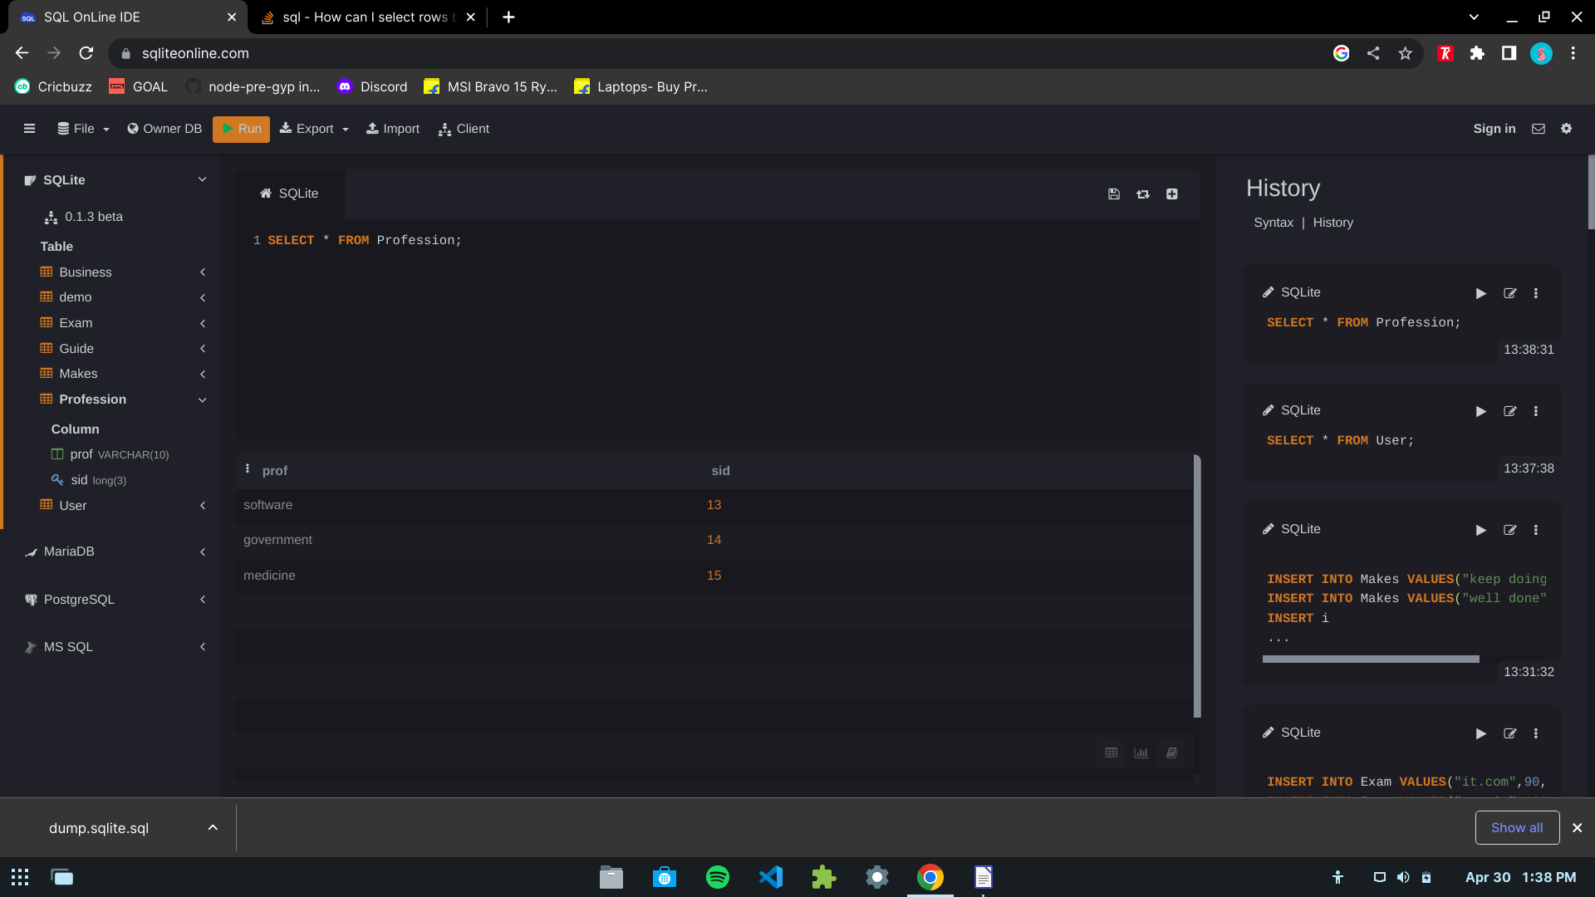
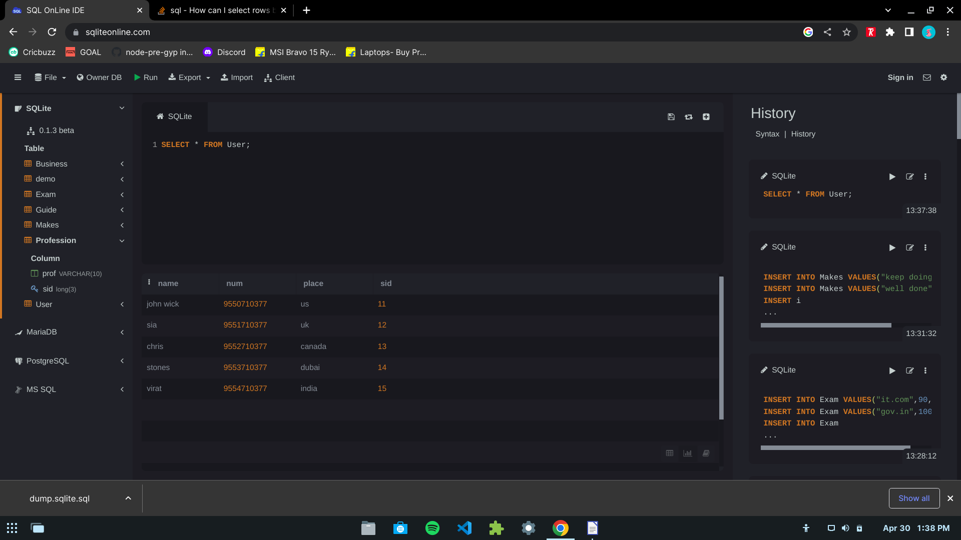

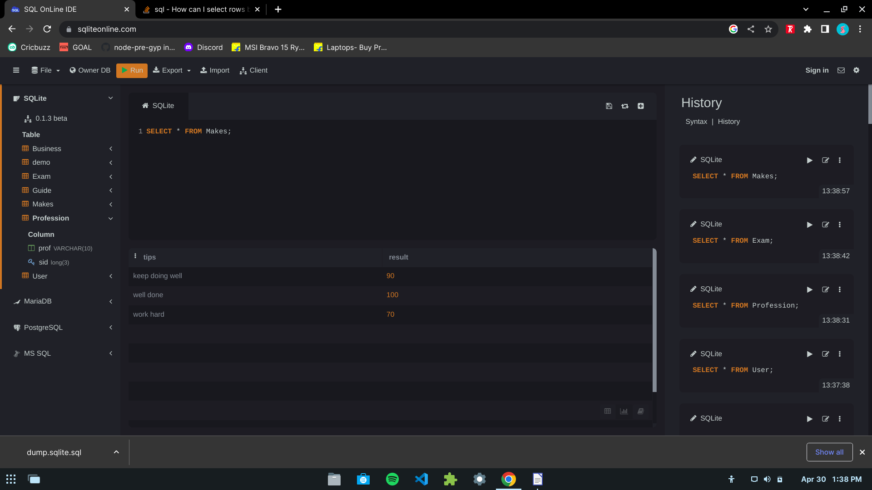
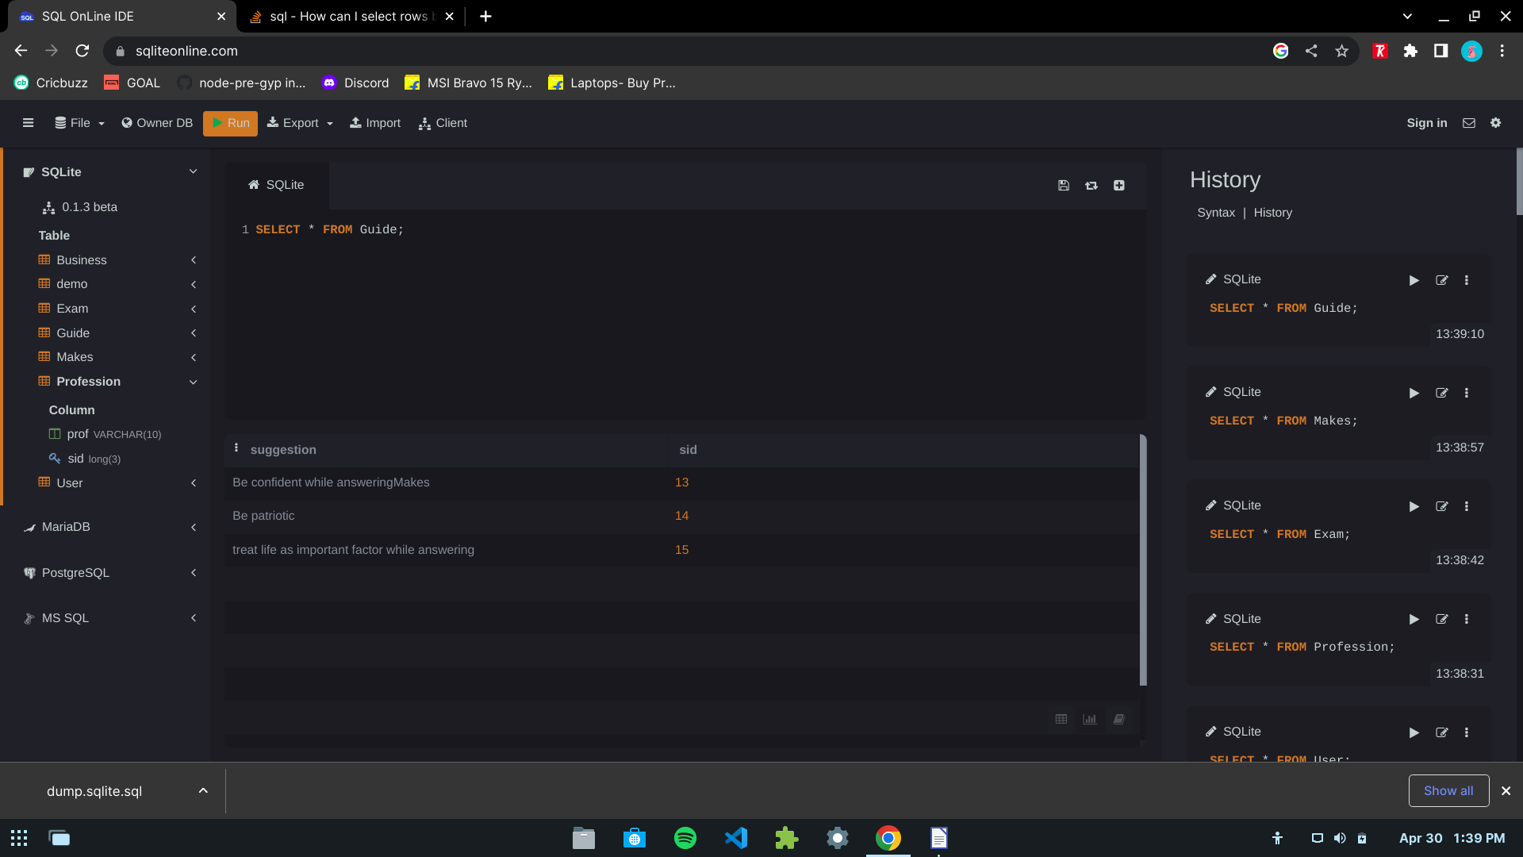

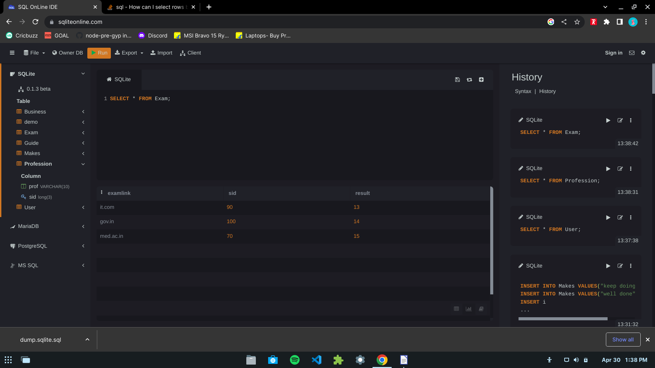
GITHUB LINK :
https://github.com/Abhi-dev00/DB-Sql

