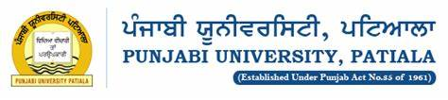Project Report

A python based

***HANDLAUNCH PRO***

**Yadavindra Department of Engineering, Guru Kashi campus Talwandi Sabo**

**Bachelor of Technology in Computer Science & Engineering**

**(Session 2021-2025)**

Under the supervision of

Er. Rajan goyal sir

Assistant professor

Submitted by –

Gursewak singh (22101118)

pardeep (22101106)