Documentation

JARVIS – A VIRTUAL ASISTANCE

**About:** Jarvis is a virtual assistance, like Alexa, Siri, etc. which can be used to perform different task. It can help you to open YouTube, Stack overflow, GitHub and can open system browser. It also saves your time and effort in turning off and restarting your pc using voice command.

**Programming Language**: Python3 **IDE Used:** VS Code v-1.66.1

**System Requirement:**

* Python 3.9 and above
* Window 8 and above
* ROM: 250GB and above
* Ram: 4GB and above

**Features:**

* Voice command based
* It can fetch information from Wikipedia
* Can send email
* Tell time
* Play music
* Shutdown/restart system
* Open website in browser (GitHub, Stack overflow, etc.)
* Open application in your pc(i.e. VS code)

**Limitations:**

* Cannot store information.
* **Require internet connection** to recognise voice command
* No database to store record
* Require email id and password to send mail

**Command for different task:**

|  |  |
| --- | --- |
| **Task** | **Command** |
| To open YouTube | ‘open youtube’ |
| To Search on Wikipedia | Query + ‘wikipedia’ |
| To ask for Time | ‘what is the time’ |
| Send email | ‘send email’ |
| Play music | ‘play music’ |
| Open vs code | ‘open code’ |
| Open stack overflow | ‘Open stack overflow’ |
| Open google | ‘Open google’ |
| To close | ‘thank you’ |
| To know about your assistance | ‘tell about yourself’ |
| To ask its name | ‘What is your name Jarvis’ |
| To ask his age | ‘What is your age’ |
| To know what it can do | ‘What can you do Jarvis’ |
| To exit from ‘know about Jarvis’ menu | ‘ok, thank you’ |
| To restart system/pc | ‘restart this system’ |
| To shutdown system/pc | ‘shut down this system’ |

**Module Used:**

* **Pyttsx3:** pyttsx3 is a text-to-speech conversion library in Python. It uses TTS (text to speech) engine “sapi5” to convert text into speech.
  + **Install command:** pip install pyttsx3
* **Speech Recognition:** It is a library for performing speech recognition, for several TTS engines offline and online both.
  + **It** also includes modules like **pyAudio** for using voice input using microphone.
* **Datetime:** Datetime module is used to get system time for performing various operations. It is available in ‘**hh:mm:ss’** format**.**
* **Wikipedia:** This module in python helps us to fetch search results from Wikipedia. In our system Wikipedia module is used as search engine to get information for different queries.
* **Webbrowser:** This python module connects us with our default system browser. We can perform query, open websites, etc. with the help of ‘Webbrowser’ module.
* **OS :** This python module help us to control operating system of any system. In our project I have used OS module to turn off and restart system using voice command
* **Smtlib:** Python provides smtplib module, which defines an SMTP client session object that can be used to send mail to any Internet machine with an SMTP or ESMTP listener daemon.

**In** our project smtlib module is used to send automatic mail on voice command. **Jarvis** helps to send email to anyone based on voice command.

**Module installation required to run Jarvis program:**

1.pip install pyttsx

2.pip install pyttsx3

3. pip install SpeechRecognition

4.pip install wikipedia

5.pip install pipwin

6.pipwin install pyaudio

**Working:** Once the program is started it will work based on voice command. To terminate the program, give command as “Thank you”.

**Function Used:**

* **wishMe ():** This function is executed as the program begins. It contains the command to wish the user according to day time (i.e., morning or afternoon). It uses system time to check whether its morning or noon. And ask for command to execute task.
* **Speak ():** This is the most important function of our program. Speak () function is used to convert text into speech. With the help of this our assistance is able to speak. It uses pyttsx3 module and ‘sapi5’ TTS engine to use inbuilt system voice for text to speech conversion.
* **takecommand ():** This function is used to take voice command as user input. It uses system microphone to listen users command and uses speech recognition to analyse the user input.
* **sendmail ():** It is used to send email using smtplib python module. It uses smtp server to authenticate and send an email to user.
* **exit ():** This is an inbuilt python keyword to exit or terminate the program.
* **print ():** It an inbuilt function to print values on output window.

Jarvis_2.exe

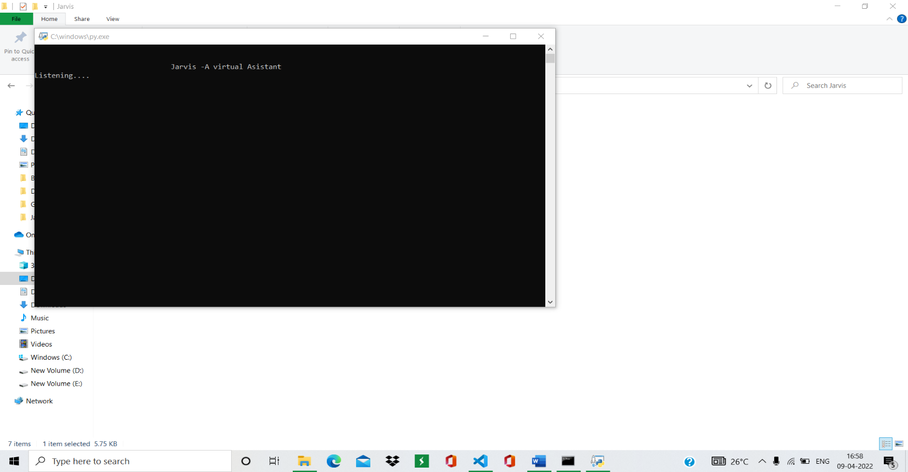

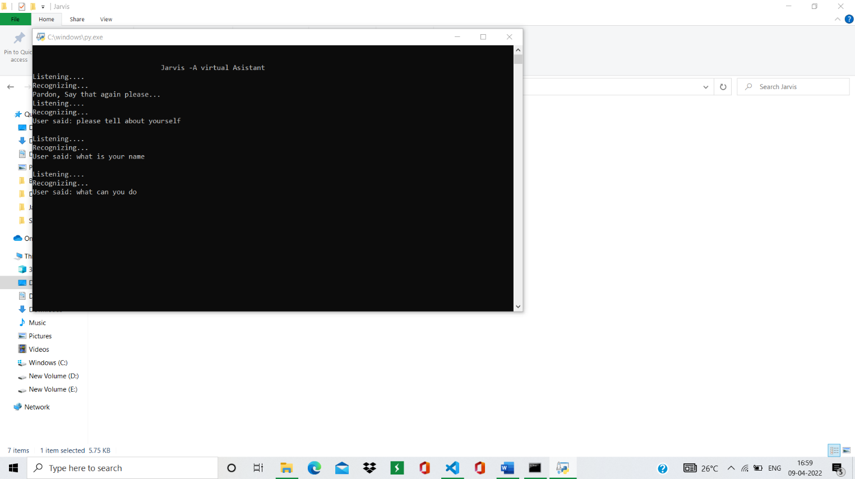

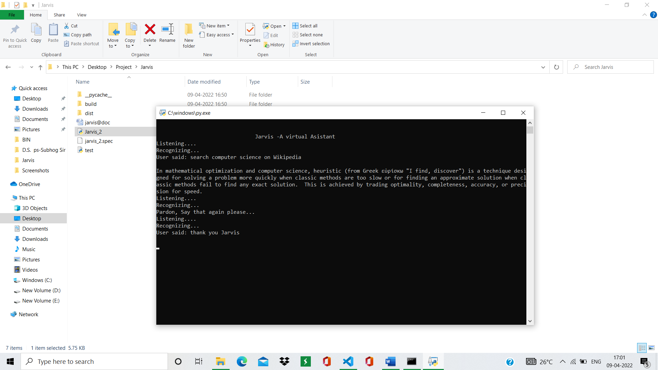

Bibliography

* [www.google.com](http://www.google.com)
* [www.youtbe.com](http://www.youtbe.com)
* [www.pypi.org](http://www.pypi.org)
* Python documentation

**Project link: https://github.com/Abhi-gits/jarvis.git**