NAME : K VENKATA ABHIRAM

REG NO : 192124154

**MELTING AND CASTING IN R**

1. Melt airquality data set and display as a long – format data ?

**Aim** : Melt airquality data set and display as a long – format data.

**Procedure :**

1. Load the air quality dataset into R using read.csv() or read.table().
2. Use the melt() function from the reshape2 package to convert the data from wide-format to long-format
3. Specify the identifier variables using the id.vars argument and the variables to be melted using the measure.vars argument
4. Rename the variables if necessary using the variable.name and value.name arguments.
5. Display the melted data using the head() or print() function.

**OUTPUT :**

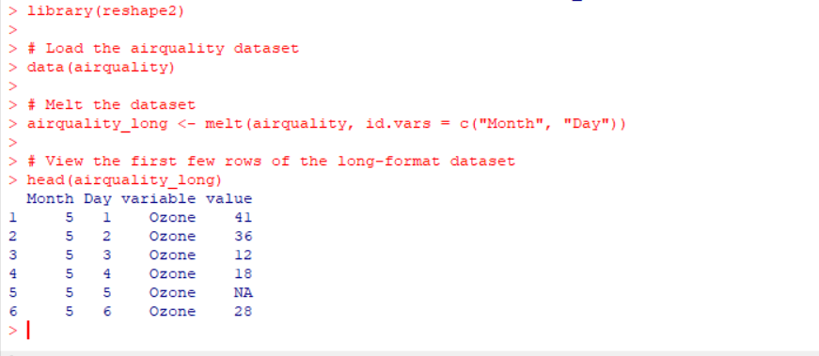

**RESULT :** Melt airquality data set and display as a long – format data has been executed successfully.

1. Melt airquality data and specify month and day to be “ID variables” ?

**AIM :** To convert the air quality dataset from wide-format to long-format using R, and specify the month and day columns as ID variables.

**Procedure :**

1 :Load the air quality dataset into R using read.csv() or read.table()

2 :.Use the melt() function from the reshape2 package to convert the data from wide-format to long-format.

3 :Specify the month and day columns as ID variables using the id.vars argument.

4 :Specify the remaining variables to be melted using the measure.vars argument.

5 :Rename the variables if necessary using the variable.name and value.name arguments.

6 :Display the melted data using the head() or print() function.

**OUTPUT :**

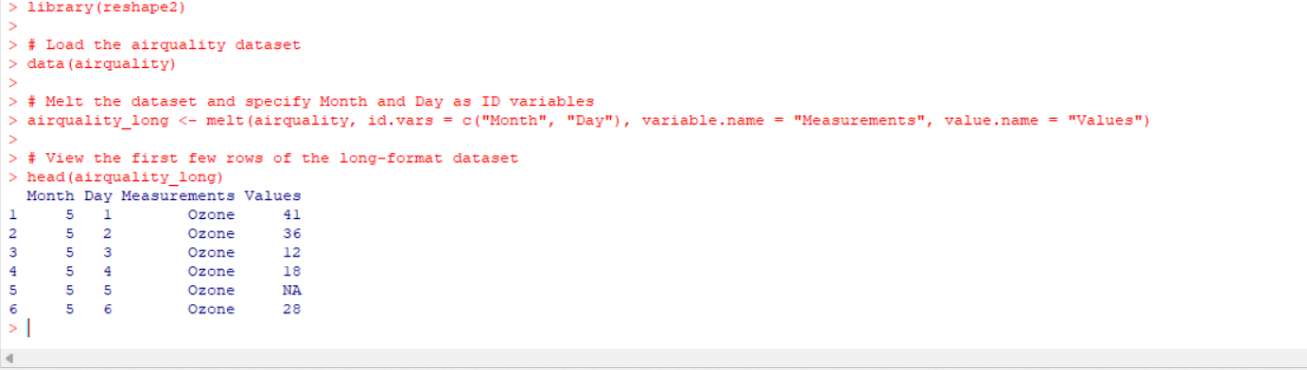

**RESULT :** Melt airquality data and specify month and day to be “ID variables” has been executed successfully.

1. Cast the molten airquality data set .

**Aim :** To cast the molten air quality dataset back to wide-format using R**.**

**Procedure :**

1. Load the molten air quality dataset into R.
2. Use the dcast() function from the reshape2 package to cast the data back to wide-format.
3. Specify the columns to use as row identifiers using the formula argument.
4. Specify the column to use as the variable using the value.var argument.
5. Display the cast data using the head() or print() function.

**OUTPUT :**

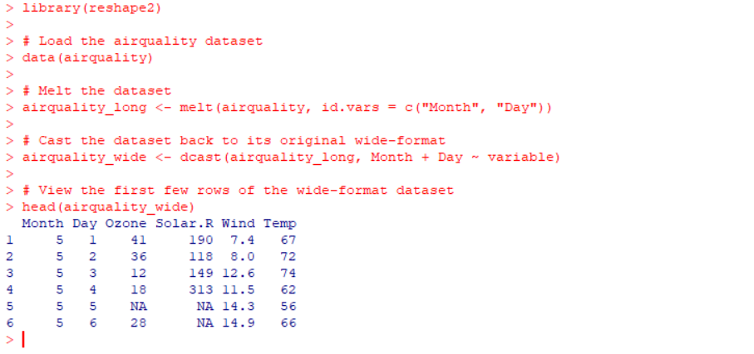

**RESULT :** molten airquality data sethas been executed successfully.

1. Use cast function appropriately and compute the average of Ozone, Solar.R , Wind and temperature per month ?

**AIM :**To use the cast() function to compute the average of Ozone, Solar.R, Wind, and temperature per month in the air quality dataset**.**

**Procedure :**

1.Load the air quality dataset into R using read.csv() or read.table().

2.Use the cast() function from the reshape package to compute the average of Ozone, Solar.R, Wind, and temperature per month.

3.Specify the formula for casting the data.

4.Specify the fun.aggregate argument to compute the average of each variable.

5.Display the cast data using the head() or print() function.

**OUTPUT :**

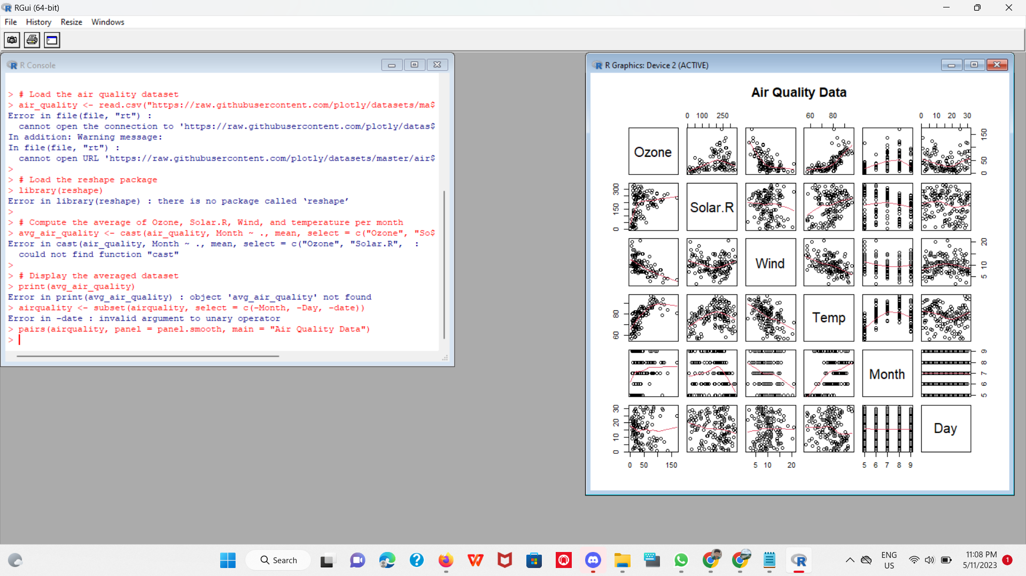

**RESULT** :

The average of Ozone, Solar.R , Wind and temperature per month has been exeucted successfully.