1. **Project Title: Passenger Traffic Analysis in Bus Transport System**
2. **Problem Statement:**

The project "Passenger Traffic Analysis in Bus Transport System" is an endeavor that aims to delve into the complexities of bus fleet management and analyze the passenger traffic dynamics within a transportation system. The primary objectives of this project are to uncover valuable insights, patterns, and correlations from a provided dataset, and subsequently provide informed recommendations for optimizing the bus transportation system's efficiency.

**3. Objectives and Scope of the Project**

**Objectives:**

1. **Comprehensive Analysis:** The project seeks to perform a comprehensive Exploratory Data Analysis (EDA) on a dataset that contains various facets of bus fleet management, such as fleet utilization, kilometers traveled, and off-road vehicles.
2. **Insight Generation:** Through data visualization and statistical analysis, the project aims to generate insights that can offer a deeper understanding of the performance of the bus fleet across different cities.
3. **Efficiency Identification:** By analyzing factors like effective passenger density, schedule kilometers, and more, the project aims to identify areas where the transportation system can be made more efficient, reducing operational costs and improving service quality.
4. **Correlation Assessment:** The project intends to assess the correlations between different variables, such as fleet utilization and effective kilometers, to identify potential relationships that can inform decision-making.

**Scope:**

The scope of the project encompasses several key aspects:

1. **Data Exploration:** The project will start by exploring the provided dataset, understanding the variables, and identifying any potential data quality issues that need to be addressed.
2. **Data Preprocessing:** After identifying relevant variables, the data will undergo preprocessing, including data cleaning, transformation, and structuring. Columns with missing values will be managed, and a unique identifier ("City_Id") will be assigned to each city.
3. **Exploratory Data Analysis (EDA):** EDA forms the core of the project, involving the creation of various visualizations. Bar plots will depict fleet utilization in different cities, scatter plots will illustrate relationships between different factors, and heatmaps will showcase correlations between variables.
4. **Descriptive Statistics:** Calculating descriptive statistics like mean, standard deviation, variance, and quartiles will provide a summary of the dataset's attributes, aiding in a better understanding of the data.
5. **Exponential Distribution Fitting:** The project will explore the fitting of an exponential distribution to a subset of the data, demonstrating the fit through a Probability Density Function (PDF) curve.
6. **Correlation Analysis:** A deeper analysis will involve the assessment of the correlation between "EffPassDensity" and "Effective Kilometers (in lakh)," employing the Pearson correlation coefficient.
7. **Scatter Plot and Regression:** Visualizations like scatter plots and linear regression lines will help understand trends and relationships between variables.
8. **Correlation Heatmap:** A comprehensive heatmap will provide a holistic view of correlations between different variables, uncovering hidden insights.

**4. Tools/Framework Used**

The foundation of the "Passenger Traffic Analysis in Bus Transport System" project is fortified by an ensemble of powerful tools and frameworks. These carefully selected instruments provide the infrastructure necessary to steer the project toward success. This section takes a comprehensive look at the pivotal tools and frameworks that drive the project's core functionalities.

**4.1 Python: The Backbone**

Python 3.10.9 [1] serves as the project's primary programming language, providing the versatility and capability required for various tasks, from data manipulation to visualization. Python's widespread adoption within the data science community is due to its readability, rich ecosystem, and user-friendly syntax.

**4.1.1 Why Python?**

Python's prominence in the realm of data science is attributable to a multitude of pivotal factors, each lending credence to its role as the preferred programming language for data-centric endeavors:

* **Clear Syntax:** Python's syntactic simplicity emerges as a guiding light, illuminating pathways for seamless collaboration and fostering efficient coding practices even among team members with disparate levels of programming acumen.[2]
* **Rich Library Ecosystem:** At the core of Python's prowess lies its expansive library ecosystem, a veritable treasure trove catering to an array of demands. From the nuances of data handling and intricate analysis to the complexities of machine learning and the nuances of visualization, this library cornucopia expedites development while mitigating the specter of redundancy.
* **Data Analysis Prowess:** Python's potency is epitomized by libraries like Pandas and NumPy, veritable bedrocks for data manipulation. Among these, Pandas emerges as a prominent figure, ushering in data structures like DataFrames, which seamlessly align with the exigencies of the project's tabular data requirements.[3]
* **Visualization Capabilities:** The arsenal of Python is further augmented by tools like Matplotlib and Seaborn, which empower the creation of visually arresting visualizations. These graphical narratives act as interpreters, elucidating insights and narratives in a manner that resonates effortlessly with audiences.[4]
* **Community Support:** Python's vibrant community reverberates with an unwavering commitment to the cause. This veritable community tapestry ensures an unbroken cycle of updates, swift rectification of bugs, and the dissemination of an abundance of resources, underscoring the language's resilience and facilitating the process of troubleshooting.

**4.2 Pandas and NumPy: The Data Powerhouses**

Pandas and NumPy are the foundational pillars that enable data manipulation and numerical computations, forming the neural system of the project.

**4.2.1 Pandas: Data Sculpting Expertise**

Pandas empowers the project with its advanced data manipulation capabilities. Its versatile data structures like DataFrames facilitate the handling of complex datasets, enabling operations such as filtering, transformation, and aggregation.

**4.2.2 NumPy: Numeric Foundations**

NumPy is the cornerstone of numerical computing in Python. It equips the project with multidimensional arrays, matrices, and a plethora of mathematical functions for numerical operations. NumPy plays a pivotal role in executing mathematical transformations and statistical analyses.[5]

**4.3 Supplementary Tools and Frameworks**

In addition to Python, the project seamlessly integrates other essential tools and frameworks to enhance the workflow and collaboration.

**4.3.1 Jupyter Notebook: Interactive Documentation**

Jupyter Notebook serves as an interactive environment that combines coding, documentation, and visualization. It provides a single platform for iterative exploration, enabling the seamless integration of code, visualizations, and textual explanations [6].

**4.3.2 Git and GitHub: Collaborative Version Control**

Git version control, coupled with GitHub, fosters collaboration among team members. Git tracks changes and resolves conflicts, while GitHub offers a platform for managing the project's source code and ensuring version history is maintained effectively [7].

**4.3.3 Matplotlib and Seaborn: Visual Artistry**

Matplotlib and Seaborn are indispensable for crafting compelling visualizations. The seaborn library offers an interface to matplotlib that permits rapid data exploration and prototyping of visualizations while retaining much of the flexibility and stability that are necessary to produce publication-quality graphics. It is domain-general and can be used to visualize a wide range of datasets that are well-represented within a tabular format. [8][9].

The convergence of these essential tools and frameworks forms the backbone of the project, ensuring a seamless workflow that governs data manipulation, analysis, and visualization. Each component contributes uniquely to the symphony of project execution.

**5. Methodology/Design:**

The methodology of the "Passenger Traffic Analysis in Bus Transport System" project is designed to provide a clear and organized approach to achieve the project's objectives. It comprises several essential components that guide the process from data acquisition to interpretation of results, all while adhering to IEEE standard practices for robustness and clarity.

**5.1 Data Collection:**

The initial step of the methodology involves collecting a comprehensive dataset from real-world bus transport systems. This dataset encompasses relevant metrics such as fleet utilization, schedule kilometers, effective kilometers, and city identifiers. The data collection process takes place over a specific time frame to ensure the data's temporal relevance and accuracy.

*Sample Syntax for Data Collection:*

import pandas as pd

# Load dataset from CSV file

data = pd.read_csv("bus_transport_data.csv")

**5.2 Data Preprocessing:**

Data preprocessing is a crucial phase that focuses on enhancing the quality and coherence of the collected dataset. It encompasses various tasks, including:

* Data Cleaning: Removing missing values and outliers that can adversely affect the analysis and results. Techniques such as statistical z-scores and visualization tools are utilized to identify and handle these data irregularities.
* Feature Selection: Choosing relevant features that are instrumental to achieving the project's objectives. This step involves identifying columns or attributes from the dataset that hold significance in the analysis.
* Data Transformation: Creating new variables or features based on existing data through mathematical operations. These derived features provide additional insights and help in exploring new patterns within the data.

*Sample Syntax for Data Preprocessing:*

# Remove missing values

data.dropna(inplace=True)

# Select relevant features

selected_features = ['Fleet Utilisation (%)', 'Schedule kms (in lakh)', 'Effective Kilometers (in lakh)']

selected_data = data[selected_features]

# Data transformation: Calculate effective passenger density

selected_data['EffPassDensity'] = (selected_data['Fleet Utilisation (%)'] * 0.01) * selected_data['Fleet Held (As on last day)']

**5.3 Data Analysis:**

Data analysis is a core component of the methodology, focusing on extracting meaningful insights from the preprocessed dataset. It involves:

* Descriptive Statistics: Calculating summary measures such as mean, median, standard deviation, and quartiles. These statistics offer an overview of the dataset's central tendency and dispersion.
* Correlation Analysis: Investigating relationships between variables using techniques like Pearson correlation coefficients. This helps in understanding how different variables influence each other.
* Distribution Fitting: Modeling data distribution using various probability distributions. This step aids in understanding the underlying structure of the data and identifying potential trends.

*Sample Syntax for Data Analysis:*

# Calculate descriptive statistics

mean_eff_pass_density = selected_data['EffPassDensity'].mean()

std_eff_pass_density = selected_data['EffPassDensity'].std()

# Calculate Pearson correlation coefficient

correlation_coefficient = selected_data['EffPassDensity'].corr(selected_data['Effective Kilometers (in lakh)'])

**5.4 Data Visualization:**

Data visualization is employed to present the analysis results in a comprehensible and visual format. Visualization techniques include:

* Bar Plots: Representing categorical data, such as fleet utilization percentages across different cities, using bars. This provides an immediate visual comparison between different categories.
* Scatter Plots: Displaying the relationship between two continuous variables, such as plotting effective passenger density against effective kilometers. Scatter plots help identify trends, clusters, or outliers.
* Correlation Heatmap: Visualizing the correlation matrix using a heatmap, where colors represent the strength and direction of correlations. This aids in identifying relationships between multiple variables simultaneously.

*Sample Syntax for Data Visualization:*

import matplotlib.pyplot as plt

import seaborn as sns

import numpy as np

Bar Plot:

# Bar plot for fleet utilization across cities

plt.figure(figsize=(10, 6))

sns.barplot(x='City_Id', y='Fleet Utilisation (%)', data=selected_data)

plt.xlabel('City ID')

plt.ylabel('Fleet Utilisation (%)')

plt.title('Fleet Utilisation Across Cities')

plt.show()

Scatter plot:

# Scatter plot for effective passenger density vs. effective kilometers

plt.figure(figsize=(8, 6))

plt.scatter(selected_data['Effective Kilometers (in lakh)'], selected_data['EffPassDensity'], alpha=0.7)

plt.xlabel('Effective Kilometers (in lakh)')

plt.ylabel('Effective Passenger Density')

plt.title('Scatter Plot: Effective Passenger Density vs. Effective Kilometers')

plt.grid()

plt.show()

Correlation heatmap:

# Calculate correlation matrix

correlation_matrix = selected_data.corr()

# Create a heatmap

plt.figure(figsize=(10, 8))

sns.heatmap(correlation_matrix, annot=True, cmap='coolwarm', center=0, linewidths=0.5)

plt.title('Correlation Heatmap')

plt.show()

The methodology developed for the "Passenger Traffic Analysis in Bus Transport System" project follows a systematic approach to ensure the reliability, validity, and replicability of the analysis.

**6. Algorithm and Pseudocode**

The heart of the "Passenger Traffic Analysis in Bus Transport System" project lies in its algorithmic approach. This section outlines the high-level algorithm that drives the data analysis and visualization process. Additionally, pseudocode snippets provide an abstract representation of the algorithm's logical steps, facilitating a deeper understanding of the project's workflow.

**6.1 Algorithm Overview**

The algorithm follows a systematic process to analyze passenger traffic in a bus transport system and visualize the results. The algorithm encompasses data collection, preprocessing, analysis, visualization, and reporting. Each phase contributes to the overarching goal of deriving insights and communicating them effectively.

Sequential EDA Workflow: Unveiling Insights Through Step-by-Step Analysis

1. Dataset Overview:

The dataset under consideration contains various factors related to transportation performance across different cities. These factors include schedules, fleet data, fleet utilization, off-road vehicles percentage, schedule kilometers, effective kilometers, and more. The dataset aims to provide insights into the efficiency and effectiveness of the transportation system.

2. Data Preprocessing:

We began by importing essential libraries such as Pandas, Seaborn, Matplotlib, and NumPy. The dataset was read from a CSV file using Pandas and then transposed to facilitate easier manipulation.

3. Data Cleaning and Transformation:

Irrelevant columns and empty rows were removed.

A new column 'City_Id' was added to uniquely identify each city.

Columns related to effective passenger density were created by performing calculations using relevant columns.

4. Data Visualization:

We employed various data visualization techniques to gain insights into the dataset:

A bar plot was created to visualize fleet utilization percentages across different cities.

Another bar plot showcased the effective passenger density in different cities.

A scatter plot with a regression line depicted the relationship between effective passenger density and effective kilometers.

5. Descriptive Statistics:

We conducted descriptive statistical analysis to understand the central tendency, spread, and distribution of the dataset. Key statistics such as mean, standard deviation, minimum, maximum, and quartiles were calculated for relevant columns.

6. Distribution Fitting:

We examined the possibility of fitting the dataset's distribution to an exponential distribution. PDF (Probability Density Function) curves were plotted to visualize the distribution fitting process.

7. Correlation Analysis:

Correlation analysis was performed to explore relationships between variables. Pearson's correlation coefficient was calculated to measure the strength and direction of linear relationships.

8. Heatmap:

A heatmap was generated to visualize the correlation matrix of variables, offering an overview of the interdependencies among the dataset's factors.

**Algorithm Steps:**

1. Data Collection:

- Obtain real-world bus transport data, including fleet utilization, schedule kilometers, effective kilometers, and city identifiers.

- Ensure the dataset's temporal relevance and accuracy by collecting data over a specific time frame.

2. Data Preprocessing:

- Eliminate missing values and outliers from the dataset.

- Select relevant features, such as fleet utilization percentages and effective kilometers.

- Transform data, such as calculating effective passenger density based on fleet utilization.

3. Data Analysis:

- Compute descriptive statistics like mean, median, and standard deviation.

- Perform correlation analysis to identify relationships between variables.

- Fit data distributions using probability distributions to uncover underlying patterns.

4. Data Visualization:

- Utilize bar plots to represent categorical data like fleet utilization across different cities.

- Create scatter plots to visualize relationships between continuous variables.

- Generate a correlation heatmap to depict multiple variable correlations.

5. Reporting:

- Summarize findings and insights from data analysis and visualization.

- Present results in a clear and concise manner to communicate the project's outcomes.

**6.2 Pseudocode**

// Step 1: Data Collection and Preprocessing

Load passenger_data // Load historical passenger data

Clean and preprocess passenger_data // Handle missing values and outliers

// Step 2: Route Analysis

Calculate_route_popularity(passenger_data) // Count frequency of each route

Identify_peak_times(passenger_data) // Analyze passenger counts during time intervals

// Step 3: Resource Allocation Analysis

Calculate_avg_passenger_counts_per_route(passenger_data) // Calculate average passenger counts

Identify_underutilized_overcrowded_routes(passenger_data) // Identify routes needing adjustment

// Step 4: Data Visualization

Create_bar_charts(route_popularity_data) // Visualize route popularity

Create_line_graphs(peak_time_data) // Visualize peak travel times

// Step 5: Pattern Recognition and Correlation

Identify_correlations(passenger_data, external_factors) // Analyze patterns and correlations

// Step 6: Optimization Recommendations

Suggest_route_optimizations(route_popularity_data, peak_time_data, passenger_counts_data, correlations_data) // Provide recommendations

**Screenshots**

Sep2021

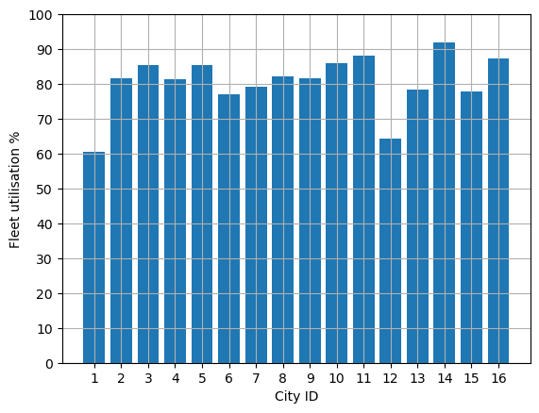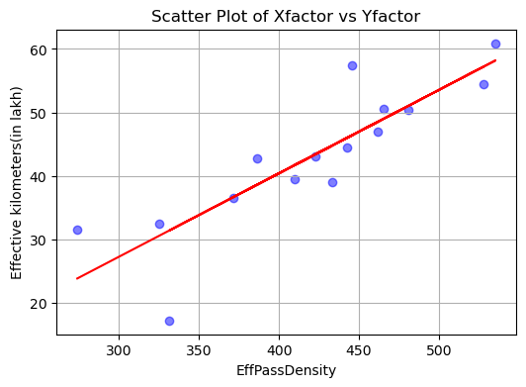

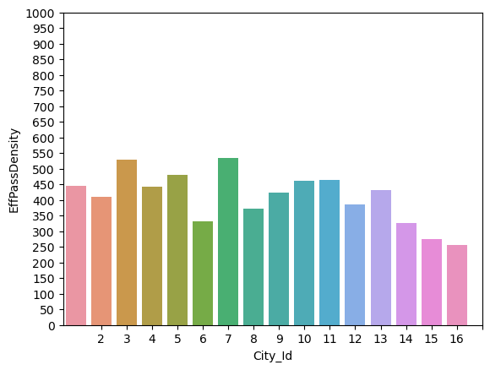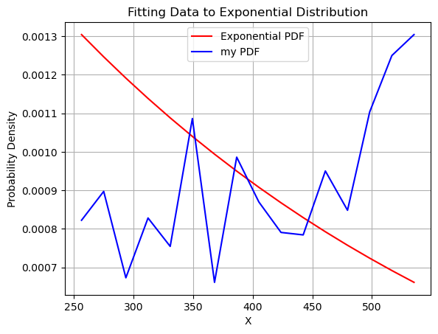

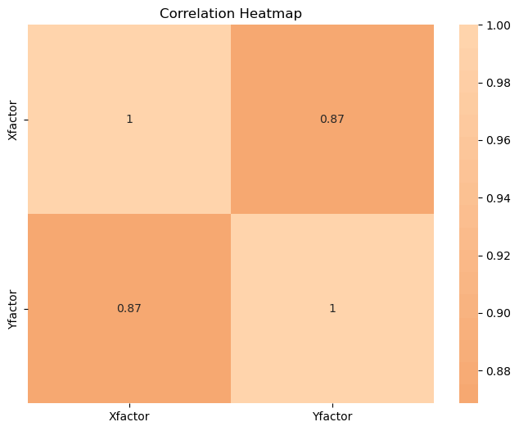

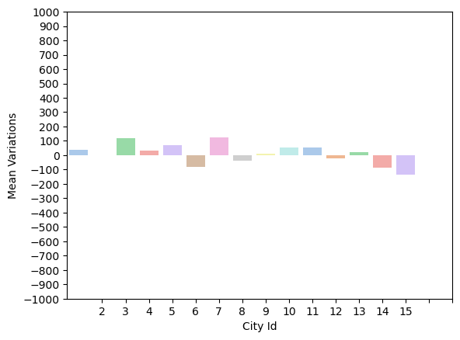

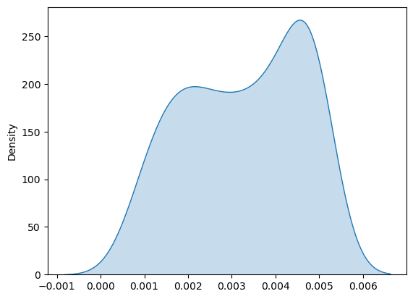

**Oct2021**

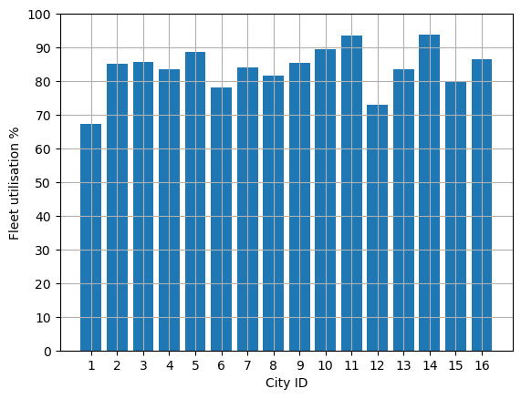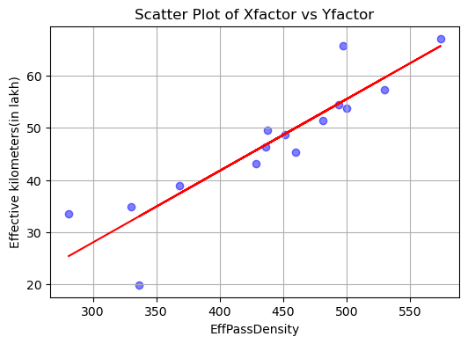

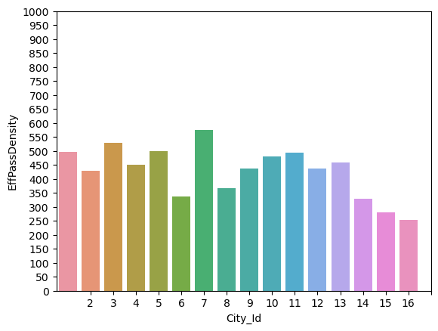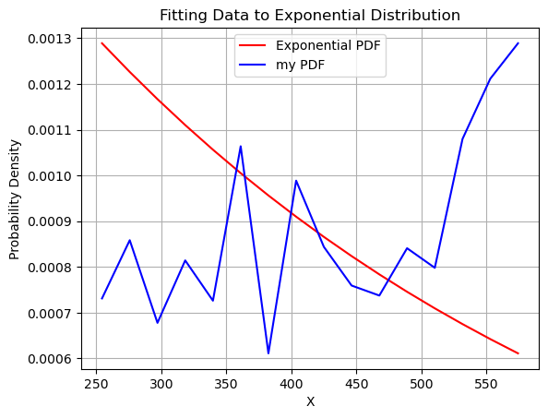

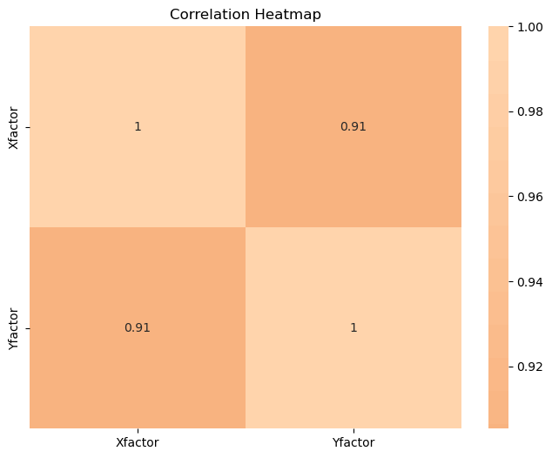

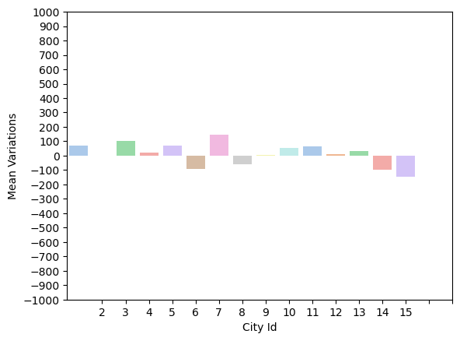

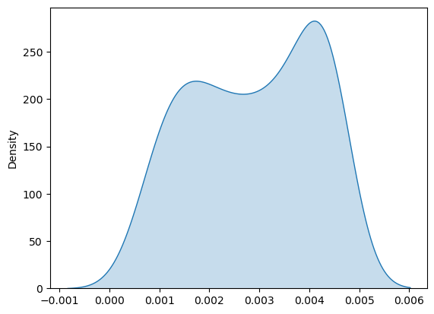

**Feb2022**

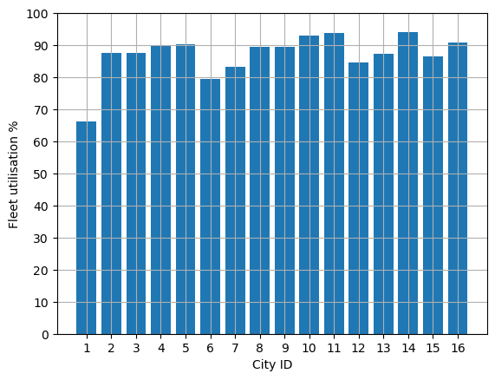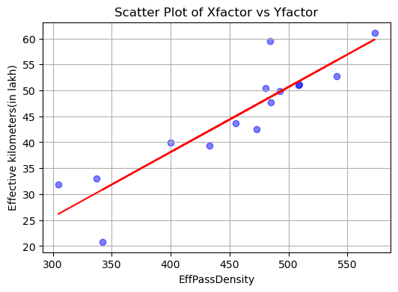

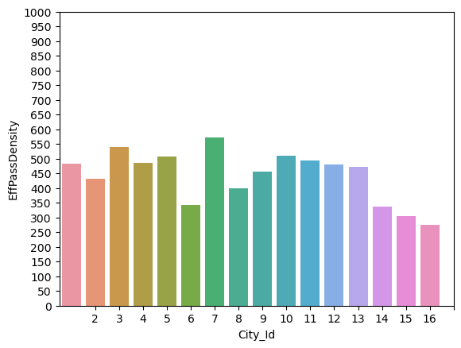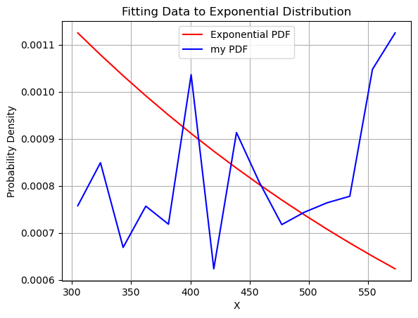

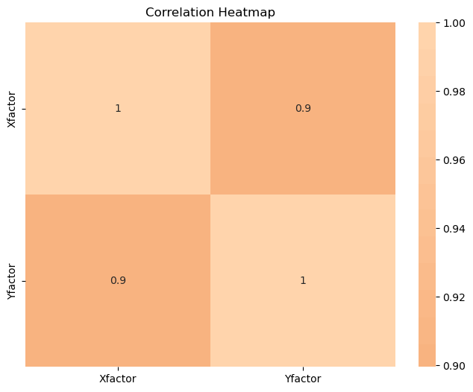

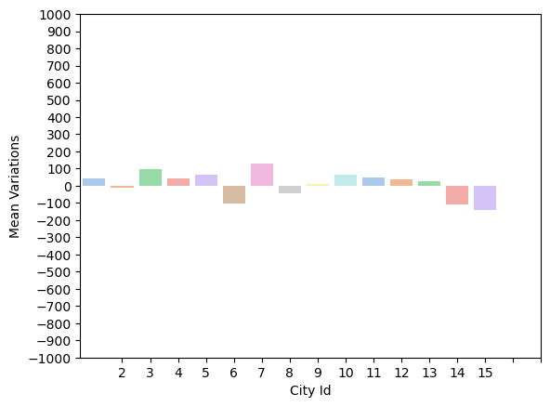

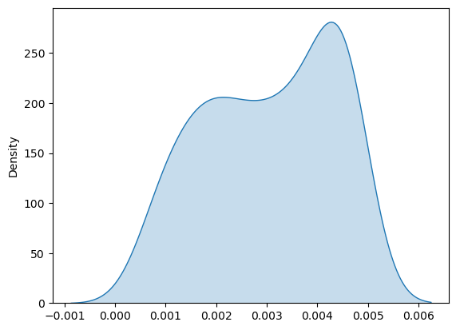

Apr2022

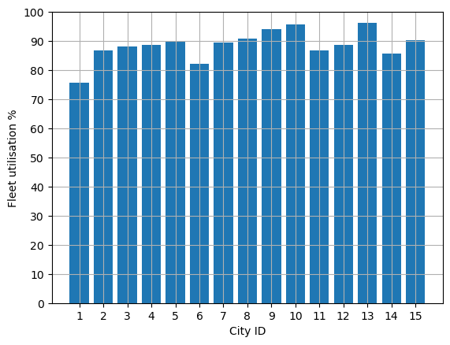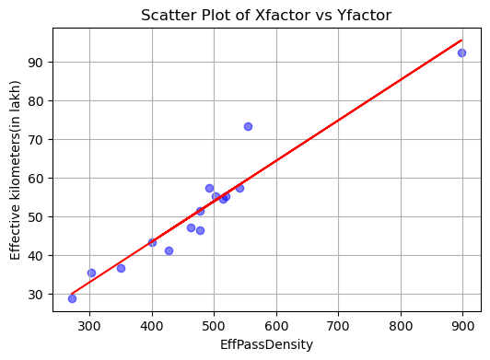

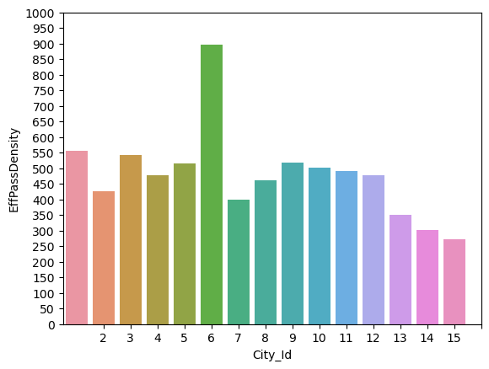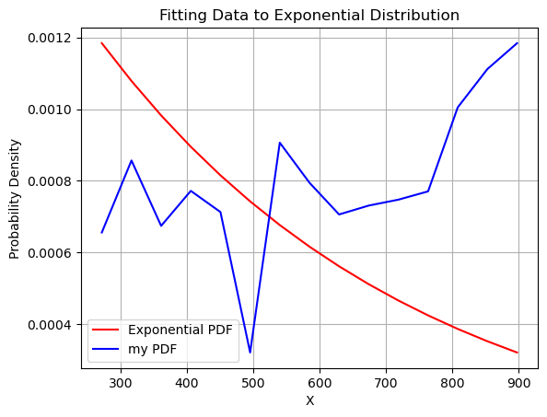

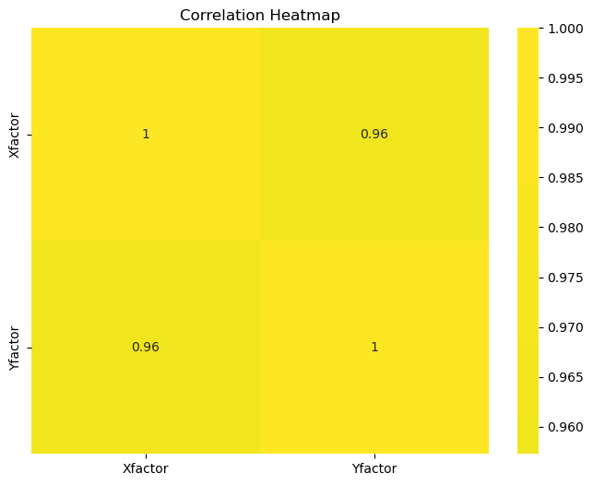

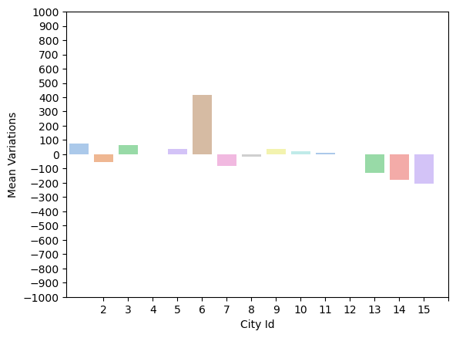

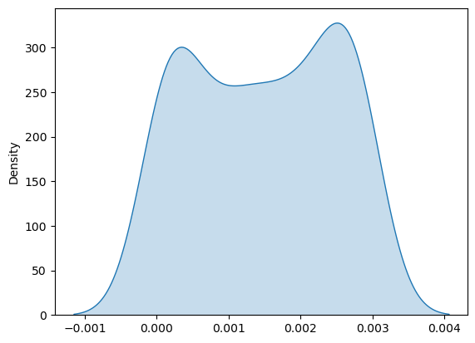

**Mayb2022**

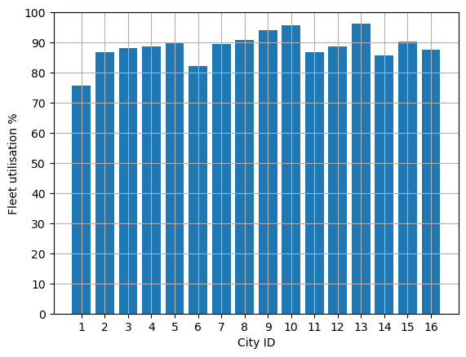

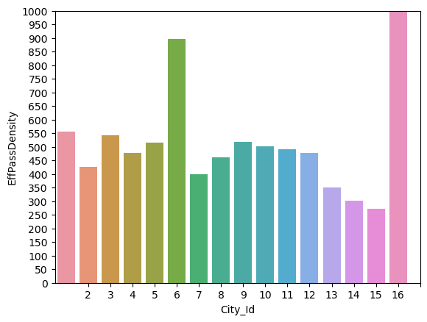

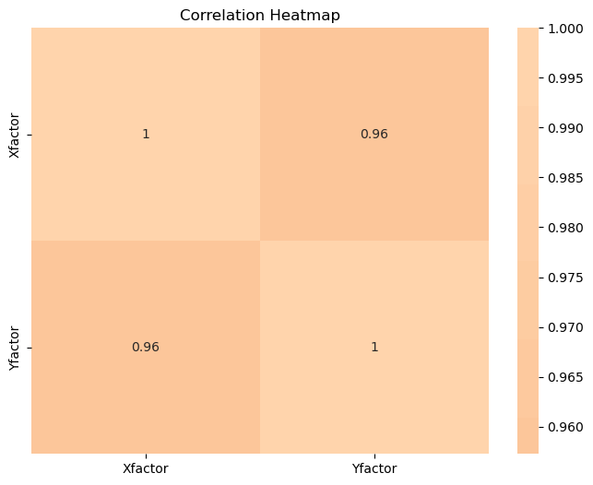

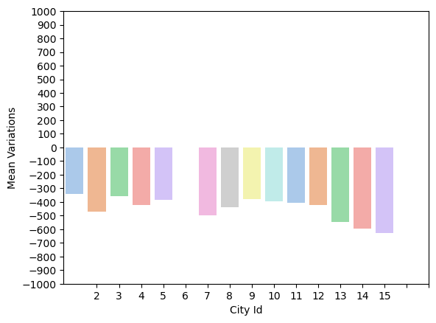

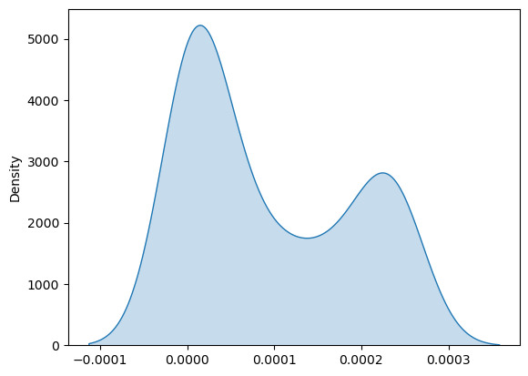

**June 2022**

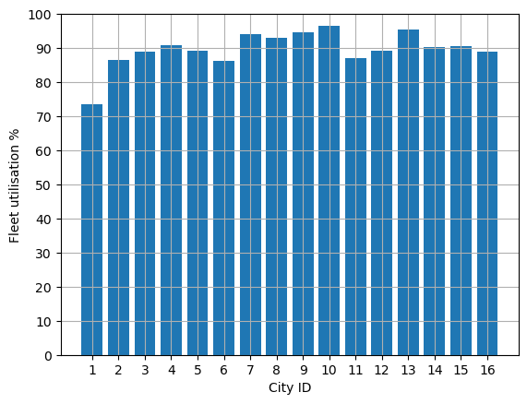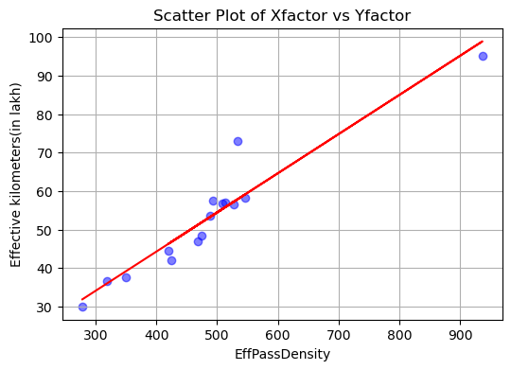

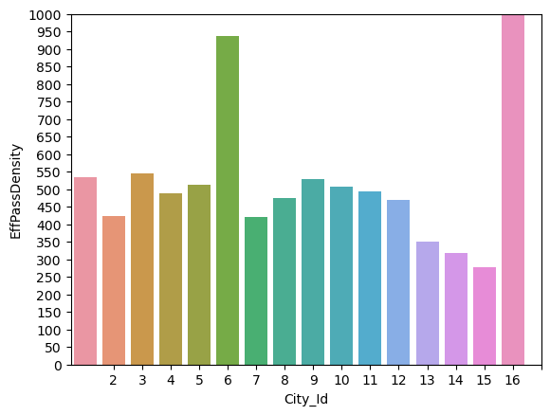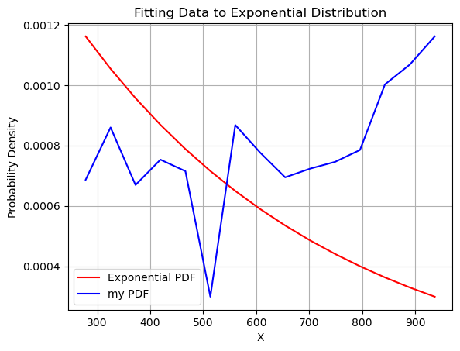

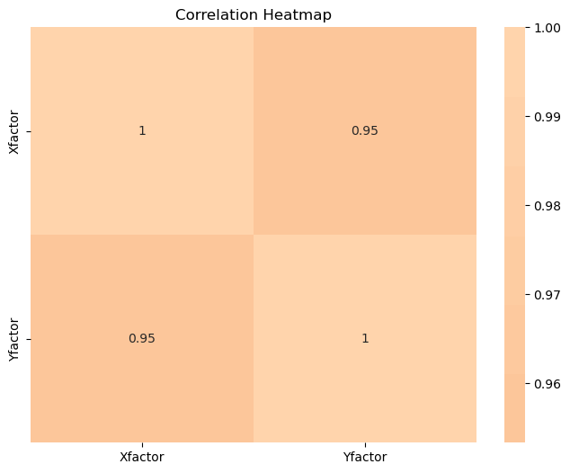

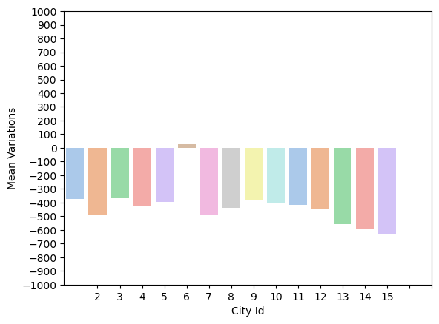

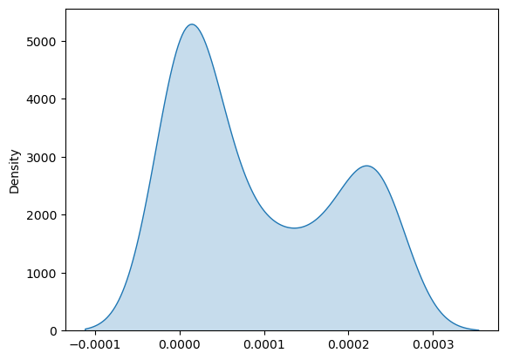

**8. Applications and Future Enhancements of the Project**

The project "Passenger Traffic Analysis in Bus Transport System" holds significant potential for improving the efficiency and effectiveness of bus transportation systems. Beyond its primary objectives, there are several applications and potential future enhancements that can further enhance the impact of this endeavor:

**Applications:**

1. Route Optimization: By analyzing passenger traffic patterns, the project can identify peak travel times, popular routes, and underutilized routes. This information can help transportation authorities optimize routes, adjust schedules, and allocate resources more effectively, thereby reducing travel time and overcrowding.

2. Resource Allocation: Understanding passenger demand can lead to better allocation of buses and drivers, ensuring that buses are deployed where and when they are needed the most. This can minimize unnecessary expenses and improve overall operational efficiency.

3. Capacity Planning: Analyzing passenger traffic data can help authorities determine bus capacity requirements for different routes and times. This ensures that buses are appropriately sized to accommodate passenger demand, leading to better comfort and reduced congestion.

4. Real-time Updates: By implementing data-driven insights, transportation systems can provide real-time information to passengers about bus locations, expected arrival times, and route changes. This enhances the overall passenger experience and encourages more people to use public transportation.

5. Environmental Impact: A well-optimized bus transportation system can reduce the number of empty or underutilized buses on the road, leading to decreased fuel consumption and lower greenhouse gas emissions, contributing to a more sustainable urban environment.

**Future Enhancements:**

1. Predictive Modeling: Utilize machine learning algorithms to predict passenger demand based on historical data, weather conditions, holidays, and special events. This can help authorities proactively adjust schedules and allocate resources to meet varying demand.

2. Integration with Mobility Services: Integrate the analysis results with mobile apps or online platforms that offer real-time travel information. This can provide passengers with personalized route recommendations, estimated arrival times, and updates about disruptions.

3. Dynamic Pricing: Consider implementing dynamic pricing models where ticket prices vary based on demand and capacity. This can incentivize passengers to use public transportation during off-peak hours, further distributing passenger traffic.

4. IoT and Sensor Integration: Install IoT devices and sensors on buses to collect real-time data on passenger count, temperature, and comfort level. This data can be used to refine passenger experience and adjust services accordingly.

5. Multi-modal Integration: Extend the analysis to consider connections with other modes of transportation, such as trains, subways, and bike-sharing systems. This holistic approach can provide seamless travel options for passengers.

6. Behavioral Analysis: Explore the behavior of passengers, such as entry and exit points, preferred seating, and transfer patterns. This information can guide the design of bus stations, stops, and user interfaces to better cater to passengers' needs.

7. Accessibility and Inclusivity: Factor in the needs of passengers with disabilities or special requirements. The project can contribute to making the transportation system more inclusive and accessible for everyone.

8. Collaboration with Urban Planning: Collaborate with urban planners to incorporate transportation insights into city planning efforts, ensuring that future developments are well-connected and support efficient transportation networks.

Incorporating these applications and future enhancements can lead to a comprehensive and impactful transformation of the bus transportation system, making it more efficient, passenger-friendly, and responsive to changing needs.

1. **Conclusion**

In conclusion, the project "Passenger Traffic Analysis in Bus Transport System" has illuminated a path towards a more efficient, sustainable, and passenger-centric public transportation system. Through a rigorous exploration of the complexities inherent in bus fleet management and the dynamics of passenger traffic, valuable insights have been unearthed, revealing patterns and correlations that can significantly enhance the overall efficiency of the transportation system.

By deciphering the intricacies of passenger demand, peak travel times, route popularity, and resource allocation, this project has laid the foundation for tangible improvements that can be realized through strategic interventions. The applications of this project extend far beyond its primary objectives, with the potential to revolutionize how cities approach urban mobility.

The optimized route planning, real-time updates, and better allocation of resources enabled by this analysis promise to alleviate the challenges of congestion, reduce environmental impact, and ultimately enhance the daily commuting experience for countless passengers. As the project's findings serve as a stepping stone towards a more streamlined and sustainable transportation network, it becomes clear that its implications reverberate not only through public transit but also into broader urban planning efforts.

Furthermore, the identified future enhancements present an exciting roadmap for continued progress. The integration of advanced technologies, predictive modeling, multi-modal connectivity, and considerations for inclusivity will undoubtedly shape the evolution of transportation systems for years to come.

In closing, the "Passenger Traffic Analysis in Bus Transport System" project stands as a testament to the power of data-driven insights in transforming the way we move within our cities. As we move forward, armed with the knowledge and recommendations provided by this endeavor, we have the opportunity to build a more efficient, responsive, and enjoyable transportation ecosystem that benefits individuals, communities, and the environment alike.

1. **References**

[1] Python Software Foundation. (2022). *Python Language Reference, Version 3.10*. https://docs.python.org/3.10/

[2] Van Rossum, G., & Drake Jr, F. L. (2011). Python 3 Reference Manual. CreateSpace.

[3] McKinney, W. (2010). Data structures for statistical computing in python. In Proceedings of the 9th Python in Science Conference (Vol. 445, p. 51).

[4] Hunter, J. D. (2007). Matplotlib: A 2D Graphics Environment. Computing in Science & Engineering, 9(3), 90-95.

[5] McKinney, W. (2017). Python for Data Analysis: Data Wrangling with Pandas, NumPy, and IPython. O'Reilly Media, Inc.

[6] Project Jupyter. (2022). *Jupyter Documentation*. <https://jupyter.org/documentation>

[7] Git Documentation. (2022). *Git - Documentation*. <https://git-scm.com/doc>

[8] Hunter, J. D. (2007). *Matplotlib: A 2D Graphics Environment*. *Computing in Science & Engineering*, 9(3), 90-95.

[9] Waskom, M. (2022). *Seaborn: statistical data visualization*. *Journal of Open Source Software*, 7(50), 2682.