Proactive Congestion Prediction in a 5G NR Urban Cluster
OMNeT++ / Simu5G Simulation, KPI Dataset, and LSTM-Based Prediction
Results & Findings Report
CDAC Internship — AI-Powered Predictive Framework for Traffic Demand Estimation and Congestion Prediction in 5G and Beyond Networks
29 June 2026

1. Executive Summary
This report compiles the results produced so far in the congestion-prediction track of the CDAC internship project. A five-cell urban 5G NR cluster (1 macro + 3 micro gNBs, 50 mobile UEs) was simulated in OMNeT++/Simu5G with a baseline CBR traffic floor and a deliberately injected, asymmetric uplink burst (T=50–70s) to create a controlled congestion event. Ten seed-repetitions of the run were parsed into a 60,043-row KPI time-series dataset, analysed statistically, and used to train an LSTM sequence model that forecasts next-step latency, throughput, and HARQ retransmission load from a 1-second history window.
The result is mixed but informative. The model predicts next-step latency (R² = 0.85) and HARQ retransmission attempts (R² = 0.71) well on the held-out test set but fails on downlink throughput (R² = 0.19). Network behaviour analysis shows that the injected burst produces a real and measurable radio-layer degradation. But one that is asymmetric (uplink-only), lags the burst itself, and does not recover by the time the simulation ends, which complicates a clean “before/during/after” congestion narrative. Two of the KPIs the project explicitly set out to record MAC queue depth and PRB utilization are entirely empty in the final dataset, and the central deliverable metric for this phase — a quantified lead-time comparison between the LSTM's proactive forecast and a reactive (post-hoc threshold) detector has not yet been produced, even though the code for it exists. These points, and what they mean for the project's central claim, are detailed in Sections 8 and 9.

2. Background & Objective
The framework calls for: (a) generating realistic, large-scale 5G KPI datasets via simulation, (b) modelling representative scenarios such as slicing and congestion, and (c) training and comparing statistical, deep-learning (LSTM), and graph-aware (GNN) models to forecast KPIs and congestion ahead of time, for proactive rather than reactive network planning.
The distinction the project is built around is:
- Reactive congestion handling — a controller observes a KPI (e.g. latency, queue length) and reacts only after it crosses a threshold, i.e. after congestion has already occurred.
- Proactive congestion prediction — a model forecasts a KPI's near-future trajectory from its recent history, so a threshold breach can be anticipated and acted on before it happens.
The work reported here is the first concrete attempt at the proactive side: a single, controlled congestion scenario simulated end-to-end, parsed into a dataset, and used to train a first LSTM predictor. The GNN / spatial-graph branch and the multi-scenario batch sweep are not yet started.
Phase | Status | Notes
Environment setup (OMNeT++ + Simu5G) | Done | Stable on WSL2/Ubuntu
NED topology design | Done | Multi-cell, parameterized
.ini configuration | Done | Multi-scenario, seeded runs
KPI vector recording | Partially done | Throughput, delay, SINR recorded; PRB/queue not (see §7)
.vec → CSV parser | Done | Chunked, memory-safe
LSTM training (this report) | In progress | First model trained; lead-time claim not yet validated
Batch sweeps (UE density, traffic mix, seeds) | Pending | Only one scenario simulated so far
Spatial / graph feature engineering | Pending | Needed for GNN branch
GNN model training | Pending | Not started
Pipeline integration & reporting | Pending | This document is a step toward it
Table 1. Project phase status.

3. Simulation Architecture

3.1 Network Topology
The simulated network (UrbanCongestionCluster.ned) is a Simu5G NR topology with one macro gNB and three micro gNBs around a 1000×1000 m area, a wired core (server — router — UPF — iUPF) and 50 NrUe nodes.
Node | Position (x, y) | Tx Power | Role
macroGnb | 500 m, 500 m | 46 dBm | Central macro cell, wide coverage
microGnb1 | 500 m, 100 m | 30 dBm | Edge micro cell
microGnb2 | 850 m, 700 m | 30 dBm | Edge micro cell
microGnb3 | 150 m, 700 m | 30 dBm | Edge micro cell
ue[0..49] | Uniform random | 26 dBm | RandomWaypoint mobility, 1–5 m/s
Table 2. Cell placement and transmit power.
All four gNBs connect only to a shared iUPF hub (iUpf.pppg++ ↔ gNB.ppp), not to each other directly. There is no inter-gNB X2 link in the topology built. No X2 is needed if cells never hand a UE off — but it means the current topology cannot yet support any handover-aware or multi-cell-coordinated congestion experiment without rework.

3.2 Radio / PHY Configuration
- Carrier: 2 GHz, numerology 0, 50 resource-block bands, single component carrier per cell.
- Target BLER 0.01; downlink and uplink interference modelling both enabled.
- Cell association: dynamicCellAssociation = true, but enableHandover = false — a UE picks its best cell at attachment/re-association time but is never handed off as it moves.

3.3 Traffic Model
Two layers of traffic are configured: an always-on CBR floor, and a 20-second asymmetric UDP burst injected into the UL only.
Traffic | UEs | Direction | Packet / Interval | Active Window | Aggregate Load
Baseline CBR (DL) | all 50 | server → UE | 100 B / 20 ms | 0–120 s | ≈250 KB/s cell-wide
Baseline CBR (UL) | all 50 | UE → server | 100 B / 20 ms | 0–120 s | ≈250 KB/s cell-wide
Burst, Group A | UE 0–29 (30) | UE → server | 500 B / 5 ms | 50–65 s (15 s) | ≈100 KB/s/UE — heavy
Burst, Group B | UE 30–49 (20) | UE → server | 100 B / 100 ms | 50–70 s (20 s) | ≈1 KB/s/UE — light
Table 3. Traffic profile. The downlink CBR rate is fixed and never increases — it is not a function of network load, which matters in Section 5.3.
So the injected event is not a symmetric “half the users burst for 20 seconds” — it is a heavy 15-second uplink surge from 30 UEs (≈12× the baseline uplink rate) overlapping a much lighter 20-second trickle from the remaining 20 UEs. This asymmetry shows up directly in the results (§5).

3.4 Mobility & Handover
UEs move under RandomWaypointMobility at 1–5 m/s with 0–5 s pause times, across the full 1000×1000 m area, for the entire 120 s run — independent of the burst window. Because handover is disabled, a UE that random walks away from its serving cell's coverage keeps degrading in SINR with no corrective re-association. This is one of two plausible explanations (the other being genuine queueing) for the continuous, non-recovering SINR/CQI decline seen in Section 5.2.

3.5 Run Configuration & Output Pipeline
- sim-time-limit = 120 s; seed-set = ${repetition}, repeated over 10 seeds.
- Scalar recording disabled (**.scalar-recording = false); only vector outputs (throughput, delay, SINR, CQI, HARQ, RLC delay, queue length) recorded, per UE.
- .vec files parsed by a custom chunked Python parser into a single time-binned CSV (100 ms bins, columns: Time_Bin, Node_ID, KPI values).

4. Dataset Produced
The parsed dataset (dataset_urban_congestion.csv) has 60,043 rows × 16 columns, covering all 50 UEs across 1,201 time bins (0–120 s in 100 ms steps).
KPI | Min | Mean | Max | Nulls
Avg_Latency (s) | 0.0041 | 0.0142 | 0.9307 | 1,428
Total_Throughput (B/s, DL) | 5,071 | 32,409 | 134,630 | 1,428
Avg_CQI (0–15) | 5.50 | 13.83 | 15.00 | 40
Avg_SINR (dB) | −18.97 | 26.96 | 103.18 | 187
Avg_PacketLoss | 0.00 | 0.22 | 1.00 | 42
Avg_HARQ_Attempts | 1.00 | 1.39 | 4.00 | 237
Max_MAC_Queue | — | — | — | 60,043 (100%)
Avg_PRB_Usage | — | — | — | 60,043 (100%)
Table 4. KPI ranges and null counts. The last two rows are flagged in Section 9: these columns exist but contain zero valid samples in the entire dataset.

5. Results: Network Behaviour Under the Congestion Event

5.1 Pre / During / Post-Burst Comparison
Network-wide means were computed over three windows: pre-burst (T=40–49 s), during the burst (T=50–70 s), and post-burst (T=70–90 s).
Metric | Pre-burst | During burst | Post-burst
Avg. latency (s) | 0.00888 | 0.01062 | 0.01723
DL throughput (B/s) | 32,459.5 | 32,453.9 | 32,833.9
HARQ Tx attempts | 1.321 | 1.369 | 1.440
RLC delay (s) | 0.00888 | 0.01061 | 0.01723
Table 5. Network-wide KPI means by burst phase (values match Figure 1).
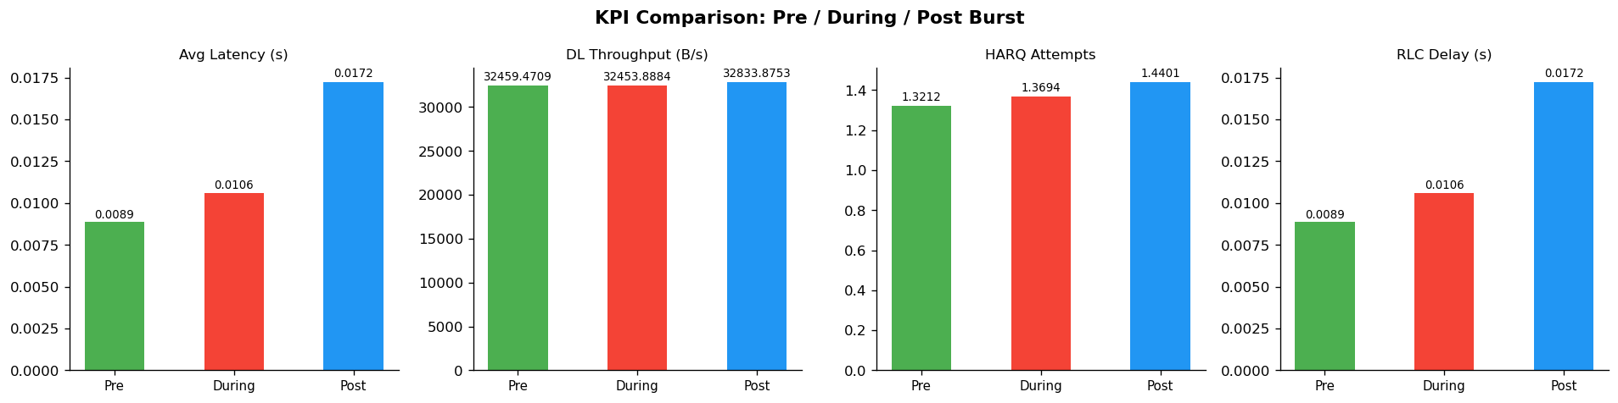
Figure 1. Latency, DL throughput, HARQ attempts and RLC delay across the three windows.
Two things stand out. First, latency and RLC delay are numerically identical to four decimal places in every window — confirmed as r=1.00 in the correlation matrix (Section 6.1); they are effectively the same signal recorded twice. Second, DL throughput is essentially flat (32,454–32,834 B/s) across all three windows — it does not register the burst at all. The reason is structural, not incidental: the downlink is fixed-rate CBR (100 B/20 ms per UE, §3.3), so it cannot reflect congestion however severe the load gets, because it never tries to send more than its fixed rate allows.

5.2 Time-Series Behaviour: Lag and Non-Recovery
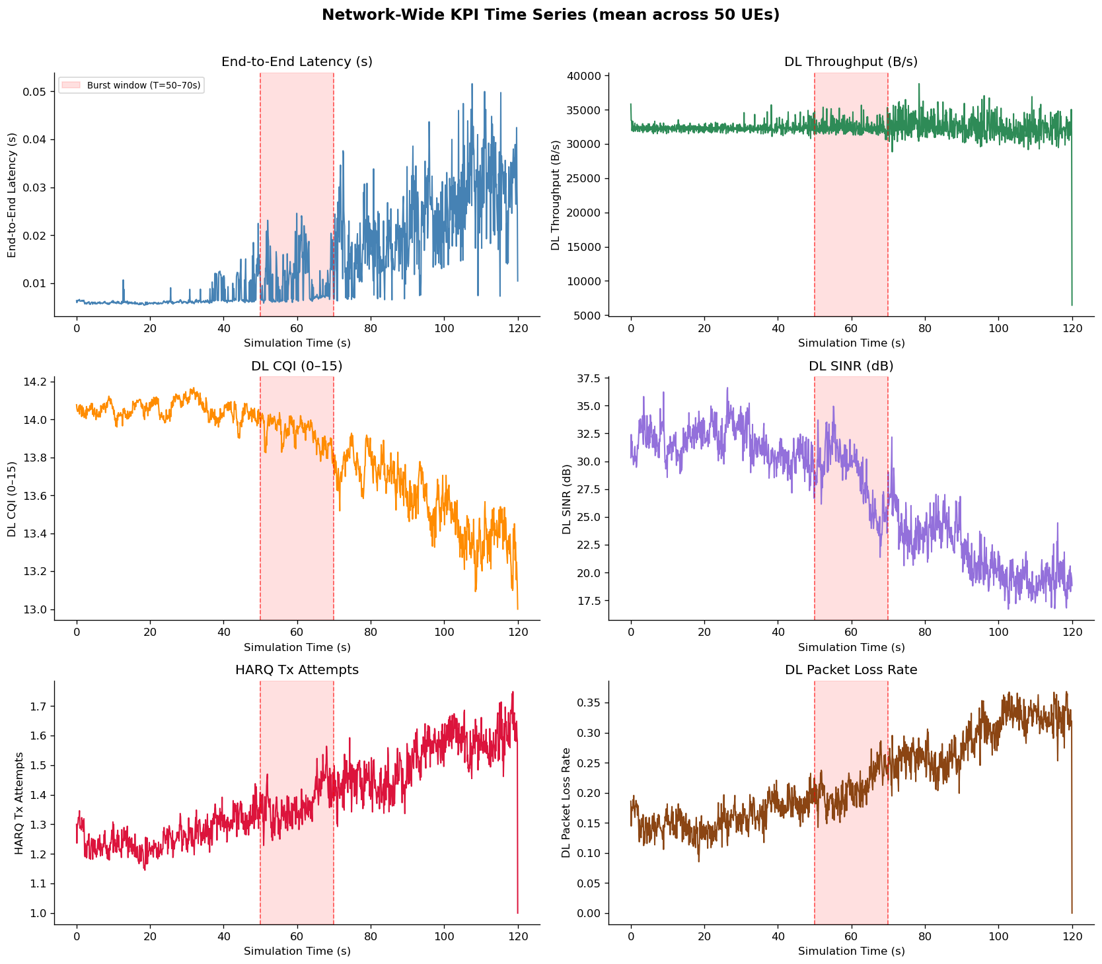
Figure 2. Network-wide KPI time series (mean across 50 UEs), burst window shaded.
The full time series tells a less tidy story than the three-window average suggests:
- Latency begins climbing around T≈40 s — before the burst starts at T=50 s — and keeps climbing well past T=70 s, reaching its highest values (0.03–0.05 s) near the end of the 120 s run, long after the burst traffic has stopped.
- DL CQI drifts down slowly from ≈14.1 to ≈13.0–13.3 by T=120 s, with no inflection that lines up cleanly with the burst boundaries.
- DL SINR falls steadily from ≈31 dB to ≈18–20 dB by the end of the run, again continuing well after the burst ends.
- HARQ Tx attempts and DL packet loss both rise monotonically from ≈40 s onward and do not turn over after T=70 s.
In other words, the network does not recover after the burst within the simulated window. Given that UE mobility runs continuously and handover is disabled, this pattern is at least partly explained by UEs random-walking into progressively worse radio conditions with no corrective re-association — a mobility/coverage effect that is independent of the deliberately injected congestion. The dataset as it stands does not cleanly separate “congestion caused by the traffic burst” from “degradation caused by uncorrected mobility,” which matters directly for what the LSTM in §7 is actually learning to predict.

5.3 Throughput: Downlink vs Uplink
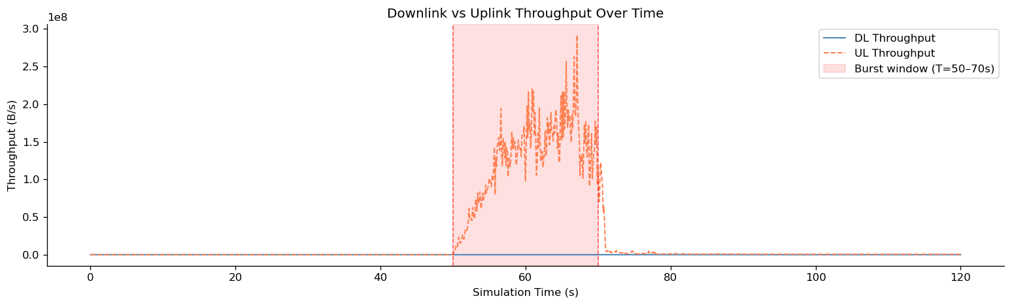
Figure 3. Downlink (flat) vs uplink (bursting) throughput.
This plot makes the asymmetry in figure 3 visible: DL throughput stays flat near baseline for the entire run, while UL throughput spikes by roughly two orders of magnitude during T=50–70 s, driven almost entirely by the 30-UE heavy burst group, then collapses back to baseline immediately once the burst apps stop. The uplink is the only channel in which the injected congestion event is directly observable as a throughput signal.

5.4 Radio Quality and Its Coupling to Latency
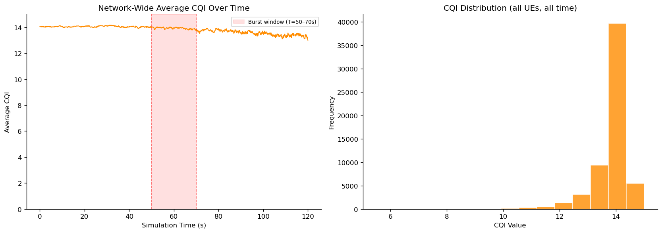
Figure 4. Network-wide average CQI over time, and its distribution across all UEs and time bins.
CQI is heavily ceiling-saturated: the histogram shows the overwhelming majority of samples at CQI 13–15, with a thin tail down to 5.5–7. The burst window itself only nudges average CQI down marginally (≈14.0 → ≈13.9); the larger decline happens afterward (§5.2).
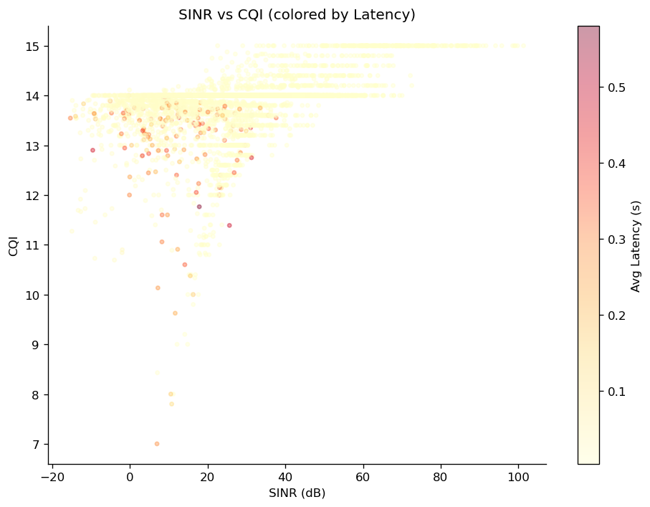
Figure 5. SINR vs CQI, coloured by average latency. The high-latency tail (dark/red points) sits almost entirely below CQI≈13 and SINR<30 dB.
Figure 5 confirms the expected relationship — high latency is concentrated in the low-SINR, low-CQI corner — but only for a small minority of points. The bulk of the data sits in a CQI-saturated band (13–15) across a wide SINR range, which limits how much discriminative information CQI alone carries for a congestion predictor.

6. Statistical Structure of the KPI Dataset

6.1 Correlation Structure
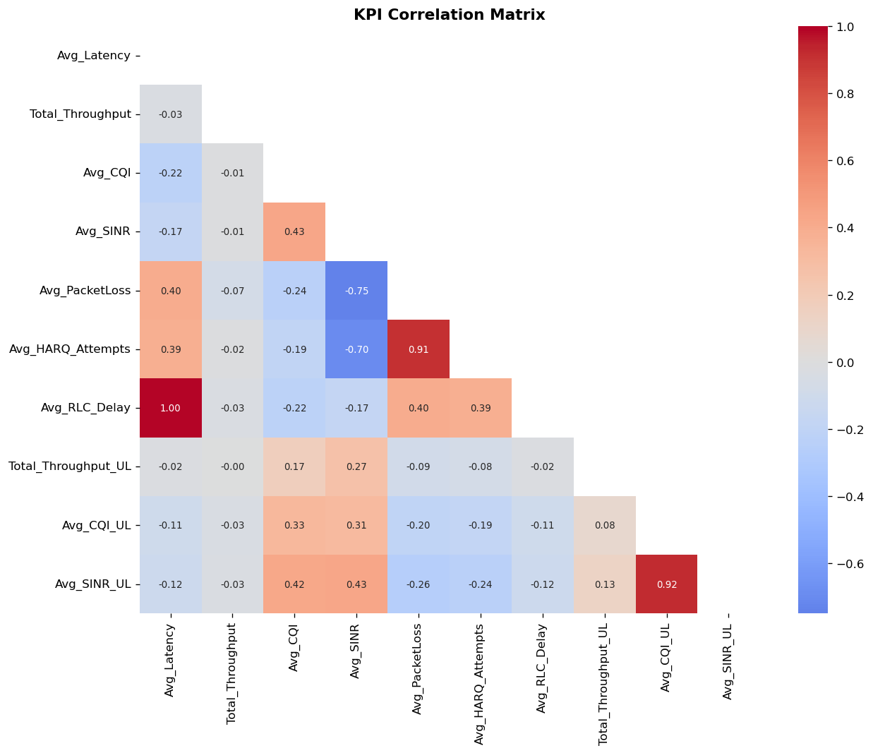
Figure 6. Pairwise KPI correlation matrix.
KPI Pair | r | Reading
Avg_Latency ↔ Avg_RLC_Delay | 1.00 | Identical signal, recorded under two names — not two independent KPIs.
Avg_PacketLoss ↔ Avg_HARQ_Attempts | 0.91 | Near redundant; both track the same retransmission/loss process.
Avg_CQI_UL ↔ Avg_SINR_UL | 0.92 | Expected: CQI is derived from measured SINR.
Avg_SINR ↔ Avg_PacketLoss | -0.75 | Expected inverse relationship — weaker signal, more loss.
Avg_SINR ↔ Avg_HARQ_Attempts | -0.70 | Same relationship via retransmissions.
Total_Throughput ↔ everything else | ≈0.00 to −0.07 | DL throughput is statistically decoupled from every radio/congestion KPI in this dataset — a direct consequence of the fixed-rate CBR sender (§5.1, §5.3).
Table 6. Notable correlations and what they imply for modelling.

6.2 Latency and Throughput Distributions
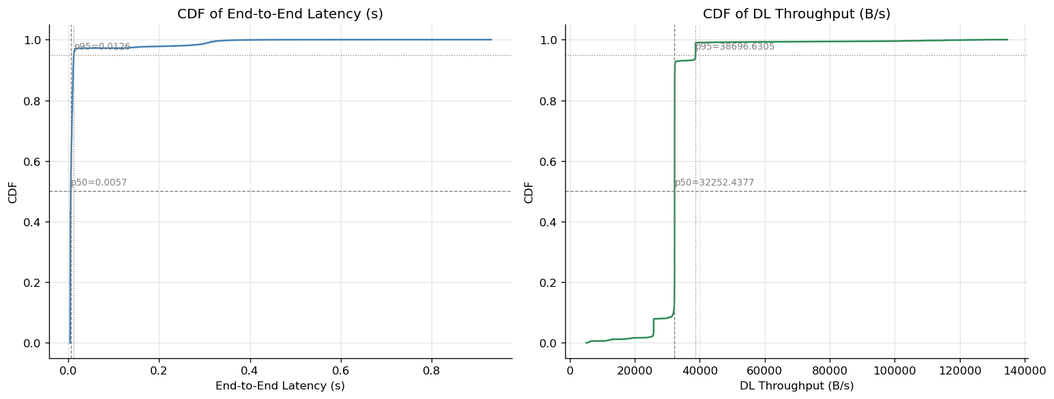
Figure 7. Empirical CDFs of end-to-end latency and DL throughput.
Metric | p50 (median) | p95
End-to-end latency | 0.0057 s | 0.0126 s
DL throughput | 32,252 B/s | 38,697 B/s
Table 7. Latency and throughput percentiles.
Latency is heavily long-tailed: the 95th percentile (12.6 ms) is barely more than 2× the median (5.7 ms), but the maximum reaches 930 ms (Table 4) — meaning the “congestion signal” the model has to learn lives in a thin tail of the distribution, not in a broad shift of the whole population.

7. LSTM-Based Congestion Prediction Model

7.1 Architecture & Training Setup
Parameter | Value
Input | (batch, window=10 bins = 1 s history, features=8)
Features | Avg_Latency, Total_Throughput, Avg_CQI, Avg_SINR, Avg_PacketLoss, Avg_HARQ_Attempts, Avg_RLC_Delay, Total_Throughput_UL
Targets (next time bin) | Avg_Latency, Total_Throughput, Avg_HARQ_Attempts
Model | 2-layer LSTM (hidden=64, dropout=0.2) → LayerNorm → Linear(64→32) → ReLU → Dropout → Linear(32→3)
Parameters | 54,531
Optimizer / Schedule | Adam (lr=1e-3, weight decay 1e-4), ReduceLROnPlateau (patience 5, factor 0.5)
Batch size / Epochs (planned) | 256 / 50, gradient-clipped at norm 1.0
Data split | Train 36,243 / Val 6,396 / Test 7,525 windowed sequences (after dropping rows with missing features/targets)
Device | CPU (no GPU acceleration used for this run)
Table 8. LSTM model and training configuration.
Note on the training run itself: the saved notebook does not contain the executed epoch-by-epoch loss log or the final best_val_loss value — only the test-set prediction scatter (Figure 8, saved separately) survives as a record of this run's outcome.

7.2 Test-Set Prediction Accuracy
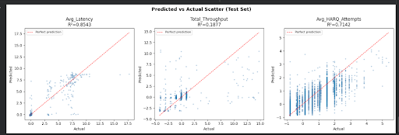
Figure 8. Predicted vs. actual values on the held-out test set, with R² per target.
Target | Test R² | Verdict
Avg_Latency | 0.854 | Strong fit — but see §7.3 on leakage via Avg_RLC_Delay.
Avg_HARQ_Attempts | 0.714 | Good fit; HARQ has strong short-term persistence in the input window.
Total_Throughput | 0.188 | Weak — consistent with §6.1: throughput carries almost no linear relationship to any other KPI, including its own recent history beyond the fixed CBR mean.
Table 9. Test-set R² by target.

7.3 Interpretation
The headline numbers need two caveats before they can be read as “the model predicts congestion well”:
- Latency leakage: Avg_RLC_Delay is in the input feature set, Avg_Latency is a predicted target, and the two are correlated at r=1.00 (§6.1). The model effectively has near-perfect knowledge of one of its own targets already sitting in its input window one second earlier. The 0.85 R² is real, but it is closer to measuring the model's ability to carry forward a near-identical signal than to genuinely forecasting a causally distinct quantity.
- Throughput failure is structural, not a modelling shortfall: §5.1 and §6.1 both show DL throughput is fixed-rate and decoupled from load. No sequence model can forecast congestion-driven throughput collapse from a signal that was never designed to collapse under congestion in the first place.
- HARQ's 0.71 R² is the most credible “genuine” predictive result of the three, since HARQ attempts are not duplicated elsewhere in the feature set and do carry real short-horizon persistence tied to radio conditions (Section 5.4, Section 6.1).

8. Conclusions (Result-Based)
Taking the results at face value:
- The simulated burst produces a real, measurable degradation in latency, SINR, CQI, packet loss and HARQ load — the controlled-congestion experiment works as a way to generate non-trivial KPI dynamics.
- The degradation is asymmetric (visible in uplink, invisible in the fixed-rate downlink) and lagged/non-recovering rather than a clean during-burst spike that resolves afterward — the project's own “pre/during/post” framing (Table 5) understates how messy the underlying time series is (Figure 2).
- The LSTM can forecast next-step latency and HARQ load with useful accuracy on this dataset (R² 0.85 and 0.71), which is encouraging evidence that a short history window does contain predictive signal for at least two of the three target KPIs.
- However, the project's central claim — that this kind of proactive forecast meaningfully outperforms a reactive, post-hoc threshold detector — has not yet been empirically demonstrated. The notebook contains the start of exactly this comparison (a 95th-percentile latency threshold check against the LSTM's forecast, §9) but the cell was never executed to completion, so there is currently no lead-time number, no false-alarm rate, and no head-to-head comparison against a reactive baseline to point to.
- The latency result is also partly an artifact of duplicate KPIs (Avg_Latency ≡ Avg_RLC_Delay) rather than purely a causal forecast, so the 0.85 R² should be read as an upper bound, not the model's “true” forecasting skill.
Net assessment: the pipeline — simulate → inject congestion → parse → train → evaluate — is working end to end, and there is genuine predictive signal in two of three targets. What is missing is the one comparison the whole project is framed around (proactive vs. reactive), and a traffic model in which downlink throughput can reflect congestion.

9. Shortcomings & Limitations
- Proactive-vs-reactive comparison not completed. The 95th-percentile threshold / lead-time check (intended to be the project's core deliverable metric) exists as code but was never run to completion in the saved notebook — no quantitative comparison against a reactive baseline currently exists.
- Two configured KPIs are entirely empty. Max_MAC_Queue and Avg_PRB_Usage — arguably the two most direct congestion-load indicators — have zero valid samples across all 60,043 rows. This is the same class of bug the project status doc already flags as previously hit and fixed (“missing or zero-valued KPI vectors — incorrect signal path in .ini”); it appears to have recurred for these two signals specifically and was not caught before training.
- Downlink throughput cannot reflect congestion by design. The fixed-rate CBR sender (100 B/20 ms) means DL throughput is statistically unrelated to every other KPI (§6.1) and is the weakest LSTM target (R²=0.19) for a structural reason, not a tuning issue. An elastic or load-adaptive traffic generator is needed before throughput can serve as a meaningful congestion signal.
- Confounded degradation source. Continuous UE mobility with handover disabled (§3.4, §5.2) means the dataset mixes “mobility-driven coverage loss” with “traffic-driven congestion” in the same KPI trends, and the current pipeline has no way to separate the two. The LSTM is therefore learning a blend of two different physical causes under a single label set.
- Feature/target redundancy. Avg_Latency and Avg_RLC_Delay are perfectly correlated (r=1.00) yet both appear in the feature and/or target set, inflating the apparent capability of the model on the latency target (§7.3).
- Single scenario, single topology. Only one traffic pattern, one cell layout, and one UE density (50) have been simulated across 10 seeds. The project's own roadmap (Table 1) lists batch sweeps across UE density, traffic mix, and load level as pending — so the LSTM's generalization beyond this one scenario is untested.
- No spatial/graph component yet. The current model is purely per-UE and temporal; no cell-level graph, neighbour-cell interference, or GNN-based cross-cell congestion propagation has been built, despite being part of the original framework's scope.
- Limited, possibly overfit-prone training set. After null-dropping and windowing, only 50,164 sequences remain, drawn from a single 120 s scenario replicated over 10 seeds rather than 10 independent scenarios — train/val/test splits may share more structural similarity than a typical i.i.d. split would suggest.
Minor data inconsistency. The dataset-analysis notebook loads dataset_urban_congestion.csv (60,043 rows) while the LSTM notebook loads dataset_optA_final.csv (60,044 rows) — likely the same export under two filenames/versions, but worth reconciling so both notebooks are demonstrably analysing the same data.
- Time-series edge artifacts. Several KPI panels (Figure 2) show sharp, physically implausible jumps in the final 100 ms bin (e.g. HARQ attempts dropping to exactly 1.0 at T≈120 s) — most likely an averaging artifact from very few samples landing in the last bin, not a real network recovery. These boundary bins are not currently filtered out.

10. Recommended Next Steps
- Run the 95th-percentile threshold check (already drafted) to completion and quantify lead time, false-alarm rate, and miss rate for the LSTM vs. a simple reactive threshold detector — this is the single highest-value next step, since it is the project's actual deliverable metric.
- Diagnose and fix the Max_MAC_Queue / Avg_PRB_Usage recording path in the .ini, and re-run a short validation simulation to confirm both vectors populate before the next full batch run.
- Replace or supplement the fixed-rate downlink CBR with a load-adaptive or TCP-like downlink flow so DL throughput can actually respond to congestion.
- Either enable handover or run a stationary-UE control scenario, to separate mobility-driven SINR decay from traffic-driven congestion in the training labels.
- Drop Avg_RLC_Delay from the LSTM's feature set (keep only Avg_Latency) to get an unbiased read on the model's true latency-forecasting skill.
- Begin the batch parameter sweep (UE density, traffic mix, multiple independent scenarios) that Table 1 already lists as pending, so the next model iteration is evaluated across scenarios rather than across seeds of one scenario.
- Save the full training log (per-epoch loss, best_val_loss, environment/package versions) for every future run, so results are independently reproducible.

