Predicting Radio-Access Congestion from Standard O-RAN Key Performance Measurements
A Simulation-to-Reality Study
Project report, revision 3
Stage 1 results and Stage 2 plan
Guide: Dr. Radhika Joshi
Department of Electronics and Telecommunication Engineering
COEP Technological University, Pune
2 October 2026

Abstract
Mobile networks react to congestion after users already feel it. This project asks two questions. First, can the standard measurements that an O-RAN base station already reports every 250 ms warn that a user will be starved of radio resources about one second before it happens? Second, and more important, does a predictor trained on simulated data still work on real network data?
The work is split into two stages. Stage 1, completed and reported here, builds the data. It repairs an OMNeT++/Simu5G city-network simulation and runs six scenarios (22 runs, 485,546 user-intervals); reduces the public TRACTOR O-RAN dataset to its slicing-free part (601,592 user-intervals, 188 users, 33 conditions); maps both onto one set of six measurements in identical units; labels congestion with the same code on both; and produces train and test sets for five experiments. Stage 2 trains and compares the prediction models on those sets.
Stage 1 also produced results that change the method. The two-peak shape on which the earlier label was built is an artefact of network slicing, not of congestion. In the real data, starvation rises with load, from 0 % of active intervals with one or two users to 48 % with eight. The repaired simulator now congests, from 0.9 ± 1.7 % (light load) to 29.2 ± 4.3 % (urban) and 52.5 ± 1.1 % (heavy load) of intervals. Before any model is trained, the two sources already differ: starvation is fifteen times more common in simulation (34.1 % against 2.2 %), and four of the six shared measurements are far apart in distribution. These numbers set the bar that Stage 2 must clear.
Keywords: O-RAN, near-real-time RIC, congestion prediction, simulation-to-reality transfer, E2SM-KPM, Simu5G, TRACTOR.

Contents
Abstract 2
1. Introduction 5
1.1 The problem 5
1.2 What changed: O-RAN 5
1.3 The gap this work addresses 5
1.4 Two stages, and what this report contains 5
2. Scope, aim and objectives 7
2.1 Scope 7
2.2 Aim 7
2.3 Objectives and status 7
3. Where the model sits: O-RAN in brief 7
4. Key performance measurements: what each one achieves 8
4.1 How the measurements connect to congestion 8
4.2 The six shared measurements, ordered by the question they answer 9
4.3 Where each measurement comes from in the system 10
4.4 Measurements used only to build the label 10
4.5 Measurements deliberately left out 10
4.6 Simulation-only quantities 11
5. Related work 11
5.1 Established sequence and graph models 11
5.2 Recent work, 2024 to 2026 11
5.3 Preliminary baseline comparison 12
6. Methodology 12
6.1 Stage 1: repairing the simulator 12
6.2 Stage 1: the simulated scenarios 13
6.3 Stage 1: preparing the real data (TRACTOR) 13
6.4 Stage 1: defining congestion (the label) 13
6.5 Stage 1: experiment datasets 14
6.6 Stage 2: models 14
6.7 Stage 2: evaluation protocol 15
7. Stage 1 results 15
7.1 The simulator now produces congestion 16
7.2 What the real data shows 18
7.3 Choosing and checking the label 20
7.4 Simulation against reality, before any model 21
7.5 Datasets ready for Stage 2 22
8. Deployment context 23
9. Limitations 23
10. Corrections to revision 2 23
11. Stage 2 plan and future work 24
11.1 Stage 2 steps 24
11.2 Optional strengthening 24
11.3 Future applications 24
12. References 24

1. Introduction

1.1 The problem
Radio access networks today react. A scheduler notices that a queue has filled, or that delay has crossed a threshold, and responds; by then the user has already seen the video stall. Yet the base station measures a great deal several times per second: how much data waits for each phone, how many radio resources each phone asked for and received, and how good each phone's radio link is. These numbers change before the stall. This project asks whether a model fed only those numbers can say this user will be starved about one second from now early enough for the network to act.

1.2 What changed: O-RAN
Historically a base station was a sealed box from one vendor; fine-grained measurements could not be read out and third-party software could not run inside it. O-RAN splits the base station into parts with standard interfaces and adds the near-real-time RAN Intelligent Controller (near-RT RIC), which hosts applications (xApps) on control loops between 10 ms and 1 s. Per-user measurements now flow out over the E2 interface, and an xApp can act on them within the same loop. A one-second warning finally has somewhere to go (Section 3).

1.3 The gap this work addresses
Predicting congestion inside a simulator is not hard, and it has been done many times, including in our own earlier work. Almost all published work trains and tests on data from the same source, which measures interpolation rather than generalisation. A model trained on a simulator may learn the simulator's quirks rather than anything true about networks. This project deliberately trains on simulated data, tests on real O-RAN telemetry, and reports the size of the gap, including if it is unfavourable.

1.4 Two stages, and what this report contains
Figure 1 shows the whole project on one page. Stage 1 builds the data from both sources and ends with ready-to-use datasets; it is complete. Stage 2 trains baselines and models on those datasets and runs the five experiments; it is the next step. Stage 1 contributes:
- A repaired simulation. Twelve configuration and parsing faults were found and fixed; six scenarios were run with several seeds each (22 runs) and every recorded measurement was checked (Section 6.1).
- The real data, prepared. TRACTOR's 189 multi-user logs were aligned on 250 ms intervals and filtered to slicing-free records (Section 6.3).
- Six shared measurements with a stated purpose. Each is explained by what it achieves for prediction, what it means in a real network and where it comes from in the system (Section 4).
- One congestion label for both sources, with every choice tested against the data (Sections 6.4 and 7.3).
- Five datasets and a measured sim-to-real gap before modelling (Sections 6.5 and 7.4).
Section 7 reports the analysis behind these steps with graphs; Section 10 lists every claim of revision 2 that the data did not support.

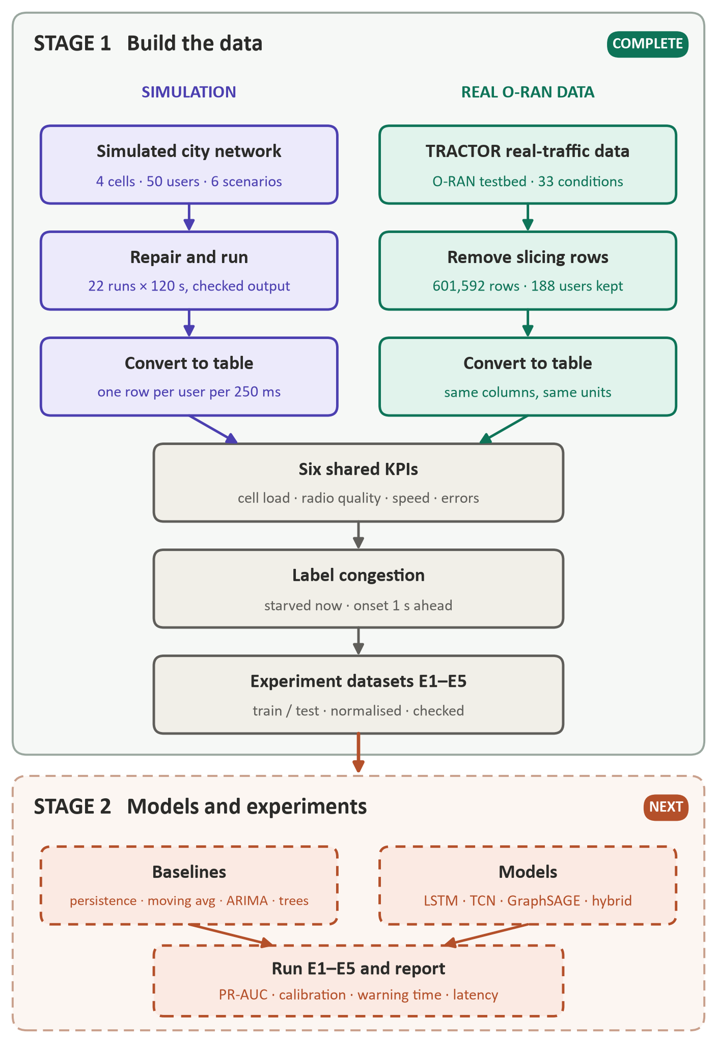
Figure 1. Project overview. Stage 1 (complete) builds comparable data from a simulator and from a real O-RAN testbed and ends in labelled experiment datasets. Stage 2 (next, dashed) trains baselines and models on them and runs experiments E1–E5.

2. Scope, aim and objectives

2.1 Scope
The scope is defined by the measurements the model may use: only quantities that a base station reports over the standard E2 key-performance-measurement service model (E2SM-KPM) and that exist in both the simulated and the real data. Section 4 lists the six that qualify and explains why the others are excluded. All measurements are aggregated into 250 ms intervals, the reporting period of the real dataset. The target is the onset of starvation for one user, one second (four intervals) ahead. Onset rather than state, because starvation persists: a user starved now is still starved one second later 72 % of the time (Section 7.2), so predicting the state forward is nearly trivial and says nothing about when trouble begins.
Out of scope: packet inspection or user payload, closed-loop control (the model raises an alarm and does not act), millimetre wave, and multi-vendor interoperability.

2.2 Aim
To develop and evaluate a congestion-onset predictor whose inputs are restricted to measurements obtainable over the E2 interface, to quantify how much of its performance survives the move from simulated to real O-RAN telemetry, and to establish whether it fits within near-real-time RIC timing.

2.3 Objectives and status
Table 1. The four objectives and where each stands.
Objective | What it requires | Status
1. Architect a reproducible data pipeline | Simulator and real data in one format at 250 ms; a label built from resource allocation, free of the earlier feature-target leakage | Complete (Stage 1)
2. Analyse established forecasters | Moving average, ARIMA, LSTM, TCN and GraphSAGE under one protocol, with trivial baselines, several seeds and confidence intervals | Stage 2; datasets ready
3. Synthesise a hybrid model | Per-cell graph context feeding a per-user time encoder; ablation against simple cell averages | Stage 2; design in Section 6.6
4. Assess sim-to-real transfer | Zero-shot gap, real data needed to close it, cost of restricting inputs | Data and splits ready; gap before modelling measured (Section 7.4)

3. Where the model sits: O-RAN in brief
Figure 2 shows the target deployment. The base station is split into three logical nodes. The O-DU (distributed unit) runs the MAC scheduler, which every millisecond decides which phone gets which physical resource blocks (PRBs); most measurements used here originate there. The O-CU-UP (central unit, user plane) carries user data through PDCP and so knows delivered throughput. The O-CU-CP (central unit, control plane) handles connection set-up and mobility and knows each phone's serving cell. The O-RU radio unit transmits over the air.
Above them sit two controllers. The near-RT RIC reads measurements over E2 and hosts xApps that decide within 10 ms – 1 s; the congestion predictor is designed as such an xApp. The Non-RT RIC / SMO trains and manages models on a slower loop and sends policies over A1; A1 carries no telemetry. Restricting inputs to E2-reported quantities is what makes the model deployable without access to node internals or to the phone. End-to-end latency is not reported over E2, which is why it is not an input. Deployment itself is outside this project.
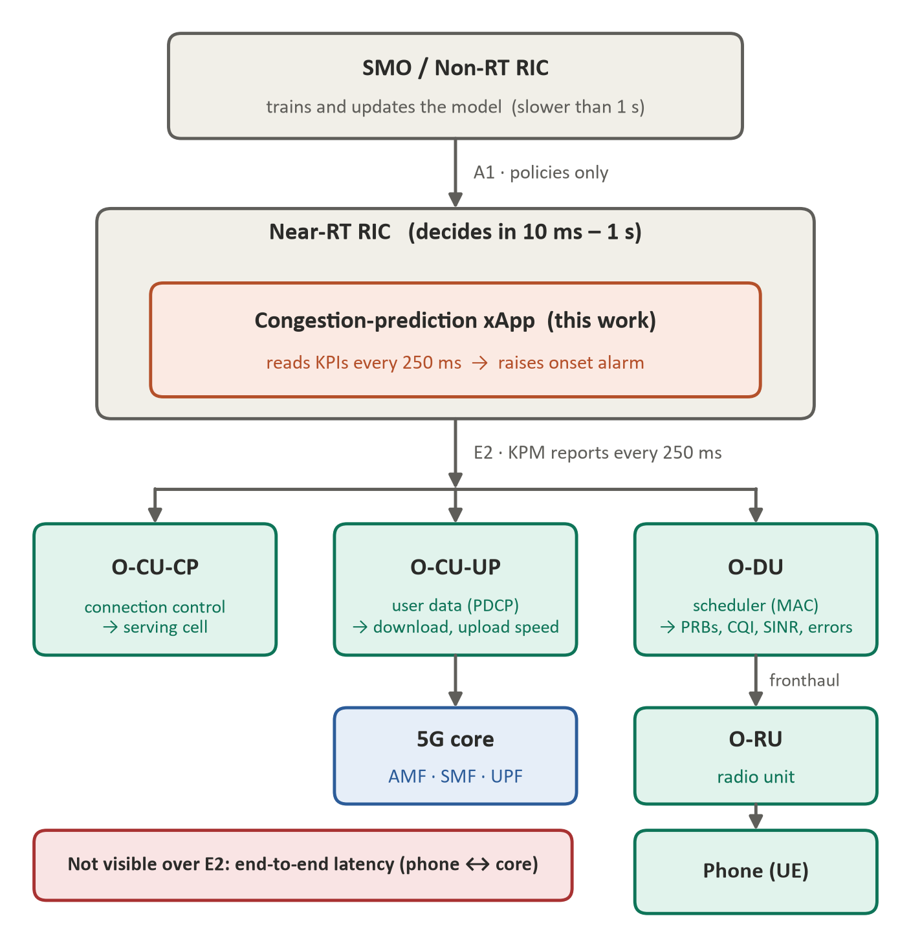
Figure 2. Target deployment. The predictor runs as an xApp on the near-RT RIC (coral) and reads measurements from the RAN nodes (teal) over E2 every 250 ms. Each node box names the measurements it produces. This placement is a design target; deployment is not performed here.

4. Key performance measurements: what each one achieves
Revision 2 listed the measurements by their names. This section orders them by the question each one answers about the network, states what each achieves for the prediction, and traces each to the part of the system that produces it.

4.1 How the measurements connect to congestion
Congestion in a cell is a shortage of PRBs. Every 250 ms a user needs a number of PRBs, set by how much data is waiting and by how many bits each PRB can carry for that user's radio link. The user gets a number of PRBs, set by how many are still free in the cell and by the scheduler's fairness rule. When a user gets less than half of what it needs, it is starved: its data queues, its speed drops and, a little later, the user notices. Figure 3 shows where each measurement enters this chain.
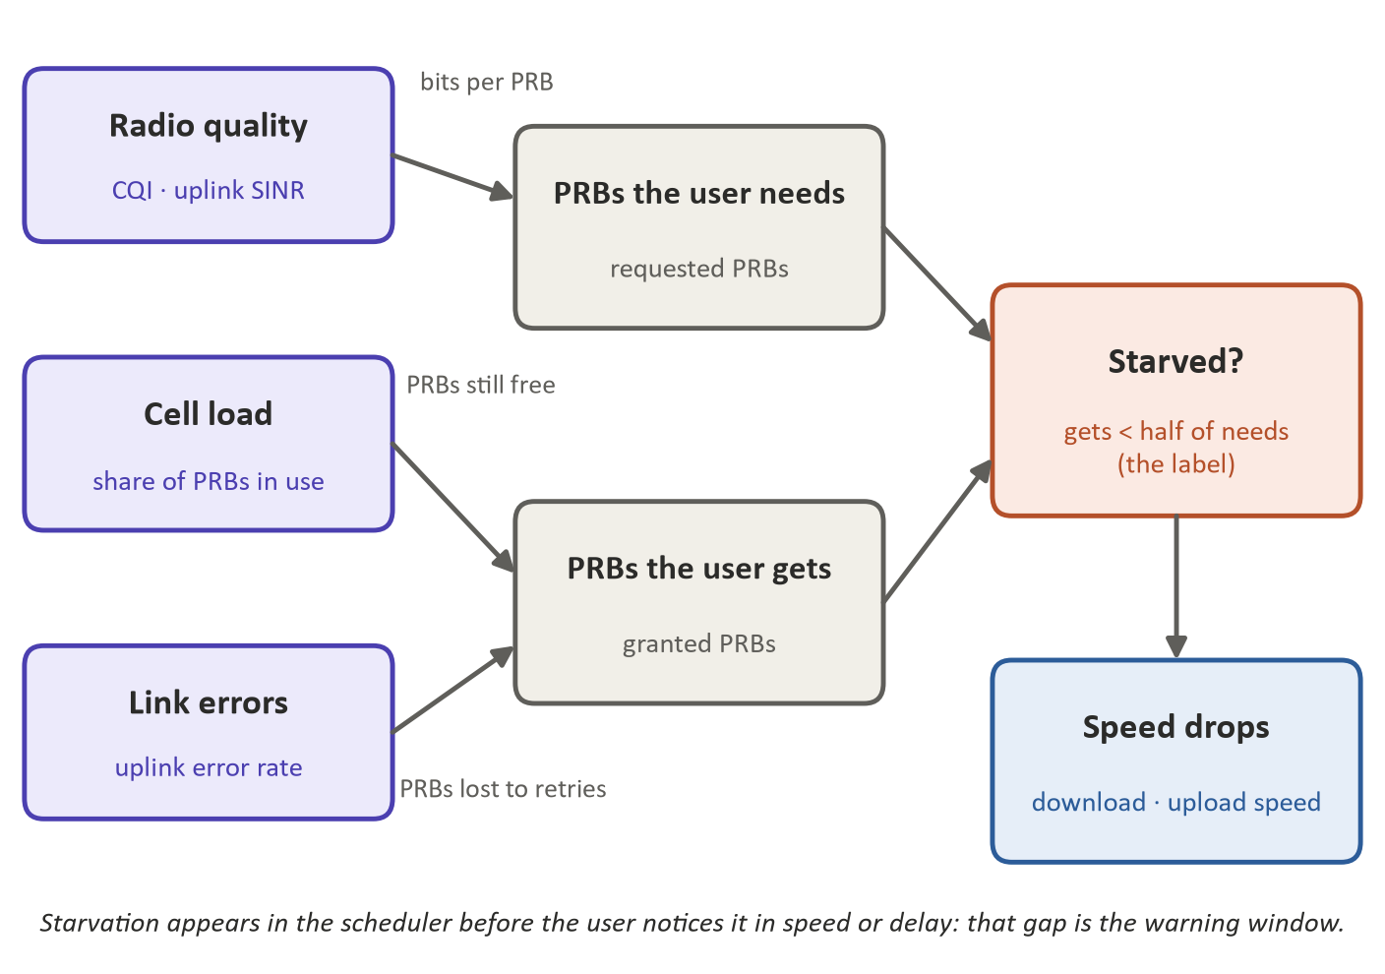
Figure 3. How the shared measurements relate to starvation. Radio quality sets how many PRBs a user needs; cell load and link errors limit how many it gets; starvation then shows up as lower speed. The scheduler sees the shortfall before the user does, which is the window prediction exploits.

4.2 The six shared measurements, ordered by the question they answer
The six model inputs are grouped below from the cell level to the individual user and from cause to effect: first whether the cell has room, then whether this user's link is efficient, then what the user actually receives, and finally whether capacity is being wasted.
Table 2. What each input achieves for the prediction and what it means in a real network.
Question | Measurement | What it achieves for the prediction | What it means in real life
A. Is the cell running out of room? | Cell load  cell_util  share of the cell's PRBs in use | The main warning sign. Near 100 % any new demand must be taken from another user, so starvation becomes possible; well below it, starvation is almost impossible. | A road with fixed lanes: near full, every extra car slows others. Busy at stadiums, stations, evening peaks.
B. Can this user's link carry data efficiently? | Downlink CQI  dl_cqi, 0–15 | Sets how many bits each PRB carries for this user. Low CQI means the same video needs more PRBs, so this user is starved first when the cell is busy. | The phone's signal quality: drops at the cell edge, indoors and near interference.
 | Uplink SINR  ul_sinr, dB | The uplink counterpart, measured at the base station. Low SINR means fewer bits per uplink PRB and more failed transmissions. | How clearly the tower hears the phone; falls with distance and with neighbouring cells.
C. Is the user actually getting data? | Download speed  dl_mbps | The delivered result. It falls when the user is starved, and its pattern reveals the kind of demand (steady video, bursty browsing). | What a speed test or a buffering video shows.
 | Upload speed  ul_mbps | The same for the uplink; heavy uploads compete for the cell's shared capacity. | Video calls, photo backups, cloud sync.
D. Is capacity being wasted? | Uplink error rate  ul_error_pct, % | Share of uplink transmissions that failed and are sent again. Every resend uses PRBs that move no new data, an early sign of a struggling link. | Having to repeat yourself on a bad phone line.

4.3 Where each measurement comes from in the system
The same quantity must come from the same place in both sources, otherwise a model can learn the difference between instruments instead of the difference between congested and free cells. Table 3 traces each input.
Table 3. Origin of each input in a real network, in the simulator and in TRACTOR.
Measurement | Produced by | Simulator (Simu5G) | Real data (TRACTOR column)
Cell load | O-DU, MAC scheduler (per cell) | avgServedBlocksDl at each gNB, summed over 250 ms, ÷ 12,500 | sum_granted_prbs summed over the cell's users, ÷ 12,500
Downlink CQI | Phone report → O-DU | averageCqiDl (phone, NR stack) | dl_cqi
Uplink SINR | O-DU uplink receiver | measuredSinrUl (per phone) | ul_sinr
Download speed | O-CU-UP, PDCP | PDCP bytes delivered to the phone | tx_brate downlink [Mbps]
Upload speed | O-CU-UP, PDCP | RLC bytes the phone sends | rx_brate uplink [Mbps]
Uplink error rate | O-DU, HARQ | harqErrorRateUl × 100 | rx_errors uplink (%)

All six reach the near-RT RIC over E2 every 250 ms. The ceiling of 12,500 PRBs per interval (250 slots of 1 ms × 50 PRBs) is identical in both sources, so cell load needs no rescaling. The real PRB counters are downlink: per-user grants track downlink speed (rank correlation 0.94) far more than uplink speed (0.33).

4.4 Measurements used only to build the label
The label needs what a user needs and what it gets. These quantities define the answer the model must predict, so they are never model inputs.
Table 4. Label inputs in each source.
Source | What the user needs | What the user gets | Starved when
TRACTOR (real) | Requested PRBs (downlink) | Granted PRBs | granted ÷ requested < 0.5
Simulator | Bytes the server sends to the phone (exact, constant rate) | Bytes the phone's app receives | received ÷ sent < 0.5

The simulator emits no requested-PRB statistic, so its label is measured in bytes. For one user in one interval, PRBs needed and PRBs granted are both bytes divided by the same bits-per-PRB, so the two ratios agree up to changes in modulation within the interval. Section 7.3 tests the alternatives.

4.5 Measurements deliberately left out
Table 5. Measurements that are not model inputs, and why.
Measurement | Why it is not an input
End-to-end latency | Not reported over E2; absent from TRACTOR
Buffer occupancy (downlink, uplink) | No buffer statistic exists in Simu5G 1.4.3
Requested PRBs | Not in Simu5G; used only to label TRACTOR
Per-user granted PRBs | Simu5G reports only the cell total, so the shared input is cell load
Serving cell, handovers | TRACTOR has a single cell, so these carry no information there
Downlink error rate | Zero in every TRACTOR record
Power headroom, RSSI, PMI, rank, turbo iterations | Zero or LTE-specific in TRACTOR
RLC throughput statistic | A running average since the start of the run; cannot react to load
Latency together with RLC delay | The same signal (correlation 1.0); using one to predict the other is leakage

4.6 Simulation-only quantities
Application latency, RLC delay, downlink SINR and HARQ attempts are recorded in the simulator only. They describe the scenarios (Section 7.1) and support a simulation-only upper-bound experiment, but they are never inputs in the transfer experiments.

5. Related work

5.1 Established sequence and graph models
The five approaches in the preliminary comparison represent the sequence and graph families established between 1997 and 2019: long short-term memory networks [15], temporal convolutional networks [16], GraphSAGE inductive graph learning [14] and classical Box–Jenkins forecasting [20]. Spatio-temporal graph models from road-traffic forecasting [17]–[19] are the structural ancestors of the hybrid proposed here.

5.2 Recent work, 2024 to 2026
Table 6. Recent work and its relevance.
Work | Relevance
PRB-RUPFormer (2026) [10] | Probabilistic transformer forecasting residual PRBs as a Non-RT RIC rApp. Closest target quantity; different timescale and tier.
Multi-scale structured state-space mixtures (2026) [11] | Lightweight per-user KPI forecaster inside the near-RT RIC; argues transformers are too heavy for near-real-time bounds.
Transformer traffic prediction in O-RAN (2024) [12] | Uses forecasts to switch a traffic-steering xApp or cell-sleeping rApp on demand; the closed-loop continuation of this work.
JEPA for AI-native 6G (2026) [13] | Argues task-specific forecasters transfer poorly across deployments, the concern measured here.
Sim-to-real studies [6]–[8] | Twinning commercial traces and measuring the sim-to-real gap on testbeds; motivate measuring the gap before modelling (Section 7.4).

The five models evaluated here predate the current state of the art, which has moved toward state-space and probabilistic transformer architectures. The choice is defended on inference cost, since the near-RT RIC imposes a sub-second budget; a state-space or gradient-boosted baseline is added in Stage 2 so the comparison is not one-sided.

5.3 Preliminary baseline comparison
Table 7. Earlier internal comparison (pre-repair pipeline; to be regenerated in Stage 2).
Model | ROC-AUC | F1 | Latency R² | Role
GraphSAGE GNN | 0.924 | 0.535 | 0.039 | Binary alarm
TCN | 0.880 | 0.507 | 0.775 | Balanced
LSTM | 0.879 | 0.482 | 0.832 | Numeric forecast
Moving average | 0.890 | 0.505 | 0.269 | Statistical floor
ARIMA (2,0,1) | 0.798 | 0.392 | −261.96 | Unstable

These numbers are not results. They came from the pre-repair pipeline, which had a feature identical to the target, a throughput column that was a running average, and empty columns. Two lessons survive: the moving average is a strong baseline, and no model won both classification and regression.

6. Methodology
Figure 1 (Section 1.4) shows the method. Sections 6.1–6.5 describe Stage 1, which is complete; Sections 6.6 and 6.7 describe Stage 2, which is planned.

6.1 Stage 1: repairing the simulator
The simulator is OMNeT++ 6.4.0 [23] with INET 4.6.0 [24] and Simu5G 1.4.3 [1]. A review of the configuration against the Simu5G source code, followed by real runs, found the faults in Table 8. Several were silent: OMNeT++ ignores a configuration line that matches nothing, and the first matching line wins, so a setting could look correct and have no effect.
Table 8. Faults found in the simulation and the parser, their effect, and the fix.
Fault | Effect | Fix
Network description path not set when run from a shell | Simulation stopped at start-up ("cannot resolve module type") | Launcher script that sets the path
Default transmit-power lines placed before per-tower lines | Every tower at 40 dBm instead of 46 (macro) and 30 (micro) | Reordered; phone power set on the active NR stack
Interference cells configured on a module they do not have | Four corner cells transmitted nothing; CQI almost constant (median 14, spread 0.25) | Ten background users per cell on the same carrier
Buffer limit set on the MAC layer | Never dropped anything; the queue lives in RLC | 128 KiB limit per user on RLC
HARQ-process setting | Ignored by Simu5G | Removed
Uplink SINR recorded at the tower | Always empty; Simu5G records it on the phone | Recorded per phone
Application delay under an INET name | Latency column would be empty | Correct Simu5G statistic
All default statistics recorded | Huge files; about 12 GB of memory reserved per run | Only the needed statistics
Uplink speed taken from what the phone tried to send | Uplink starvation invisible | Bytes actually sent
"HeavyLoad" lowered the video rate | Heavy scenario lighter than the baseline | Only web and IoT rates raised
Parser mixed the idle LTE stack's "cell 0" into the serving cell | False finding of zero handovers | Idle stack ignored; 1.3–2.7 handovers per user now
Parser put the cell's PRB total in a per-user column | Same name, different meaning in the two sources | Kept as cell load only

On Windows two further problems appeared: INET 4.6.0 did not export two classes that Simu5G needs (fixed by back-porting the upstream INET correction), and the per-vector buffer reservation exhausted memory when three runs started together (fixed by declaring vectors only once they hold data). Neither affects results.

6.2 Stage 1: the simulated scenarios
The network covers 1 km × 1 km: one macro cell (46 dBm) in the centre, three micro cells (30 dBm), and four interference-only cells at the corners. Fifty phones move by random waypoint at 1–5 m/s. The carrier has 50 PRBs at 15 kHz spacing (10 MHz, 1 ms slots) and a proportional-fair scheduler. A server sends constant-rate downlink traffic to three groups: video (users 0–19, 2.8 Mbit/s), web (20–34, 0.2 Mbit/s) and IoT (35–49, 32 kbit/s). Every phone also sends 40 kbit/s uplink, and users 0–29 add an 0.8 Mbit/s uplink burst between 50 and 65 s. Each run lasts 120 s.
Table 9. The six scenarios.
Scenario | Users | What it changes | Seeds
Light load | 20 | 40 kbit/s downlink per user: the uncongested reference | 3
Urban (baseline) | 50 | The traffic described above | 5
Gradual | 50 | Uplink burst starts in steps at 30, 50 and 70 s | 3
High mobility | 50 | Vehicular speed, 10–30 m/s | 3
Low mobility | 50 | Pedestrian speed, 0.5–1.5 m/s, long pauses | 3
Heavy load | 50 | Web and IoT users raised to 0.64 Mbit/s each | 5

6.3 Stage 1: preparing the real data (TRACTOR)
TRACTOR [2], [25] replays real smartphone traffic (video streaming, browsing, file transfer, video calls and background activity) through a complete srsRAN-based O-RAN system on the Colosseum radio emulator; an xApp records each phone's measurements every 250 ms over E2. It is a real protocol stack, a real scheduler and real traffic over an emulated radio channel, not a live commercial network. The multi-user logs hold 189 files in 33 conditions: Trial 0 has twelve single-class conditions (eMBB, URLLC or mMTC with one to four users); Trials 1–3 are load sweeps with four to ten users. Preparation:
- Read all 189 files; drop the single file without slicing columns.
- Align each condition's users on common 250 ms intervals.
- Compute cell-level quantities over all users before any filtering: cell load (sum of grants ÷ 12,500) and the number of users present.
- Keep only records with slicing disabled: 601,592 of 735,117. With slicing on, a 14-PRB slice cap fixes the grant regardless of load, which is configuration, not congestion (Section 7.2).
- Attach each user's traffic class from the trace lists (Trial 1 has none and is marked unknown).
- Map columns onto the six shared measurements (Table 3).

6.4 Stage 1: defining congestion (the label)
The same code labels both sources. For each user and 250 ms interval:
- Ratio = what the user gets ÷ what it needs (Table 4). Intervals with no demand have no ratio.
- Starved (raw) when the ratio is below 0.5: the user receives less than half of what it needs.
- Starved (state) with hysteresis: two starved intervals in a row to enter, two normal intervals in a row to leave. Single-interval blips are mostly noise. A gap in a user's record resets the state.
- Onset at time t when the user is not starved at t and is starved at t + 1 s (four intervals). Where t + 1 s lies outside the record, onset is undefined.
Revision 2 placed the threshold at 0.415, the valley of a two-mode mixture. Section 7.2 shows that those two modes are slicing-on against slicing-off records, so on slicing-free data there is no valley to fit. The threshold is therefore set by meaning (less than half) and its effect is reported across 0.2–0.8 (Figure 13).

6.5 Stage 1: experiment datasets
Table 10. Experiments and the datasets built for them. Rows are user-intervals; onsets in brackets.
Exp. | Train on | Test on | Question | Train rows | Test rows
E1 | Simulator | Simulator, held-out seeds | Does the model work at all? | 355,737 (24,693) | 129,809 (7,207)
E2 | Simulator | Real, unseen | Does it transfer with no help? (headline) | 485,546 (31,900) | 242,347 (1,026)
E3 | Simulator + 5/10/20 % real | Real, unseen | How much real data is needed? | 500,034–557,017 | 242,347 (1,026)
E4 | Real | Real, unseen | Upper bound; E4 − E2 is the gap | 359,245 (2,580) | 242,347 (1,026)
E5 | Real, 4–6 users | Real, 9–10 users | Does it extrapolate to higher load? | 139,104 (237) | 124,701 (1,355)

E2, E3 and E4 share one real test set, a fixed 30 % of each trial's conditions (Trial0 mmtc3, mmtc4, urllc1, urllc3; Trial1 multi4, multi10; Trial2 multi4, multi9; Trial3 multi6, multi10), so E4 − E2 compares models on identical data. E1 holds out the highest seed of every scenario. No user's record is split between training and testing, and the real slices in E3 are whole user sessions from outside the test set. Features are standardised with the training set's mean and deviation only. Automated checks confirm each of these properties.

6.6 Stage 2: models
Every model sees the last 2.5 s (ten intervals) of the six measurements for one user and outputs the probability of an onset one second later. Baselines set the floor: persistence (the label does not change), moving average, ARIMA, and gradient-boosted trees on windowed features, which often match small neural networks on tabular time series. The learned models are LSTM, TCN, GraphSAGE and a hybrid (Figure 4): a graph summary of all users in the same cell and interval is combined with the user's own history before a time encoder. The graph is not split by service class, because one class crowding out another is exactly what it should capture. All models are trained on the onset label directly and calibrated afterwards; no threshold is picked by hand.
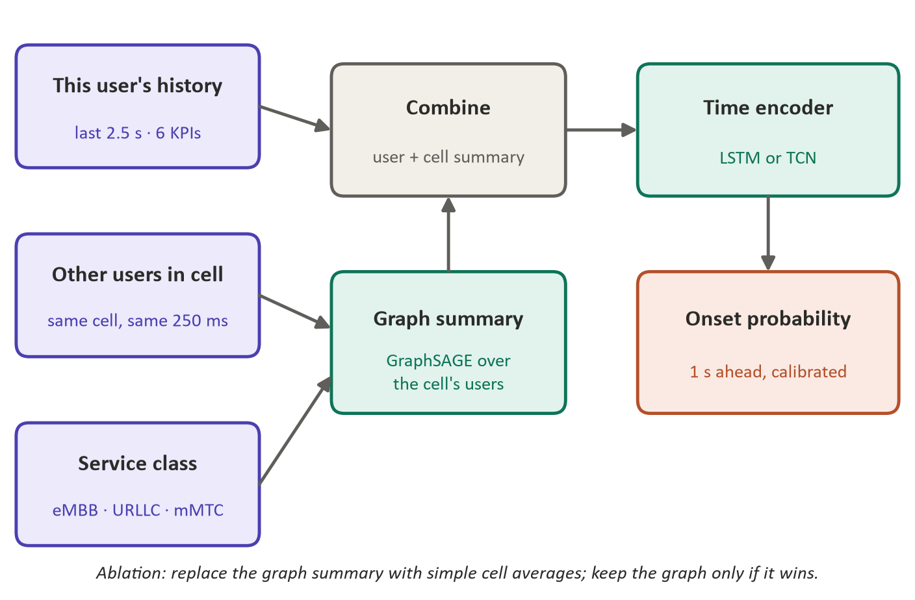
Figure 4. Hybrid model (Stage 2). A graph summary of the other users in the cell supplies contention context to a per-user time encoder that outputs a calibrated onset probability.
The ablation replaces the graph summary with simple cell averages; if accuracy holds, message passing is not earning its cost, and that is reported. In the real data the graph has one to ten nodes per cell.

6.7 Stage 2: evaluation protocol
Table 11. Metrics and why each is used.
Metric | Why
Precision–recall AUC (primary) | Onsets are rare (0.6 % of real intervals); ROC-AUC flatters models when positives are this rare
Precision, recall, F1 | Shown separately so the trade-off between false alarms and misses is visible
Reliability curve, Brier score | The output must be a usable probability, not only a ranking
Warning-time distribution | How far ahead true onsets are flagged, across all users and per class
False alarms on calm conditions | Measured on conditions with almost no starvation (one or two users)
Results per episode length | Episodes range from 0.5 s to 3 minutes; long ones must not dominate
Parameter count, inference time | Must fit the near-RT RIC's sub-second budget

Training on a mixture of both sources is avoided for the headline result: once real data enters training, the transfer claim can no longer be made. E3 measures what mixing buys.

7. Stage 1 results
This section reports what the Stage 1 data shows, with every figure computed from the final datasets.

7.1 The simulator now produces congestion
Revision 2 reported that the old simulation barely congested: latency moved from 8.9 to 11.5 ms during the burst. After the repairs, starvation responds to load as a congestion label should (Figure 5 and Table 12).
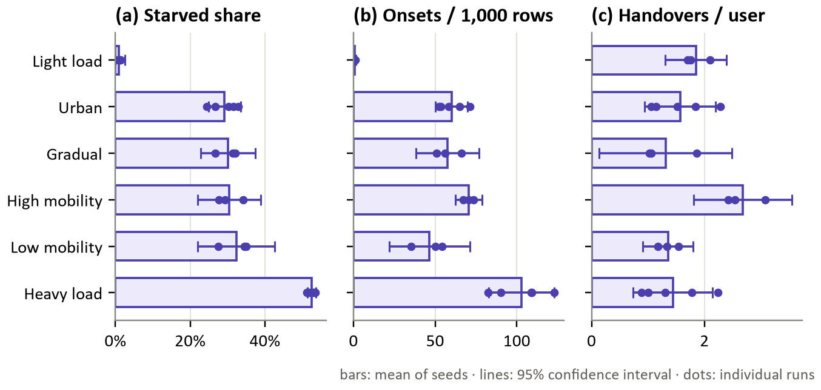
Figure 5. Simulator scenarios. (a) Share of user-intervals starved, (b) onsets per 1,000 user-intervals, (c) handovers per user in 120 s. Bars are means over seeds, lines 95 % confidence intervals, dots individual runs.
Table 12. Simulator scenarios: means over seeds, ± half-width of the 95 % confidence interval. Peak cell load is the 95th percentile of a cell's PRB share.
Scenario | Seeds | Starved (%) | Onsets / 1,000 | Peak cell load | CQI median | Handovers / user | Latency p50 / p95
Light load | 3 | 0.9 ± 1.7 | 0.9 ± 0.8 | 3 % | 14.0 | 1.8 | 5 / 10 ms
Urban | 5 | 29.2 ± 4.3 | 60.0 ± 9.9 | 89 % | 11.1 | 1.6 | 48 ms / 3.3 s
Gradual | 3 | 30.1 ± 7.3 | 57.6 ± 19.3 | 89 % | 11.3 | 1.3 | 45 ms / 3.2 s
High mobility | 3 | 30.4 ± 8.4 | 70.4 ± 8.2 | 90 % | 11.7 | 2.7 | 53 ms / 2.5 s
Low mobility | 3 | 32.3 ± 10.2 | 46.6 ± 24.6 | 88 % | 10.0 | 1.4 | 38 ms / 4.1 s
Heavy load | 5 | 52.5 ± 1.1 | 102.7 ± 20.0 | 89 % | 10.9 | 1.4 | 275 ms / 8.0 s

Light load stays essentially uncongested (0.9 ± 1.7 %). The urban baseline starves 29.2 ± 4.3 % of intervals and heavy load 52.5 ± 1.1 %, a clean load gradient comparable to TRACTOR's response to user count (Section 7.2). Mobility changes handovers as intended (2.7 per user at vehicular speed against 1.4 at walking pace) but hardly changes starvation. Median latency rises from 5 ms to 275 ms, and the 95th percentile reaches seconds because a starved user's 128 KiB queue drains slowly.
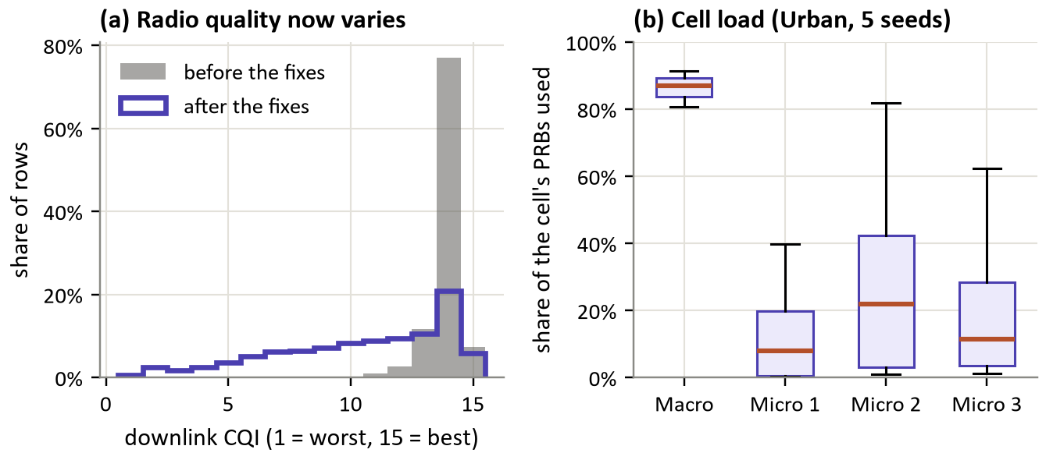
Figure 6. (a) Downlink CQI before the repairs (grey, old run) and after (blue, urban runs): with the interference cells active, radio quality now spans the full range. (b) PRB share used per cell in the urban scenario: the macro cell runs near capacity while the micro cells are lightly used.
Two properties of the scenario matter for Stage 2. First, radio quality now varies (Figure 6a): the CQI spread between quartiles grew from 0.25 to 5.7, and its 5th percentile fell from 12.7 to 3.6. Second, load is concentrated (Figure 6b): on average 42 of the 50 users attach to the 46 dBm macro cell, whose median load is 87 %, while the micro cells sit at 8–22 %. Nearly all contention happens inside one cell, which resembles TRACTOR's single cell more than intended.
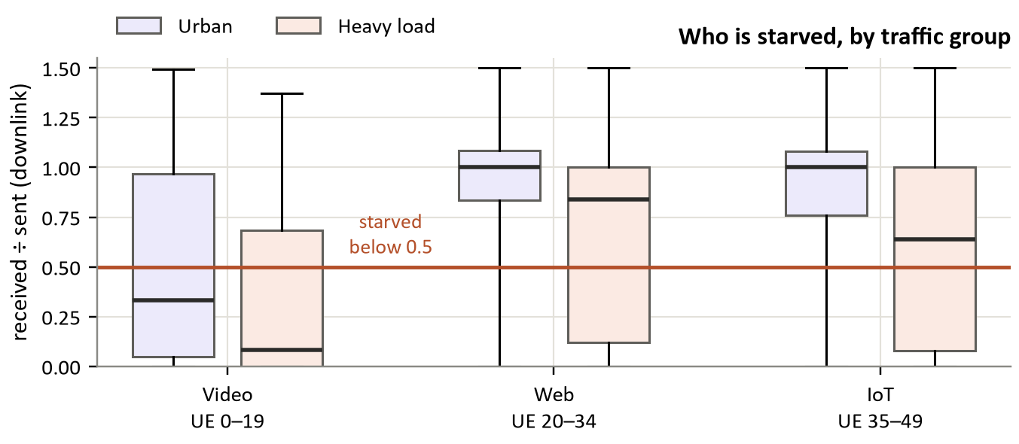
Figure 7. Downlink received ÷ sent per traffic group (box: quartiles; whiskers: 5th–95th percentile). In the urban scenario the video users are starved; in heavy load every group suffers.
Starvation falls on users whose demand is large relative to their link (Figure 7). In the urban scenario video users receive a median 0.33 of what is sent to them, while web and IoT users receive all of it. In heavy load the video median drops to 0.08 and web and IoT users, now at 0.64 Mbit/s, are starved in 40 % and 45 % of intervals. The scheduler shares PRBs fairly, so whoever needs the most PRBs per bit of demand is cut first.
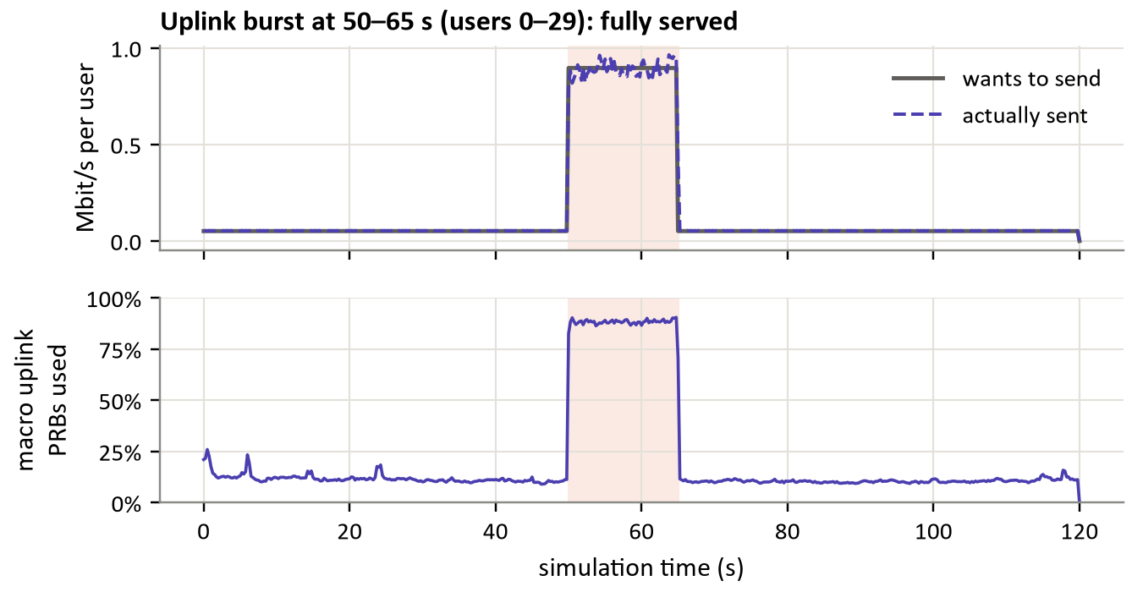
Figure 8. The uplink burst (shaded) in an urban run. Users 0–29 offer 0.9 Mbit/s each and are served almost exactly that; the macro cell's uplink PRB use rises from about 11 % to 88 % without saturating.
The uplink never congests (Figure 8): during the burst users send 0.89 of the 0.90 Mbit/s they offer, and macro uplink use rises from 11 % to 88 %. Uplink starvation stays at 0–2 % in every scenario, so all labels are downlink, like TRACTOR's, and the Gradual scenario, which only reshapes the burst, behaves like the urban one. A heavier burst would be needed to study uplink congestion.

7.2 What the real data shows
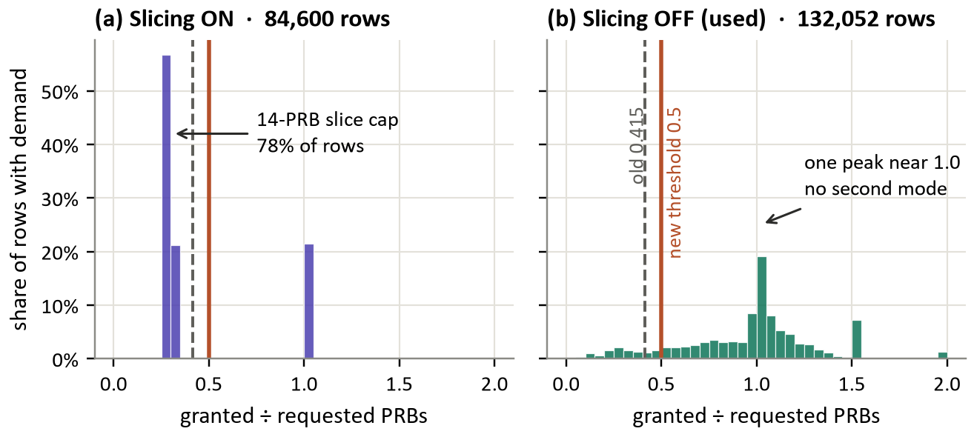
Figure 9. Granted ÷ requested PRBs in TRACTOR, intervals with demand. (a) With slicing on, the 14-PRB cap pins 78 % of intervals between 0.2 and 0.4. (b) With slicing off there is one peak near 1.0 and a smooth tail; values above 2 are drawn at 2.
The two-mode shape is slicing, not congestion. With slicing on, 78 % of intervals sit between 0.2 and 0.4 (median 0.294) and 22 % at 1.0. With slicing off there is a single mode at 1.01 (58 % of intervals between 0.9 and 1.5) and a smooth tail, with no second mode (Figure 9). The 0.292 / 0.978 modes and the 0.415 valley in revision 2 therefore separated capped from uncapped users. The same holds for mMTC devices, described in revision 2 as permanently capped: their median is 0.29 with slicing on and 1.29 with slicing off, so no per-user baseline is needed.
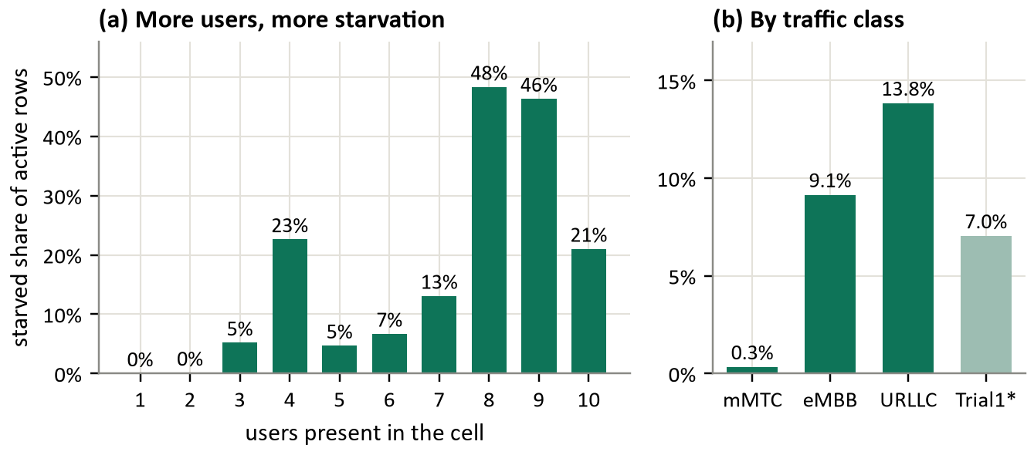
Figure 10. TRACTOR, slicing off: starved share of active intervals (a) by the number of users present and (b) by traffic class. *Trial 1 has no trace list, so its users' class is unknown.
Starvation follows load (Figure 10a): 0.0 % of active intervals with one user, 0.1 % with two, 5.2 % with three, and 48 %–46 % with eight or nine. The curve is not monotonic because each user count comes from a few conditions with different traffic mixes; ten users rest on only 490 active intervals. By class (Figure 10b), URLLC users are starved most (13.8 %), eMBB 9.1 %, mMTC almost never (0.3 %).
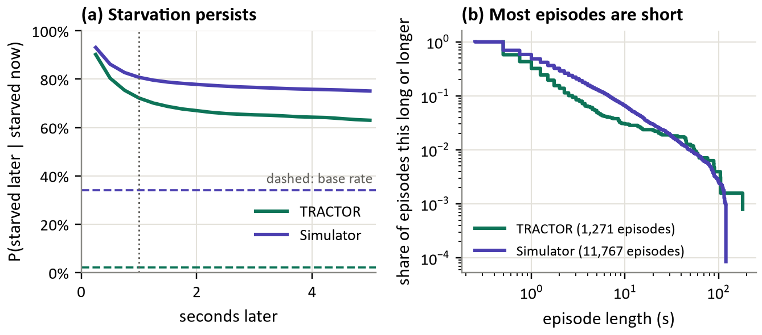
Figure 11. Persistence and length of starvation. (a) Probability of still being starved a given time later; dashed lines are base rates. (b) Share of episodes at least a given length (log–log).
Starvation persists but episodes are short (Figure 11). A starved real user is still starved one second later 72 % of the time against a base rate of 2.2 %, which is why the target is onset, not state. Yet most episodes are brief: median 0.75 s, 90 % shorter than 2.5 s, longest 181 s. The simulator's episodes are somewhat longer (median 1 s, 90 % under 6.8 s). Results in Stage 2 are therefore reported per episode-length band.
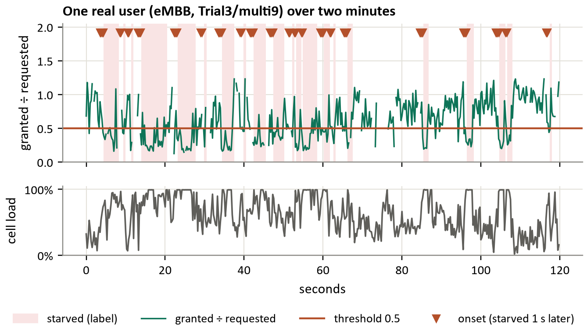
Figure 12. Two minutes of one real eMBB user (Trial3/multi9). Shaded: starved state; triangles: onsets, i.e. intervals one second before starvation begins. Gaps in the line are intervals with no demand. Below: the cell's PRB load.
Figure 12 shows what the label looks like on a single user: starvation coincides with the cell's PRB load approaching 100 %, and each onset marks the moment, one second ahead, that a model must flag.

7.3 Choosing and checking the label
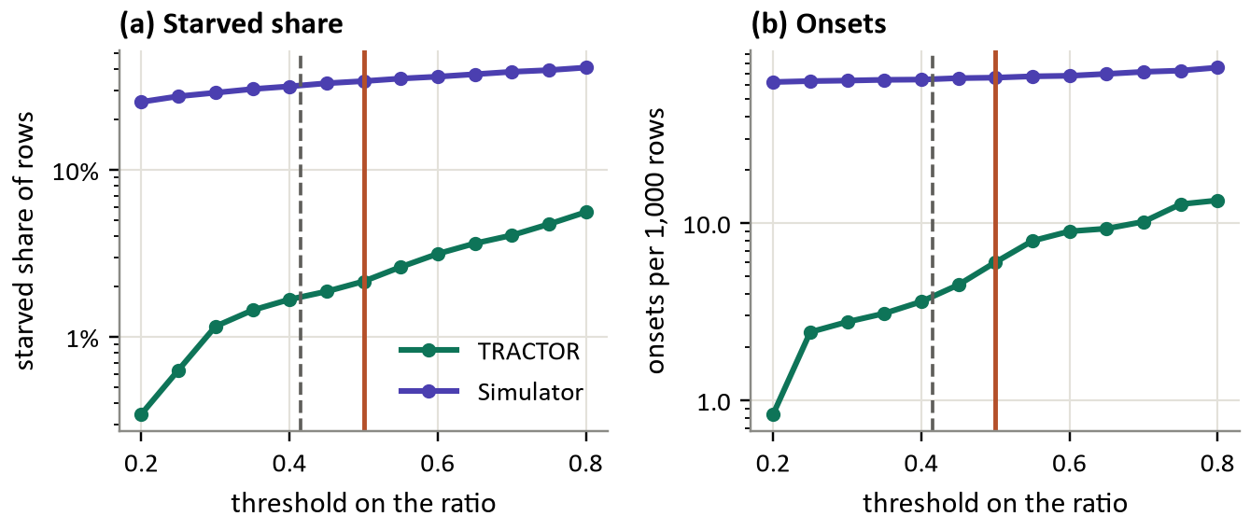
Figure 13. Sensitivity of the label to the threshold. (a) Starved share and (b) onsets per 1,000 user-intervals, both on a log scale. Solid vertical line: chosen 0.5; dashed: revision 2's 0.415.
Threshold. In TRACTOR the starved share rises steadily with the threshold, from 1.2 % at 0.3 to 2.2 % at 0.5 and 4.1 % at 0.7, with no plateau that would mark a natural cut (Figure 13). In the simulator the curve is nearly flat (29 % to 39 %): simulated starvation is deep, so most starved intervals are far below any reasonable threshold. 0.5 is kept for its plain meaning, and Stage 2 reports results at 0.3 and 0.7 as well.
Table 13. Checking ways to label the simulator against reference labels. Kappa: agreement beyond chance (1 = perfect, 0 = chance).
Candidate label | Tested on | Precision | Recall | Kappa | Verdict
Received ÷ (received + buffer growth) | TRACTOR vs true PRB label | 0.95 | 0.006 | 0.01 | Not usable on real data
Cell load ≥ 90 % while the user is active | TRACTOR vs true PRB label | 0.59 | 0.65 | 0.61 | Works in one cell
Cell load ≥ 90 % while the user is active | Simulator vs received ÷ sent | 0.21 | 0.05 | -0.05 | Fails in the simulator

Simulator label. Revision 2 planned a proxy from cell load and a per-user throughput drop, validated on TRACTOR. Table 13 shows the result. A cell-saturation rule agrees well with the true label on TRACTOR (kappa 0.61) but not with the simulator's direct measurement (kappa -0.05; -0.13 at a 70 % threshold): in the multi-cell simulator the macro cell is near capacity much of the time, and which user starves depends on its own radio link, not on the cell. Rebuilding the simulator's byte ratio on TRACTOR also fails, for a different reason: when a real user is starved its downlink buffer is already standing (median 10 kB against 0), so served bytes plus buffer growth barely differ from served bytes. Real traffic adapts or is dropped, while the simulator's constant-rate traffic does not. The simulator is therefore labelled with received ÷ sent bytes, which is exact there (Section 4.4); the remaining difference between the two labels is stated as a limitation.

7.4 Simulation against reality, before any model
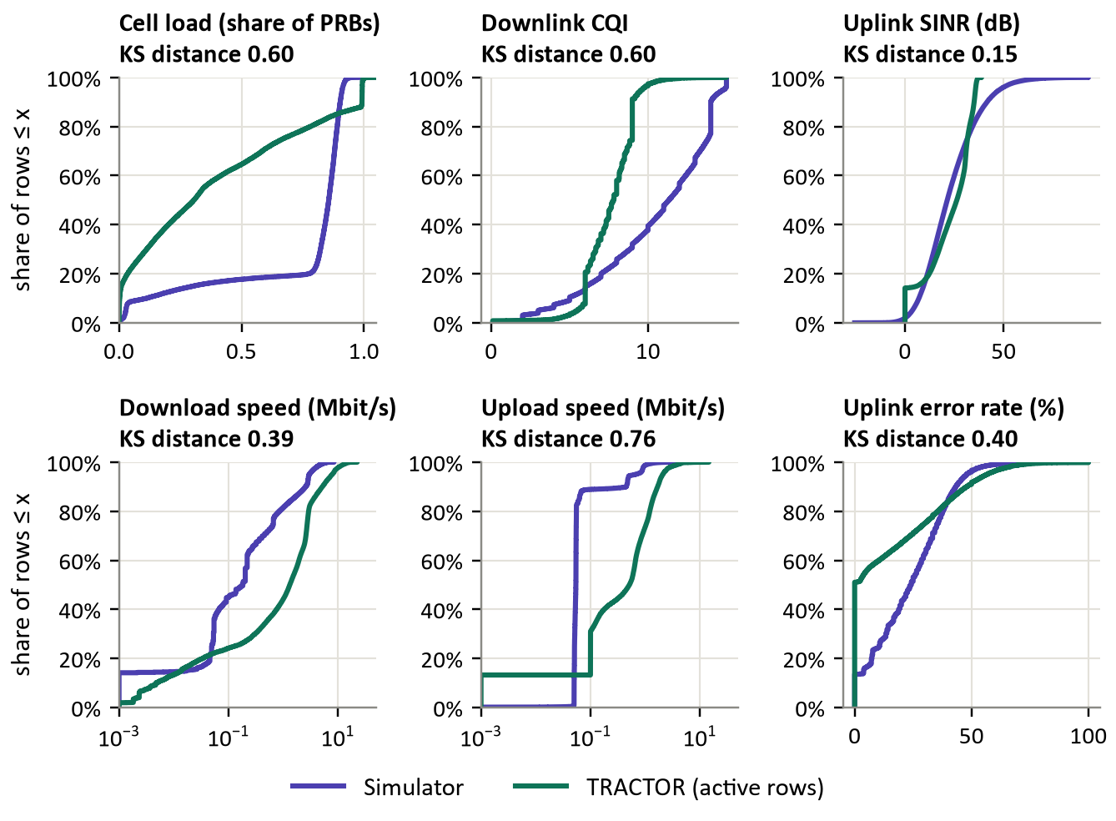
Figure 14. Distribution of each shared input in the simulator (all intervals) and in TRACTOR (intervals with demand), as cumulative shares. The Kolmogorov–Smirnov distance is the largest vertical gap (0 = identical, 1 = no overlap).
Table 14. The shared inputs in both sources: medians and distance.
Measurement | Simulator median | TRACTOR median (active) | KS distance | Reading
Cell load | 0.86 | 0.31 | 0.60 | Simulated macro cell far busier
Downlink CQI | 11.3 | 7.8 | 0.60 | Simulated radio better
Uplink SINR (dB) | 21.4 | 26.3 | 0.15 | Close: the best-aligned input
Download speed (Mbit/s) | 0.18 | 1.32 | 0.39 | Real users far faster when active
Upload speed (Mbit/s) | 0.05 | 0.51 | 0.76 | Largest mismatch
Uplink error rate (%) | 24 | 0 | 0.40 | Half of real intervals error-free

Only uplink SINR is well aligned (Figure 14, Table 14). Cell load and CQI differ in opposite ways: the simulated macro cell is busier but its radio is better. Real users move far more data when active, and the simulated uplink error rate (median 24 %) has no counterpart in the real data, where half of active intervals have no errors at all. Label prevalence differs by an order of magnitude (Figure 15a): 34.1 % of simulated intervals are starved against 2.2 % of real ones, and onsets are 6.6 % against 0.6 %.
These gaps exist before any model is trained, and they shape Stage 2:
- A model trained on the simulator will see real inputs outside its training range; E2 measures the cost.
- Probabilities calibrated on simulated data will be far too high on real data; calibration is evaluated per source and precision–recall AUC is the primary metric.
- Standardising each source with its own statistics, and dropping the uplink error rate, are tested as ablations.
- The uplink-SINR alignment and the shared load–starvation relationship (Figures 5 and 10) are what a model can hope to transfer.

7.5 Datasets ready for Stage 2
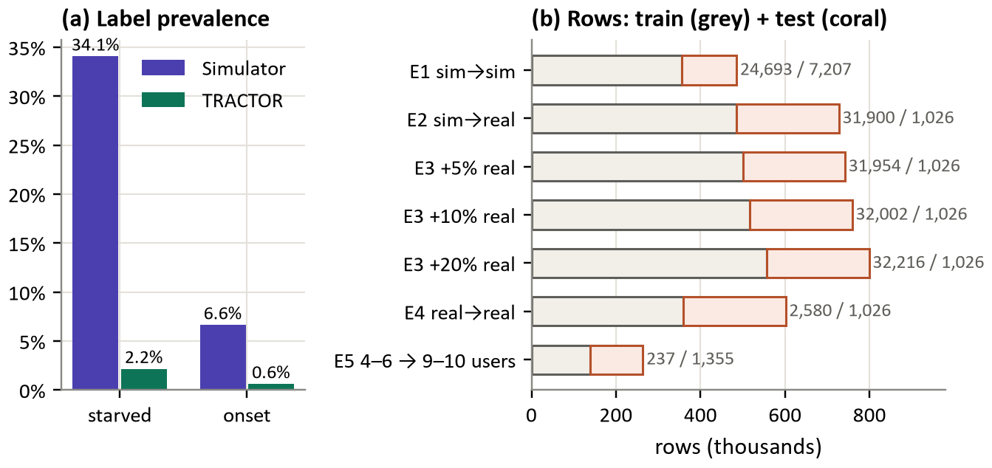
Figure 15. (a) Share of intervals starved and with an onset in each source. (b) Train (grey) and test (coral) rows per experiment; labels give onsets in train / test.
All seven datasets (Figure 15b) pass the automated checks: no user record crosses train and test, E2–E4 share one test set, E3's real rows come only from the training pool, and features are standardised with training statistics. E5 has only 237 onsets to learn from, since four to six users rarely starve, against 1,355 to predict at nine or ten users; that imbalance is the point of the experiment.

8. Deployment context
The model is designed as an xApp on the near-RT RIC (Figure 2): it would read the six measurements for each user over E2 every 250 ms, keep a 2.5 s history and output an onset probability within the same interval. Training and lifecycle management sit in the Non-RT RIC and SMO; A1 carries policy down and no telemetry. Because every input is an E2SM-KPM quantity [21], the model needs no node-internal state and no handset instrumentation. Deployment and closed-loop evaluation are not performed here; the intended next step is a simulated control loop inside OMNeT++ in which predictions bias the scheduler and the change in quality of service is measured, described as a simulated loop rather than an xApp.

9. Limitations
- One real cell. TRACTOR is single-cell, so the graph models contention among users of one scheduler, not spatial structure across cells.
- Emulated radio. TRACTOR's channel is emulated, not over the air.
- MAC-level inputs. The transferable inputs are almost all MAC-layer quantities, which recent work finds insufficient on their own to describe user experience [6].
- Different label instruments. The real label is PRB-based, the simulated one byte-based. They agree in principle (Section 4.4) but cannot be checked against each other directly; an identical label needs Simu5G patched to emit requested PRBs.
- Different traffic. Simulated traffic is constant-rate; real traffic is bursty and adapts to the network. Real users have demand in 22 % of intervals, simulated users in all of them.
- Large shift before modelling. Four of six inputs differ strongly (KS 0.39–0.76).
- Real trials are not repeats. Trials 2 and 3 assign the same trace to the same user in 2 of 49 cases, and Trial 1 has no trace list.
- Few seeds. Three to five seeds per scenario leave wide confidence intervals for some quantities.
- No uplink congestion in the simulator.

10. Corrections to revision 2
Recorded so that no superseded claim survives into the final paper.
Table 15. Claims in revision 2 that the data does not support.
Revision 2 said | What the data shows | Change
Ratio bimodal: starved mode 0.292, served 0.978, valley 0.415 | Slicing artefact; one mode with slicing off (Figure 9) | Threshold 0.5 by meaning, with sensitivity
Per-user baseline needed: mMTC sits at the starved mode | mMTC median 1.29 with slicing off | One absolute threshold
114,057 starved records (15.4 %) | 2.2 % of slicing-off records (9.5 % of active ones) | Updated
8,670 onsets at 1 s | 3,606 | Updated
Starvation 0.006 % with one user, 82 % with nine | 0 % → 46 % of active intervals (Figure 10) | Updated
Persistence 0.86–0.97 on the state label | 0.72 after 1 s (base 0.022) | Updated; onset framing kept
Median episode 2 intervals, longest over 1,900 | Median 3, longest 725 | Updated
350 continuity segments | Not needed: a gap resets the label state | Removed
Simulator proxy: cell load + throughput drop | Kappa 0.61 on TRACTOR, -0.05 in the simulator | Received ÷ sent bytes
Uplink SINR measured on the gNB channel model | Simu5G records it on the phone | Recorded per phone
App delay is endToEndDelay; cbrFrameDelay absent | The opposite for the CbrReceiver | Fixed
Zero handovers | Parser artefact; 1.3–2.7 per user | Fixed
Granted PRBs as a per-user input | Simulator has only the cell total | Input is cell load
Scalers fitted per source | Train-set scaling used; per-source scaling is an ablation | Stage 2

11. Stage 2 plan and future work

11.1 Stage 2 steps
- Run the floor baselines (persistence, moving average, ARIMA, gradient-boosted trees) on E1–E5.
- Train LSTM, TCN and GraphSAGE under one protocol with several seeds and confidence intervals.
- Build the hybrid model and its ablation against simple cell averages.
- Calibrate every model; report precision–recall AUC, reliability, warning time, false alarms on calm conditions, results per episode length, parameter count and inference time.
- Test per-source standardisation and the removal of the uplink error rate as ablations.
- Report the transfer gap (E4 − E2), the real data needed to close it (E3) and load extrapolation (E5).

11.2 Optional strengthening
- More seeds for the scenarios with wide confidence intervals (up to ten are configured).
- A heavier uplink burst, so that uplink congestion can be studied.
- A topology matched to TRACTOR (one cell, four to ten users) to separate topology mismatch from the sim-to-real gap proper.

11.3 Future applications
- Closing the loop, so that a predicted onset triggers a scheduling or mobility action rather than an alarm.
- Energy saving, by predicting intervals in which a cell can be powered down without harm.
- Protecting latency-sensitive traffic from broadband contention before degradation occurs.
- Intent-driven operation, where the network's own predictions determine the configuration needed for an operator's goal.

12. References
[1] G. Nardini, D. Sabella, G. Stea, P. Thakkar and A. Virdis, “Simu5G – An OMNeT++ Library for End-to-End Performance Evaluation of 5G Networks,” IEEE Access, vol. 8, pp. 181176–181191, 2020.
[2] J. Groen, M. Belgiovine, U. Demir, B. Kim and K. R. Chowdhury, “TRACTOR: Traffic Analysis and Classification Tool for Open RAN,” IEEE ICC, 2024, pp. 4894–4899.
[3] J. Groen, Z. Yang, D. Muruganandham, M. Belgiovine, L. Ying and K. Chowdhury, “From classification to optimization: Slicing and resource management with TRACTOR,” Computer Communications, vol. 257, art. 108625, 2026.
[4] A. Lacava, M. Bordin, M. Polese, R. Sivaraj, T. Zugno, F. Cuomo and T. Melodia, “ns-O-RAN: Simulating O-RAN 5G Systems in ns-3,” Proc. 2023 Workshop on ns-3, pp. 35–44.
[5] M. Polese, L. Bonati, S. D’Oro, S. Basagni and T. Melodia, “ColO-RAN: Developing Machine Learning-based xApps for Open RAN Closed-loop Control on Programmable Experimental Platforms,” IEEE Transactions on Mobile Computing, vol. 22, no. 10, pp. 5787–5800.
[6] L. Bonati, R. Shirkhani, C. Fiandrino, S. Maxenti, S. D’Oro, M. Polese and T. Melodia, “Twinning Commercial Network Traces on Experimental Open RAN Platforms,” ACM MobiCom, 2024, pp. 1914–1921.
[7] C. Ruah, H. Sifaou, O. Simeone and B. M. Al-Hashimi, “How to Bridge the Sim-to-Real Gap in Digital Twin-Aided Telecommunication Networks,” arXiv:2507.07067.
[8] M. McManus, Y. Cui, J. Z. Zhang, E. S. Bentley, M. Medley, N. Mastronarde and Z. Guan, “On the Effects of Modeling on the Sim-to-Real Transfer Gap in Twinning the POWDER Platform,” IEEE GLOBECOM Workshops, 2024.
[9] D. Raca, D. Leahy, C. J. Sreenan and J. J. Quinlan, “Beyond Throughput, the Next Generation: A 5G Dataset with Channel and Context Metrics,” ACM MMSys, 2020, pp. 303–308.
[10] “PRB-RUPFormer: A Recursive Unified Probabilistic Transformer for Residual PRB Forecasting,” arXiv:2605.15363, 2026.
[11] F. Rezazadeh, H. Chergui, M. Debbah, H. Song and L. Liu, “Rivaling Transformers: Multi-Scale Structured State-Space Mixtures for Agentic 6G O-RAN,” arXiv:2510.05255.
[12] “Transformer-Based Wireless Traffic Prediction and Network Optimization in O-RAN,” arXiv:2403.10808.
[13] “JEPA for AI-Native 6G: Predictive Representations and Open Challenges,” arXiv:2607.09798.
[14] W. L. Hamilton, R. Ying and J. Leskovec, “Inductive representation learning on large graphs,” Advances in Neural Information Processing Systems, vol. 30, 2017, pp. 1024–1034.
[15] S. Hochreiter and J. Schmidhuber, “Long short-term memory,” Neural Computation, vol. 9, no. 8, 1997, pp. 1735–1780.
[16] S. Bai, J. Z. Kolter and V. Koltun, “An empirical evaluation of generic convolutional and recurrent networks for sequence modeling,” arXiv:1803.01271, 2018.
[17] Y. Li, R. Yu, C. Shahabi and Y. Liu, “Diffusion convolutional recurrent neural network: Data-driven traffic forecasting,” ICLR, 2018.
[18] B. Yu, H. Yin and Z. Zhu, “Spatio-temporal graph convolutional networks,” IJCAI, 2018, pp. 3634–3640.
[19] S. Guo, Y. Lin, N. Feng, C. Song and H. Wan, “Attention based spatial-temporal graph convolutional networks for traffic flow forecasting,” AAAI, vol. 33, no. 1, 2019, pp. 922–929.
[20] G. E. P. Box, G. M. Jenkins, G. C. Reinsel and G. M. Ljung, Time Series Analysis: Forecasting and Control, 5th ed., Wiley, 2015.
[21] O-RAN Alliance, E2 Service Model — Key Performance Measurement (O-RAN.WG3.E2SM-KPM), and O-RAN Architecture Description.
[22] ITU-T Recommendation Y.3172, Architectural framework for machine learning in future networks including IMT-2020.
[23] A. Varga and R. Hornig, “An overview of the OMNeT++ simulation environment,” Proc. SIMUTools, 2008.
[24] L. Mészáros, A. Varga and M. Kirsche, “INET Framework,” in Recent Advances in Network Simulation, A. Virdis and M. Kirsche, Eds., Springer, 2019, pp. 55–106.
[25] TRACTOR repository, logs/Multi-UE, https://github.com/genesys-neu/TRACTOR (commit 9509fbf, accessed 2 October 2026).
Entries 5, 10, 12, 13 and 21 still need author lists or exact versions confirmed; standards must be cited with the version and date of the document actually used.

