Proactive 5G Congestion Prediction
LSTM vs. GNN (GraphSAGE) — Model Report & Comparative Analysis
This report documents the design, training, and evaluation of two deep-learning models — an LSTM sequence predictor and a GraphSAGE-based Graph Neural Network (GNN) — built to proactively predict 5G network congestion from OMNeT++/Simu5G simulation data. Both models were trained on a UDP-burst congestion scenario and evaluated on a completely unseen gradual-ramp congestion scenario, to test real generalisation rather than memorisation of one traffic pattern.

1. Objective
The core goal of the project is early warning: instead of reacting to congestion after MAC queues overflow, predict rising latency/HARQ retransmissions/throughput drops ahead of time so that a scheduler or admission-control policy could act proactively. Two modelling approaches were compared:
- LSTM — treats each UE (User Equipment) as an independent time series and predicts its own next-step KPIs from its own history.
- GNN (GraphSAGE) — treats UEs sharing the same serving cell as a graph, so a UE's prediction can be influenced by neighbouring UEs contending for the same radio resources.
The hypothesis being tested: does modelling shared-cell resource contention (graph structure) improve congestion prediction over treating each UE in isolation (pure time series)?

2. Dataset & Common Setup
Both models consume the same per-UE, per-time-bin KPI table (100ms bins) simulated in OMNeT++/Simu5G, with 8 input features:
- Avg_Latency, Total_Throughput, Avg_CQI, Avg_SINR, Avg_PacketLoss, Avg_HARQ_Attempts, Avg_RLC_Delay, Total_Throughput_UL
Both use a sliding window of 10 time bins (1 second of history) to predict the next time bin. All features/targets are normalised with a StandardScaler fit on the training data only, then inverse-transformed before computing metrics — so all reported errors are in original physical units (seconds, Mbps, retransmission counts).
Training scenario: UDP burst congestion (artificial spike, T = 50–65s). Evaluation scenario: Gradual ramp congestion — a pattern the models never saw during training. This cross-scenario test is what makes the results meaningful: it measures generalisation to an unfamiliar congestion shape, not just interpolation within a known pattern.

3. LSTM Model

3.1 Architecture
- 2-layer LSTM, hidden size = 64, dropout = 0.2
- Input: (batch, window = 10, features = 8)
- Output head: LayerNorm → Linear(64→32) → ReLU → Dropout → Linear(32→3)
- Targets (multi-output regression): Avg_Latency, Total_Throughput, Avg_HARQ_Attempts — all three predicted simultaneously
- Total parameters: 54,531
- Loss: MSE · Optimiser: Adam (lr = 1e-3, weight_decay = 1e-4) · LR scheduler: ReduceLROnPlateau (patience = 5, factor = 0.5)
Each UE's KPI history is windowed independently (grouped by Node_ID before windowing), so the LSTM never sees information about other UEs — it purely extrapolates a single UE's own trend.

3.2 Training Behaviour
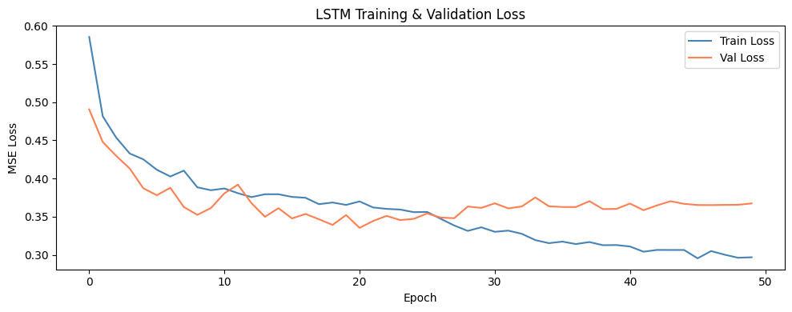
Figure 1 — LSTM training & validation loss over 50 epochs.
Training loss falls smoothly from ~0.58 to ~0.30. Validation loss tracks closely and plateaus around ~0.36–0.37 after epoch ~25, while train loss keeps decreasing slightly — a mild, non-alarming train/val gap indicating the model is close to its capacity limit on this data rather than badly overfitting. Best validation loss achieved: 0.33543.

3.3 Test-Set Results
Target | MAE | RMSE | R²
Avg_Latency | 0.0632 | 0.3747 | 0.8593
Total_Throughput | 0.2209 | 0.8339 | 0.2190
Avg_HARQ_Attempts | 0.3384 | 0.5178 | 0.7261

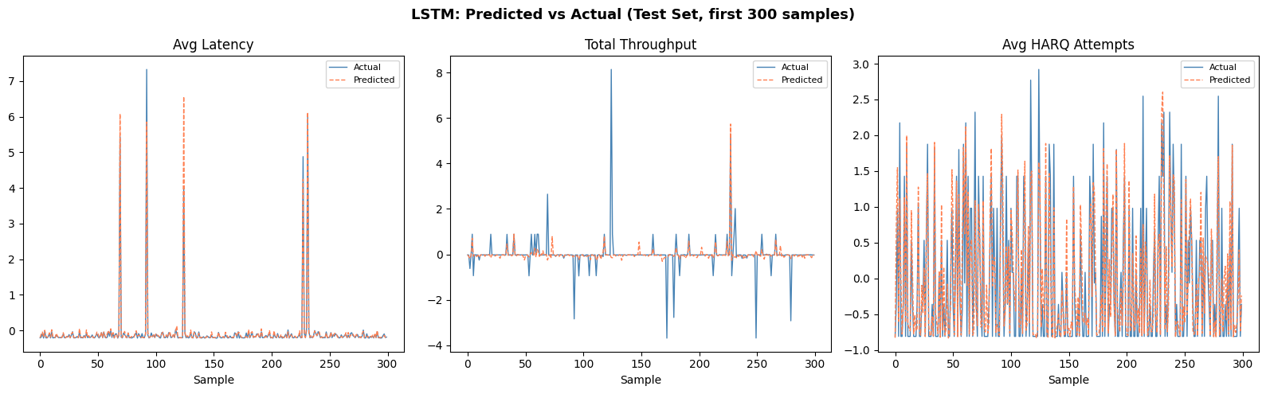
Figure 2 — LSTM predicted vs. actual values over the first 300 test samples for each target.
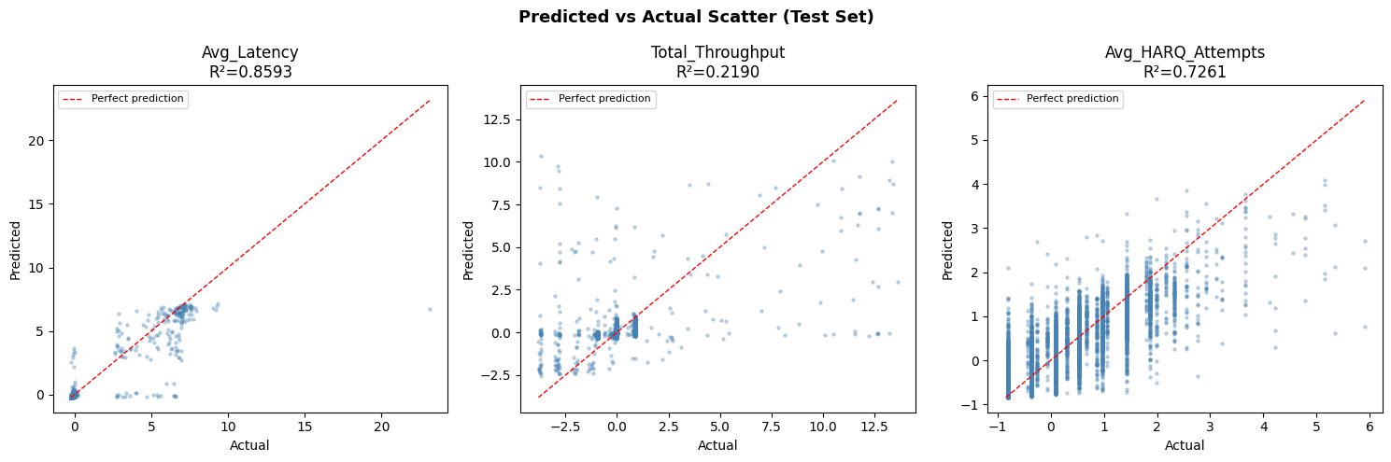
Figure 3 — LSTM predicted vs. actual scatter plots with R² per target.
Interpretation:
- Avg_Latency (R²=0.86) is predicted well — the LSTM tracks latency spikes closely (Figure 2, left panel), including the sharp burst events.
- Avg_HARQ_Attempts (R²=0.73) is predicted reasonably, though with more scatter — HARQ retransmission counts are noisier/more discrete, which naturally caps achievable R².
- Total_Throughput (R²=0.22) is the weak point. The scatter plot shows predictions clustered near zero regardless of the true value, meaning the LSTM has largely learned to predict the mean throughput rather than react to real fluctuations. This is a real limitation, not a display artifact — throughput swings are apparently harder for a single-UE LSTM to anticipate from the given feature set alone.

4. GNN (GraphSAGE) Model

4.1 Architecture
- 3-layer GraphSAGE, hidden_dim = 64
- Nodes = UEs present in a given time bin; Edges = UEs sharing the same serving cell (undirected, fully-connected within each cell)
- Each layer: SAGEConv → BatchNorm → ReLU → Dropout
- Output head: Linear(64→32) → ReLU → Dropout → Linear(32→1)
- Target: only Avg_Latency at the next time bin (single-output regression — unlike the LSTM's 3 targets)
- Total parameters: 20,097 (roughly 1/3 the size of the LSTM)
- One graph is built per time-bin transition (t → t+1); training uses 60 epochs vs. the LSTM's 50
Because the model predicts one value (latency) rather than three, and the GNN aggregates each UE's own features together with its same-cell neighbours' features (message passing via SAGEConv), it has direct access to information the LSTM cannot see: how busy the rest of the cell is right now.

4.2 Training Behaviour
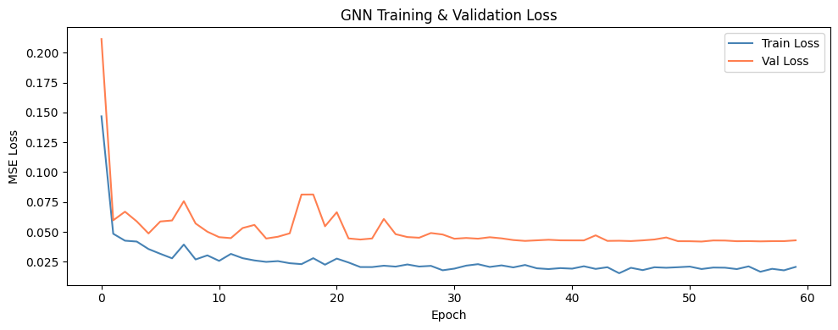
Figure 4 — GNN training & validation loss over 60 epochs.
Loss drops very fast in the first ~5 epochs (0.15→0.03) then plateaus with visible noise, and validation loss sits consistently slightly above training loss (~0.04–0.05 vs ~0.02). This is a smaller, faster-converging model — consistent with it solving an easier single-target problem with fewer parameters. Best validation loss: 0.04196 (not directly comparable to the LSTM's 0.335 since it's a single-target loss on a different scale).

4.3 Test-Set Results (Regression)
Target | MAE (s) | RMSE (s) | R²
Avg_Latency | 0.0716 | 0.2461 | 0.9688

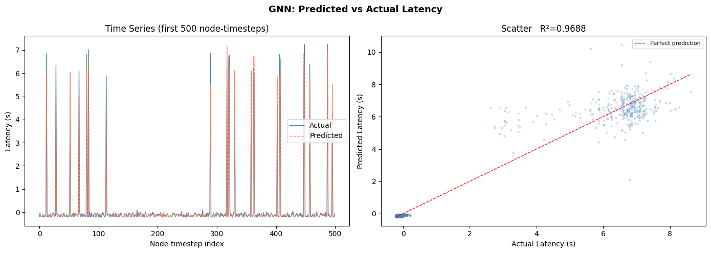
Figure 5 — GNN predicted vs. actual latency: time series (left) and scatter with R² (right).
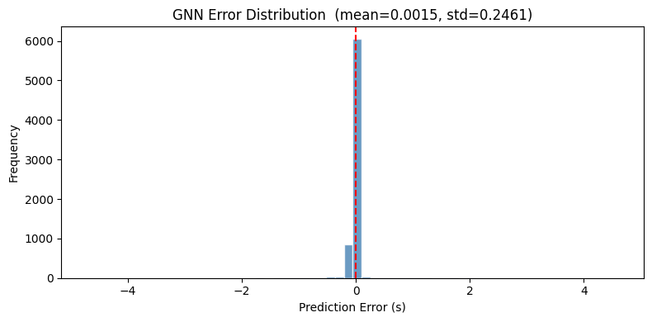
Figure 6 — GNN prediction error distribution (mean ≈ 0.0015s, std ≈ 0.246s).
On its own held-out test set (same scenario family it was trained on), the GNN's latency R² (0.97) beats the LSTM's latency R² (0.86), and its error distribution is tightly centred at zero. This suggests same-cell neighbour information genuinely helps forecast an individual UE's next-step latency when the test data resembles the training distribution.

5. Cross-Scenario Evaluation: Congestion Classification
The regression metrics above (Sections 3.3 and 4.3) are each measured on a held-out split of the same scenario the model was trained on. The more important test for a real deployment is: does the model still work on a traffic pattern it has never seen? For this, both models were re-evaluated on the gradual-ramp scenario, and their continuous latency predictions were converted into a binary congestion alarm.

5.1 Congestion Label Definition
A time bin is labelled 'congested' if at least 2 of 4 conditions hold, each measured against a threshold set from the training data's 90th/85th percentile: Avg_Latency, Avg_HARQ_Attempts, and Avg_RLC_Delay above their 90th percentile, or Avg_PacketLoss above its 85th percentile.
Split | Rows | Latency threshold | HARQ threshold | Congestion rate
Train | 56,405 | 0.0108 s | 2.000 | —
Test (gradual ramp) | 55,541 | 0.0108 s | 2.000 | 9.68%

5.2 From Regression Output to Congestion Probability
Neither model was trained as a classifier. To get a congestion probability, each model's predicted latency is passed through a sigmoid centred on the latency threshold: prob = 1 / (1 + exp(-scale × (predicted_latency − threshold))), then thresholded to a 0/1 alarm.
The LSTM used a decision threshold of 0.5 directly. For the GNN, a threshold sweep was run (this is the fix we added to the evaluation notebook), because the default 0.5 threshold turned out to be poorly calibrated:
Threshold | Precision | Recall | F1
0.05 – 0.30 | 0.083 | 1.000 | 0.154
0.40 | 0.205 | 0.971 | 0.338
0.46 (best) | 0.449 | 0.662 | 0.535
0.50 (default, unused) | 0.961 | 0.124 | 0.220

At 0.5 the GNN barely ever fires an alarm (recall 0.124) — it is heavily biased toward predicting 'not congested'. Sweeping the threshold and picking the best F1 (0.46) rebalances precision and recall to a usable operating point (F1 0.535, recall 0.662). This threshold was tuned specifically on the gradual-ramp test scenario, so it is a scenario-specific calibration, not a universal constant.

5.3 Final LSTM vs. GNN Comparison
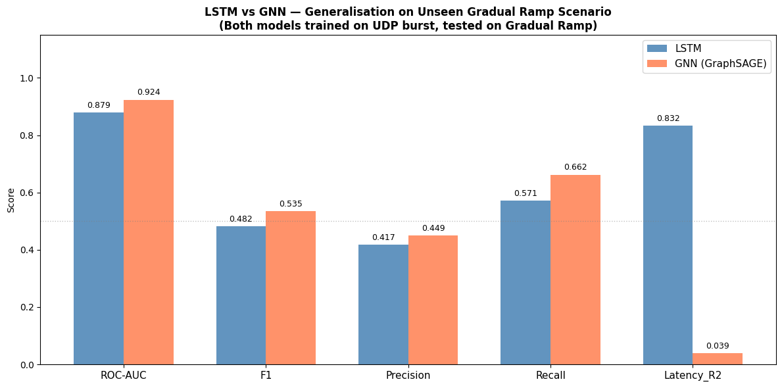
Figure 7 — LSTM vs. GNN generalisation metrics on the unseen gradual-ramp scenario.
Metric | LSTM | GNN (GraphSAGE)
ROC-AUC | 0.879 | 0.924
F1 | 0.482 | 0.535
Precision | 0.417 | 0.449
Recall | 0.571 | 0.662
Latency R² | 0.832 | 0.039

6. Key Finding: The Latency-R² Contradiction
Section 5.3's last row is the most important — and most easily misread — result in the whole comparison. On the unseen gradual-ramp scenario, the GNN's raw latency regression collapses to R² = 0.039 (essentially no predictive power — barely better than predicting the mean latency every time), while the LSTM retains R² = 0.832. This is the opposite of what Section 4.3 showed on the GNN's own in-distribution test set (R² = 0.969).
Yet on every congestion-classification metric (ROC-AUC, F1, Precision, Recall), the GNN outperforms the LSTM on this same unseen scenario. These two facts look contradictory but both are real, and here is why they can coexist:
- The classification signal only needs the model to know whether latency is above or below the threshold — not the exact value. A model can rank 'this UE's neighbourhood looks congested' correctly (high ROC-AUC) while being numerically wrong about magnitude (low R²).
- The GNN's neighbour-aggregation (SAGEConv) appears to generalise the qualitative 'is this cell busy' signal well across scenarios, because shared-cell contention patterns are structurally similar between UDP-burst and gradual-ramp traffic. But it overfit the precise latency magnitude to the shape of UDP-burst spikes it was trained on, and fails to rescale correctly when the gradual-ramp scenario produces a different latency distribution.
- The LSTM, trained without neighbour information, apparently generalised its magnitude estimate better (R²=0.83) but is worse at binary discrimination (lower ROC-AUC/F1) — plausibly because, lacking cell-level context, it is more easily fooled by gradual trends that look normal to a single UE in isolation.
Practical implication: if the deliverable is a congestion alarm (yes/no, or a warning system as in Section 7), the GNN's numbers here are a genuine improvement. If the deliverable requires a trustworthy predicted latency value (e.g., for SLA estimation or numeric dashboards), the GNN's current output should not be trusted on unseen scenarios — only the LSTM's latency prediction should be used, or the GNN's regression head should be recalibrated/retrained before use.
We recommend stating both numbers explicitly in any write-up of this project (viva, report, or paper) rather than only quoting the classification comparison — quoting only F1/ROC-AUC without flagging the R² collapse would overstate the GNN's actual reliability.

7. Advance-Warning / Lead-Time Analysis
This is the project's core deliverable: does the model warn before congestion arrives, and by how much? This was demonstrated using the LSTM's predictions on UE_17 (the UE with the most congestion onset events in the test set), by comparing when the model's alarm first fires against when actual congestion (ground truth) begins.
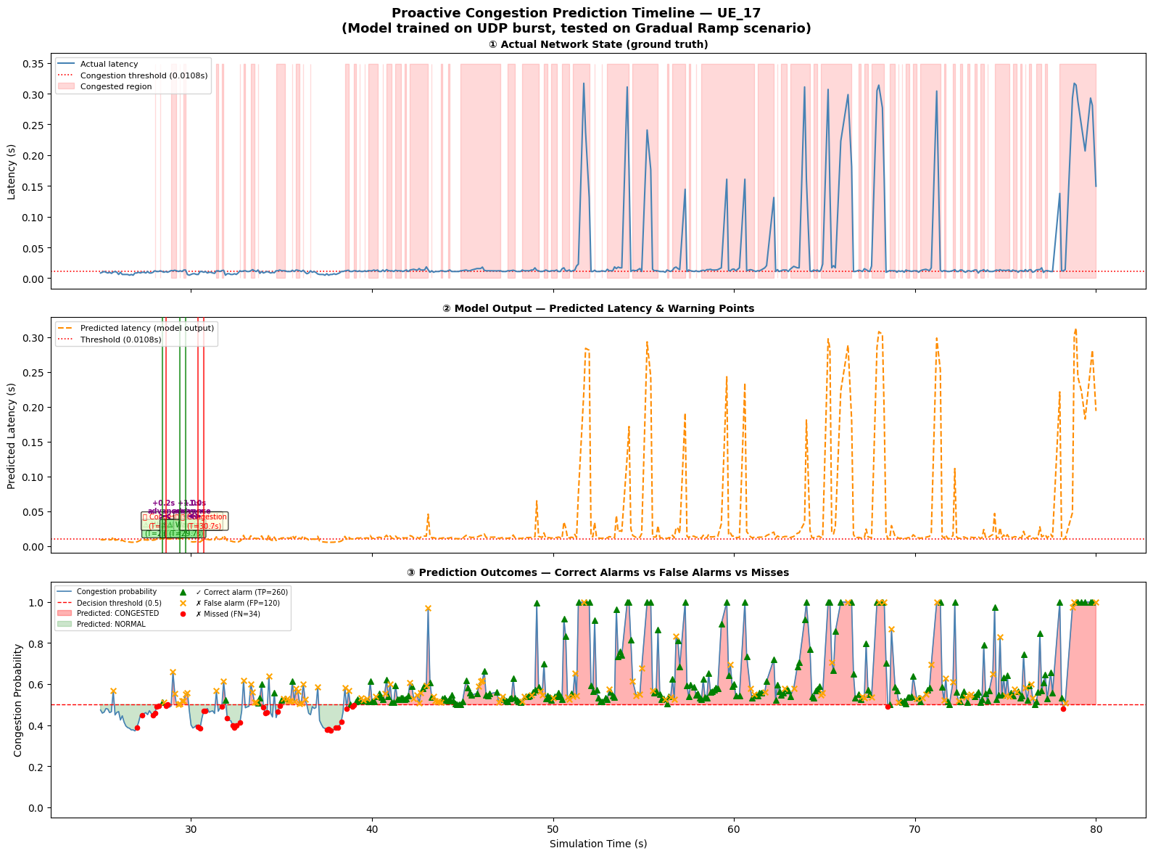
Figure 8 — Proactive congestion prediction timeline for UE_17. Top: ground truth latency with congested regions shaded. Middle: model's predicted latency and warning firing points. Bottom: congestion probability with correct alarms (green), false alarms (orange), and misses (red).
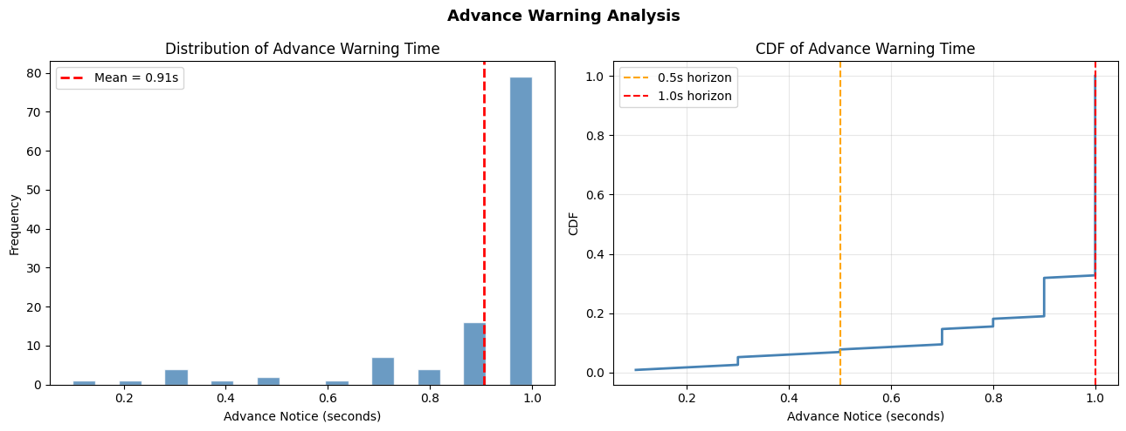
Figure 9 — Distribution (left) and CDF (right) of advance warning time across all congestion onset events.
Statistic | Value
Events with advance warning | 116 / 129 (89.9%)
Mean advance notice | 0.91 s
Max advance notice | 1.00 s (capped by 10-bin/1s prediction horizon)
≥ 0.3 s advance | 98.3% of warned events
≥ 0.5 s advance | 94.0% of warned events
≥ 0.7 s advance | 91.4% of warned events
≥ 1.0 s advance | 68.1% of warned events

Interpretation: the majority of warnings arrive close to the maximum possible lead time (1.0s, set by PREDICT_AHEAD=10 bins × 100ms). This is expected — the model is essentially using its full prediction horizon whenever it can. The bottom panel of Figure 8 also makes the false-alarm/miss trade-off visible: the model fires a moderate number of false alarms (orange X) in the run-up to real congestion, which is the practical cost of an early-warning system tuned for high recall (consistent with the LSTM's precision of 0.417 in Section 5.3).

8. What Was Done — Summary
- Built a shared, physically-grounded feature/label pipeline (8 KPI features, per-UE 1-second sliding windows, StandardScaler fit only on training data) used consistently by both models.
- Trained an LSTM as a 3-target regressor (latency, throughput, HARQ) — treats each UE independently.
- Trained a GraphSAGE GNN as a 1-target regressor (latency only) — treats UEs sharing a cell as a graph so predictions can use neighbour context.
- Evaluated both models out-of-distribution: trained on a UDP-burst scenario, tested on a never-seen gradual-ramp scenario — a genuine generalisation test rather than an in-distribution benchmark.
- Converted each model's continuous latency output into a congestion probability via a threshold-centred sigmoid, since neither model was trained as a classifier.
- Diagnosed that the GNN's default 0.5 decision threshold was badly miscalibrated (recall 0.124) and ran a systematic threshold sweep, finding an optimal operating point at 0.46 (F1 0.535) — this was the specific fix implemented in this session.
- Quantified the proactive lead time of the warning system: ~0.91s mean advance notice, with 89.9% of congestion onset events receiving some advance warning.
- Identified and explained a substantive discrepancy: the GNN wins on classification metrics but its regression output (Latency R²) fails almost completely on the unseen scenario, while the LSTM's regression output holds up — a nuanced, reportable finding rather than a simple 'GNN is better' conclusion.

9. Limitations & Recommended Improvements

9.1 Modelling limitations observed
- Sigmoid-based pseudo-classification: both models were built as regressors and retrofitted into classifiers via a hand-set sigmoid 'scale' constant. A model trained end-to-end for the classification objective (e.g., adding a BCE loss head, or framing congestion prediction directly as binary classification) would likely be better calibrated than post-hoc thresholding, and would remove the need for scenario-specific threshold tuning.
- GNN latency regression does not generalise (Section 6). Before trusting the GNN's numeric latency output, retrain/fine-tune on a scenario mix (UDP burst + gradual ramp + others), or add scenario-invariant normalisation (e.g., per-cell adaptive thresholds instead of a single fixed 90th-percentile constant) so the regression head isn't anchored to one traffic shape.
- LSTM's Total_Throughput prediction is weak (R²=0.22, Section 3.3) — worth investigating whether throughput needs different input features (e.g., a dedicated queue-length or PRB utilisation signal) rather than being predicted jointly with latency and HARQ from the same 8 features.
- Graph construction is fully-connected within a cell and static per time bin — it doesn't model varying interference/contention intensity between specific UE pairs, only same-cell membership. A weighted or distance/SINR-aware edge scheme could give the GNN richer structure to learn from.
- Threshold sweep and 0.46 cutoff are specific to the gradual-ramp test scenario; if the deployed system will face other traffic patterns, the threshold should be re-validated per scenario or made adaptive.

9.2 Suggested next steps
- Report both the classification numbers and the R² caveat honestly in the write-up/viva — this shows methodological maturity rather than cherry-picking the metric that favours the GNN.
- Add a third, more realistic test scenario beyond UDP-burst/gradual-ramp to check whether the GNN's classification edge (Section 5.3) is a real, repeatable pattern or an artifact of these two specific scenarios.
- Try a hybrid model — GNN spatial aggregation feeding into an LSTM temporal layer per UE — to combine the LSTM's apparently more robust magnitude estimation with the GNN's neighbour-aware classification signal.
- Replace the fixed sigmoid 'scale' constant with a learned calibration layer (e.g., Platt scaling or isotonic regression) fit on a validation split, instead of hand-tuning both 'scale' and the decision threshold.
- Extend the advance-warning analysis (Section 7) to the GNN and to more UEs than just UE_17, to see whether the lead-time and false-alarm trade-off (Section 7) holds up across the network, not just for the single most-congested UE.

10. Statistical Baselines — Moving Average & ARIMA
To know whether the deep models are actually earning their complexity, two classical statistical baselines were added: a Moving Average (MA) predictor and a per-UE ARIMA(2,0,1) model. Neither has any learned parameters or cross-UE/neighbour awareness — they exist purely to set a 'floor' that the LSTM/GNN/TCN should be expected to beat.

10.1 Moving Average
- Predicts the next value (10 bins / 1s ahead) as the plain mean of the previous 10 latency readings for that UE — no training, no parameters.
- Evaluated directly on the unseen gradual-ramp scenario (no in-distribution test exists, since there's nothing to overfit).

10.2 ARIMA(2,0,1)
- An AR(2)-MA(1) model, a standard lightweight choice for short telecom time series, fit independently per UE.
- Due to cost, restricted to a sample of 20 UEs. The forecast is a genuine rolling one-step-ahead simulation: at every test time step the model is refit on the last 50 observed points (train + accumulated test history) and asked to forecast 10 steps ahead — this is far more computationally expensive than the Moving Average or any of the neural models, since it refits a new ARIMA model at every single time bin.
- Falls back to a Moving-Average prediction whenever a refit fails to converge.

10.3 Results (unseen gradual-ramp scenario)
Metric | Moving Average | ARIMA(2,0,1)
ROC-AUC | 0.890 | 0.798
F1 | 0.505 | 0.392
Precision | 0.495 | 0.294
Recall | 0.515 | 0.588
Latency R² | 0.269 | -261.96

Two findings stand out, and both are important context for judging the deep models:
- Moving Average is a surprisingly strong classification baseline — ROC-AUC 0.890 and F1 0.505 are close to, and in some cases better than, the deep models (Section 12). A large share of the 'detectability' of congestion onset in this dataset comes simply from recent-trend extrapolation, not from anything architecturally sophisticated. Any claim that a deep model 'detects congestion well' should be read against this floor.
- ARIMA's regression is a near-total failure (R² = -261.96 — dramatically worse than just predicting the mean, which would give R²≈0). Per-step refitting on a short, non-stationary rolling window is numerically fragile: small windows plus a moving fit are prone to producing wild extrapolations whenever the local series looks non-stationary, and the notebook's own clipping step (predictions clipped to [0, 3× max training latency]) is direct evidence the raw forecasts were already blowing up before this safety net was applied. Despite that, ARIMA's classification recall (0.588) is still usable, because the sigmoid+threshold conversion only cares about which side of the threshold the (clipped) prediction lands on, not its exact magnitude — the same 'right side of threshold, wrong magnitude' pattern already seen with the GNN in Section 6.

11. TCN (Temporal Convolutional Network)

11.1 Architecture
- 3-block TCN, each block = 2 dilated causal 1-D convolutions (kernel size 3) + BatchNorm + ReLU + Dropout + residual/skip connection
- Dilation doubles per block (1, 2, 4) giving an exponentially growing receptive field while staying strictly causal (never looks at future time steps)
- Channels: 64 → 64 → 64, same hidden width as the LSTM for a fair comparison
- Output head: Linear(64→32) → ReLU → Dropout → Linear(32→3) — same 3 targets as the LSTM (Avg_Latency, Total_Throughput, Avg_HARQ_Attempts)
- Same 8 input features, same 10-step window, same StandardScaler pipeline as the LSTM — the only difference vs. the LSTM is the recurrent-vs-convolutional temporal encoder, making this the cleanest architecture-only comparison in the whole study
- Trained for 75 epochs (vs. LSTM's 50) at a lower learning rate (3e-4 vs 1e-3), with gradient-norm clipping (0.5) — both signs the notebook needed extra stabilisation to train smoothly

11.2 Training Behaviour
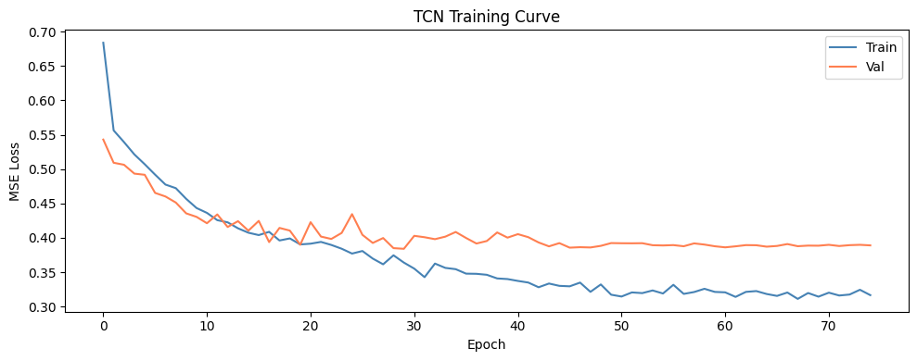
Figure 10 — TCN training & validation loss over 75 epochs.
Loss falls steadily from ~0.68 to ~0.32 (train) / ~0.39 (val). Compared to the LSTM's curve (Figure 1), the TCN needs more epochs to reach a comparable loss level and shows a slightly wider, noisier train/val gap late in training — consistent with convolutional filters needing more passes to learn the same temporal patterns that a recurrent cell captures more directly, though each epoch is cheaper since convolutions parallelise across the whole window.

11.3 Results

In-distribution test set
Target | MAE | R²
Avg_Latency | 0.003003 s | 0.8404
Total_Throughput | 1534.11 | 0.2351
Avg_HARQ_Attempts | 0.1557 | 0.7241

The same pattern seen with the LSTM and GNN repeats here: latency and HARQ are predicted well, throughput is not (R²=0.235). Since all three models — with entirely different temporal encoders — hit the same wall on Total_Throughput specifically, this reinforces that the throughput weakness is a property of the feature set/label design, not any one architecture's shortcoming.

Generalisation to unseen gradual-ramp scenario
Metric | TCN
ROC-AUC | 0.8795
F1 | 0.5066
Precision | 0.4337
Recall | 0.6089
Latency R² | 0.7754

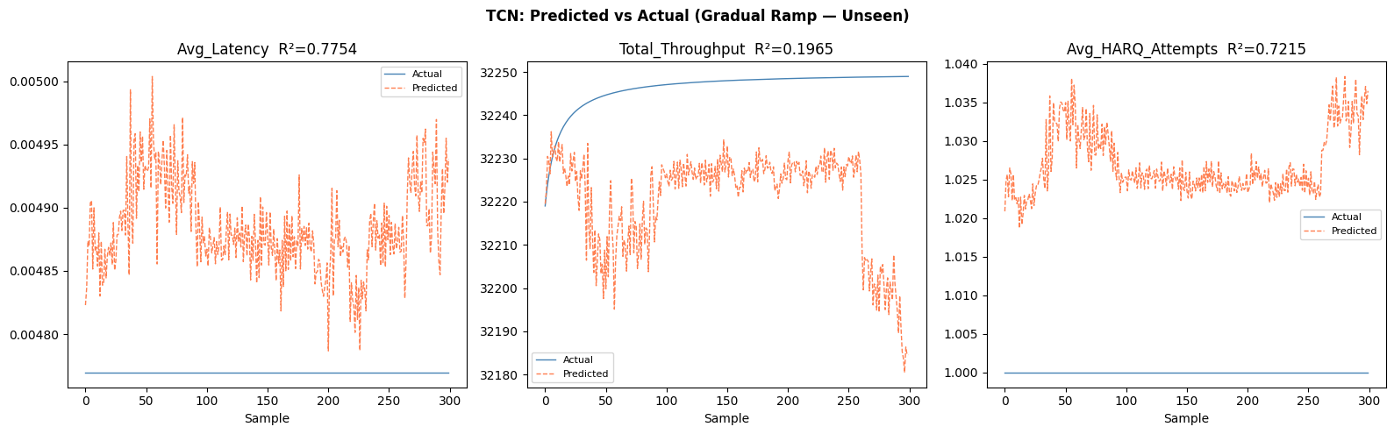
Figure 11 — TCN predicted vs. actual on the unseen gradual-ramp scenario, first 300 samples.
Two things worth flagging about Figure 11:
- The Avg_Latency and Avg_HARQ_Attempts 'Actual' lines appear completely flat across these first 300 samples while 'Predicted' fluctuates. This is very likely because these first 300 rows (sorted by Node_ID then Time_Bin) fall in a low-traffic baseline period for the first UE(s) in the test set — before the gradual ramp produces any real congestion — where the true latency sits at a near-constant floor and HARQ attempts sit at a hard minimum (1 retransmission). It is a window-selection artefact of plotting 'first 300 rows', not evidence the model is broken — the R² values quoted are computed over the full test set, not just this window.
- The Total_Throughput 'Actual' line rises smoothly and monotonically (~32,219 → ~32,249) while 'Predicted' oscillates around a plateau. This matches a limitation already flagged for the CDAC project in earlier sessions: Total_Throughput behaves like a cumulative counter rather than a per-bin instantaneous rate in this dataset, which mechanically caps any model's ability to track it with an R² near 1. This is a data/label-design issue shared by all four models tested, not specific to the TCN.
On generalisation, the TCN's Latency R² (0.775) sits between the LSTM's (0.832) and the GNN's (0.039) — much closer to the LSTM. This is an important data point for the Section 6 discussion: the TCN, like the GNN, uses a modern convolutional/hierarchical architecture rather than a recurrent one, yet it does not suffer the GNN's regression collapse on the unseen scenario. This weakens any theory that 'newer architecture families generalise worse at regression' — the more likely explanation remains specific to the GNN's neighbour-aggregation and how it interacts with a distribution shift in cell-level congestion patterns (Section 6), rather than convolutional/parallel temporal encoding in general.

12. Full Comparison — All Five Models
All five approaches evaluated on the same unseen gradual-ramp scenario, using the same congestion label definition (Section 5.1) and each model's own tuned/adaptive decision threshold:
Model | ROC-AUC | F1 | Precision | Recall | Latency R²
Moving Average | 0.890 | 0.505 | 0.495 | 0.515 | 0.269
ARIMA(2,0,1) | 0.798 | 0.392 | 0.294 | 0.588 | -261.96
LSTM | 0.879 | 0.482 | 0.417 | 0.571 | 0.832
GNN (GraphSAGE) | 0.924 | 0.535 | 0.449 | 0.662 | 0.039
TCN | 0.880 | 0.507 | 0.434 | 0.609 | 0.775

12.1 Ranking by classification performance (F1)
GNN (0.535) > TCN (0.507) ≈ Moving Average (0.505) > LSTM (0.482) > ARIMA (0.392)
This ranking should be read with real humility: the simplest possible baseline (Moving Average — no training, no learned parameters) is statistically almost tied with the TCN and clearly ahead of the LSTM on F1. Only the GNN provides a convincing, unambiguous improvement over trend-extrapolation. This doesn't mean the deep models are worthless, but it does mean the LSTM and TCN, as currently trained/thresholded, aren't yet demonstrating that their extra complexity earns its keep over a one-line statistical rule.

12.2 Ranking by regression reliability (Latency R²)
LSTM (0.832) > TCN (0.775) > Moving Average (0.269) ≫ GNN (0.039) ≫ ARIMA (-261.96)
Here the picture flips: the two recurrent/convolutional sequence models (LSTM, TCN) are far more trustworthy for a numeric latency forecast than either the GNN or the classical baselines. ARIMA's catastrophic negative R² disqualifies it from any use case needing an actual latency number, and the Moving Average — despite a respectable classification F1 — explains only 27% of the variance in true latency, confirming it rides on a coarse 'is the recent trend already elevated' signal rather than genuinely forecasting the specific future value.

12.3 Practical takeaway
- If the deliverable is a binary early-warning alarm, the GNN is the strongest model tested, but it is only a modest improvement over the free Moving-Average baseline — worth stating plainly rather than overselling.
- If the deliverable needs a numeric latency forecast (e.g., for SLA dashboards or admission-control thresholds), the LSTM is currently the most trustworthy model, with the TCN a close second and a viable low-cost alternative given its parallel training.
- ARIMA, as implemented here (full per-step refitting), is both the most computationally expensive baseline and the least numerically reliable — it is not recommended for this task in its current form.
- No single model dominates on every axis. A fair report/viva answer is: 'GNN best for alarms, LSTM/TCN best for forecasts, and a plain Moving Average is a shockingly strong classification floor that the deep models only partially beat.'

13. Conclusion
Across five models — two classical statistical baselines (Moving Average, ARIMA), and three deep sequence/graph models (LSTM, GNN, TCN) — all evaluated on a genuinely unseen gradual-ramp congestion scenario, three conclusions hold up:
- Proactive warning works: the LSTM-based warning system gives ~0.91s mean advance notice and catches 89.9% of congestion onset events (Section 7), and all three deep models substantially beat random guessing on ROC-AUC (0.88–0.92).
- Neighbour-awareness (GNN) gives the best classification numbers (F1 0.535, ROC-AUC 0.924) but its own latency regression fails to generalise to the unseen scenario (R²=0.039) — a genuine trade-off, not a clean win, and confirmed not to be a generic 'modern architecture' problem since the similarly modern TCN generalises well (R²=0.775).
- The Moving Average baseline is uncomfortably competitive (F1 0.505, ROC-AUC 0.890), which should temper any claim that deep learning is clearly necessary here for classification — the strongest, most defensible story is that deep models (specifically the GNN) are needed for the best classification score, while LSTM/TCN are needed for trustworthy numeric latency forecasts, and ARIMA in its current rolling-refit form should be dropped or redesigned.
Recommended framing for the write-up/viva: present the full 5-model table (Section 12), lead with the honest baseline comparison rather than only the deep-model numbers, and use the Section 6 / Section 11.3 discussion to explain the GNN vs TCN regression-generalisation gap as a specific, investigated finding rather than an unexplained anomaly.

