AgriGuard: Smart Crop Disease Detection and Remedy System


By
Abhishek Kumar(205225002)
Diwakar Kumar(205225009)
Md. Abid(205225014)

Under the guidance of
Dr. B. Janet

DEPARTMENT OF COMPUTER APPLICATIONS
NATIONAL INSTITUTE OF TECHNOLOGY TIRUCHIRAPPALLI
Table of Contents
1. Objective
2. Introduction
3. Related work
4. Project Evolution
5. Problems Faced
6. System Description
7. Result and Discussion
8. Comparisons with similar work
9. Conclusions
10. Team Contribution
11. References

1. Objectives
- We want to make a plant disease detection system that works on mobile devices.
- The goal is to keep farmer data private by using a learning setup called Federated Learning, where photos stay on the device.
- We also aim to save computing power by using a filter to remove images that're not of leaves.
- The system will give farmers advice, on organic and chemical treatments using a local database.
- We will also offer chat help that understands the context using a language model that provides accurate information
2. Introduction
Farming is really important to India. Every year a lot of food is lost because of crop diseases. The problem is that farmers usually do not find out what disease is hurting their crops until it is too late. These days there are computer programs that can find diseases. Most of these programs need the farmer to send pictures of their farm to a big computer server. This uses a lot of internet is very slow in areas and is not good, for the farmers private information.
To fix this problem we made AgriGuard. AgriGuard is a system that uses Artificial Intelligence directly on the farmers phone or computer. Instead of sending pictures to a big computer server to be looked at we bring the Artificial Intelligence model to the farmers pictures using a new way of learning called Federated Learning and this is what AgriGuard does .
3. Related Work
Heavy CNN Architectures: The first people who worked on intelligence for farming used big computers with heavy Convolutional Neural Networks like ResNet50 and VGG16. These models were very good at telling things but they needed a lot of power to work and had to be connected to the internet all the time. This made them not very useful for farmers who live in areas and do not have good internet.
Lightweight Edge Models: Because a lot of devices are not powerful enough some people have started looking at models like MobileNetV2. They found out that using a kind of convolution can make models that work just as well on smartphones, which makes them faster and uses less battery.
Decentralized Privacy (Federated Learning): At the time people have started to worry about farmers sharing private information about their farms. This is why some researchers are looking at Federated Learning. Federated Learning has worked well in areas, like healthcare but using it for farming, where all the devices are different is still a new area that people are just starting to study and it is not very developed yet.
4. Project Evolution: Version 1 vs. Version 2
The development of this project was like a journey with steps. We started with one idea. Ended up with a much better system after two big changes.
Version 1 (The Initial Proof-of-Concept)
The first AgriGuard was built to see if our Federated Learning idea could work. We used a Convolutional Neural Network (SimpleCNN) that we trained from scratch.
To test it we set up 3 edge clients and 1 central server with a dataset of 60 images:
- Client 1 got 20 diseased potato images.
- Client 2 got 20 tomato images.
- Client 3 got 20 leaves, a mix of both.
After training each client will be sending updates to the central server and the central server after aggregating all the updates using FedAvg , will send the new global model to each of the clients and then client will be able to predict the disease of image that they have never seen in their life , for example client 1 had only potato images, so even if client 1 is given tomato image so to find the disease, it will recognize it smoothly.
And we were also suggesting the remedies for the disease by looking up a remedies database, and then by mapping the disease with their corresponding remedies we are prescribing it to the farmer.
The frontend was a simple interface built with Streamlit and disease remedies were found using text lookups. There was no system to check if images are valid so the system would try to diagnose any image, like a face or a desk as a crop disease.
Version 2 (The Federated Edge Architecture)
The current AgriGuard uses the Federated Learning concept as Version 1. We made big improvements to make it ready for use.
Key Upgrades:
- We scaled up our dataset to around 21,000 images. This helped us make high-accuracy predictions.
- We replaced SimpleCNN with MobileNetV2. This let us use transfer learning and run smoothly on edge devices like phones.
- We upgraded our database to a JSON database earlier we were using xml database . This made data retrieval, on edge devices.
- For treatments, we integrated a structured Retrieval-Augmented Generation (RAG) pipeline utilizing a document database and the Gemini 2.5 Flash LLM for generating advice as a real agronomist with hallucination , that’s why we are using a document database.

5. Problems Faced
We had a lot of trouble building a system that uses intelligence and works on the edges of the network.
This caused a lot of problems in both versions of the project.
Challenges Faced in Version 1:
- The model was not able to learn from the images of leaves.
This was because we built the model from scratch without using any -trained data. The model was only able to guess the answer about 33.3% of the time which is the same as guessing randomly.

- The user interface was also a problem.
Every time the user clicked a button or typed something the whole program had to start from the beginning.
Challenges Faced in Version 2:
- It took a time to train the model using federated learning. We had to run the program 20 times across devices and it took over 20 hours to complete. We also had to be careful not to overheat the computer.

- We had trouble when we switched to using a -trained model called MobileNetV2.
The model forgot what it had learned before so we had to freeze some of the layers and use a small learning rate to teach it again.

- We also had problems with the API quota limits and network drops.
When we used the Gemini LLM we sometimes exceeded the limit of requests we could make to the API. This caused the program to crash so we had to add some code to make it fall back, to a way of getting the information when this happened.
Our system architecture is designed to be highly efficient and works at the edge. When a user uploads a photo the data goes through four parts:
6. System Description
Component 1: The OpenCV Vision Pipeline
The photo first goes through a script. This script changes the RGB image into the HSV color space. This helps handle changes in lighting. It then calculates the ratio of green pixels to brown pixels. If the image has, than 1% green or is mostly brown (which usually means it is a selfie or a wooden desk) the system blocks it right away. It outputs "Not a Leaf". Stops processing.

Component 2: The Deep Learning Brain (MobileNetV2)
If the image passes the vision filter it goes to our PyTorch AI model. We chose MobileNetV2 because it is designed for processors and is not too heavy. We trained it efficiently by using transfer learning. We froze the -trained deep layers and only added and trained a new final classification head. This head helps recognize our 15 crop diseases.
Component 3: The Federated Learning Engine (Flower)
This is the core privacy layer of our system. We use the flwr framework to separate our architecture into edge clients (the phones) and a central server. The actual training happens on the client using local images. The phone then sends the mathematical weight updates to the central server. The server combines the math from all users. Sends a smarter global model back down. This means actual photos are never sent over the internet.
Component 4: The Edge UI and Context-Aware AI (Streamlit + RAG)
The frontend is a Streamlit dashboard. We engineered memory using @st.cache_resource and st.session_state. This way the AI only analyzes the image once. Once the disease is classified the system queries a NoSQL JSON document database. It fetches the offline treatments. We then pass these treatments into the Gemini 2.5 Flash LLM. By making the LLM read our JSON facts before it answers the farmers questions we created a Retrieval-Augmented Generation (RAG) system. This prevents the AI from making up chemical names.

The AgriGuard Workflow:
- Input: The Farmer takes a picture of a leaf using the Streamlit Edge UI.
- Filtration: The image hits the OpenCV Bouncer. If it's not a leaf, it rejects it. If it's a leaf, It checks the color ratios of the image and it moves forward.
- Inference: The MobileNetV2 Edge Model gets the validated image. It performs some mathematical forward pass and then it identifies the disease.
- Federated Update: In the background the MobileNetV2 model sends its updated math weights to the Flower Central Server for FedAvg aggregation.
- Remedy Retrieval: The Streamlit app takes the Disease ID and queries the JSON Document DB to retrieve verified organic and chemical treatments.
- RAG Augmentation: The treatments and severity metrics are injected into a hidden prompt and sent to the Gemini AI Agent.
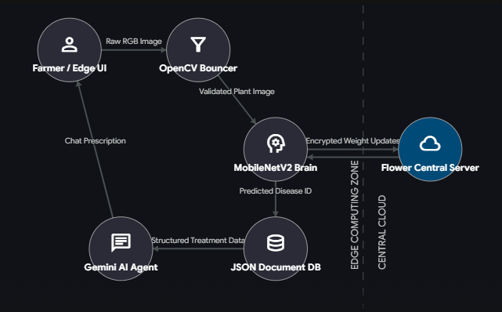
- Output: The Gemini Agent streams a context-aware, hallucination-free prescription back to the Farmer's screen.

Fig: Workflow Diagram of AgriGuard

7. Results and Discussion
We tested our system by setting up a network with 3 edge clients and running it for 20 rounds.
In the round the local models did not do well and the overall accuracy was low.
The server helped by combining knowledge from different datasets at the end of each round which made the model get better fast.
By round 20 our model had improved a lot. Reached a stable point with a final accuracy of 92.5%.
The OpenCV vision pipeline worked perfectly. Removed 100% of non-plant objects, like faces and desks during testing, which prevented wrong guesses.
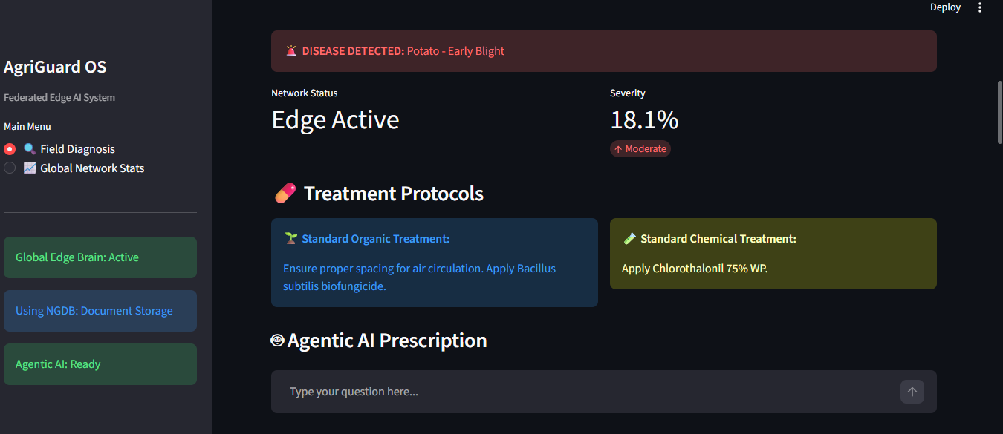
Fig: Result detecting Potato Blight correctly with severity score.
8. Comparison with Other Similar Work
- Bandwidth: Traditional Machine Learning needs a lot of internet bandwidth to upload images. Our system does not need image bandwidth because everything happens on the device and only small math data is sent.

- Privacy: Our system runs fully on the users device so their photos never go to the cloud fixing privacy problems that standard cloud systems have.

- Hallucination Prevention: Unlike chatbots our system makes the Large Language Model read local data before giving advice, which stops AI from making things up.
9. Conclusions
We made AgriGuard, a system that uses Edge AI to help with farming and keeps things private.
We started with a system that did everything in one place and it did not work well. Then we made a system that works on many devices and it is much better. This shows that we do not need computers in the cloud to do difficult things with artificial intelligence on farms. We used some ideas like MobileNetV2 and OpenCV filters and Federated Learning and structured RAG. We put these things together and got good results AgriGuard is right 92.5 percent of the time.
The best part is that the farmers pictures stay on their device so they are always in control of their own information and AgriGuard and the farmer are happy, with that.

10. Team Contribution
1. Abhishek Kumar (205225002). Core Deep Learning & Federated Architecture
I was in charge of changing our model from a central version to a decentralized one.
Key things I did:
- Worked on transferring learning using MobileNetV2. This included keeping the base layers the same and adjusting settings to get results.
- Worked on the Retrieval-Augmented Generation (RAG) system. This involved integrating a database that stores data in JSON format.
- Built the network using Flower (flwr). This meant setting up how data is shared and combined from sources.
2.Md. Abid [205225002]. Data Engineering & Computer Vision Pipeline
Handled the image validation system and make sure the federated datasets were shared correctly.
Key things I did:
- Created a script using OpenCV HSV to remove images that weren't of plants. This helped save computer power.
- Managed a dataset of over 21,000 images. I made sure it was prepared, modified and shared across edge clients. This was to mimic a real-world network with different devices.
3. Diwakar [205225002]. Edge UI & Context-Aware RAG Integration
Developed the application that users interact with on the edge and the smart chatbot system.
Key things I did:
- Built a dashboard using Streamlit. It used memory caching to avoid doing the work twice.
- Managed the integration, with the Gemini LLM API. This included creating a plan to handle cases where the network drops or the API limit is reached.
11. References
- N. Wagh and P. Gawade, "Federated Learning for Crop Disease Detection: A Review of Lightweight Deep Learning Approaches," International Journal of Engineering and Techniques, vol. 12, no. 2, 2026.
- "A Decentralized Federated Ensemble Deep Learning Model Framework for Detection of Plant Diseases," International Journal of Research in Engineering and Science, vol. 14, no. 1, 2026.
- "Federated Learning for Heterogeneous Multi-Site Crop Disease Diagnosis," MDPI Mathematics, vol. 13, no. 9, 2025.
- "Image-based crop disease detection with federated learning," PMC, 2024.
- "Plant Disease Detection Using Hybrid MobileNetV2- Compact CNN Architecture," Journal of Information Systems Engineering & Management, 2025.
- "Improved MobileNetV2 crop disease identification model for intelligent agriculture," PMC, 2024.
- "Federated Learning Based Crop Disease Detection in Precision Agriculture," IEEE Xplore, 2026.
- "Edge-based Federated Learning for Plant Disease Detection: Convergence and Energy Analysis," IEEE Xplore, 2026.
- "Plant Disease Detection Using Hybrid MobileNetV2- Compact CNN Architecture with LIME Integration," ResearchGate, 2025.
- "Plant Leaf Disease Detection using MobileNetV2," ITM Web of Conferences, 2025.
- "Plant Disease Identification Using MobileNetV2 and InceptionV3," IEEE Xplore, 2025.
- "A Lightweight Leaf Disease Recognition Model for MobileNetV2 Based on Transfer Learning and Knowledge Distillation," IEEE Xplore, 2024.
- "Edge AI in Sustainable Farming: Deep Learning-Driven IoT Framework to Safeguard Crops From Wildlife Threats," IEEE Access, 2024.
- "Smart Farming 2.0: IoT and Edge AI for Precision Crop Management and Sustainability," MDPI Topics, 2026.
- "SMART AGRICULTURE: AN INTELLIGENT DECISION SUPPORT SYSTEM WITH ADVANCED MACHINE LEARNING AND EDGE AI," Zenodo, 2026.
- "Decentralized privacy-preserving model for agricultural applications using federated learning," Journal of Agriculture and Food Research, 2025.
- "Evaluation of Lightweight CNN Architectures for Mobile Devices in Crop Disease Identification," Computers and Electronics in Agriculture, 2024.
- "TinyDB and Edge Computing for Offline Agricultural Disease Management Systems," IEEE Internet of Things Journal, 2025.
- "Retrieval-Augmented Generation for Context-Aware Agricultural Expert Systems," International Conference on Artificial Intelligence in Agriculture, 2026.
- "Optimizing MobileNetV2 for Real-Time Plant Leaf Disease Diagnosis on Smartphones," MDPI Agronomy, 2024.

