***Is the  code compiles ? If yes then what will be the output ?***

[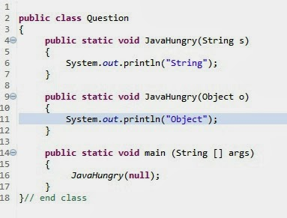](http://4.bp.blogspot.com/-EA0vQgrKTf0/UkQNB27tvgI/AAAAAAAAAgo/NyDPA2f2XfQ/s1600/questions1.jpg)  
  
***Answer >>***  
***Compile :  Yes***  
***Output   :  String***

***Next Question >>***  
 ***Is the  code compiles ? If  yes then what will be the output ?***

[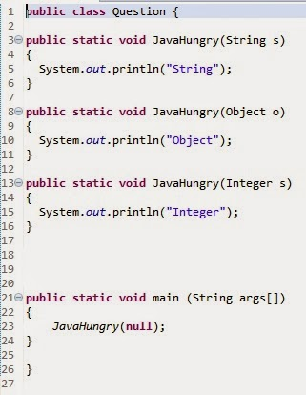](http://2.bp.blogspot.com/-hyoSgbvYxU8/Uk775NsbXtI/AAAAAAAAAC0/3ALFoNQM8KI/s1600/original+2.jpg)

***Answer >>Compile :  No   , Error at  line 23***  
***Reason  :   Method is ambiguous Next Question >>***  
 ***Is the  code compiles ? If  yes then what will be the output ?***

[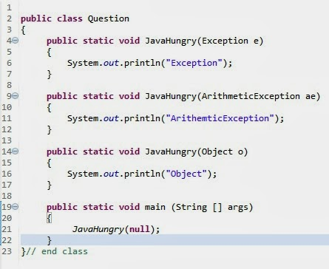](http://2.bp.blogspot.com/-E9jwhalq1Mg/UkQONSQk7pI/AAAAAAAAAg4/dQkfYdlr2aU/s1600/questions1.jpg)

***Answer >>***  
 ***Compile :  Yes***  
***Output  :   ArithmeticException***  
 ***Next Question >>***  
***Is the  code compiles ? If  yes then what will be the output ?***

[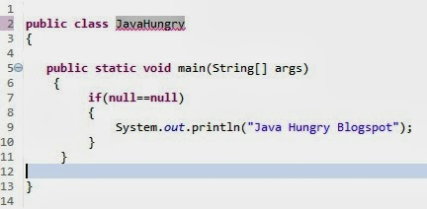](http://3.bp.blogspot.com/-zfZtmBXL2pk/UkKqUPUuO3I/AAAAAAAAAfA/H-uyxB2_sRY/s1600/questions1.jpg)

***Answer >>***  
***Compile :  Yes***  
***Output  :   Java Hungry Blogspot***

***Next Question >>***  
 ***Is the  code compiles ? If  yes then what will be the output ?***

[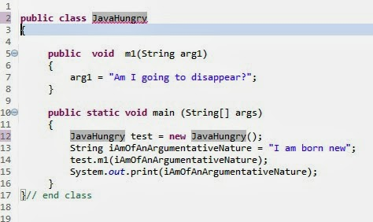](http://1.bp.blogspot.com/-8Aky_jQFXgY/UkKs6dfOWnI/AAAAAAAAAfM/Dtkbfgcy1CA/s1600/questions1.jpg)***Answer >>***  
 ***Compile :  Yes***  
***Output  :   I am born new***

***Next Question >>***  
 ***Is the  code compiles ? If  yes then what will be the output ?***

[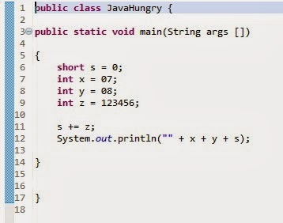](http://4.bp.blogspot.com/-51wg6-wC6Wg/Ula-57TdvtI/AAAAAAAAAE8/sqaH6GyU62I/s1600/most+java+developers+puzzled.jpg)

***Compile :  No ,  Error at line 8***  
***Reason  :   Any  number starting with 0  is  an octal number***  
  
  
  
***Next Question >>***  
 ***Is the  code compiles ? If  yes then what will be the output ?***

[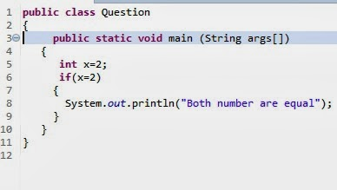](http://4.bp.blogspot.com/-RbuGNPTDfTs/Uk78Gn2cB8I/AAAAAAAAAC8/MdnL6Q3Guw8/s1600/original+6.jpg)

***Answer >>***  
 ***Compile :  No , Error at line 6***  
***Reason  :   Type mismatch , can not convert from int to boolean***  
  
  
  
***Next Question >>***  
 ***Is the  code compiles ? If  yes then what will be the output ?***

[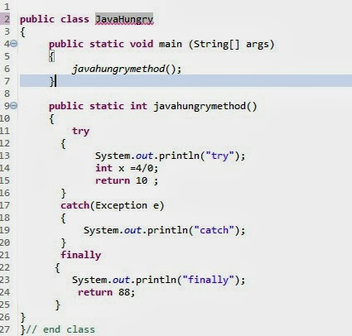](http://3.bp.blogspot.com/-azq59dT5l44/UkK0FTq9c8I/AAAAAAAAAfc/kFF71GmUQY4/s1600/questions1.jpg)

***Answer >>***  
 ***Compile :  Yes***  
***Output  :   try***  
***catch***  
***finally***  
  
  
  
***Next Question >>***  
 ***Is the  code compiles ? If  yes then what will be the output ?***

[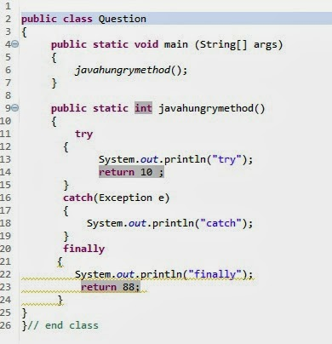](http://2.bp.blogspot.com/-Pl7kmroFF5Y/UkK0_heH3aI/AAAAAAAAAfk/wx0V1VefLQ4/s1600/questions1.jpg)

***Answer >>***  
 ***Compile :  Yes***  
***Output  :   try***  
***finally***  
  
  
  
  
  
  
***Next Question >>***  
 ***Is the  code compiles ? If  yes then what will be the output ?***

[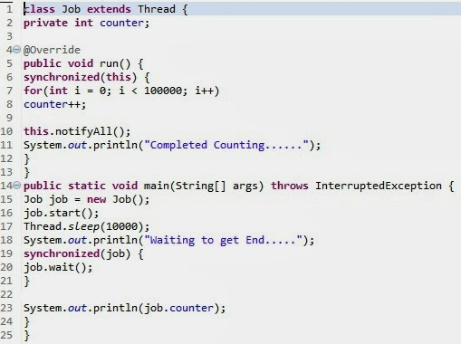](http://1.bp.blogspot.com/-ZKW5CImq03s/UkK7jIta3nI/AAAAAAAAAf4/S17qdavH_n0/s1600/questions1.jpg)

***Answer >>***  
 ***Compile :  Yes***  
***Output  :   Completed Counting . . . . . .***  
***Waiting to get End . . . . .      ( Infinite loop )***

***Next Question >>***  
 ***Is the  code compiles ? If  yes then what will be the output ?***

[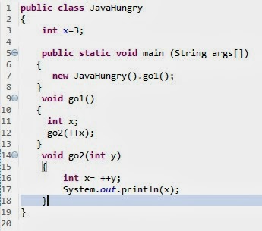](http://3.bp.blogspot.com/-30Rc9CT-Uqg/Uk78eJAyv9I/AAAAAAAAADE/yjlna0rYf7g/s1600/original+10.jpg)

***Answer >>***  
 ***Compile :  No , Error at  line 12***  
***Reason  :  Local variable x  has not been initialized***

***Next Question >>***  
 ***Is the  code compiles ? If  yes then what will be the output ?***

[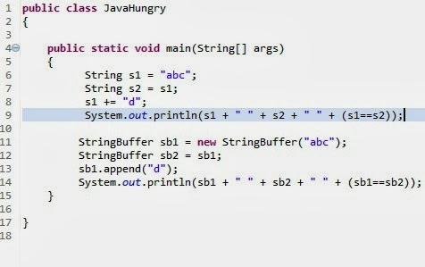](http://3.bp.blogspot.com/-rF9dNc6K_wY/UkPNUNkwy7I/AAAAAAAAAgY/0cwT8pO8Trg/s1600/questions1.jpg)

***Answer >>***  
 ***Compile :  Yes***  
***Output  :    abcd abc false***  
***abcd abcd  true***   
Here we only discuss the technical questions along with the answer .