Name – Abhishek Nishad
Roll No. – M24MSA009

Code: -
# ==========================================
# Predicting Productivity Category
# Using Multinomial Logistic Regression & Naive Bayes
# ==========================================

# --- Step 1: Import Libraries ---
import pandas as pd
import numpy as np
import matplotlib.pyplot as plt
import seaborn as sns
from sklearn.linear_model import LogisticRegression
from sklearn.model_selection import train_test_split
from sklearn.preprocessing import StandardScaler, LabelEncoder
from sklearn.metrics import classification_report, confusion_matrix
from sklearn.naive_bayes import GaussianNB

# --- Step 2: Load Dataset ---
file_path = "/content/sample_data/productivity - productivity.csv"
data = pd.read_csv(file_path)

print("Dataset Loaded Successfully!\n")
print(data.head())

# --- Step 3: Data Cleaning ---
# Drop any unnecessary columns
data = data.drop(columns=["Unnamed: 0"], errors="ignore")

# Fill missing numeric values with median
for col in data.select_dtypes(include=["float64", "int64"]).columns:
data[col].fillna(data[col].median(), inplace=True)

# Encode the target variable
le = LabelEncoder()
data["Productivity"] = le.fit_transform(data["Productivity"])

# --- Step 4: Define Features and Target ---
X = data[["targeted_productivity", "smv", "wip", "over_time", "incentive", "idle_time"]]
y = data["Productivity"]

# --- Step 5: Train-Test Split ---
X_train, X_test, y_train, y_test = train_test_split(
X, y, test_size=0.25, random_state=42, stratify=y
)

# --- Step 6: Feature Scaling ---
scaler = StandardScaler()
X_train_scaled = scaler.fit_transform(X_train)
X_test_scaled = scaler.transform(X_test)

# =========================================================
# 🧩 Multinomial Logistic Regression
# =========================================================
print("\n🔹 TRAINING MULTINOMIAL LOGISTIC REGRESSION...\n")

log_model = LogisticRegression(multi_class="multinomial", solver="lbfgs", max_iter=1000)
log_model.fit(X_train_scaled, y_train)

# Coefficients
print("Model Coefficients:")
coef_df = pd.DataFrame(log_model.coef_, columns=X.columns, index=le.inverse_transform(sorted(y.unique())))
print(coef_df)

# --- Plotting Coefficients ---
plt.figure(figsize=(10, 6))
for i, class_name in enumerate(coef_df.index):
plt.plot(coef_df.columns, coef_df.loc[class_name], marker="o", label=class_name)

plt.title("Multinomial Logistic Regression Coefficients by Class")
plt.xlabel("Features")
plt.ylabel("Coefficient Value")
plt.axhline(0, color="grey", linewidth=0.5)
plt.legend(title="Productivity Class")
plt.xticks(rotation=45)
plt.tight_layout()
plt.show()

# --- Evaluate Logistic Regression ---
y_pred_lr = log_model.predict(X_test_scaled)
print("\n Logistic Regression - Classification Report:\n")
print(classification_report(y_test, y_pred_lr, target_names=le.inverse_transform(sorted(y.unique()))))

cm_lr = confusion_matrix(y_test, y_pred_lr)
sns.heatmap(cm_lr, annot=True, fmt="d", cmap="Greens")
plt.title("Confusion Matrix - Multinomial Logistic Regression")
plt.xlabel("Predicted")
plt.ylabel("Actual")
plt.show()

# --- Predicted Probabilities ---
prob_lr = log_model.predict_proba(X_test_scaled)
prob_df_lr = pd.DataFrame(prob_lr, columns=le.inverse_transform(sorted(y.unique())))
print("\nPredicted Probabilities (first 5 rows):")
print(prob_df_lr.head())

# =========================================================
# Naive Bayes (GaussianNB)
# =========================================================
print("\n🔹 TRAINING NAIVE BAYES MODEL...\n")

nb_model = GaussianNB()
nb_model.fit(X_train_scaled, y_train)

# --- Predictions & Probabilities ---
y_pred_nb = nb_model.predict(X_test_scaled)
y_prob_nb = nb_model.predict_proba(X_test_scaled)

print("Naive Bayes - Classification Report:\n")
print(classification_report(y_test, y_pred_nb, target_names=le.inverse_transform(sorted(y.unique()))))

cm_nb = confusion_matrix(y_test, y_pred_nb)
sns.heatmap(cm_nb, annot=True, fmt="d", cmap="Blues")
plt.title("Confusion Matrix - Naive Bayes")
plt.xlabel("Predicted")
plt.ylabel("Actual")
plt.show()

print("\nPredicted Probabilities (first 5 rows):")
print(pd.DataFrame(y_prob_nb, columns=le.inverse_transform(sorted(y.unique()))).head())

Output: -
Dataset Loaded Successfully!

Unnamed: 0 targeted_productivity smv wip over_time incentive \
0 1 0.80 26.16 1108.0 7080 98
1 2 0.75 3.94 NaN 960 0
2 3 0.80 11.41 968.0 3660 50
3 4 0.80 11.41 968.0 3660 50
4 5 0.80 25.90 1170.0 1920 50

idle_time Productivity
0 0.0 High
1 0.0 Meet Expectations
2 0.0 Meet Expectations
3 0.0 Meet Expectations
4 0.0 Meet Expectations

🔹 TRAINING MULTINOMIAL LOGISTIC REGRESSION...

Model Coefficients:
targeted_productivity smv wip \
High 0.142984 -0.541303 0.270769
Meet Expectations 0.954660 0.004370 0.185478
Needs Encouragement -0.361003 0.438419 -0.009222
Plan for detail conversation -0.736641 0.098514 -0.447025

over_time incentive idle_time
High 0.034643 0.390582 -0.248258
Meet Expectations 0.225415 0.477582 -0.652159
Needs Encouragement -0.153974 0.381982 -0.445614
Plan for detail conversation -0.106085 -1.250147 1.346032
/tmp/ipython-input-3273588604.py:30: FutureWarning: A value is trying to be set on a copy of a DataFrame or Series through chained assignment using an inplace method.
The behavior will change in pandas 3.0. This inplace method will never work because the intermediate object on which we are setting values always behaves as a copy.

For example, when doing 'df[col].method(value, inplace=True)', try using 'df.method({col: value}, inplace=True)' or df[col] = df[col].method(value) instead, to perform the operation inplace on the original object.

data[col].fillna(data[col].median(), inplace=True)
/usr/local/lib/python3.12/dist-packages/sklearn/linear_model/_logistic.py:1247: FutureWarning: 'multi_class' was deprecated in version 1.5 and will be removed in 1.7. From then on, it will always use 'multinomial'. Leave it to its default value to avoid this warning.
warnings.warn(

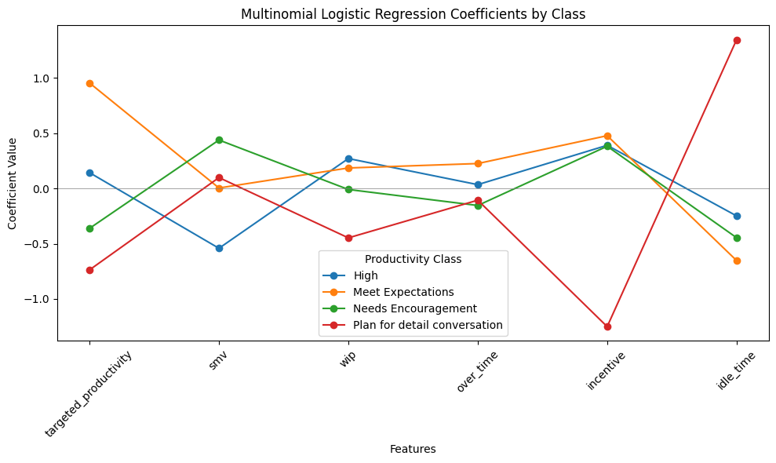
Logistic Regression - Classification Report:

precision recall f1-score support

High 1.00 0.04 0.08 51
Meet Expectations 0.46 0.76 0.57 91
Needs Encouragement 0.58 0.27 0.37 67
Plan for detail conversation 0.48 0.62 0.54 91

accuracy 0.48 300
macro avg 0.63 0.42 0.39 300
weighted avg 0.58 0.48 0.43 300

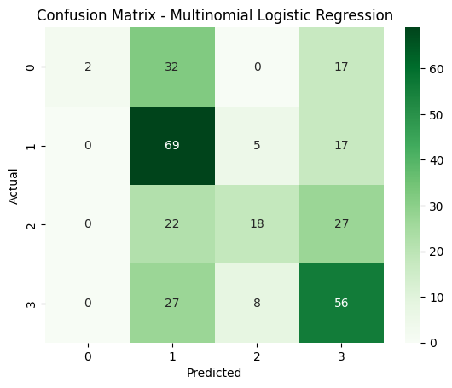
Predicted Probabilities (first 5 rows):
High Meet Expectations Needs Encouragement \
0 0.023629 0.002086 0.166700
1 0.288038 0.360246 0.133892
2 0.180324 0.232090 0.276624
3 0.068615 0.008165 0.157606
4 0.120042 0.252159 0.255907

Plan for detail conversation
0 0.807585
1 0.217824
2 0.310962
3 0.765613
4 0.371892

🔹 TRAINING NAIVE BAYES MODEL...

Naive Bayes - Classification Report:

precision recall f1-score support

High 0.21 0.73 0.33 51
Meet Expectations 0.39 0.53 0.45 91
Needs Encouragement 0.00 0.00 0.00 67
Plan for detail conversation 1.00 0.05 0.10 91

accuracy 0.30 300
macro avg 0.40 0.33 0.22 300
weighted avg 0.46 0.30 0.22 300

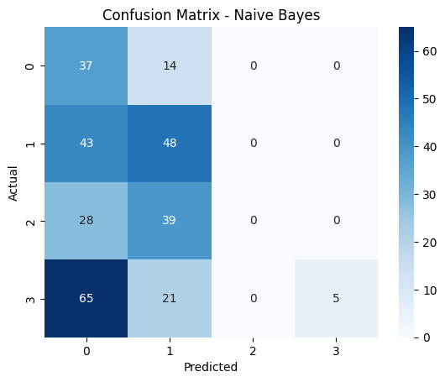
Predicted Probabilities (first 5 rows):
High Meet Expectations Needs Encouragement \
0 0.979991 1.768828e-07 0.000011
1 0.667172 3.323809e-01 0.000410
2 0.526163 4.704568e-01 0.003317
3 0.998452 3.744524e-04 0.000156
4 0.403368 5.944683e-01 0.002120

Plan for detail conversation
0 0.019997
1 0.000037
2 0.000063
3 0.001017
4 0.000043

Analysis: -
The goal of this lab is to predict an employee's performance category (productivity) based on various work-related metrics. Two non-tree-based classification models were trained and evaluated:
- Multinomial Logistic Regression
- Naive Bayes
The dataset contains 300 instances (rows) with the following features (attributes):
- targeted_productivity: The productivity goal set by the supervisor.
- smv (Standard Minute Value): The allocated time for a task.
- wip (Work in Progress): The number of unfinished items (note: this column had missing values that were filled with the median).
- over_time: Overtime in minutes.
- incentive: Financial incentive provided.
- idle_time: Time production was interrupted.
- productivity: The target variable (the category to be predicted). The classes are:
  - High
  - Meet Expectations
  - Needs Encouragement
  - Plan for detail conversation

1. Data Preprocessing Note
The report shows a FutureWarning from pandas, indicating that a method was used to fill missing values (NaN) in-place that will not work in future versions. This is a coding style note, not an error. It confirms that missing data in the wip column was handled by replacing it with the column's median value, which is a standard practice.

2. Multinomial Logistic Regression Model
Model Coefficients
This table shows how each feature influences the prediction for each class. A positive coefficient means the feature makes that class more likely, while a negative coefficient makes it less likely.
Interpretation by Class:
- High:
  - Employees are more likely to be "High" performers if they have a higher targeted_productivity, more wip, and a higher incentive.
  - They are less likely to be "High" if the task takes longer (smv), they have more over_time, or have more idle_time. This suggests efficient employees complete tasks quickly with minimal interruptions.
- Meet Expectations:
  - This class is strongly associated with high targeted_productivity, over_time, and incentive. This might indicate a group that is motivated by targets and incentives and works extra hours to meet them.
- Needs Encouragement:
  - Likely to have a lower targeted_productivity but a higher smv (tasks take longer). Overtime and idle time also have a negative influence.
- Plan for detail conversation:
  - This is the most critical category. The model strongly associates it with very low incentive and high idle_time. It is also negatively influenced by targeted_productivity and wip. This paints a picture of disengaged employees with significant production interruptions and low motivation.
Classification Report (Performance Metrics)
- Accuracy: 0.48 - The model correctly predicted the performance category only 48% of the time. This is not a strong performance.
- Precision: The ratio of correct positive predictions to total positive predictions.
  - For "High," precision is 1.00, but this is misleading because...
- Recall: The ratio of correct positive predictions to all actual positives.
  - ...the recall for "High" is only 0.04. This means the model correctly identified only 4% of all actual "High" performers. It was overly cautious.
- F1-Score: The harmonic mean of precision and recall. It's a single metric to balance the two.
  - The scores are low across all classes (the highest is 0.57 for "Meet Expectations"), confirming the model's overall weakness.
- Support: The number of actual occurrences of each class in the test dataset.
Conclusion for Logistic Regression: The model is not very effective. It struggles to correctly identify most classes, especially "High" performers.
Predicted Probabilities (First 5 Rows)
This shows the model's "thinking." For each employee (row), it assigns a probability for each class. The class with the highest probability is the final prediction.
- Example (Row 0): The model is 80.7% confident this employee falls into the "Plan for detail conversation" category.
- Example (Row 1): The predictions are more spread out, with the highest confidence being "High" at 28.8%, indicating the model is less certain.

3. Naive Bayes Model
Classification Report
- Accuracy: 0.30 - This is significantly worse than the Logistic Regression model. It only gets 30% of predictions correct.
- Critical Warning: The warnings about "undefined metrics" occur because the "Needs Encouragement" class had zero predicted samples. This means the model never once predicted that anyone belonged to this category—a major failure.
- Precision and Recall:
  - "High" has low precision (0.21) but high recall (0.73). This means the model labels many people as "High," catching most of the true "High" performers but also including many who are not.
  - "Plan for detail conversation" has perfect precision (1.00) but terrible recall (0.05). It is very conservative, only predicting this class when it's absolutely sure, and thus missing 95% of the people who actually belong to it.
Conclusion for Naive Bayes: This model performed very poorly. Its inability to even predict one of the four classes ("Needs Encouragement") makes it unusable for this task.
Predicted Probabilities (First 5 Rows)
The probabilities here are very "extreme" (very close to 0 or 1) compared to the Logistic Regression model. This is a known characteristic of Naive Bayes.
- Example (Row 0): The model is 98% confident this employee is a "High" performer.
- Example (Row 3): The model is 99.8% confident this employee is a "High" performer.
This over-confidence, combined with the poor results, suggests the model's assumptions (that features are independent) are likely violated by this dataset.

Summary and Final Interpretation
- Model Comparison: Both models performed poorly, but Multinomial Logistic Regression (Accuracy: 48%) was clearly superior to Naive Bayes (Accuracy: 30%) for this specific dataset and prediction task.
- Best Model: While Logistic Regression was better, its 48% accuracy is still low. It shows some logical patterns in the coefficients (e.g., high idle time and low incentive predict a need for a conversation), but it is not reliable enough for real-world deployment without improvement.
- Reason for Poor Performance:
  - The features may not have a strong enough linear relationship with the target variable for Logistic Regression to capture well.
  - The "naive" assumption of feature independence is likely false for this data, explaining Naive Bayes's terrible performance (e.g., overtime and incentive are probably related).
  - The classes might be imbalanced or not well-separated by the given features.
- Recommendations:
  - Try Different Models: Tree-based models (like Random Forest or Gradient Boosting) or Support Vector Machines might capture the complex patterns in the data more effectively.
  - Feature Engineering: Create new features from existing ones (e.g., overtime_per_unit).
  - Data Investigation: Check for class imbalance and consider techniques like oversampling if necessary.
  - Hyperparameter Tuning: The default parameters for Logistic Regression might not be optimal; a grid search could improve performance.

