Redis

What is Redis:

Ans:- **Redis** is an open source (BSD licensed), in-memory data structure store, **used** as a database, cache and message broker. It supports data structures such as strings, hashes, lists, sets, sorted sets with range queries, bitmaps, hyperloglogs, geospatial indexes with radius queries and streams.

1. Redis is the Key value database which is volatile in nature. It means it uses RAM for the storage of the data you store.
2. Because it uses RAM as its memory you can think of speed. The biggest benefit of redis is speed to query for any data.
3. It has ttl facility which provides you to auto delete any data after certain period of time.
4. It can be used as backend to store result by Message Broker system Using celery.
5. Limited functionality also makes it easy to learn.

Redis Installation:

Officially, **Redis** is not supported on **Windows**. There is, however, a 3.2. 1 version of **Redis** that was ported to **Windows** by MSOpenTech.

Windows :

Link: <https://github.com/microsoftarchive/redis/releases/tag/win-3.2.100>

This version of redis support windows:

When you go that link select .msi file

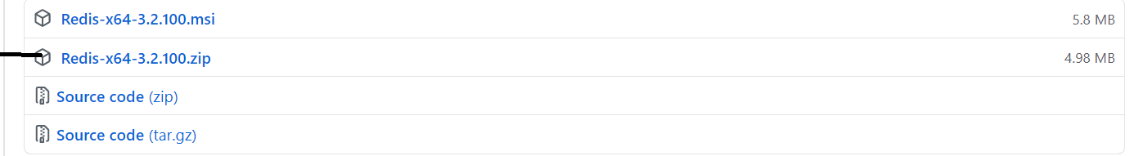

After download and extract first open redis server.

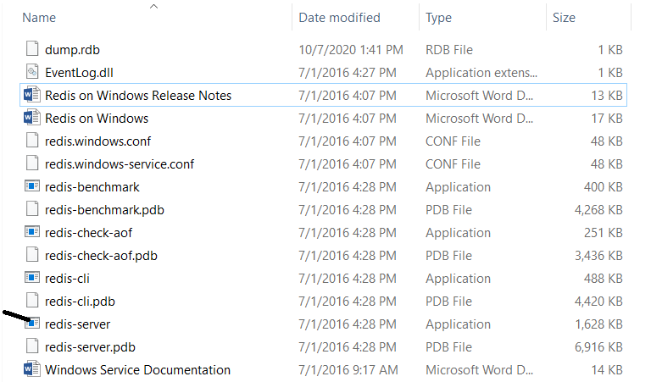

When you open server you will get

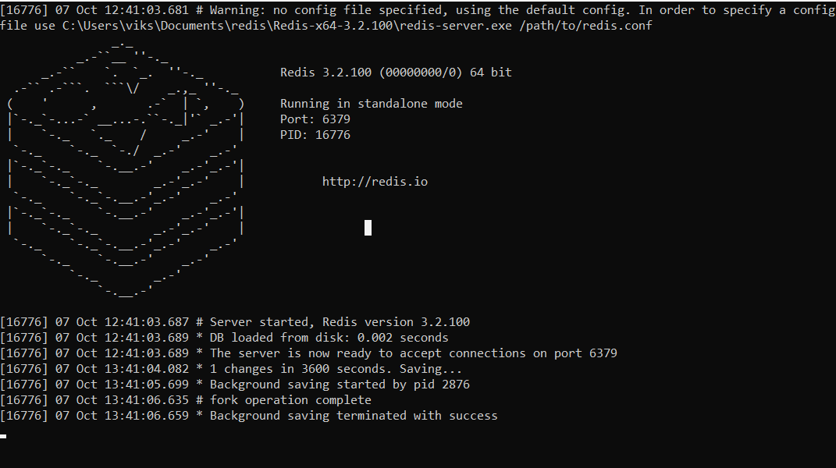

After this open redis cli.

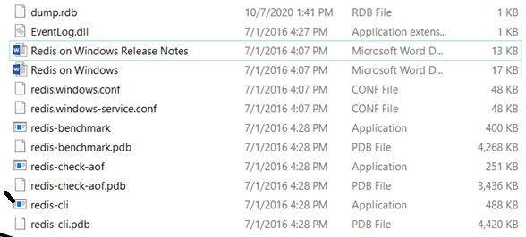

Then you will get screen

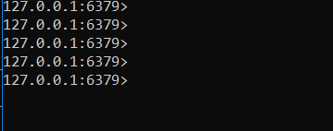

How to Work redis with Python:

To work redis with python install redis library.

pip install redis

This command will install redis.

RedisInsight:

**RedisInsight** is designed to educate and “give insights” to Redis users in several ways: By making it easier to write commands for all data structures (including all Redis Labs modules).

By using RedisInsight we can view the data which store in redis server.

To install RedisInsight:

<https://docs.redislabs.com/latest/ri/installing/install-redis-desktop/>

Then select windows 10 it will download msi file install it in your system.

The RedisInsight will open in the browser.



Now click on the Add Redis database. -> select ADD DATABASE

Fill this information: and click ADD Redis Database in bottom.

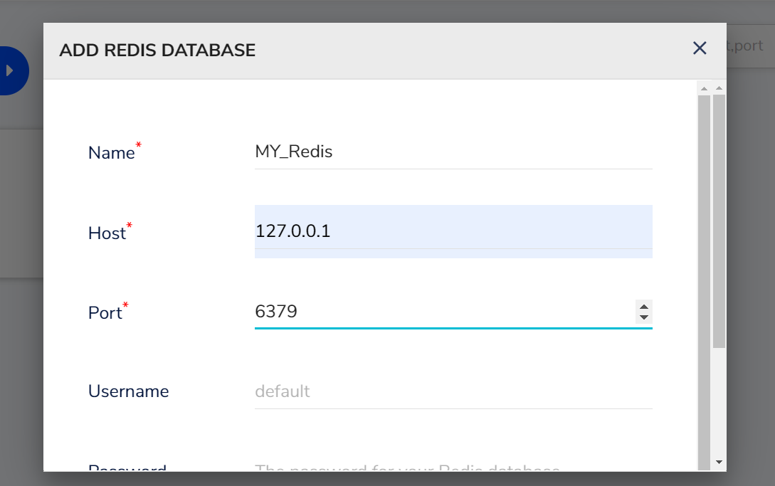

Once you connected you will get page which having all the information.

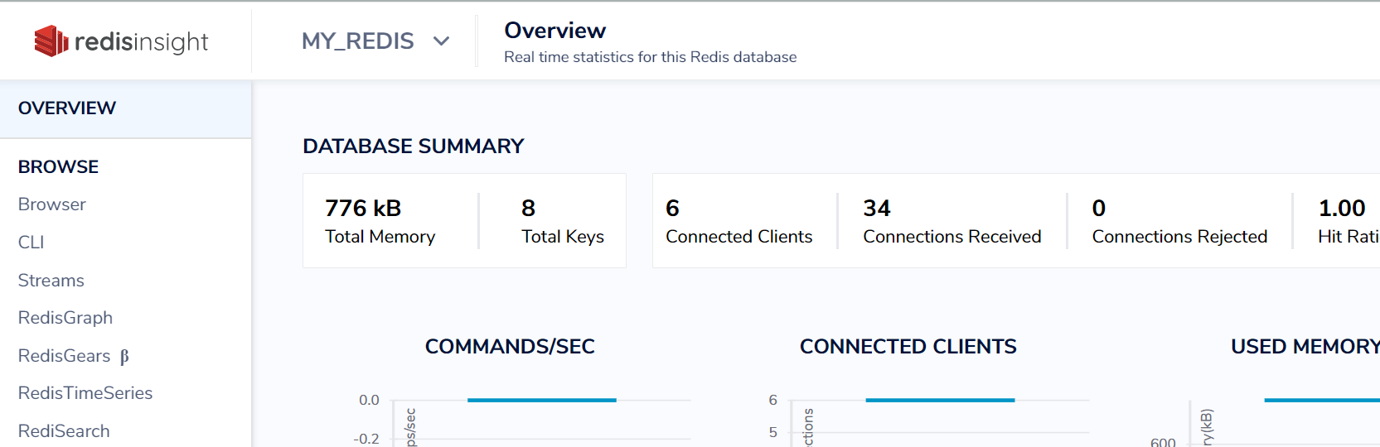

To verify the installation click on CLI

Type command **ping** this will give response pong.

