**SQOOP**

Sqoop is a tool designed to transfer data between Hadoop and relational database servers. It is used to import data from relational databases such as MySQL, Oracle to Hadoop HDFS, and export from Hadoop file system to relational databases

**Sqoop** − “SQL to Hadoop and Hadoop to SQL”

**How Sqoop Works?**

The following image describes the workflow of Sqoop.

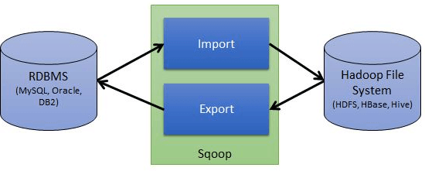

**Sqoop Import**

The import tool imports individual tables from RDBMS to HDFS. Each row in a table is treated as a record in HDFS. All records are stored as text data in text files or as binary data in Avro and Sequence files.

Syntax: $ sqoop import (generic-args) (import-args)

## Sqoop Export

The export tool exports a set of files from HDFS back to an RDBMS. The files given as input to Sqoop contain records, which are called as rows in table. Those are read and parsed into a set of records and delimited with user-specified delimiter.

syntax: sqoop export (generic-args) (export-args)

## Sqoop Import all

The import-all-tables tool imports a set of tables from an RDBMS to HDFS. Data from each table is stored in a separate directory in HDFS.

For the import-all-tables tool to be useful, the following conditions must be met:

Each table must have a single-column primary key or --autoreset-to-one-mapper option must be used.

You must intend to import all columns of each table.

You must not intend to use non-default splitting column, nor impose any conditions via a WHERE clause.

syntax: sqoop import-all-tables (generic-args) (import-args)

## sqoop-create-hive-table

The create-hive-table tool populates a Hive metastore with a definition for a table based on a database table previously imported to HDFS, or one planned to be imported. This effectively performs the "--hive-import" step of sqoop-import without running the preceeding import.

If data was already loaded to HDFS, you can use this tool to finish the pipeline of importing the data to Hive. You can also create Hive tables with this tool; data then can be imported and populated into the target after a preprocessing step run by the user.

sysnax: sqoop create-hive-table (generic-args) (create-hive-table-args)