**Oozie workflow**

Oozie is a workflow scheduler system to manage Apache Hadoop jobs.

Oozie Workflow jobs are Directed Acyclical Graphs (DAGs) of actions.

Oozie Coordinator jobs are recurrent Oozie Workflow jobs triggered by time (frequency) and data availability.

Oozie is integrated with the rest of the Hadoop stack supporting several types of Hadoop jobs out of the box (such as Java map-reduce, Streaming map-reduce, Pig, Hive, Sqoop and Distcp) as well as system specific jobs (such as Java programs and shell scripts).

Oozie is a scalable, reliable and extensible system.

**How to run script on cloudera 5.8pig Script**

**Step 1** create a file (eg. emp) stored in HDFS

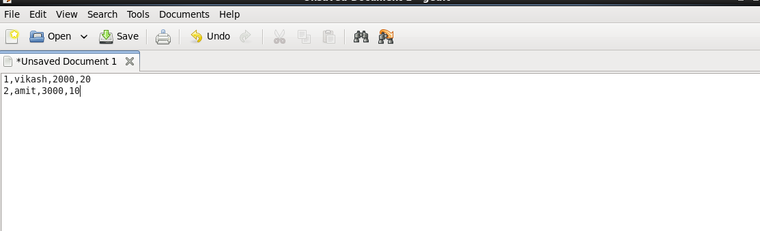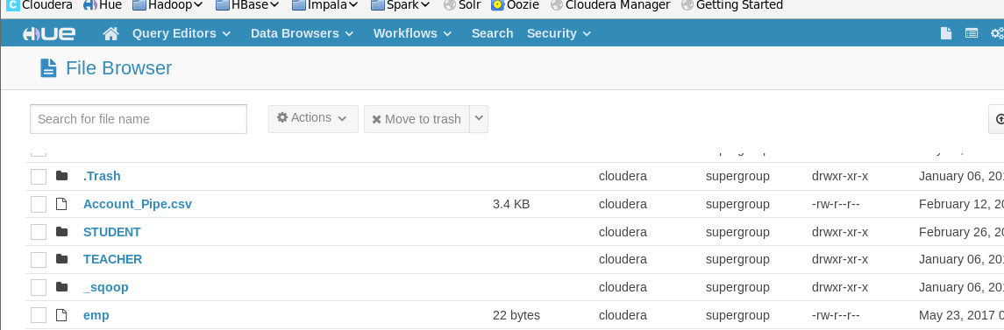

**Step 2**write a pig script and save it as employee.pig extension in Hdfs

**Pig script**

em = load '/user/cloudera/emp' using PigStorage(',') as (eid:int, ename:chararray, sal:int);

B = FOREACH em GENERATE $0;

c = STORE B INTO '/user/cloudera/input/pig2';

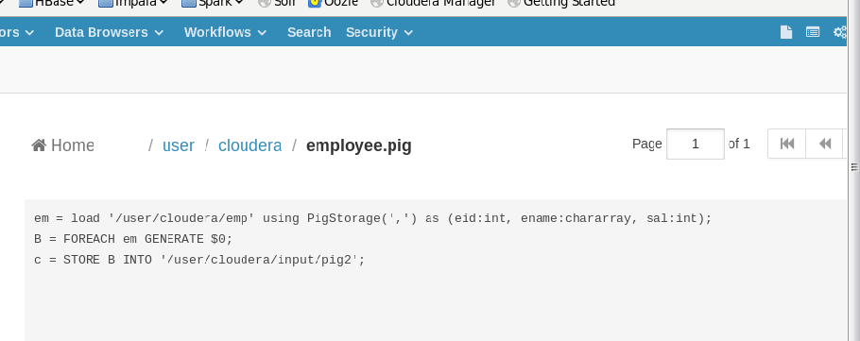

**Step 3** - select WorkFlows -> Editiors -> Workflows

Click on create

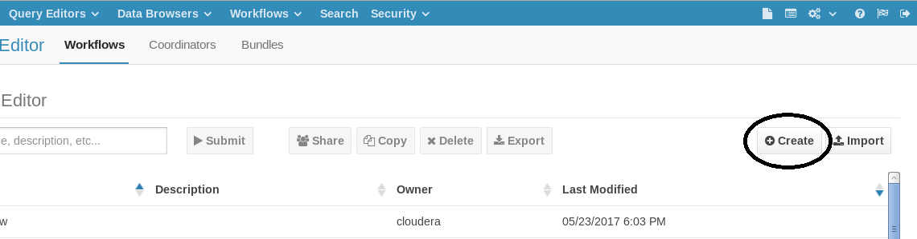

**Step - 4** select a pig script and drag it

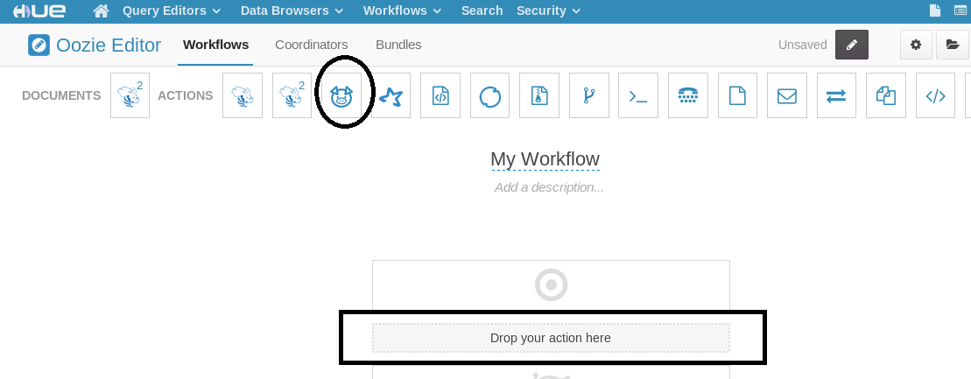

**Step 5**- select HDFS path where you save your pig script and then ADD

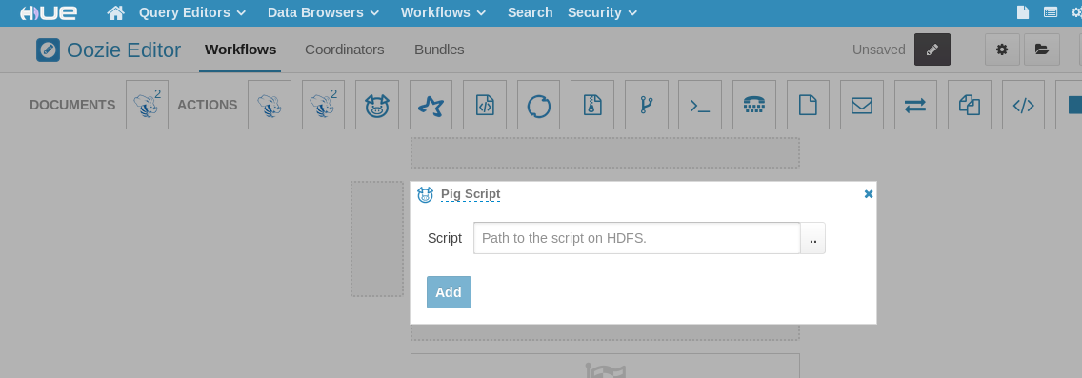

**Step 6**And then SAVE and RUN script

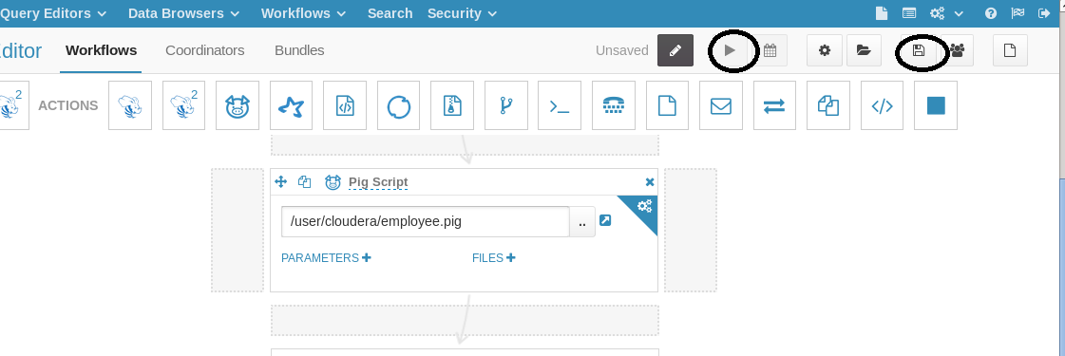

**Step 7**After submit the script you will get this screen

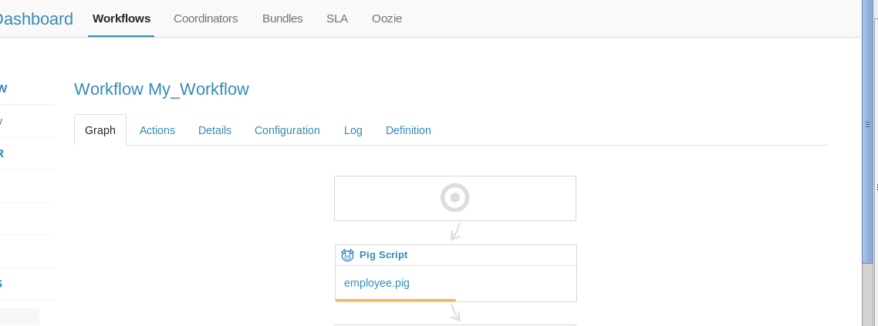

**Step 8**After successful run script you will get this screen

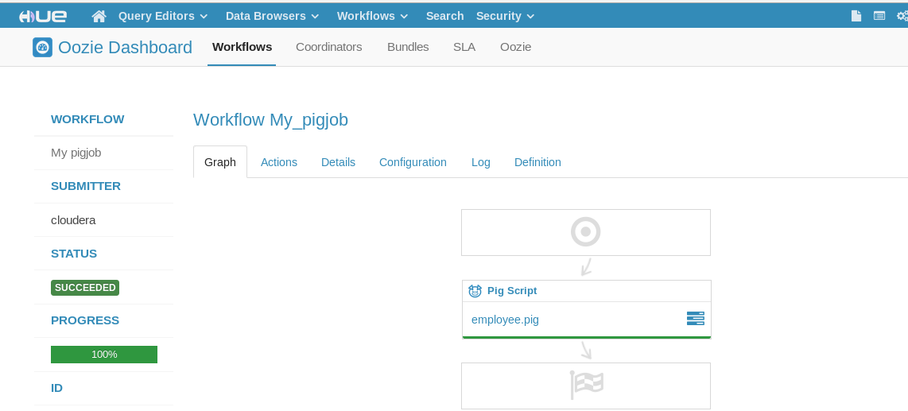

**How to run Hive script on oozie**

**Step 1** create table in hive and load data on hive table

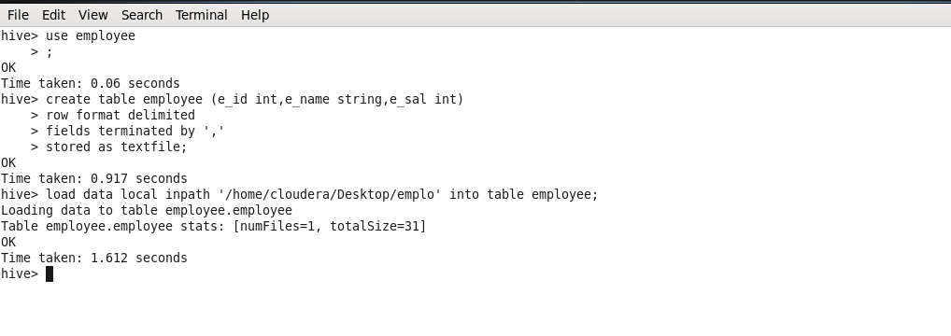

**Step 2** Write a hive script

select* from employee.employee;

and save itemployee.hql extension and save it in HDFS

**Step 3** go in /etc/hive/conf/ copy hive -site.xml file and past in hdfs

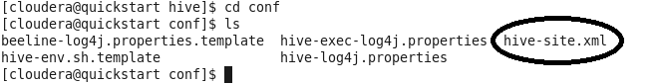

**Step 4**and drag hive script

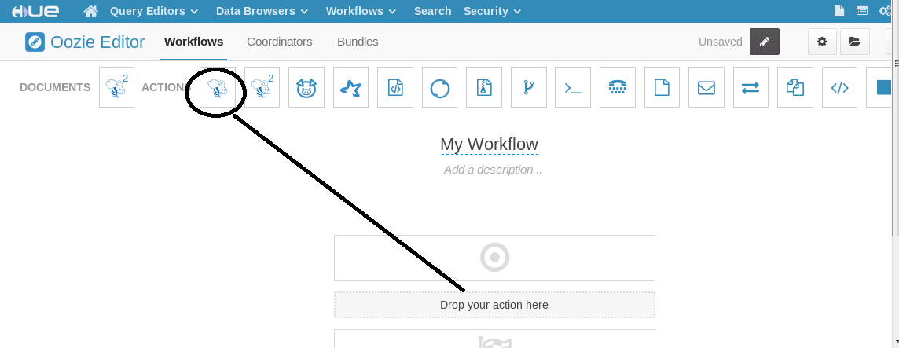

**Step 5** below here:

1. In first Script path give your hive script path in HDFS

2. In Hive xml give hive-site.xml path where you copy that file

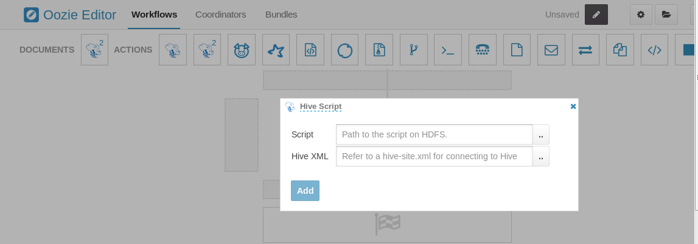

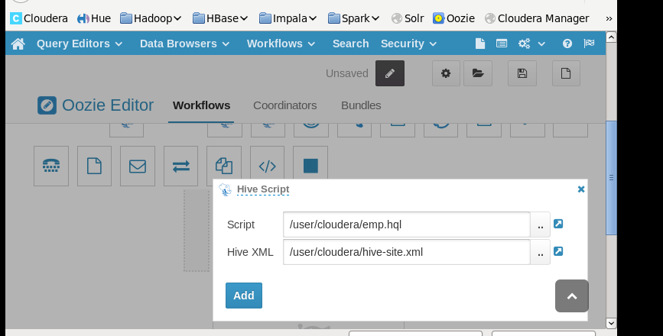

**Step6**Save your script and Run it

