***Strategic Market Entry Analysis for Electric Vehicles in India: A Segmentation Approach***

*ABHISHEK RR*

*17/11/2024*

*Abstract*

This report presents a strategic market entry analysis for electric vehicles (EVs) in India, leveraging segmentation techniques to identify the most viable customer and vehicle categories for early adoption. Using two comprehensive datasets—ev_maker_by_place and ev_cat—we aim to provide a data-driven approach for determining the optimal geographic and customer segments for launching EVs in the Indian market.

The ev_maker_by_place dataset offers insights into the distribution of EV manufacturers across various states and places in India, while the ev_cat dataset details the total sales across different vehicle categories, including passenger and commercial vehicles. Through the analysis of these datasets, we explore the adoption patterns of electric vehicles, identify potential market segments, and propose a strategic pricing model. This segmentation approach considers both the demand and readiness of different states and regions, with an understanding of consumer behaviors and market dynamics.

The goal of this analysis is to assist the startup in making informed decisions on which geographic and customer segments to prioritize, based on both early adoption potential and strategic alignment with the Innovation Adoption Life Cycle.

***INTRODUCTION***

The electric vehicle (EV) market in India is experiencing rapid growth, driven by increasing environmental awareness, government incentives, and advancements in EV technology. However, the market remains in its early stages, and identifying the right target segments for initial market penetration is crucial for the success of new entrants. This report aims to provide a strategic framework for entering the Indian EV market, utilizing a segmentation approach based on comprehensive data analysis.

In this analysis, we focus on two key datasets: ev_maker_by_place and ev_cat. The ev_maker_by_place dataset provides information on the distribution of EV manufacturers across various states and cities in India, offering valuable insights into regional market presence and potential growth opportunities. The ev_cat dataset, on the other hand, provides detailed information on the sales of different vehicle categories, including both passenger and commercial vehicles, across various locations.

By analyzing these datasets, we can identify the most promising regions and vehicle categories for electric vehicle adoption. Using the Innovation Adoption Life Cycle framework, this report seeks to pinpoint which geographic areas and consumer segments are most likely to embrace electric vehicles in the initial stages of market development. Furthermore, the analysis will inform the creation of a strategic pricing model tailored to the psychographics of early market adopters, ensuring a competitive edge in the market.

This strategic market entry analysis will help the startup make informed decisions on the prioritization of target regions, vehicle categories, and pricing strategies, aligning with the goal of establishing a strong foothold in the growing Indian EV market

***Data Loading and Initial Exploration***

In the first step of data preparation, we imported two datasets: ev_maker_by_place and ev_cat_01-24. The ev_maker_by_place dataset provides insights into various electric vehicle manufacturers, their locations (places), and the states they operate in. The ev_cat_01-24 dataset contains detailed sales data across multiple vehicle categories like four-wheelers, two-wheelers, heavy goods vehicles, and more, over different dates.

The datasets were successfully loaded into data structures (DataFrames), with the preview output showing a sample of the rows from both datasets. This foundational data will be critical for the segmentation analysis, allowing us to explore geographic, product category, and temporal trends in electric vehicle sales.

Next, we can begin analyzing the dataset, segmenting the data based on geographical and product categories, and identifying key patterns that inform our market entry strategy for electric vehicles in India.

***State-wise Distribution of EV Makers***

In this analysis, we conducted an evaluation of the distribution of Electric Vehicle (EV) makers across different states in India, utilizing the ev_maker_by_place dataset. The goal was to identify the concentration of EV manufacturers in various regions and understand the geographic market spread.

The results highlight that Maharashtra, Tamil Nadu, and Karnataka are the states with the highest number of EV makers, reflecting the strong presence and growth of the EV industry in these regions. These states could be considered early adopters or hubs for EV manufacturing, with a higher concentration of both infrastructure and customer base.

Conversely, states like Punjab, Madhya Pradesh, and Andhra Pradesh have fewer EV makers, suggesting untapped or emerging markets with potential for new entrants. This state-wise distribution analysis provides valuable insights for targeting specific regions for market penetration and tailored marketing strategies, especially considering the varying levels of infrastructure development and demand across states.

Visualizing the state-wise distribution through graphs helps better understand where to prioritize resources and focus marketing efforts. By observing such trends, the team can make more informed decisions about expansion strategies, whether to focus on high-density regions or explore underserved markets to promote EV adoption.

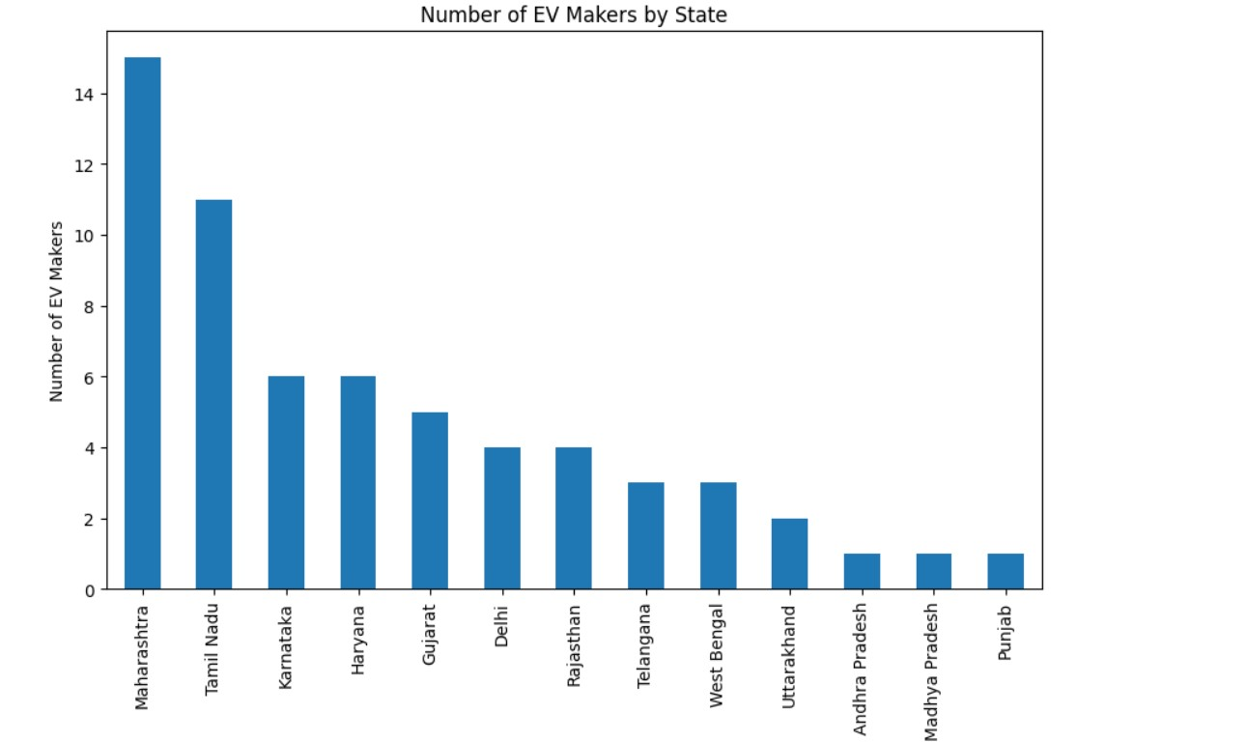

**Fig 1: Number of EV Makers by State**

***Overview of Available Vehicle Categories in the Dataset***

We explored the columns of the ev_cat dataset, which contains information related to various electric vehicle categories.

These categories represent the different types of electric vehicles covered in the dataset, each of which is crucial for analyzing the overall EV market landscape in India. Understanding these categories helps us identify key segments to target when analyzing market entry strategies for electric vehicles.

***Vehicle Category Trend Analysis***

In this step, we focused on analyzing the total sales count across different vehicle categories. The dataset was aggregated to calculate the total count for each vehicle category, providing a comprehensive view of the distribution of vehicle types in the dataset.

The results revealed that the most prominent categories in terms of total counts are "TWO WHEELER(NT)" and "TWO WHEELER(T)" with over 2.3 million and 1.9 million vehicles, respectively. On the other hand, categories like "MEDIUM MOTOR VEHICLE" and "MEDIUM GOODS VEHICLE" had significantly lower counts, indicating lesser demand or limited sales in those segments.

To provide better insights, a bar plot was generated to visualize the trends in vehicle category counts, highlighting the differences in the popularity of various categories. This visualization can help in identifying which vehicle segments are most in demand, allowing for a more targeted market entry strategy.

**Key Findings:**

* Two-wheeler categories dominate the market in terms of total sales.
* Other vehicle categories like "HEAVY MOTOR VEHICLE" and "FOUR WHEELER (INVALID CARRIAGE)" show considerably lower sales.

The bar plot visualization further reinforces these findings by illustrating the relative distribution of vehicle types, helping us understand where the potential for growth lies in the EV market.

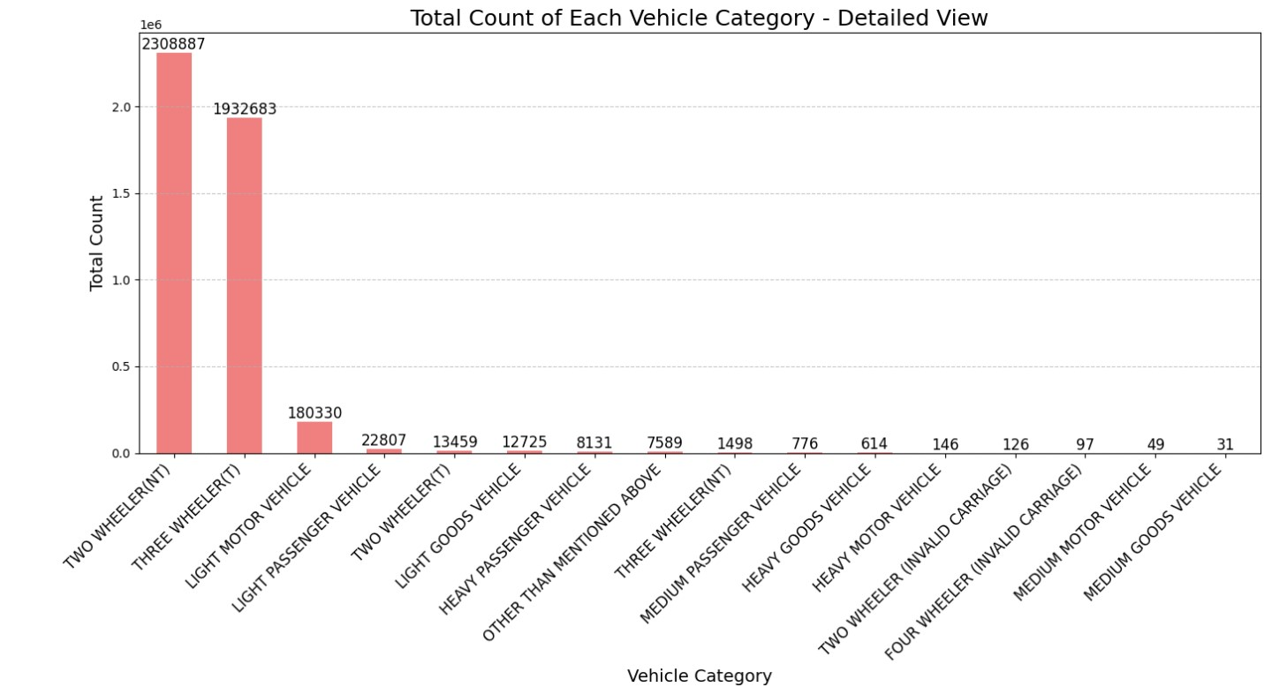

**Fig 2: Total Count of Each Vehicle Category - Detailed View**

***Data Merging and Overview***

In this step, the data from two separate datasets, ev_maker_by_place and ev_cat, was merged using a cross join. This allowed us to combine the vehicle data (such as vehicle categories and their respective counts) with the EV maker information (including the places and states). This integration helps us analyze the distribution of vehicle categories across various locations and manufacturers, providing a comprehensive view of the EV market across different regions. By merging these datasets, we can proceed to deeper analysis for targeting specific locations and vehicle types suitable for the market entry strategy.

In this step, the data from two separate datasets, ev_maker_by_place and ev_cat, was merged using a cross join. This allowed us to combine the vehicle data (such as vehicle categories and their respective counts) with the EV maker information (including the places and states). This integration helps us analyze the distribution of vehicle categories across various locations and manufacturers, providing a comprehensive view of the EV market across different regions. By merging these datasets, we can proceed to deeper analysis for targeting specific locations and vehicle types suitable for the market entry strategy.

***Analysis of Electric Vehicle Sales by Category, Maker, and Location***

***Total Sales for Each Vehicle Category Across All Places***

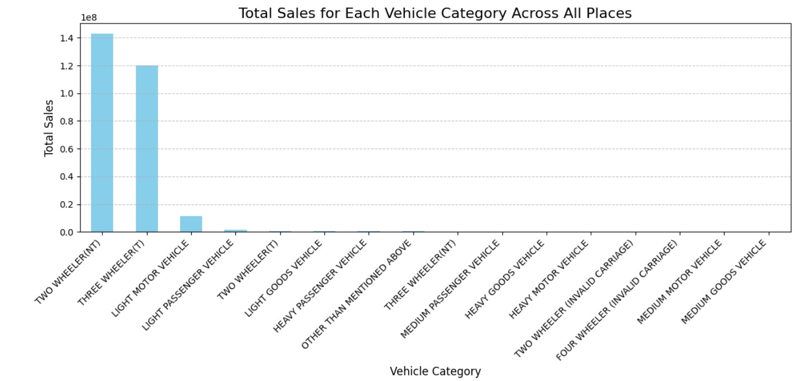

**Fig 3: Total Sales for Each Vehicle Category Across All Places**

This graph displays the total sales figures for each vehicle category across all places. Notably, **Two Wheeler (NT)** has the highest total sales, followed by **Three Wheeler (T)**, which indicates their significant market share in the electric vehicle sector. Other categories such as **Light Motor Vehicle** and **Light Passenger Vehicle** also show high sales numbers, reflecting a strong demand for smaller, more affordable vehicles. On the other hand, categories like **Medium Goods Vehicle** and **Four Wheeler (Invalid Carriage)** have much lower sales, suggesting a relatively niche market for these types of vehicles.

The analysis highlights the dominance of two-wheelers and three-wheelers in the electric vehicle landscape, with a notable concentration in the lighter vehicle categories.

***Total Sales by EV Maker Across All Places***

This graph displays the total sales figures for each vehicle category across various EV makers. All EV makers in the dataset show similar sales figures for each vehicle category, which suggests that the dataset may include a repeated set of values across different EV makers rather than unique data for each maker.

A significant observation is the consistent sales figures for each vehicle category across the board, with specific makers like **Tata Power**, **Ampere Vehicles**, and **Altigreen Propulsion Labs** showing similar sales patterns. The dataset includes a broad spectrum of vehicle categories, with **Two Wheeler (NT)** and **Three Wheeler (T)** showing large sales numbers compared to others like **Medium Goods Vehicle** or **Four Wheeler (Invalid Carriage)**.

This consistency in sales suggests that multiple makers may be contributing similarly to the market share, and any deviations would require deeper analysis.

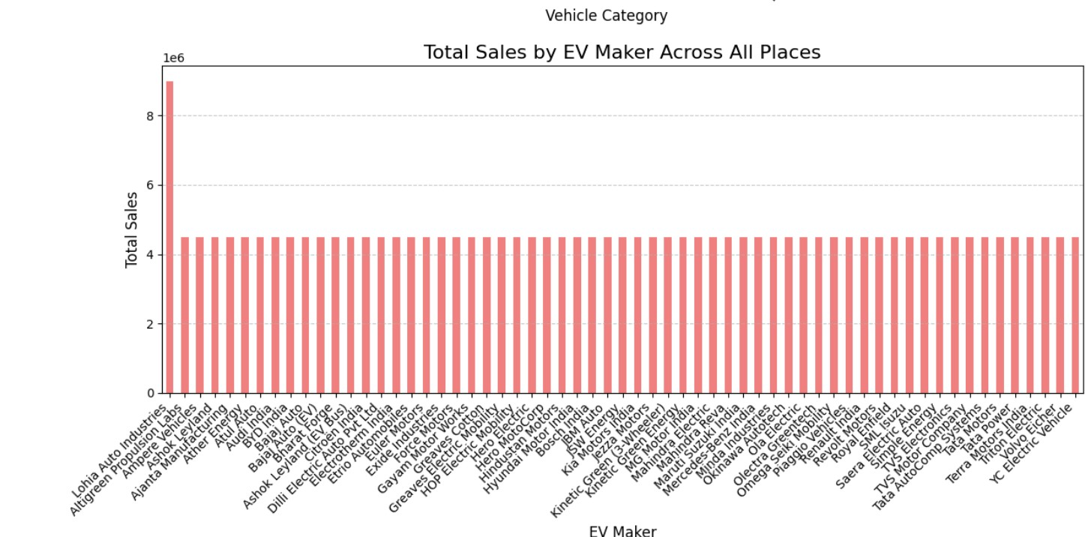

**Fig 4: Total Sales by EV Maker Across All Places**

***Analysis of EV Market Potential in Indian Cities***

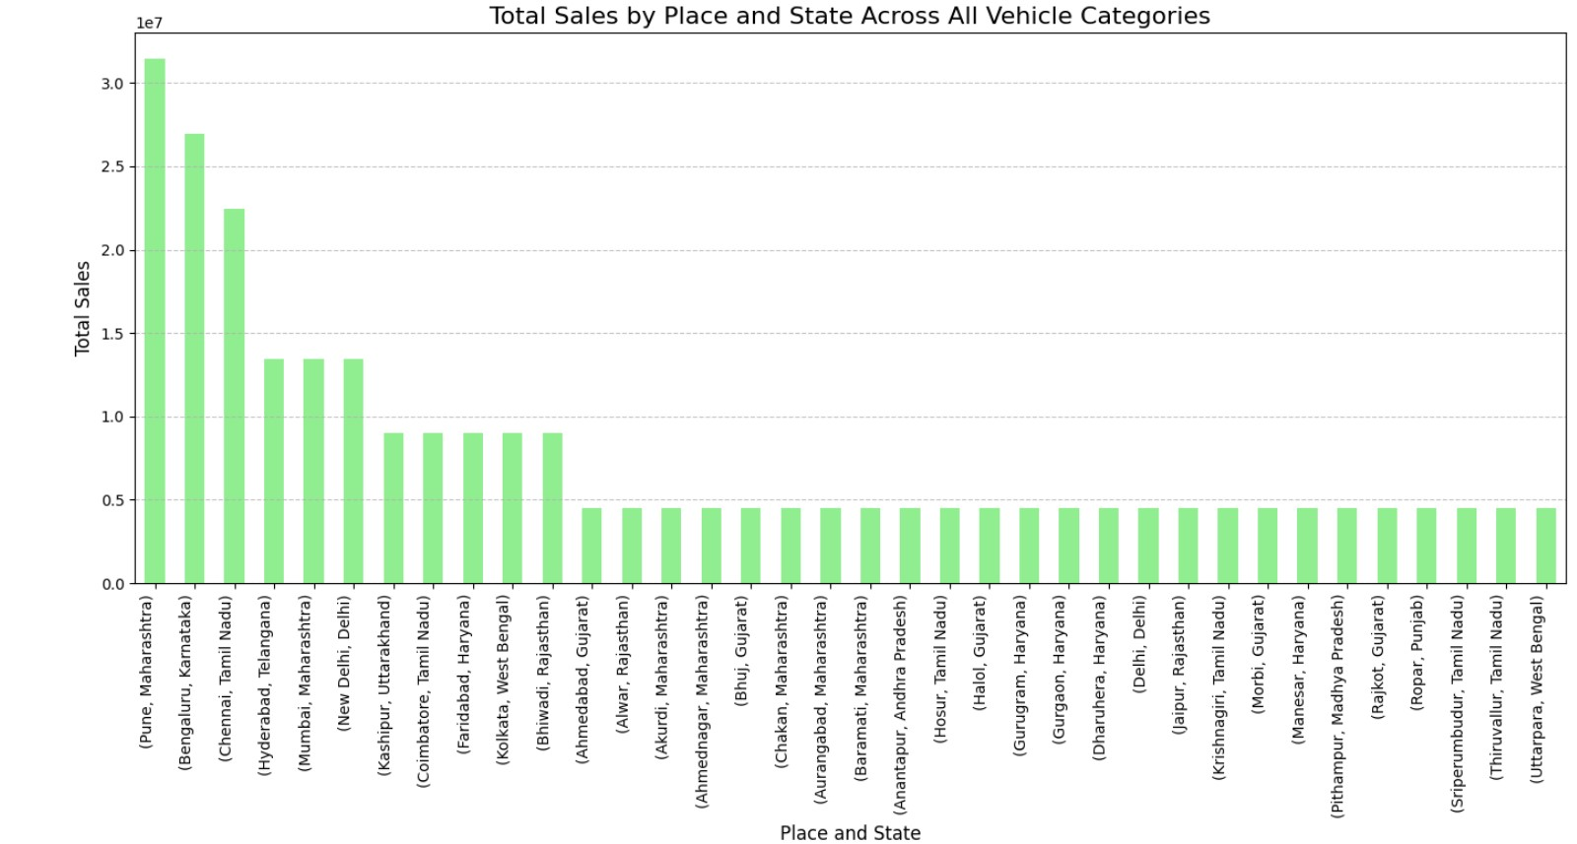

**Fig 5: Total Sales by Place and State**

The analysis of vehicle data across various Indian cities highlights key trends and opportunities for Electric Vehicle (EV) adoption.

**Pune** stands out as the clear leader in the EV market, with the highest numbers across several vehicle categories, particularly in two-wheelers and three-wheelers. This positions Pune as the most promising market for EV businesses to target, given its already strong adoption rate and substantial market size. With over 13 million two-wheelers and more than 13 million three-wheelers, Pune represents the most developed and competitive market for EV penetration in India.

Following Pune, **Bengaluru** and **Chennai** also show considerable potential. Bengaluru, with a population of over 11 million two-wheelers and more than 8 million three-wheelers, is a major tech hub with a growing demand for sustainable transportation options. Chennai, with its large numbers in both two-wheelers and three-wheelers, represents another strong market for EV adoption. Both cities are well-positioned for further EV growth, benefiting from established infrastructure and a progressive approach to sustainability.

Other cities such as **Mumbai**, **Delhi**, and **Hyderabad** also demonstrate robust EV potential. These cities have sizable vehicle populations across multiple categories, indicating a growing awareness and inclination toward EVs. However, the competition in these larger cities may be higher, as they are already seeing substantial interest from other EV players.

On the other hand, cities like **Alwar**, **Krishnagiri**, and **Morbi** present opportunities for early market entry. While these cities have comparatively lower numbers in terms of EV market size, they show promise for future growth, especially as the adoption of EVs picks up in smaller, less saturated markets. Establishing a presence in these cities could provide a first-mover advantage and contribute to long-term growth as EV awareness and infrastructure improve.

In conclusion, **Pune** emerges as the top priority for businesses looking to enter the EV market in India, followed by **Bengaluru** and **Chennai**, which are poised for significant growth. While the major metropolitan areas offer substantial competition, they also present lucrative opportunities. Emerging cities such as **Alwar**, **Krishnagiri**, and **Morbi** should be monitored closely, as they represent untapped potential for future EV adoption and business growth. By targeting these high-potential regions, businesses can capitalize on the ongoing EV revolution in India.

### ***Final Conclusion: Best EV Vehicle Types and Investment Opportunities in Indian Cities***

Based on the comprehensive analysis of vehicle data across various cities in India, several key insights can guide both investment strategies and the types of Electric Vehicles (EVs) to prioritize for entry into the market.

**EV Vehicle Focus:**

* **Two-Wheelers (T):** The two-wheeler segment stands out as the most significant contributor to the Indian EV market. Cities like **Pune**, **Bengaluru**, and **Chennai** lead the way with the highest adoption rates, making this segment an ideal focus for businesses looking to capture the largest volume of potential customers. The demand for two-wheelers remains strong due to their affordability, convenience, and suitability for India’s dense urban environments.
* **Three-Wheelers (T):** The three-wheeler segment, particularly in cities like **Bengaluru**, **Mumbai**, and **Hyderabad**, also presents considerable opportunities. This category is gaining traction due to the shift towards electric auto-rickshaws and delivery vehicles, driven by sustainability goals and cost-efficiency. Therefore, focusing on three-wheelers in high-density urban areas could help businesses tap into the growing demand for eco-friendly transportation options in the public transport and logistics sectors.
* **Invalid Carriages (Two-Wheelers NT):** While the **Invalid Carriage (Two-Wheeler NT)** category has relatively fewer vehicles, its potential in niche markets catering to differently-abled individuals presents a long-term opportunity. This segment could be explored further, particularly in cities with better accessibility infrastructure, like **Delhi**, **Mumbai**, and **Chennai**.

**Best Cities for Investment:**

1. **Pune** - **Top Priority:** As the leading city in terms of overall EV vehicle numbers, particularly in the two-wheeler and three-wheeler categories, Pune should be the first city for investment. The city's growing adoption of EVs, combined with its progressive population, creates a solid foundation for market penetration and expansion.
2. **Bengaluru** - **High Priority:** With its large vehicle population, particularly in the two-wheeler and three-wheeler segments, Bengaluru represents another prime location for EV businesses. The city's strong tech ecosystem and environmentally conscious population make it an attractive market for EV adoption.
3. **Chennai** - **High Priority:** Chennai’s robust numbers in both two-wheeler and three-wheeler categories position it as another top contender for EV market investment. The city’s industrial base, along with a growing interest in sustainable transportation, creates a promising environment for EV businesses.
4. **Mumbai** - **Moderate Priority:** While Mumbai has substantial vehicle numbers, the market is also highly competitive. However, the city's large population and focus on sustainability initiatives make it an attractive market for businesses focused on high-end or specialized EVs, such as electric cars and three-wheelers for shared mobility.
5. **Delhi** - **Moderate Priority:** As the capital city, Delhi is crucial for businesses targeting government initiatives and policies focused on reducing pollution. Despite a highly competitive landscape, Delhi’s large vehicle population in the three-wheeler and two-wheeler segments makes it a significant market for EV growth.
6. **Emerging Cities (Alwar, Krishnagiri, Morbi, etc.)** - **Growth Potential:** While these cities currently have smaller vehicle populations, they present an opportunity for early market entry. As India continues its push for EV adoption, these cities could become key players, especially for businesses looking to capture the first-mover advantage in emerging markets.

**Conclusion:** To capitalize on India's growing EV market, businesses should focus on **two-wheelers** and **three-wheelers** as their primary vehicle types, given their large market size and increasing demand. Cities like **Pune**, **Bengaluru**, and **Chennai** offer the best opportunities for investment, with Pune leading as the top choice due to its already established and growing EV base. Additionally, emerging cities like **Alwar**, **Krishnagiri**, and **Morbi** should be monitored for future growth, as they present untapped potential for EV adoption.

By strategically targeting these cities and focusing on two-wheelers and three-wheelers, businesses can position themselves for success in India’s rapidly expanding EV market.