**Path Following Bi-directional Controller for Articulated Vehicles**

Abhishek Singh Tomar1, Karel Kural1,2, Rakshith Kusumaker1, Arun Naren1

1 **HAN University of Applied Sciences, Arnhem**, 2 **Eindhoven University of Technology**

PO BOX 2217, 6802 CE Arnhem, The Netherlands

Phone: +31 (0) 6 16 41 96 89

[Abhishek](mailto:Abhishek)Singh.Tomar@han.nl

**1. Introduction**

Increasing population and demand on transportation of goods are resulting in higher number of vehicles on the road, leading to growing traffic volume and road accidents. High capacity vehicles (HCVs) which are the vehicles with one or more number of articulations might be a potential solution. HCVs have been introduced mainly in Scandinavian countries, The Netherlands, Australia, Canada, USA, and South Africa due to their ability to reduce fuel consumption, road wear and traffic congestion, as indicated by Odhams et al., see [1]. However, handling and stability aspects of HCVs become more challenging with increasing number of articulations, especially in the case of reversing and parking. Even the professional drivers find the reversing of HCVs strenuous, which further intensifies when it has to be done in constrained spaces as reported by Rakic et al., see [2].

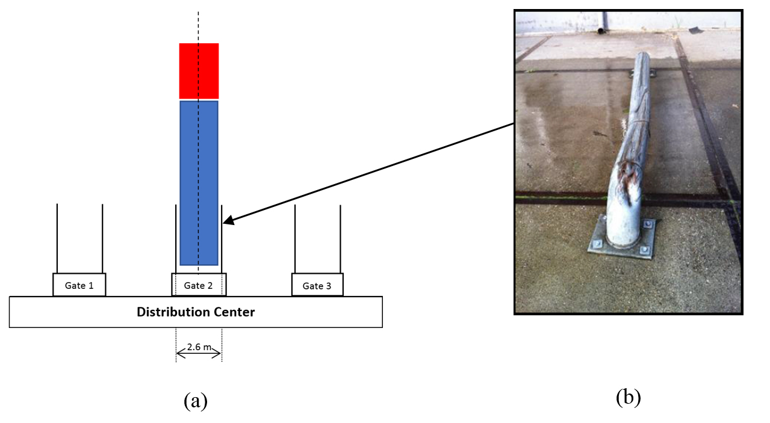

**Figure 1.: (a) Schematic presentation of distribution center; (b) Damaged docking rail**

Docking gates at various distribution centers are one of the example of such constrained spaces, where docking (or guiding) rails at docking gates provide the level of tolerance, usually in order of 10-20 cm as presented in Figure 1.(a). The complexity of maneuver and driver’s limited spatial perception results in damage to the rails, which can be found at several distribution centers, as shown in Figure 1.(b). A novel conceptual approach of driver support system, specific to the aforementioned problem, using an unmanned aerial vehicle (UAV) is presented by Karel et al., see [3], where a path following controller is developed and tested for single articulated vehicle based on the approach adapted from Morales et al., see [4].

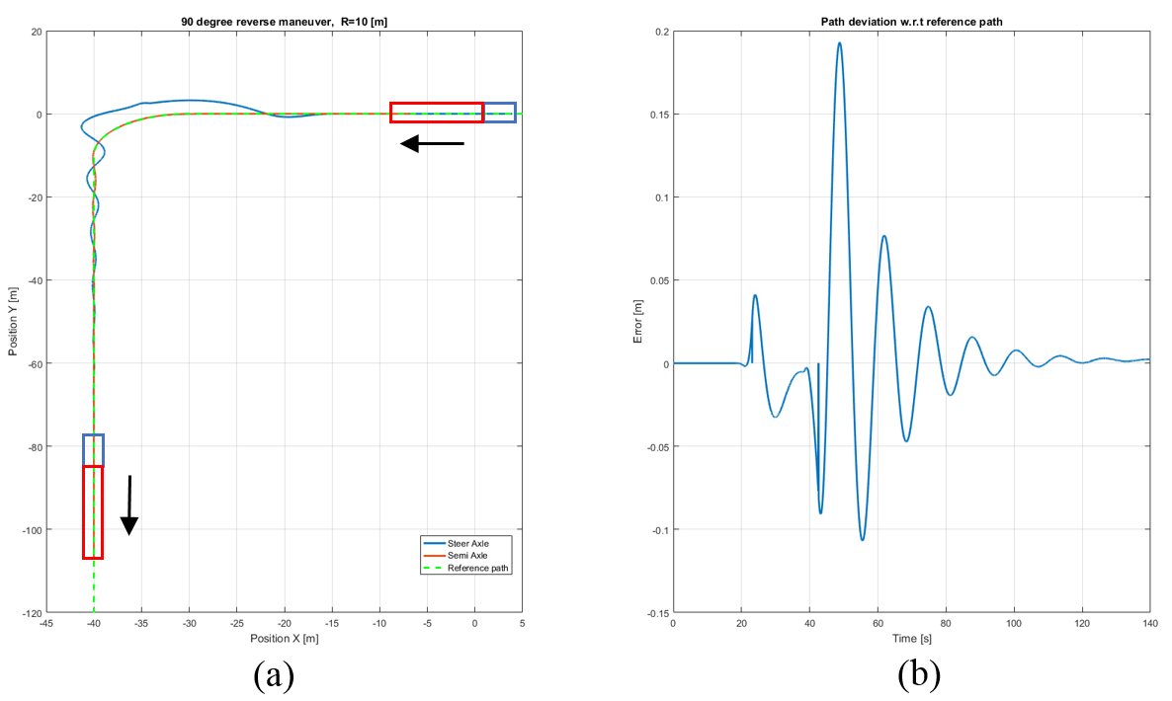

**Figure 2.: (a) Reverse path following of single articulated vehicle; (b) Path deviation error**

As presented in Figure 2.(a), the approach is suitable for docking maneuver of single articulated vehicle, however, the peak deviation error with respect to the reference path is approaching the tolerance available as shown in Figure 2.(b). Therefore, extending this approach to HCVs with higher number of articulations may result in crossing the tolerance levels. The reduction in peak deviation error is important mainly from the point of view of maneuvering space required and by keeping not only the final error within the tolerance limit, but also the intermediate peaks will result in less and efficient maneuvering space which is always preferable.

Hence, this paper aims to further improve the performance of path following controller in both forward and reverse direction and extend its applicability to HCVs with more than one articulations based on the evaluation of steer effort, peak and final deviation error with respect to reference path and by analysing its close loop stability.

**Keywords:** Low speed maneuvering, Path following controller, Bi-directional control, Articulated Vehicles, Inverse kinematics, Stability analysis, High capacity vehicles

**2. Research approach**

Before proposing the improvements in path following controller for docking maneuver, it is important to highlight two points, which are as follows:

1. The path following controller must be able to keep the rear-most axle of the HCV on the reference path.
2. The path following controller must be bi-directional (i.e. applicable in both forward and reverse direction) because the docking maneuver usually consists of both forward and reverse motion.

The path following problem of an articulated vehicle in reverse direction has been investigated and multiple approaches can be found in literature, see [5-7]. However, by considering two above mentioned points, the approach described by Morales et al., see [4] has still been found suitable but not sufficient, mainly due to the limitations of pure pursuit controller.

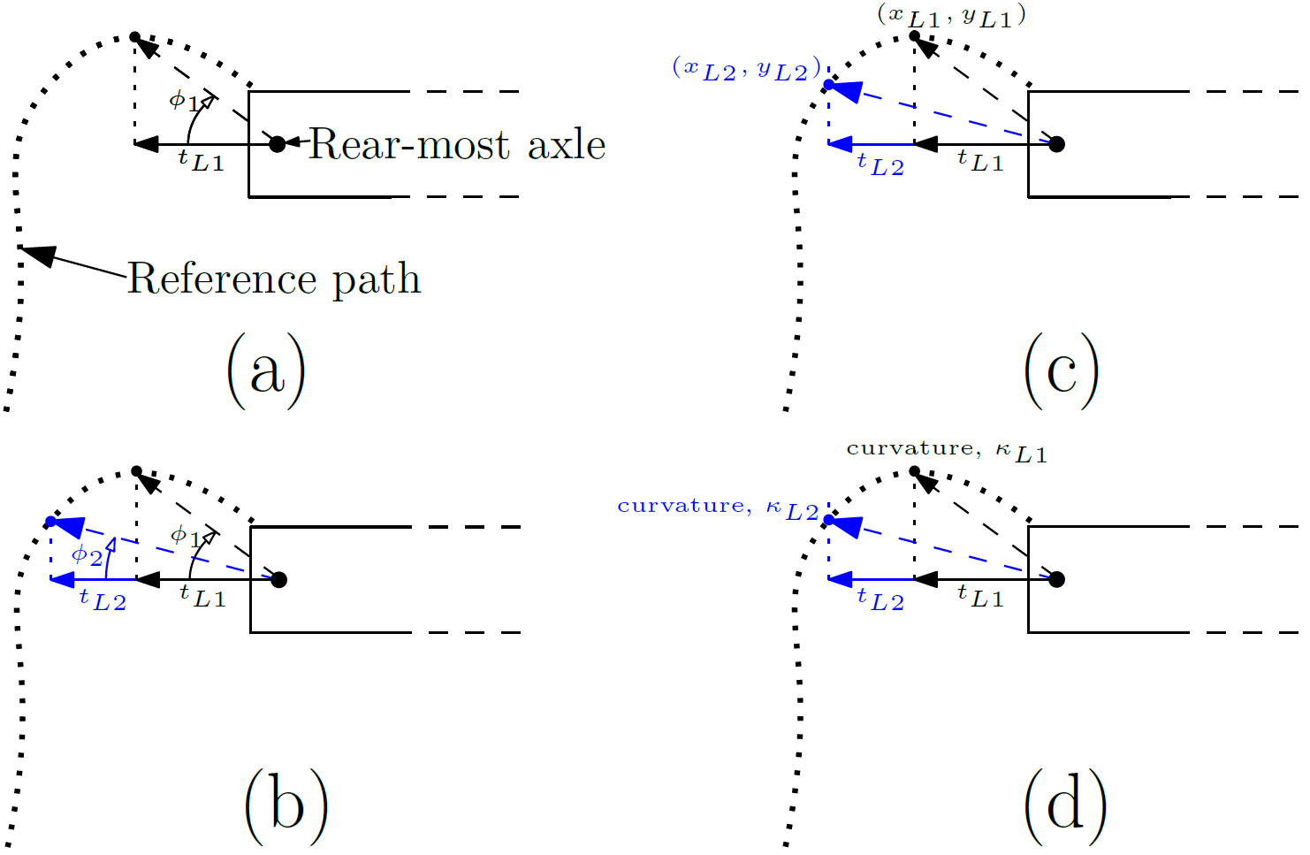

**Figure 3: Factors involved in controller: (a) virtual steer angle with one preview time, $t_{L1}$ (see [3]); (b) virtual steer angle with two preview time, $t_{L1}$ and $t_{L2}$ (see [5]); (c) heading change calculation for reference path using two preview time; (d) curvature change calculation for reference path using two preview time**

The existing path following controller, see [3] estimates the virtual steering angle $∅_{1}$, as shown in Figure 3.(a), and the required steering angle $δ$ is calculated using equation (1), where $K_{s}$ is the steering gain. The required steering angle is further translated to steer axle using inverse kinematic relations. For more details, see [3, 4].

$δ=K_{s} . (∅_{1})$ (1)

According to Salvucci et al., see [5], human driver utilize two visual points (one near point and one far point) for steering to follow the reference path. This approach may result in both accurate and smooth path following and can be incorporated in path following controller using two preview times as shown in Figure 3.(b) with their corresponding weighing factors $W_{L1}$ and $W_{L2}$. The required steering angle can be represented using equation (2).

$δ_{s}=K_{s} . (W_{L1}*∅_{1}+W_{L2}*∅_{2})$ (2)

It is envisioned to further include the heading and curvature change errors in controller (mainly due to the possibility of using two preview times) instead of heading and curvature error shown by [6, 7] to reduce the peak deviation error as shown in Figure 2.(b), which usually occurs during the curve. The heading change $∆θ_{p}$, as presented in Figure 3.(c) for reference path can be determined using equation (3), where $(x_{L1},y_{L1})$ and $(x_{L2},y_{L2})$ are the coordinates of points on reference path corresponding to preview times $t_{L1}$ and $t_{L2}$ respectively. The heading (or yaw) angle $θ_{v}$ for vehicle’s rear-most axle can be determined from vehicle feedback. The required steering angle factor corresponding to heading change error $∆δ_{θ}$ can be represented using equation (4), where $K_{θ}$ is the heading change gain.

$∆θ_{p}= \frac{(y_{L2}-y_{L1})}{(x_{L2}-x_{L1})}$ (3)

$∆δ_{θ}=K_{θ} .(∆θ_{p}-θ_{v})$ (4)

The curvature of reference path (given, $y_{p}=f(x_{p})$) at two preview points ( $κ_{L1}$ and $κ_{L2}$) as shown in Figure 3.(d) can be determined using equation (5) and curvature change $∆κ_{v}$ for vehicle’s rear-most axle can be estimated from vehicle feedback. The required steering angle factor corresponding to curvature change error $∆δ_{κ}$ can be represented using equation (6), where $K_{κ}$ is the curvature change gain.

$κ_{L,i}=\left[\frac{\left(\frac{d^{2}y}{dx^{2}}\right)}{{\left(1+{\left(\frac{dy}{dx}\right)}^{2}\right)}^{\frac{3}{2}}}\right]$; $i=1,2$ (5)

$∆δ_{κ}=K_{κ} .\left(∆κ_{p}-∆κ_{v}\right)$; where, $∆κ_{p}=$ ($κ_{L2}-κ_{L1}$) (6)

Therefore, the required steering angle by considering two preview times, heading change and curvature change error can be represented using equation (7).

$δ= δ_{s}+ ∆δ_{θ}+∆δ_{κ}$ (7)

**3. Expected results**

The controller alternatives with proposed factors will be evaluated based on the following points:

* Steer effort and number of steer reversals
* Peak and final deviation error with respect to reference path
* Space envelop required for docking maneuver
* Minimum number of tunable controller parameters
* Close loop stability analysis

Finally an optimization routine will be developed to tune the controller parameters and the most appropriate controller alternative will be selected and tested on scaled set-up with up to two articulations.

**References**

|  |  |
| --- | --- |
| [1]. | Odhams, A.M.C., Roebuck, R.L., Lee, Y.J., Hunt, S.W. and Cebon, D., 2010. Factors influencing the energy consumption of road freight transport. *Proceedings of the Institution of Mechanical Engineers, Part C: Journal of Mechanical Engineering Science*, *224*(9), pp.1995-2010. |
| [2]. | Rakic, B., Stegeman, J. and Kind, M., 2011. Monitoring Traffic Safety Longer and Heavier Vehicles. *Ministry of Infrastructure and Environment, ARCADIS, Hague*. |
| [3]. | Kural, K., Besselink, I., Xu, Y., Tomar, A. and Nijmeijer, H., 2016, November. A driver support system for improved maneuvering of articulated vehicles using an unmanned aerial vehicle. In *HVTT14: International Symposium on Heavy Vehicle Transport Technology, 14th, 2016, Rotorua, New Zealand*. |
| [4]. | Morales, J., Martínez, J.L., Mandow, A. and Medina, I.J., 2009, November. Virtual steering limitations for reversing an articulated vehicle with off-axle passive trailers. In *Industrial Electronics, 2009. IECON'09. 35th Annual Conference of IEEE* (pp. 2385-2390). IEEE. |
| |  |  | | --- | --- | | [5]. |  | | Salvucci, D.D. and Gray, R., 2004. A two-point visual control model of steering. *Perception*, *33*(10), pp.1233-1248. |
| [6]. | Pradalier, C. and Usher, K., 2008. Robust trajectory tracking for a reversing tractor trailer. *Journal of Field Robotics*, *25*(6‐7), pp.378-399. |
| [7]. | Rimmer, A.J. and Cebon, D., 2016. Theory and practice of reversing control on multiply-articulated vehicles. *Proceedings of the Institution of Mechanical Engineers, Part D: Journal of Automobile Engineering*, *230*(7), pp.899-913. |