**Path Following Bi-directional Controller for Articulated Vehicles**

Abhishek Singh Tomar1, Karel Kural1,2, Rakshith Kusumaker1, Arun Naren1

1 **HAN University of Applied Sciences, Arnhem**, 2 **Eindhoven University of Technology**

PO BOX 2217, 6802 CE Arnhem, The Netherlands

Phone: +31 (0) 6 16 41 96 89

[Abhishek](mailto:Abhishek)Singh.Tomar@han.nl

**1. Introduction**

Ever increasing population and subsequent increasing demand on transportation of goods are resulting in higher number of vehicles on the road, leading to increasing traffic volume and ~~road accidents~~. Long and heavy vehicle combinations (LHVs) which are the vehicles with more than one articulation might be a potential solution. LHVs have been introduced ~~mainly~~ in Scandinavian countries, The Netherlands, Australia, Canada, USA, and South Africa due to their ability to reduce fuel consumption, road wear, and traffic congestion, as indicated by Odhams et al., see [1]. See also[1] However, handling and stability aspects of LHVs become more challenging with increasing number of articulations especially in the case of reversing. Even the professional drivers find the reversing of LHVs strenuous which further intensifies when it has to be done in constrained spaces.

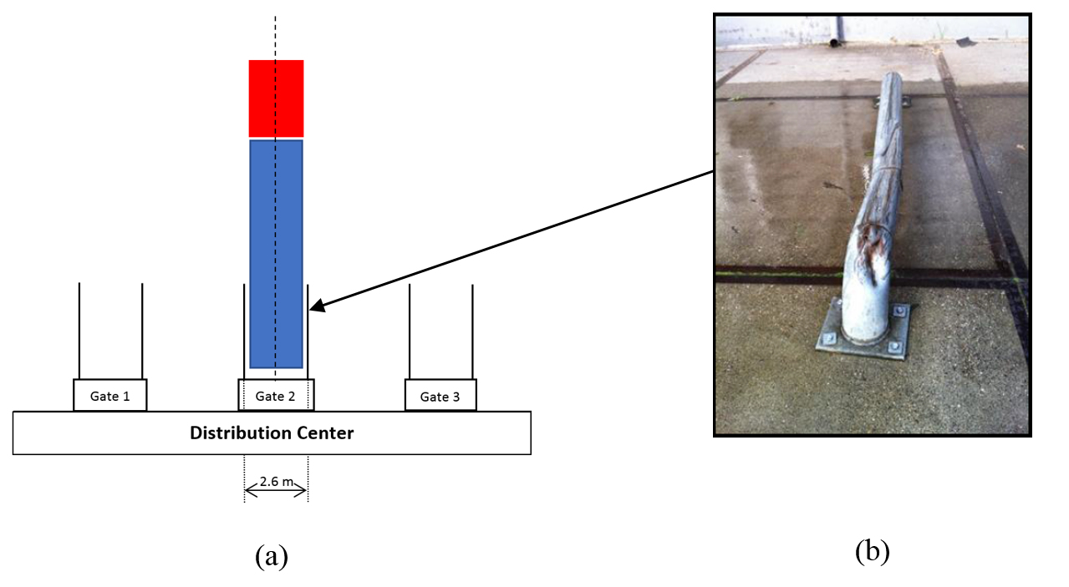

**Figure 1.: (a) Schematic presentation of distribution center; (b) Damaged docking rail**

Docking gates at various distribution centers are ~~one of the~~ example of such constrained spaces where docking (or guiding) rails at docking gates provide the level of tolerance, usually in order of 10-20 cm as presented in Figure 1.(a). Due to the complexity of maneuver and driver’s limited spatial perception, this may result in damage to the rails, ~~which can be found at several distribution centers,~~ as shown in Figure 1.(b). A novel conceptual approach of driver support system, specific to aforementioned problem, using an unmanned aerial vehicle (UAV) is presented by Karel Kural et al., see [2], where a path following controller is developed and tested for single tractor-semitrailer combination.

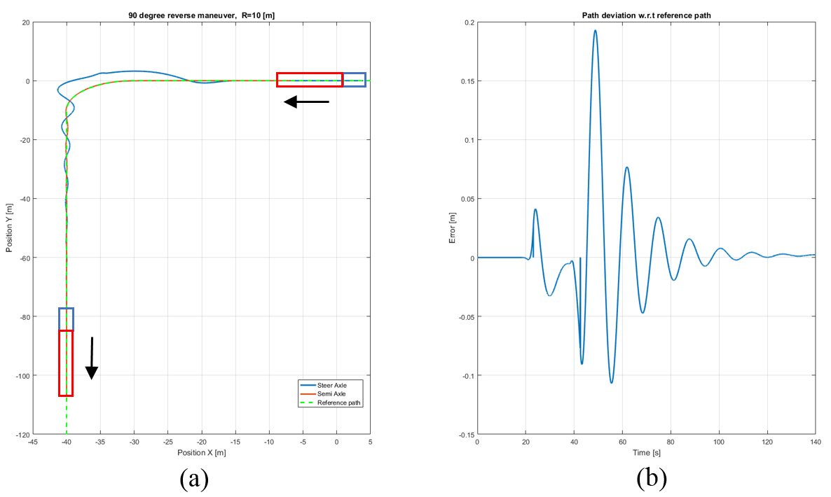

**Figure 2.: (a) Reverse path following of single articulated vehicle; (b) Path deviation error**

The path following controller approach is adapted from Morales et al., see [3]. As presented in Figure 2.(a), the approach is suitable for docking maneuver of single articulated vehicle. ~~however,~~ The peak deviation error w.r.t. the reference path is approaching the tolerance available as shown in Figure 2.(b). Therefore, extending this approach to LHVs with more ~~number of~~ articulations will certainly result in crossing the tolerance levels. The reduction in peak deviation error values is important mainly from the point of view of maneuvering space required and by keeping not only the final error with in the tolerance limit but also the intermediate peaks will result in less and efficient maneuvering space which is always preferable.

Hence, this paper aims to further improve the performance of path following controller and extend its applicability to LHVs, i.e. with more than one articulation.

**Keywords:** Low speed maneuvering, Path following controller, Bi-directional control, Articulated Vehicles, Inverse kinematics, Stability analysis

**2. Research approach**

It is important to start with highlighting two points, which are as follows:

1. The path following controller must be able to keep the rear-most axle of the LHV on the reference path.
2. The path following controller must be bi-directional (i.e. applicable in both forward and reverse direction) because the docking maneuver usually consists of both forward and reverse motion.

The path following problem of an articulated vehicle in reverse direction has been investigated and multiple approaches can be found in literature, see [4-6]. The approach described by Morales et al., see [3] has been found suitable but not sufficient against the two points above.[Are you going to explain that?]

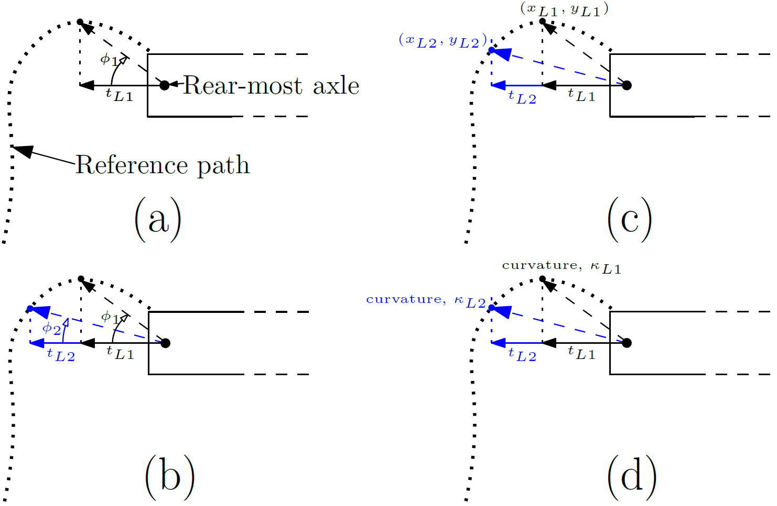

**Figure 3: Factors involved in controller: (a) virtual steer angle with one preview time, $t_{L1}$ (see [2]); (b) virtual steer angle with two preview time, $t_{L1}$& $t_{L2}$ (see [4]); (c) heading change calculation for reference path using two preview time; (d) curvature change calculation for reference path using two preview time [Quite some detail with items such as ‘virtual steer angle’ that a reader will not be able to grasp immediately]**

[You have to explain that the virtual steering angle points to a desired point on the path. You are basically already following the approach from Salvucci?]

As explained in [2], the existing path following controller estimates a virtual steering angle, $φ_{1}$ at the rear end of the vehicle (see Figure 3.(a)) and the required steering angle $δ$ [for the driver?] following from equation (1), where $K_{s}$ is the steering gain. The required steering angle is further translated to steer axle [angle, force, moment?] using inverse kinematic relations, for more details, see [2, 3].

$δ=K_{s} . (φ_{1})$ (1)

According to Salvucci et al., see [4], a human driver utilizes two visual points (one near point and one far point) for steering to follow the reference path. This approach may (may?) result in both accurate and smooth path following and can be incorporated in path following controller using two preview times as shown in Figure 3.(b) with their corresponding weighing factors, $W_{L1}$& $W_{L2}$ The required steering angle can be represented using equation (2).

$δ_{s}=K_{s} . (W_{L1}*φ_{1}+W_{L2}*φ_{2})$ (2)

It is envisioned to further include the heading and curvature change errors in controller (mainly due to [are the errors due to … or is including them due to…?] the possibility of using two preview times) instead of heading and curvature error shown by [5, 6] to reduce the peak deviation error as shown in Figure 2.(b), which usually occurs during the curve. [error vs. change error?]. The heading change, $∆θ_{p}$, as presented in Figure 3.(c) ([I don’t recognize that in the figure?] for reference path can be determined using equation (3) and heading change, $∆θ_{v}$ for vehicle’s rear-most axle can be determined from vehicle feedback. The required steering angle factor corresponding to **heading change error**, $∆δ_{θ}$ can be represented using equation (4), where $K_{θ}$ is the heading change gain.

$∆θ_{p}= \frac{(y_{L2}-y_{L1})}{(x_{L2}-x_{L1})}$ (3)

$∆δ_{θ}=K_{θ} .(∆θ_{p}-∆θ_{v})$ (4)

The curvature of reference path (given, $y_{p}=f(x_{p})$) at two preview points ( $κ_{L1}$& $κ_{L2}$) as shown in Figure 3.(d) can be determined using equation (5) and curvature change, $∆κ_{v}$ for vehicle’s rear-most axle can be estimated from vehicle feedback. The required steering angle factor corresponding to **curvature change error**, $∆δ_{κ}$ can be represented using equation (6), where $K_{κ}$ is the curvature change gain.

$κ_{L,i}=\left[\frac{\left(\frac{d^{2}y}{dx^{2}}\right)}{{\left(1+{\left(\frac{dy}{dx}\right)}^{2}\right)}^{\frac{3}{2}}}\right]$; $i=1,2$ (5)

$∆δ_{κ}=K_{κ} .\left(∆κ_{p}-∆κ_{v}\right)$; where, $∆κ_{p}=$ ($κ_{L2}-κ_{L1}$) (6)

[I guess that you include a more clear picture, to indicate the different angles, you mention]

Therefore, the required steering angle by considering two preview times, heading change and curvature change error can be represented using equation (7).

$δ= δ_{s}+ ∆δ_{θ}+∆δ_{κ}$ (7)

[I try to understand the relationship between the objective (improving path following for LHV’s) and the previous discussion on angles. Why do we expect the performance to be better in reverse driving when the heading change and curvature change errors are included? Is that a fair guess, or can you argue this beforehand?]

**3. Expected results**

The controller alternatives with proposed factors will be evaluated based on the following points, which are as follows:

* Steer effort and number of steer reversals
* Peak and final deviation error with respect to reference path
* Space envelop required for docking maneuver
* Minimum number of tunable controller parameters
* Close loop stability analysis

Finally an optimization routine will be developed to tune the controller parameters and the most appropriate controller alternative will be selected and tested on scaled set-up with up to two articulations.

**References**

|  |  |
| --- | --- |
| [1]. | Odhams, A.M.C., Roebuck, R.L., Lee, Y.J., Hunt, S.W. and Cebon, D., 2010. Factors influencing the energy consumption of road freight transport. *Proceedings of the Institution of Mechanical Engineers, Part C: Journal of Mechanical Engineering Science*, *224*(9), pp.1995-2010. |
| [2]. | Kural, K., Besselink, I., Xu, Y., Tomar, A. and Nijmeijer, H., 2016, November. A driver support system for improved maneuvering of articulated vehicles using an unmanned aerial vehicle. In *HVTT14: International Symposium on Heavy Vehicle Transport Technology, 14th, 2016, Rotorua, New Zealand*. |
| [3]. | Morales, J., Martínez, J.L., Mandow, A. and Medina, I.J., 2009, November. Virtual steering limitations for reversing an articulated vehicle with off-axle passive trailers. In *Industrial Electronics, 2009. IECON'09. 35th Annual Conference of IEEE* (pp. 2385-2390). IEEE. |
| [4]. | Salvucci, D.D. and Gray, R., 2004. A two-point visual control model of steering. *Perception*, *33*(10), pp.1233-1248. |
| |  |  | | --- | --- | | [5]. | Salvucci, D.D. and Gray, R., 2004. A two-point visual control model of steering. *Perception*, *33*(10), pp.1233-1248. |   [6]. | Pradalier, C. and Usher, K., 2008. Robust trajectory tracking for a reversing tractor trailer. *Journal of Field Robotics*, *25*(6‐7), pp.378-399.  Rimmer, A.J. and Cebon, D., 2016. Theory and practice of reversing control on multiply-articulated vehicles. *Proceedings of the Institution of Mechanical Engineers, Part D: Journal of Automobile Engineering*, *230*(7), pp.899-913. |
|  |  |
|  |  |

1. Ben Kraaijenhagen et.al.: Greening and Safety Assurance of Future Modular Road Vehicles. Book of requirements. September 2014.