INSTRUCTIONS FOR PREPARATION AND SUBMISSION OF PAPERS

 |  | 
 | J.W. RED  University of  San Marino  Graduate of Trinity College Dublin, 1992. Completed a masters degree in 1994 on the development of Bridge WIM systems. Currently director of information research at IMOXIN Data Plc.. | P.A. WHITE  National Cyrilic Authority of Wales  United Kingdom  Obtained B.E. and M.Sc. from University College Galway, Ireland and Ph.D. from University of Michigan. | L.M. BLACK  National Cyrilic Authority of Wales  United Kingdom  Obtained B.E. and M.Sc. from University College Galway, Ireland and Ph.D. from University of Michigan..

Abstract
This paper gives instructions for the preparation of papers to be presented at the 15th International Forum for Road Transport Technology (IFRTT) Heavy Vehicle Transport Technology (HVTT) symposium, to be held in Rotterdam (The Netherlands), 2 – 5 October 2018. These instructions are presented, as far as is possible, in a style consistent with a conference paper. Abstracts for these papers should not exceed 12 lines in length. The abstract should be provided in English. Nothing except the author details, photographs and abstracts should be present on the first page.
Keywords: Language, Font, Photograph, Heavy Vehicles, Freight Transport, Symposium

Paper Parts
Each paper should have the following parts:
title
author(s) information, including photo(s)
abstract in English
body of the paper, including any tables and/or figures
list of references.

General Instructions
Provide papers in electronic form (.RTF, .DOC or .DOCX file required) with any images placed within the text. The papers will be published, with no editing other than the author’s, in a conference proceedings. Papers not prepared to the correct presentation standard may be rejected regardless of their technical content. The editor reserves the right to make minor editorial changes without consultation with the authors.

Length
The session paper (including title/abstract and reference list pages) must not exceed 12 pages.

Language
All papers must be submitted for assessment in English.

Document Style
Authors are required to use this document (ie, these instructions) as the template.

Margins
Top, bottom, left, and right margins of 2.5 cm should be used on A4 size pages (210 x 297 mm).

Typeface
All papers should be in 12-point Times New Roman. Text should be single-spaced and justified on both sides. The authors’ biographies (first pages, below the photographs) should be in 9-point Times New Roman.

Headings
First-level sections (excluding the abstract and reference list) should be numbered 1., 2., 3., etc. Second-level sections should be numbered 1.1, 1.2, 1.3, etc., 2.1, 2.2, 2.3, etc. Third-level sections (such as this one) should not be numbered but should be given a title in bold italic. Capitalize all words except for articles (a, an, the) and prepositions (i.e., of, to, from).

Section Spacing
One line space should be left under a first-level section title, a half line space under a second-level section title and no space under a third-level section title. One line space should be left above all section titles. Paragraphs should be separated by one line space.

Page Numbers
Page numbers at the bottom of the page should be retained, though the format may change to suit the chosen footer.

Headers and Footers
Headers and footers may be used to identify the paper title and authors.
The footer should be 1.2 cm from the bottom of the page. Typeface and size are the same as for the body text.

Title Page
This page contains the paper title, brief information about all authors, photos of authors, and an abstract.

Title
The paper title should be centered in 12-point Times New Roman bold capital letters like the title of this document.

Author Information
See the first page of this document for an example.

Abstract
The abstract should be no more than twelve lines. Keywords should also be provided beneath each abstract.

Figures, Tables, and Equations
All figures, tables, and equations should be numbered consecutively by type and referenced within the text, e.g., Figure 1, Table 1, Equation (1). They should be placed in the paper as near as possible after the point at which they are first mentioned. The words “figure,” “table,” and “equation” may not be abbreviated.

Figures
Figures include illustrations, photographs, charts, and graphs. All figures should be given captions. Captions should be centered beneath the figure, and all words (except articles and prepositions) should be capitalized (see example below). Separate captions from body text with one line space.

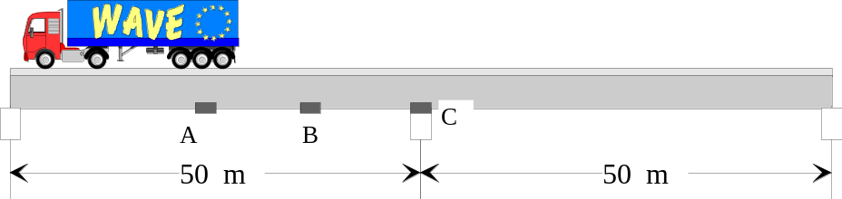
Figure 1 – This is a sample figure caption, bold 12

All writing within figures should, where possible, be in 12-point Times New Roman. Tables
Table captions should be above the table, flush left, and all words (except articles and prepositions) should be capitalized (see example below). Separate table captions from body text and the table with one line space above and below the captions as below.

Table 1 - Summary statistics for pre-weighed trucks (COV = Coefficient of Variance)

 | Type 1 |  | Type 4 |  | Type 5
 | Gross | Axle | Gross | Axle | Gross | Axle
Mean IF | 1.00 | 0.98 | 1.03 | 1.03 | 1.02 | 1.02
COV (%) | 7.21 | 9.86 | 6.21 | 8.44 | 5.18 | 7.85
Within 15% | ----- | 93 | ----- | 94 | ----- | 85

Tables should use 1-point lines for the top and bottom, and a half-point line beneath the table’s header. Thickness of all table lines must be 0.5 point. All writing within tables should, where possible, be in 12-point Times New Roman.

Equations and Units
All equations should be indented 1.2 cm from the left margin and numbered in brackets in the extreme right hand side of the page as follows:

C = 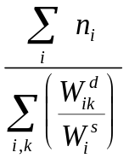 (2)

Electronic Submission Instructions
Papers must be submitted by mail in pdf format to j.duyvesteyn@columbacommunications.nl before the end of April 2018. The paper should be submitted as a .pdf file. Try to keep the whole file size reasonable, below 4Mbytes if possible.

Photographs
Photographs should be set at a minimum resolution of 300 dots per inch (dpi) because photographs with a lower resolution have a poor print quality. However, resolutions above 600 dpi are unnecessarily high quality. Use .JPG file with a rate of compression which maintains the file size of each picture below 500 kbytes. Be careful to adjust the final size of each picture in your photo editor, and import them as 1:1 scale in the Word or RTF file (in order to prevent excessively large file size).

A list of references should be given at the end of the paper. In the body of the paper, references should be referred to by author and year. For example: “Jones and Smith (1996) have extended the theory to in-motion systems” or “Kellser’s theory for WIM systems (1995) has shown” or “the theory for pseudo-static systems is well established (Kessler, 1995).”

The reference list style should be as follows (the first is a book, the second and third are conference papers, and the last is a journal paper):

References
- Jones, J.M. (1992), Elements of WIM Systems in Operation, E & F-N Spon.
- O'Brien, E.J. and Sclob, J.M. (1993), “Prediction of Extreme Load Effects in Highway Bridges” in Proceedings of the 9thIinternational Conference on Highway Structures, eds. A.M. O'Reilly and J.V. Smith, Warsaw, Poland, 131-143.
- O'Connor, W.D., Bloggs, J. and Smith, J.J. (1994), “A Proposed Renewable Energy Source” in Proc. 2nd Int. Congress on Innovation, eds A.B. Jones and Smith, Elsevier Press, 2, 121-130.
- Freud, S.J., Smith, A.W. and Mannion, A.N. (1992), “A New Approach to Behaviourism,” Journal of Structural Engineering, Am. Soc. Civ. Engnrs, 12, 1463-1479.

