Abhinay Duggaraju


Almasguda, Hyderabad, Telangana, Pin:500058, India https://github.com/Abhi271003


(+91) 6304657637 https://abhi271003.github.io/Portfolio.github.io/

abhinay271003@gmail.com

https://www.linkedin.com/in/duggaraju-abhinay-b98666239

I’m passionate about the intersection of Machine Learning, Data Science, Python and Web Development. Solid foundation in theory and practice, proficient in Python and its environment. Skilled in web development to create interactive interfaces showcasing ML insights. Seeking opportunities to contribute skills, creativity, and problem-solving for positive impact in the tech industry.
SOFT SKILLS
- Enthusiastic to learn new skills and Optimistic
- Adaptive and Self-management
- Empathy and Goal focused
- *Training on Data Science Real World Project with Python
- Udemy Certification : Data Science with Python
- Softwares Learned : Jupyter
DATA SCIENCE SKILLS AND CERTIFICATIONS

WEB DEVELOPMENT SKILLS AND CERTIFICATIONS
- *Training on Bootstrap, jQuery, PHP with MySQL and Hosting with Wordpress
- Trained in HTML5, CSS and JavaScript
- Udemy Certifications : HTML5, CSS, JavaScript
- Softwares Learned : VS Code, WordPress, GitHub
HOBBIES & INTERESTS
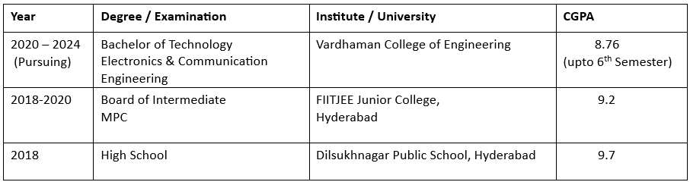
- Listening to music
- Active star gazer and avid follower of Astronomy news.
- Badminton
- Playing Video Games
EDUCATIONAL QUALIFICATIONS
- *Training on ML with Python
- Softwares Learned : Spyder
ML SKILLS AND CERTIFICATIONS
- *Training on Java Language
- Trained in Python, C
- Udemy Certifications : Python, C
PROGRAMMING SKILLS AND CERTIFICATIONS
INTERNSHIPS AND PROJECTS DEVELOPED
- Internship on Physical Design and Verification with ENTUPLE Technologies Jan 2023
- Internship on Hands-on Graphical System Design using NI Technology with VI solutions Dec 2022
- Internship on Web Application Development with MANAC Infotech (Pvt) Ltd. Feb 2023
- Internship on ML and DL with SkillDzire Jan 2023
- Academic Mini Project and Paper on Room Issue Reporting System using LabVIEW July 2023
(It involves design of semi automated room issues reporting software using LabVIEW. The issues can be anything like electronic defects, Network issues, Furniture and other issues. This proposed model can help buildings for easy and quick maintenence)
- Academic Major Project on Plant Monitoring using Python and ChatGPT Present
(It involves monitoring of of a plant using Python image image processing techniques and ML models to detect any diseases and insects on the plant and generate comprehending recommendations using ChatGPT API)

