**Project -1 HTML & CSS**

**GitHub ID :** [**https://github.com/Abhi290703**](https://github.com/Abhi290703)

<https://github.com/Abhi290703/Project>

**Output :**

**Home Page :**

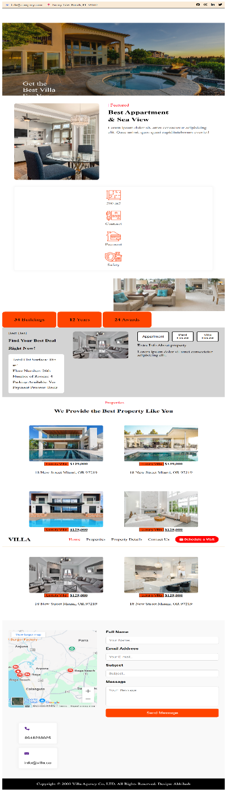

**Properties Page :**

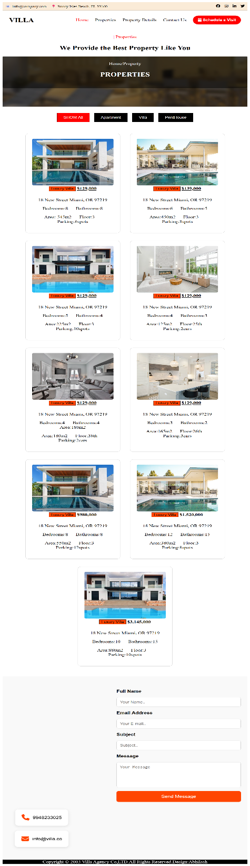

**Property Details :**

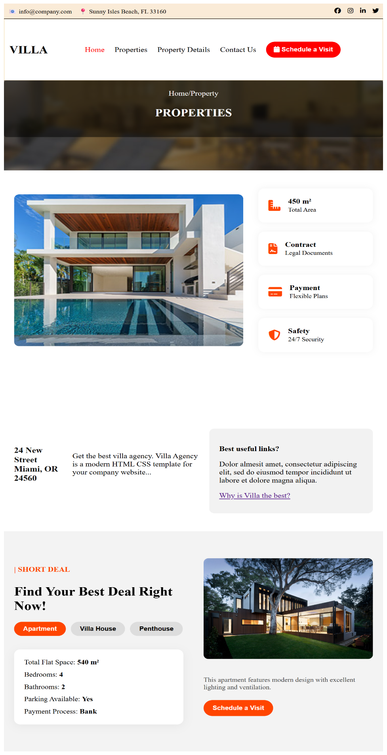

**Contact :**

