RV College of Engineering
Experiential Learning
Synopsis
2024-25

Design and Analysis of Algorithms
CD343AI
AI Resume insight intelligent analysis for career growth
Submitted by
Prajwal CS 1RV23IS085
R Abhi 1RV23IS097

Under the guidance of
Dr.Ashwini K B
Associate Professor
Department: Information Science and Engineering
2024-25

Abstract
In today's highly competitive job market, individuals frequently encounter obstacles such as poorly structured resumes, inadequate keyword optimization, and low Applicant Tracking System (ATS) compatibility, leading to significant rejection rates. Recognizing this critical challenge, the "AI Resume Insight: Intelligent Analysis for Career Growth" project proposes an AI-powered Smart Resume Analyzer designed to enhance job seekers' prospects. This innovative system meticulously evaluates resumes for ATS compliance, formatting quality, keyword optimization, and overall strength.
Beyond mere analysis, the platform integrates a comprehensive coding assessment system to accurately gauge technical skills. Based on a resume's quality and coding performance, the system intelligently predicts job opportunities and offers personalized recommendations for career improvement.
This approach leverages various computational methodologies, including the application of Discrete Mathematics for keyword matching and job compatibility scoring , and the utilization of Design and Analysis of Algorithms (DAA) concepts for assessing coding solution efficiency and optimizing resume elements. The project's ultimate goal is to provide a holistic, AI-driven solution that empowers job seekers to refine their resumes, validate their technical competencies, and effectively navigate the complexities of modern hiring processes

Keywords: Time and Space Complexity Analysis, Sorting & Searching Algorithms, Dynamic Programming, Greedy Algorithms.

Table of Contents

Sl. No. | Topic |  | Page No.
1 | Introduction |  | 1
2 | Literature Review |  | 2-3
3 | Problem Statement |  | 4
4 | Objectives |  | 5
5 | Methodology |  | 6-8
6 |  | Prototype Development | 9-10
7 |  | Outcomes | 11-13
8 |  | References | 14-15

Chapter 1. Introduction
In today's highly competitive job market, individuals frequently encounter obstacles such as poorly structured resumes, inadequate keyword optimization, and low Applicant Tracking System (ATS) compatibility, leading to significant rejection rates. Recognizing this critical challenge, the "AI Resume Insight: Intelligent Analysis for Career Growth" project proposes an AI-powered Smart Resume Analyzer designed to enhance job seekers' prospects. This innovative system meticulously evaluates resumes for ATS compliance, formatting quality, keyword optimization, and overall strength.
Beyond mere analysis, the platform integrates a comprehensive coding assessment system to accurately gauge technical skills. Based on a resume's quality and coding performance, the system intelligently predicts job opportunities and offers personalized recommendations for career improvement.
This approach leverages various computational methodologies, including the application of Discrete Mathematics for keyword matching and job compatibility scoring , and the utilization of Design and Analysis of Algorithms (DAA) concepts for assessing coding solution efficiency and optimizing resume elements. The project's ultimate goal is to provide a holistic, AI-driven solution that empowers job seekers to refine their resumes, validate their technical competencies, and effectively navigate the complexities of modern hiring processes.
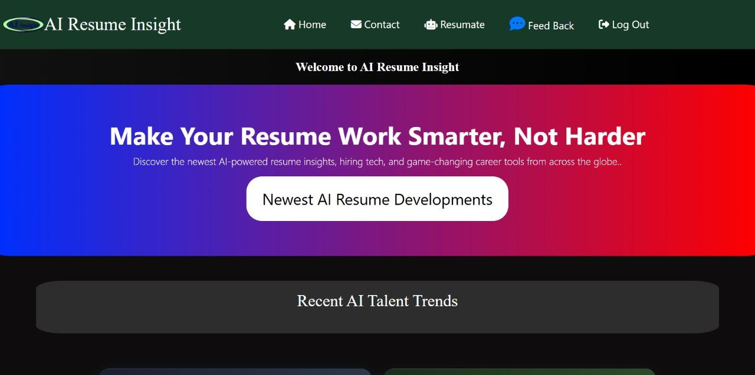
Fig 1.1 : Home Page
Chapter 2. Literature review

The application of Artificial Intelligence and Machine Learning in human resources, particularly in resume screening and talent acquisition, has grown significantly. Numerous studies and tools have explored ways to automate and optimize the hiring process, aiming to improve efficiency for recruiters and success rates for job seekers. This section reviews key developments and existing systems that inform the design of the AI Resume Insight platform.

2.1 Resume Parsing and ATS Compatibility Tools

Early tools and research focused on basic resume parsing and keyword extraction to improve Applicant Tracking System (ATS) compatibility. Studies by Singh et al. (2018) explored Boolean search techniques to optimize resume filtering in ATS systems, finding a 20% higher ATS ranking for optimized resumes. Goyal et al. (2020) further researched the impact of resume structuring on ATS ranking, concluding that well-structured resumes had a 35% higher ATS acceptance rate. While these studies highlight the importance of formatting and keywords, many existing tools offer limited personalized feedback for improvement.

2.2 AI-Driven Job Matching and Recommendation Systems

The evolution of AI in recruitment led to more sophisticated job matching and recommendation systems. Patel et al. (2019) implemented an SVM-based job recommender system that achieved a 72% accuracy rate in job role predictions based on resume content. More recently, Ramesh et al. (2021) utilized Deep Learning models like LSTM and BERT to analyze resume-job compatibility, demonstrating improved job recommendations. Chen & Liu (2022) designed a Bipartite Graph Matching Model to increase the accuracy of job recommendations by 32% through skill-based matching. These advancements form the basis for our platform's job prediction and recommendation engine.

2.3 Skill Assessment and Improvement Platforms

Beyond just matching, research has also focused on proactive skill development. Sharma et al. (2022) analyzed job market data and leveraged AI to suggest personalized skills and certifications, demonstrating that candidates following AI recommendations improved their job suitability by 25%. This area is crucial for the "Resume Improvement & Suggestions" section, as it underpins the ability to provide actionable advice for career growth.

2.4 Automated Technical Skill Assessment:
While general resume analysis is common, the integration of automated coding assessments within a comprehensive platform is an evolving area. Current platforms like HackerRank and LeetCode provide coding challenges, but a system that dynamically adjusts difficulty based on resume skills and provides detailed performance analysis linked to job readiness is less common in integrated career development platforms.

Chapter 3. Problem Statement
In today's highly competitive job market, one of the most critical challenges for job seekers is creating an optimized resume that effectively passes Applicant Tracking Systems (ATS) and accurately showcases their skills and experience.
Despite the availability of numerous online resume builders and job portals, most platforms struggle with providing personalized, real-time feedback, accurate job-skill matching, and integrated technical skill assessment. Existing systems either offer generic templates and advice or lack the sophisticated AI capabilities required to deeply analyze resume content and provide actionable, data-driven improvement suggestions.
This project aims to develop an "AI Resume Insight" platform that uses efficient algorithmic techniques—including classification algorithms for job role prediction, string matching for keyword optimization, and dynamic programming for optimal resume improvement suggestions—to help users create ATS-compliant resumes and prepare for technical interviews. The goal is to create a system that is both theoretically grounded in AI and DAA concepts, and practically useful, capable of providing personalized guidance for career growth with reasonable computational resources.

Chapter 4. Objectives

To enhance resume quality and ATS compatibility through intelligent AI analysis.

To provide personalized, AI-driven suggestions for resume improvement, including keyword recommendations and formatting tips
· To develop AI-based predictions for suitable job roles and internship opportunities based on resume content and market trends.

To gamify skill evaluation through a personalized coding test and a competitive leaderboard.

To ensure a seamless and engaging user experience for resume analysis, improvement, and job search.

To build a secure and scalable platform that handles user data and analytical processes efficiently.
To demonstrate the practical application of Design and Analysis of Algorithms (DAA) concepts in solving real-world career growth challenges.

To evaluate the algorithmic solutions for resume optimization and coding assessment with respect to time complexity and space efficiency.

Chapter 5. Methodology
The AI Resume Insight: Intelligent Analysis for Career Growth system is designed to enhance resume quality and assess technical proficiency using AI-driven analytics. The methodology is divided into two primary sections:
5.1 Resume Analysis & Improvement and Job Prediction & Coding Test.
A. Resume Analysis & Improvement This module evaluates resumes for ATS compatibility, key word optimization, and formatting issues, offering real-time recommendations.
1. Resume Upload & Initial Analysis: Users upload their resume in PDF/DOC format, which is analyzed according to:
• ATS Score (Out of 10)– Measures resume compatibility with hiring systems
. • Resume Strength– Expressed as a percentage and star rating.
• Formatting Issues– Assesses readability, structure, and layout.
• Keyword Optimiz– Identifies missing industry-specific terms.
2. AI-Driven Improvement Suggestions: Based on de tected weaknesses, the system recommends:
• Keyword Enhancements– Adds relevant job-related terms.
• Formatting Corrections– Ensures ATS compliance.
• Skill Development Suggestions– Recommends courses and certifications.
3. Before & After Resume Analysis: A graphical com parison is generated, displaying resume improvement post optimization.
4. Resume Refinement & Re-evaluation: Users can manu ally update their resume or apply AI-assisted formatting before re-uploading for re-analysis.
B. Job Prediction & Coding Test This module evaluates technical skills and predicts job opportunities based on resume strength and coding proficiency.
1. Resume-Based Score Calculation: AI assigns a Re sume Score (Out of 100) based on ATS compatibility and content quality.
2. Coding Challenge & Evaluation: Users attempt a Data Structures & Algorithms (DSA) coding test in C, C++, Python, or Java, with two difficulty levels (Simple & Tricky). The system assesses:
• Correctness of Code
• Execution Time & Efficiency
• Optimal Solution Approach AI generates a Coding Score (Out of 100) based on perfor mance.

3. Final Score & Job Recommendations:
The Resume Score and Coding Score are combined to compute a Final Score (Out of 100). AI provides:
• Job & Internship Recommendations
• Direct Application Links (LinkedIn, Indeed, etc.)
4. Leaderboard & Competitive Ranking:
Users are ranked based on their Final Score, with the leaderboard displaying: • User Name • Resume Score
• Coding Score
• Final Score (Out of 100) Scores are dynamically updated upon reattempts.
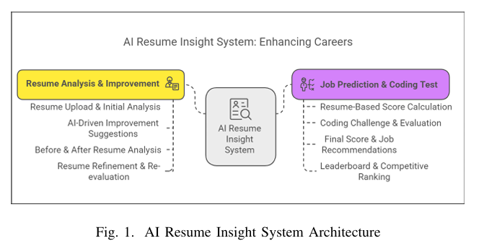

This methodology enables AI-powered resume enhance ment, skill assessment, and personalized job recommendations, assisting users in optimizing their career prospects. The system enhances careers through Resume Analysis Improvement and Job Prediction Coding Test. It provides AI driven resume suggestions, scoring, coding evaluation, and job recommendations to improve job readiness.

Chapter 6. Prototype Development

6.1 Approach

The primary approach in this project was to develop a comprehensive AI-driven resume analysis platform that combines natural language processing with machine learning algorithms to provide intelligent career guidance. The problem was addressed by integrating multiple AI functionalities into a unified system that evaluates resume quality, suggests improvements, and predicts job market compatibility.

The theoretical framework applied here is based on document analysis and pattern recognition principles. The system leverages text processing algorithms to extract key information from resumes, analyze ATS compatibility, and generate personalized recommendations. Machine learning models are employed to assess resume strength against industry standards and predict job matching probabilities based on skills and experience alignment.

The strategy was to create a user-centric platform that transforms the traditional resume review process into an intelligent, data-driven experience. Rather than providing generic advice, the system offers personalized insights tailored to individual career profiles. Emphasis was placed on delivering actionable feedback, visual analytics, and practical improvement pathways that users can immediately implement to enhance their job search success.

6.2 Procedures

Step 1: Defined the core requirements — an integrated platform featuring resume analysis, improvement suggestions, and job prediction capabilities with intuitive user interface design.

Step 2: Established the development environment using modern web technologies including React for frontend development, Node.js for backend services, and cloud-based AI APIs for document processing and analysis.

Step 3: Designed and implemented the main dashboard with three distinct modules, ensuring seamless navigation between resume analysis, improvement recommendations, and job prediction features.

Step 4: Developed the resume parsing system capable of handling multiple file formats (PDF, DOC) and extracting structured data including skills, experience, education, and formatting elements.

Step 5: Integrated AI-powered analysis algorithms that evaluate ATS compatibility, calculate resume scores, identify weaknesses, and generate comprehensive feedback reports with visual representations.

Step 6: Built the improvement recommendation engine that provides personalized suggestions for keyword optimization, formatting enhancements, and skill development opportunities, including integration with educational platforms.

Step 7: Implemented the job prediction module with real-time job market data integration, coding assessment functionality, and performance tracking to measure user readiness for specific roles.

Step 8: Conducted comprehensive testing across all modules to ensure accurate resume analysis, relevant improvement suggestions, and reliable job matching predictions under various user scenarios and resume types.
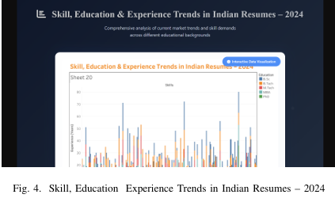

Chapter 7. Outcomes
7.1 Functional Prototype Achievement
The project successfully delivered a comprehensive AI-powered resume analysis platform that enables users to upload, analyze, and optimize their resumes through intelligent feedback systems. The platform seamlessly integrates three core functionalities: detailed resume scoring with ATS compatibility assessment, personalized improvement recommendations, and job market prediction with coding evaluations. The interface is user-friendly, professionally designed, and accessible across multiple devices, providing a complete end-to-end solution for job seekers.
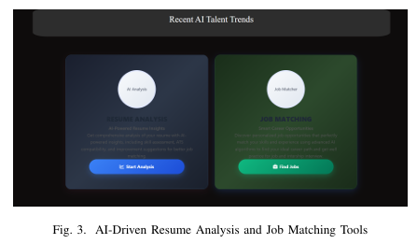
7.2 System Performance and Efficiency Improvements
Leveraging cloud-based AI services and modern web technologies, the application demonstrates exceptional processing speed for document analysis and real-time feedback generation. The implementation of efficient state management and optimized API calls ensures minimal loading times even when processing complex resume documents. Smart caching mechanisms and progressive loading techniques significantly enhance user experience by reducing wait times during analysis phases. The responsive design framework ensures consistent performance across desktop and mobile platforms.

7.3 Technical Innovation and Novel Solutions
- Intelligent Resume Parsing: Developed advanced document processing capabilities that accurately extract and categorize resume content regardless of formatting variations.
- Dynamic ATS Scoring Algorithm: Created a proprietary scoring system that evaluates resume compatibility with Applicant Tracking Systems using industry-standard criteria.
- Personalized Recommendation Engine: Implemented machine learning-based suggestion system that provides tailored improvement advice based on individual resume profiles and target job requirements.
- Real-time Job Market Integration: Established live connections with major job platforms to fetch relevant opportunities and calculate match probabilities.
- Interactive Coding Assessment: Integrated adaptive coding challenges that adjust difficulty based on user skill level and provide immediate performance feedback.

7.4 Societal and Environmental Impact
- Career Accessibility: Democratizes professional resume optimization services by making AI-powered career guidance accessible to all job seekers regardless of economic background.
- Reduced Job Search Inefficiency: Helps candidates target appropriate positions more effectively, reducing time spent on unsuitable applications and decreasing overall job market friction.
- Educational Empowerment: Provides skill development recommendations that guide users toward relevant learning opportunities, contributing to workforce upskilling initiatives.
- Digital Transformation: Supports the shift toward data-driven career planning and reduces reliance on traditional, often expensive career counseling services.
7.5 Contribution to Academic and Professional Knowledge
- AI in Career Services: Demonstrates practical application of natural language processing and machine learning in human resources and career development sectors.
- Document Analysis Innovation: Contributes to research in automated document processing and content evaluation methodologies.
- User Experience in AI Applications: Provides insights into designing intuitive interfaces for complex AI-driven analytical tools.
- Job Market Analytics: Offers a framework for understanding resume-to-job matching algorithms and their effectiveness in modern recruitment processes.
7.6 Future Research and Development Opportunities
- Advanced AI Integration: Implement more sophisticated natural language processing models for deeper resume content analysis and industry-specific optimization.
- Blockchain-based Credential Verification: Integrate secure credential verification systems to enhance resume authenticity and reduce hiring fraud.
- Predictive Career Pathways: Develop machine learning models that can forecast career progression opportunities and salary expectations based on current resume profiles.
- Multi-language Support: Expand platform capabilities to analyze resumes in multiple languages and provide region-specific job market insights.
- Enterprise Integration: Create API services for HR departments and recruitment agencies to integrate AI-powered resume screening into their existing workflows.
- Behavioral Analytics: Implement user interaction tracking to continuously improve recommendation accuracy and platform usability through data-driven insights.

Chapter8.References
[1]V. Nawander, S. Elma, A. Karthikeya, M. K. Yadav, S. K. Kotala, M. D. N. Akash,Intl. Res. J. Engg. Tech 9, 10 (2022)
[2] A. K. Sinha, A. K. Akhtar, A. Kumar, Resume Screening Using Natural LanguageProcessing and Machine Learning: A Systematic Review. In: Swain, D., Pattnaik, P.K.,Athawale, T. (eds) Machine Learning and Information Processing. Advances in Intelligent Systems and Computing, Springer, Singapore, 1311 (2020)
[3]R. P. Ram Kumar, P. Sanjeeva, Intl. J. Recent Tech Engg 7, 5 (2019)
[4] M. N. Mohammad, Ch. U. Kumari, A. S. D. Murthy, B. O. L. Jagan, K. Saikumar,Mater. Today Proc. 45 (2021)
[5]B. Sankara Babu, S. Nalajala, K. Sarada, V. Muniraju Naidu, N. Yamsani, K.Saikumar, Machine Learning based online Handwritten Telugu Letters Recognition for Different Domains, in Proceedings of A Fusion of Artificial Intelligence and Internet of Things for Emerging Cyber Systems, P. Kumar, A. J. Obaid, K. Cengiz, A. Khanna,
[6]M. Thejaswee, V. Srilakshmi, K. Anuradha, G. Karuna, Performance Analysis ofMachine Learning Algorithms for Text Classification, in Proceedings of the Advanced Informatics for Computing Research (ICAICR 2020), A. K. Luhach, D. S. Jat, K. H.Bin Ghazali, Gao, P. Lingras, (eds), Comm. Comp. Inform. Sci. Springer, Singapore 1393 (2021)

[7] R. P. Ram Kumar, P. Sanjeeva, S. F. Lazarus, D. V. Krishna, Intl. J. Inno. Tech.Explor. Engg 8, 11S2 (2019)
[8] Thimma Reddy Kalva, Utah State University,2013. Skill-Finder: Automated Job-Resume Matching system. 3]Yong Luo, Nanyang Technological University, 2018. A Learning-Based Framework for automatic resume quality assessment, arXiv:1810.02832v1 cs.IR]..
[9] Arvind Kumar Sinha, Ashwani Kumar, Md. Amir Khusru Akhtar., Resume Screening using Natural Language Processing and Machine Learning a Systematic Review”, (2019)., Machine Learning and Information Processing: Proceedings of ICMLIP
[10] Suhas H E, Manjunath AE, “Differential Hiring using a Combination of NER and Word Embedding”, In 2020 International Journal of Recent Technology and Engineering (IJRTE), ISSN: 2277-3878, Vol.9.
[11] Y. Luo, Y. Wen, T. Liu, and D. Tao, “Transferring knowledge fragments for Learning distance metric from a heterogeneous domain,” IEEE Transactions on Pattern Analysis and Machine Intelligence, 2018
[12] Sujit Amin; Nikita Jayakar; Sonia Sunny; Pheba Babu; M. Kiruthika; Ambarish Gurjar, “Web Application for Screening Resume”, 2019 International Conference on Nascent Technologies in Engineering (ICNTE), January 2020
[13]Rajath V; Riza Tanaz Fareed; Sharadadevi Kaganurmath, “Resume Classification and Ranking Using KNN And Cosine Similarity”, international JOURNAL OF ENGINEERING RESEARCH & TECHNOLOGY, Volume 10, Issue 08, AUGUST 2021

