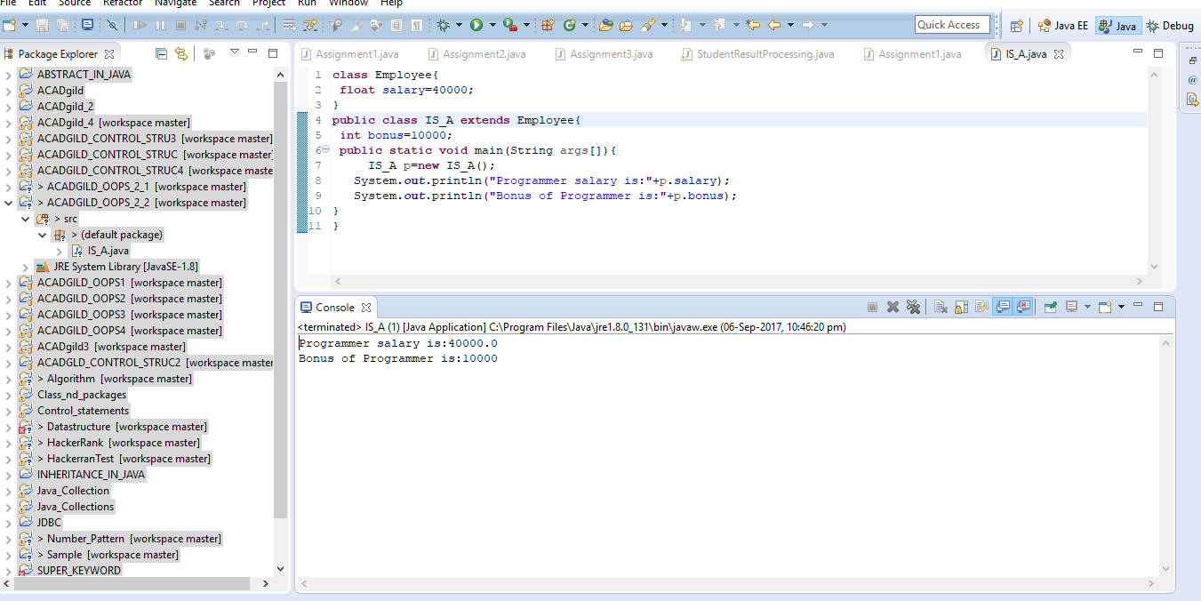

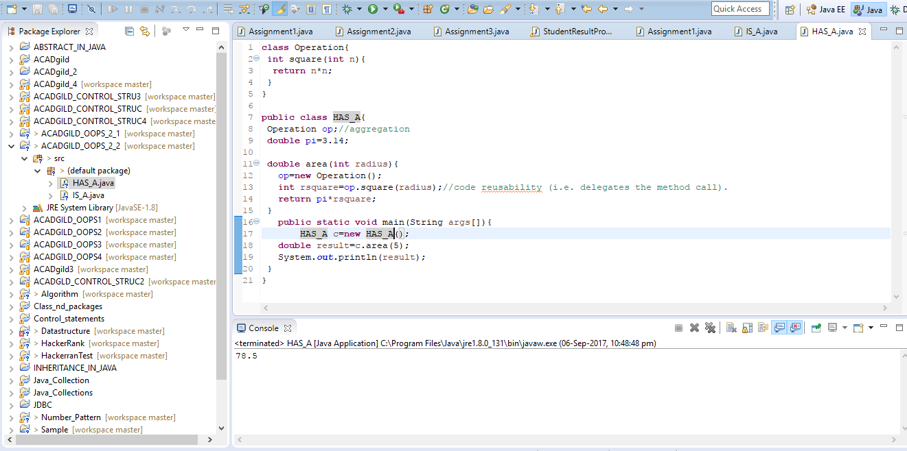

**Inheritance in java** is a mechanism in which one object acquires all the properties and behaviors of parent object.

The idea behind inheritance in java is that you can create new classes that are built upon existing classes. When you inherit from an existing class, you can reuse methods and fields of parent class, and you can add new methods and fields also.

Inheritance represents the **IS-A relationship**, also known as parent-child relationship.

If a class have an entity reference, it is known as Aggregation. Aggregation represents HAS-A relationship.