There is a final variable speed limit, we are going to change the value of this variable, but It can't be changed because final variable once assigned a value can never be changed.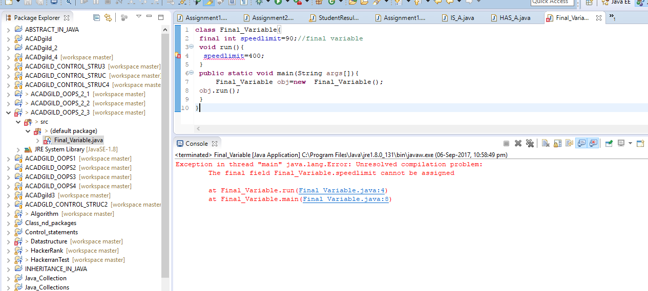

final method is inherited but we cannot override it

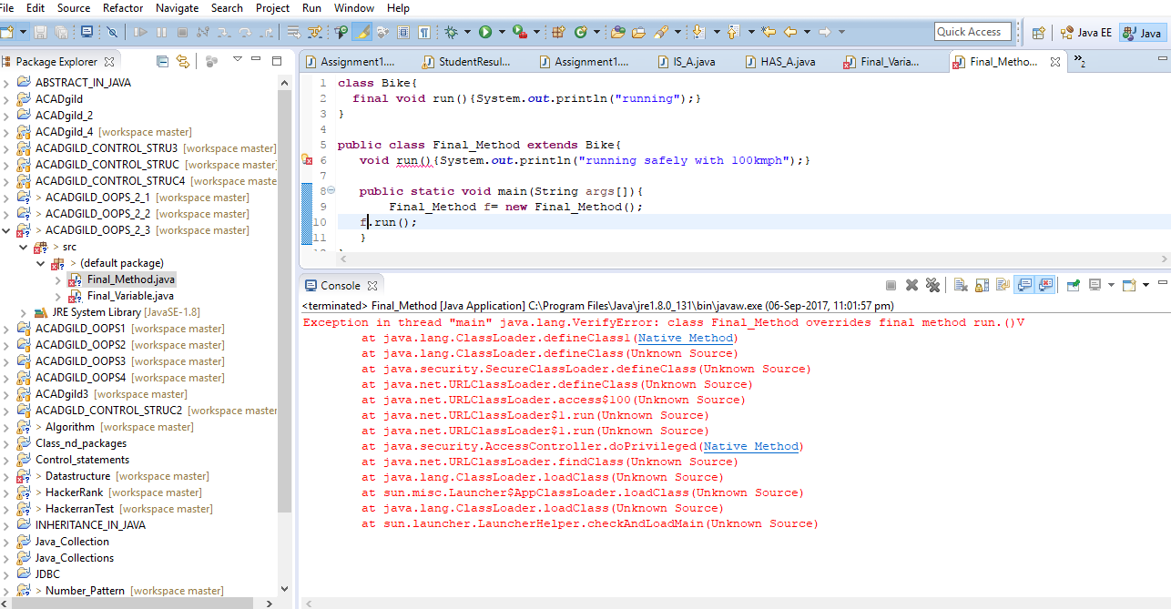

If we make any class as final, we cannot extend it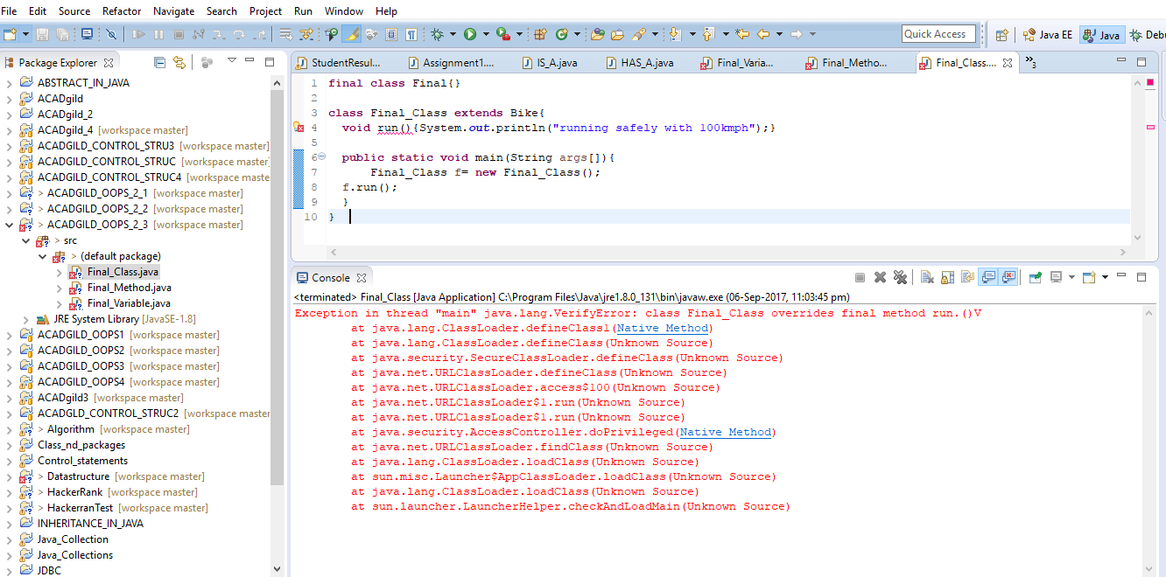

We can not make constructor final because constructor is never inherited