PWD : Linux pwd (print working directory) command displays your location currently you are working on. It will give the whole path starting from the root ending to the directory.

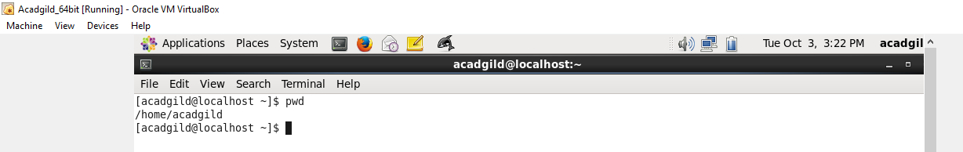

vi : The vi editor tool is an interactive tool as it displays changes made in the file on the screen while you edit the file.

In vi editor you can insert, edit or remove a word as cursor moves throughout the file.

Commands are specified for each function like to delete it's x or dd.

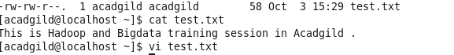

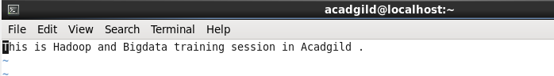

touch : touch command is a way to create empty files (there are some other mehtods also). You can update the modification and access time of each file with the help of touch command.

**Syntax:**

touch **<filename>**



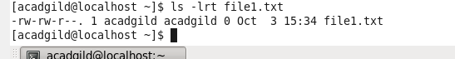

mkdir: Now let's learn how to create your own directory with the help of command prompt.

The mkdir stands for 'make directory'. With the help of mkdir command, you can create a new directory wherever you want in your system. Just type **"mkdir <dir name>** , in place of <dir name> type the name of new directory, you want to create and then press enter.

**Syntax:**

mkdir **<dirname>**

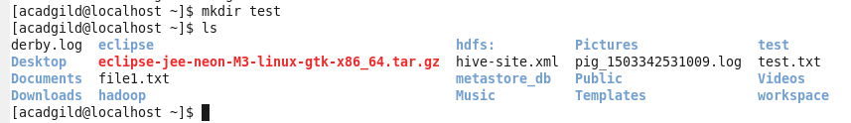

rm : The 'rm' means remove. This command is used to remove a file. The command line doesn't have a recycle bin or trash unlike other GUI's to recover the files. Hence, be very much careful while using this command. Once you have deleted a file, it is removed permanently.

**Syntax:**

rm **<filename>**

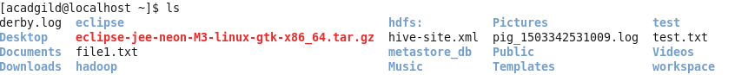

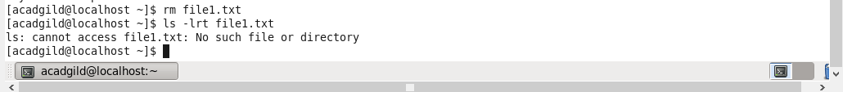

ls : The ls is the list command in Linux. It will show the full list or content of your directory. Just type ls and press enter key. The whole content will be shown.

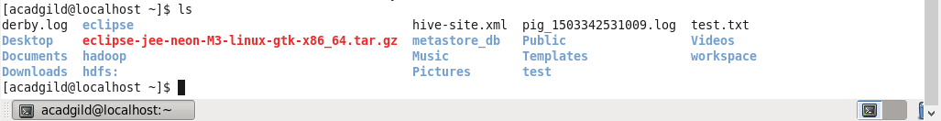

echo : echo is one of the most commonly and widely used built-in command for Linux bash and C shells, that typically used in scripting language and batch files to display a line of text/string on standard output or a file.

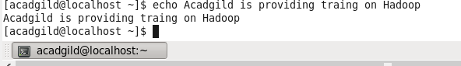

cat : The 'cat' command is the most universal and powerful tool. It is considered to be one of the most frequently used commands.

The 'cat' command can be used to display the content of a file.

**Syntax:**

cat **<fileName>**

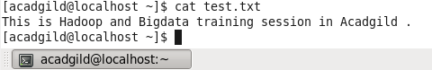

who : who command to display users who are currently logged in your server.

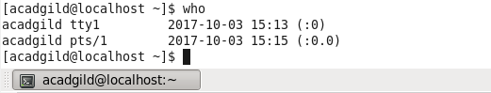

cd : The "cd" stands for 'change directory' and this command is used to change the current directory i.e; the directory in which the user is currently working.

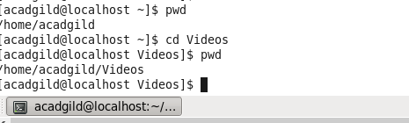

date: The **date** command is used to print out, or change the value of, the system's time and date information.

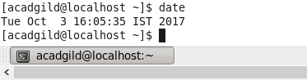

cal : Display a conveniently-formatted calendar from the command line.

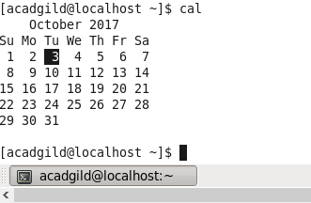

mv: Linux mv command is used to move existing file or directory from one location to another. It is also used to rename a file or directory. If you want to rename a single directory or file then **'mv'** option will be better to use.

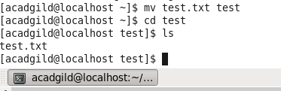

copy : 'cp' means copy. 'cp' command is used to copy a file or a directory.

To copy a file into the same directory syntax will be,

cp **<existing** file name**>** **<new** file name**>**



which : Locate the executable file associated with a given command.

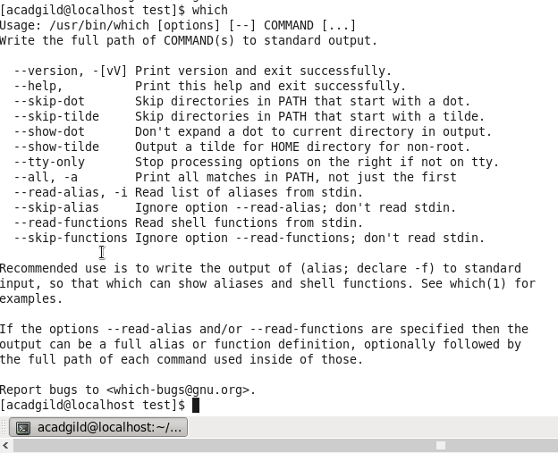s