1) Program Evaluation and Review Technique
(PERT)
-Provide three number (trivariate analysis):
-O: Optimistic estimate (wildly optimistic)
-N: Nominal estimate (greatest chance of success)
-P: Pessimistic estimate (wildly pessimistic)

a) for single task:
-standard deviation:
σ = (P – O)/6
-Mean:
µ= (O + 4T + P) / 6

b) for multiple task:
-standard deviation:
σ(sequence) = √(∑(σ(task))^2)

-Mean:
µ(sequence) = ∑(µ(task))

2)
Avoid Pressure:
The best way to stay calm under pressure is to avoid the situations that cause pressure
-Commitments
-Professionals will always help the business find a way to achieve its goals. But professionals do not necessarily accept commitments made for them by the business
-Staying clean
We can avoid pressure by keeping our systems, our code,and our design as clean as possible
- Crisis discipline
Choose discipline that you feel comfortable following in a crisis. Then follow them all the time

Handle Pressure:
Don’t panic
-Slow down. Think the problem through.
-Communicate
-Let your team and your superiors know that you are in trouble. Avoid creating surprises. Surprises multiply the pressure by ten
-Rely on your discipline
The only way through the pressure cooker is to rely on what you already know works – your disciplines
- Get help
Pair! When the heat is on, find an associate who is willing to pair program with you.

3) Screenshots of running results:

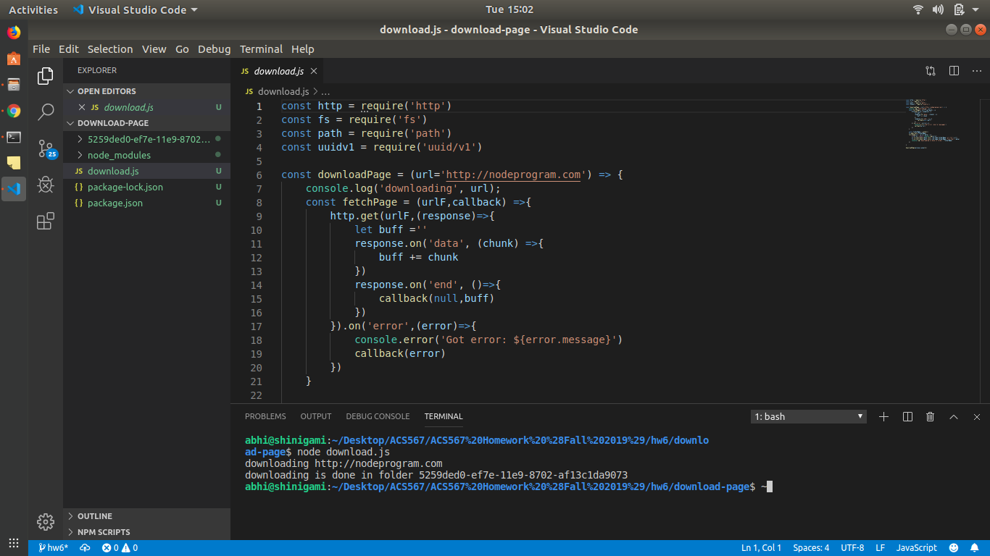

4) Screenshots of running results:
