1) Three roles in scrum:
- Product Owner : Determines what the requirements are, and controls what needs to
be developed and their order.
- Scrum Master : Guides the team in scrum process and schedules and manages the sprint
review, sprint retrospective, stand-up meeting etc.
- Development Team : They drive the work in each sprint to deliver the product
incrementally based on the requirements set by product owner.

2) IP address of university web server(pfw.edu) : 52.205.6.225

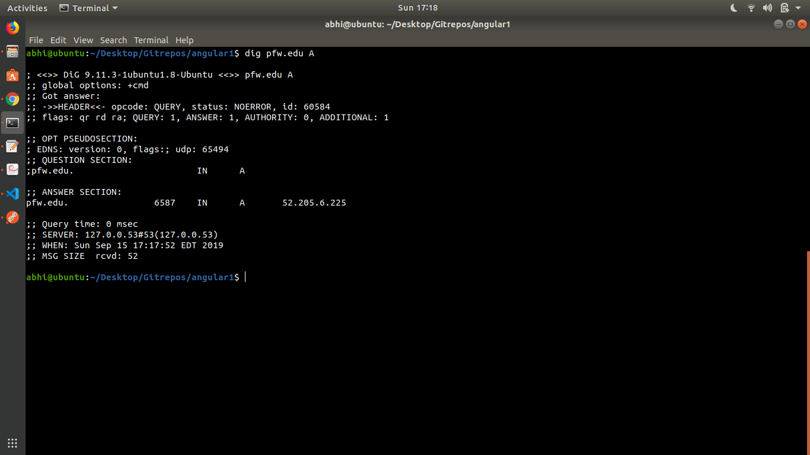
Names of domain name servers of the university : dns1.pfw.edu, dns2.pfw.edu

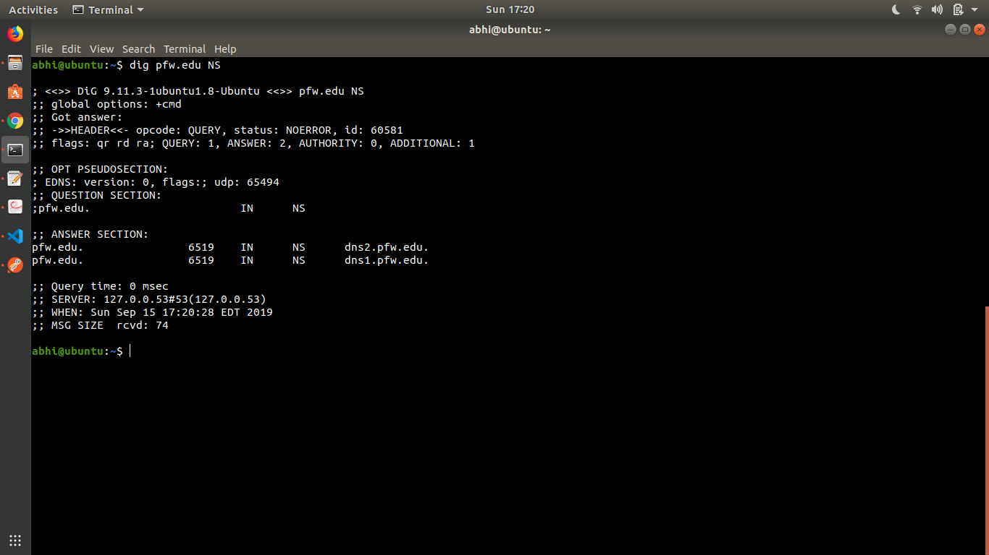
Names of mail servers of the university : mailsec3.pfw.edu, mailsec4.pfw.edu

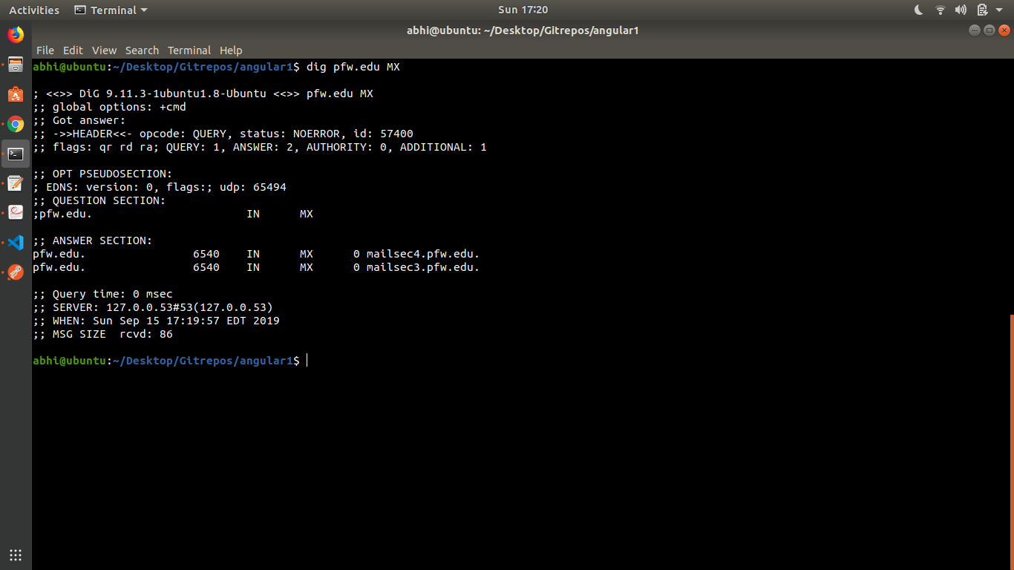

3) - HTTP GET is used to request data from a server or a resource and HTTP POST is used to
send data to a server for create or update operation.

- Generally, GET request should be used for read-only operations to get form data from the
server in xml or json format. POST should be used for requests that potential modify
state of data on the server, which is done by sending the data in json or xml format in
the body of the request.

- HTTP status codes :
1) 200 - OK
2) 301 - Moved Permanently
3) 404 - Page not found or Server not found

4) The script auto_run.sh :
echo "open $1 80"
sleep 2
echo "GET /$2 HTTP/1.1"
echo "Host:$1"
echo
echo
sleep 2

Screenshots of auto_run.sh result and curl :
1)auto_run.sh
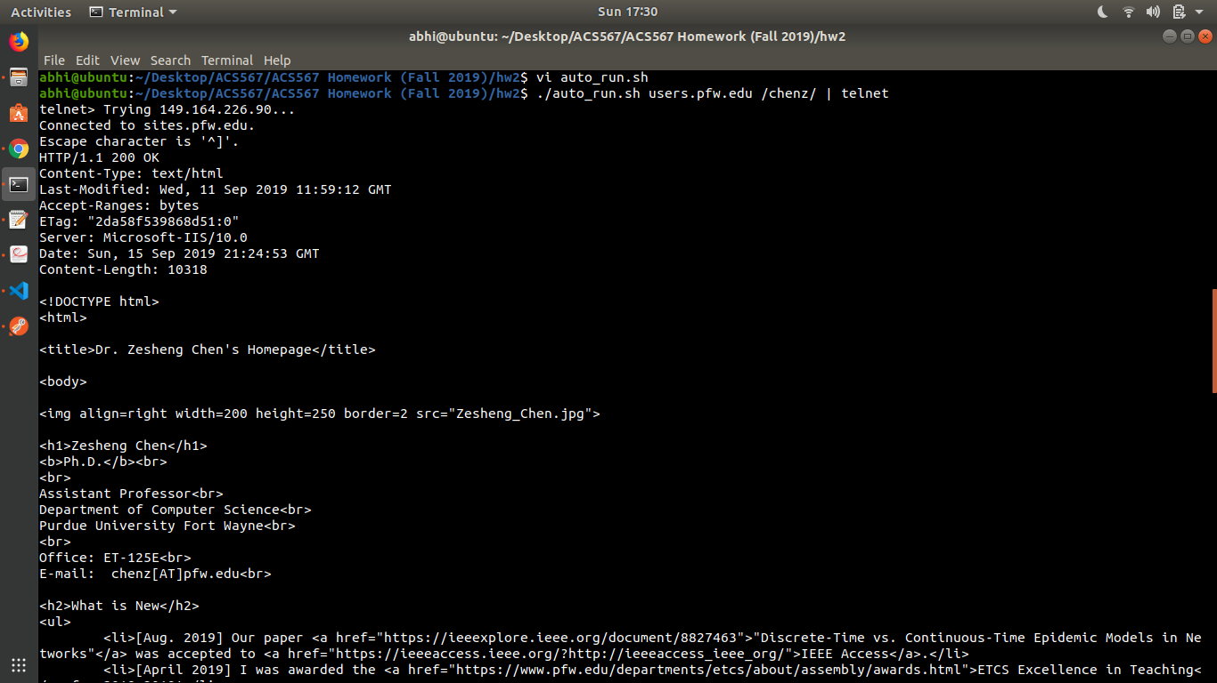
2)curl
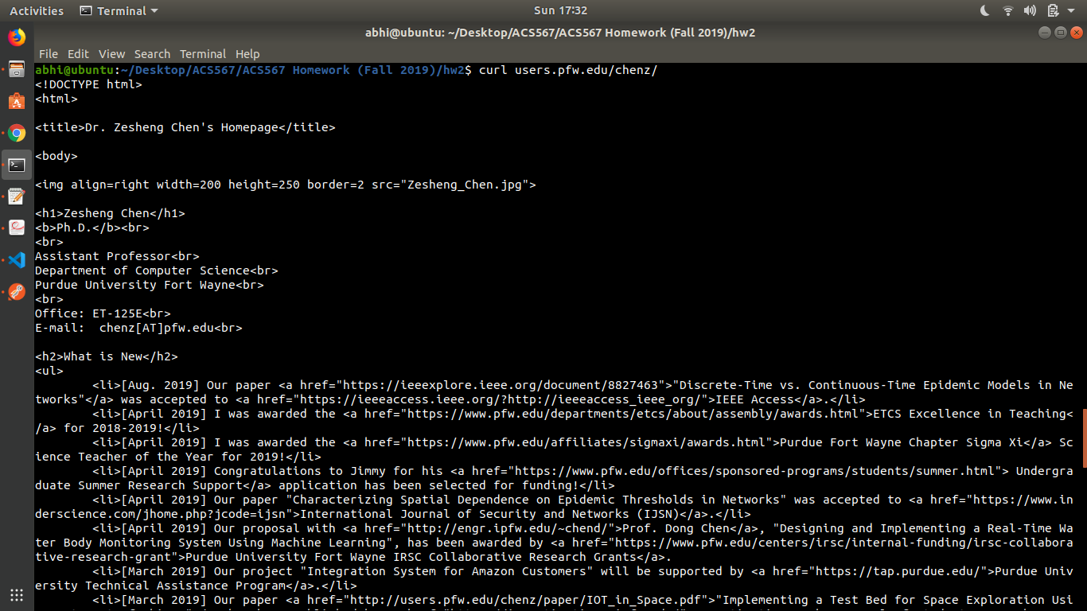

5) a) Fort Wayne, IN, USA : 75.29 F
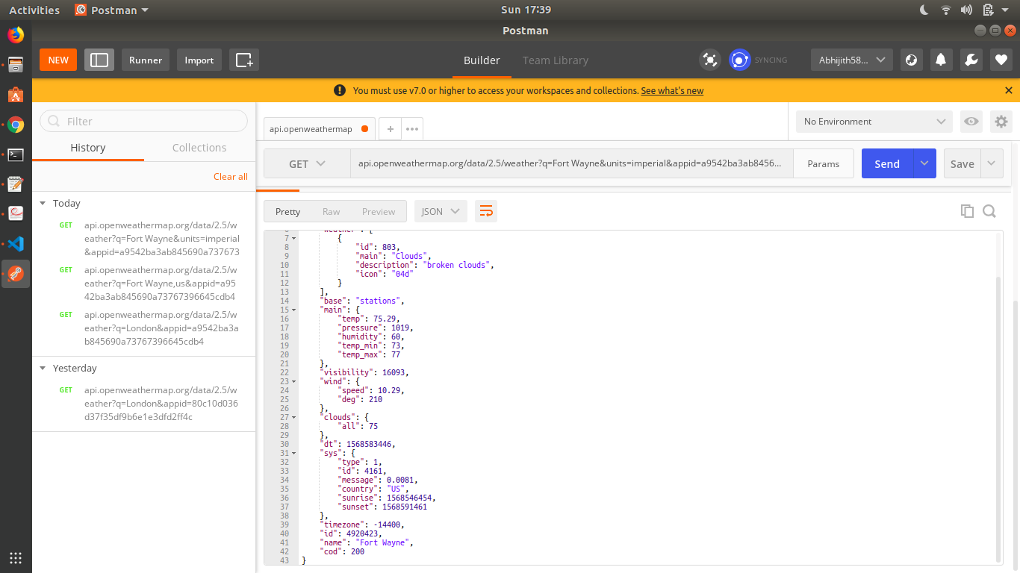

b) Miami, FL, USA : 90.12 F
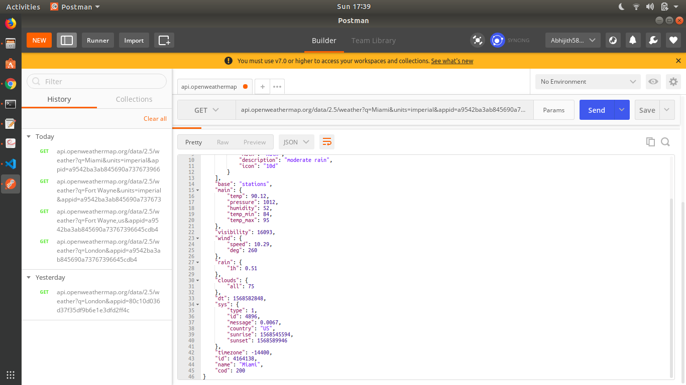
c) San Francisco, CA, USA : 75.2 F
