1) Sprints : Definition of Done:
-> Conceptually the definition of done is a
checklist of the types of work that the team
is expected to successfully complete
before it can declare its work to be
potentially shippable.

2) Product Backlog :
Good Product Backlog Characteristics:
→ DEEP
→ Detailed Appropriately
→ Emergent
→ Estimated
→ Prioritized

3)
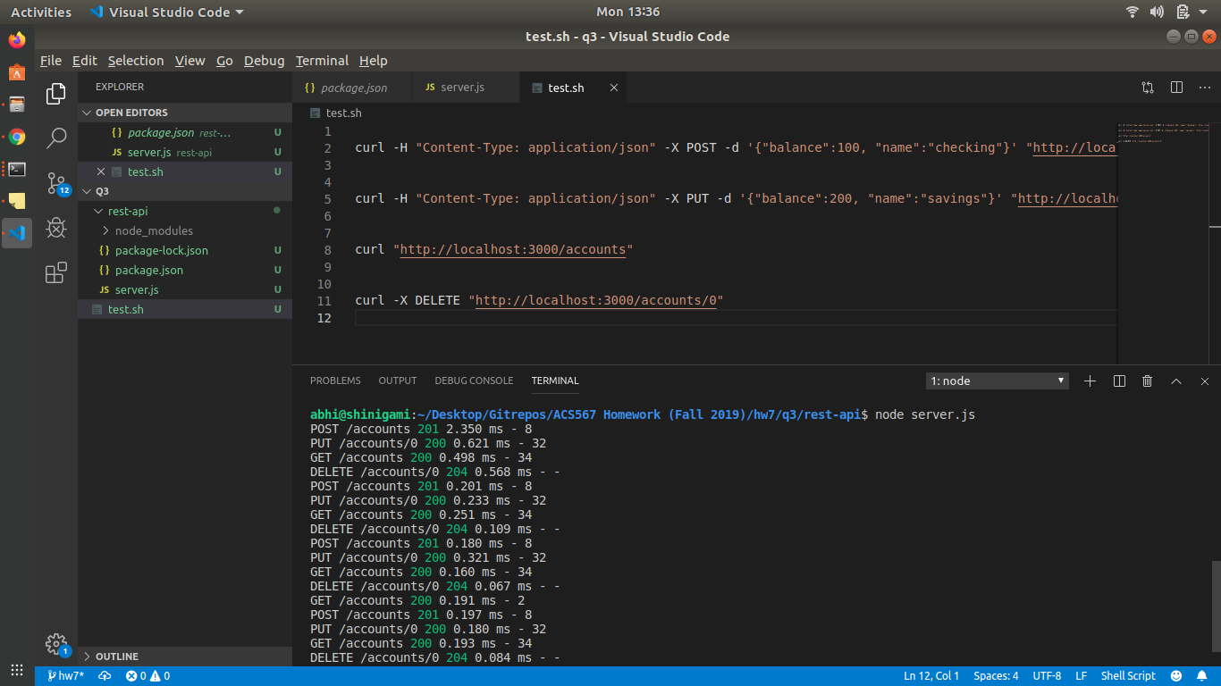

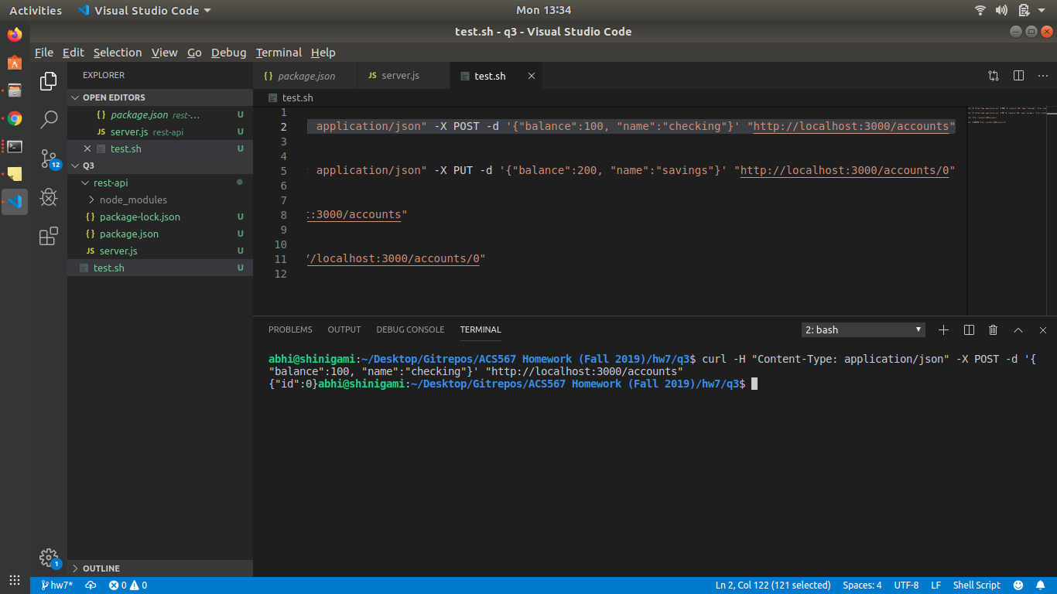

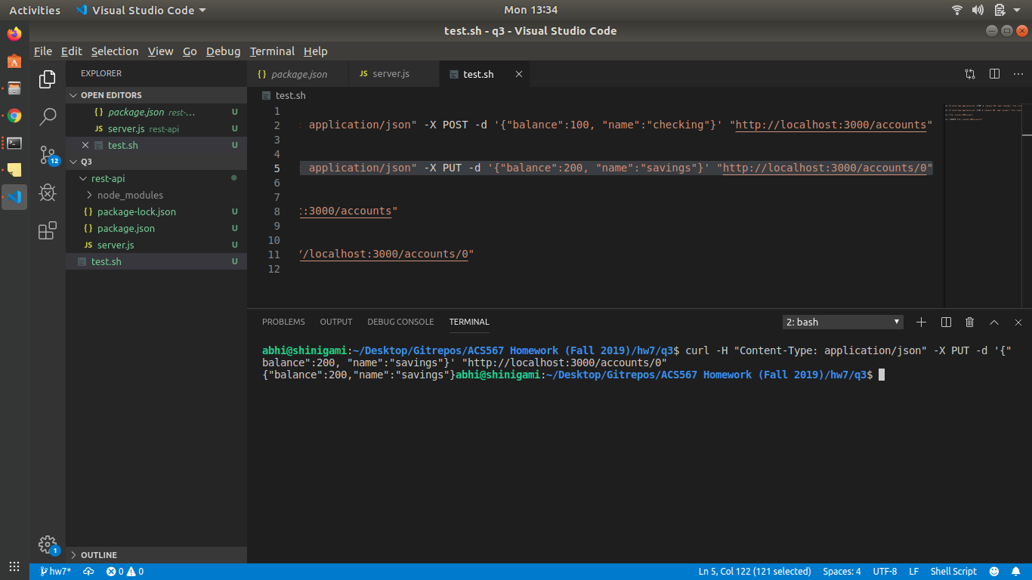

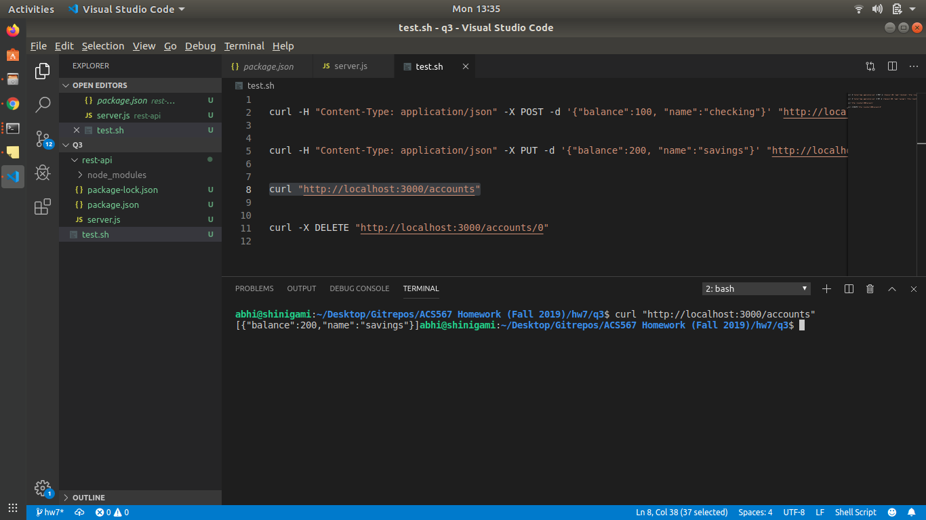

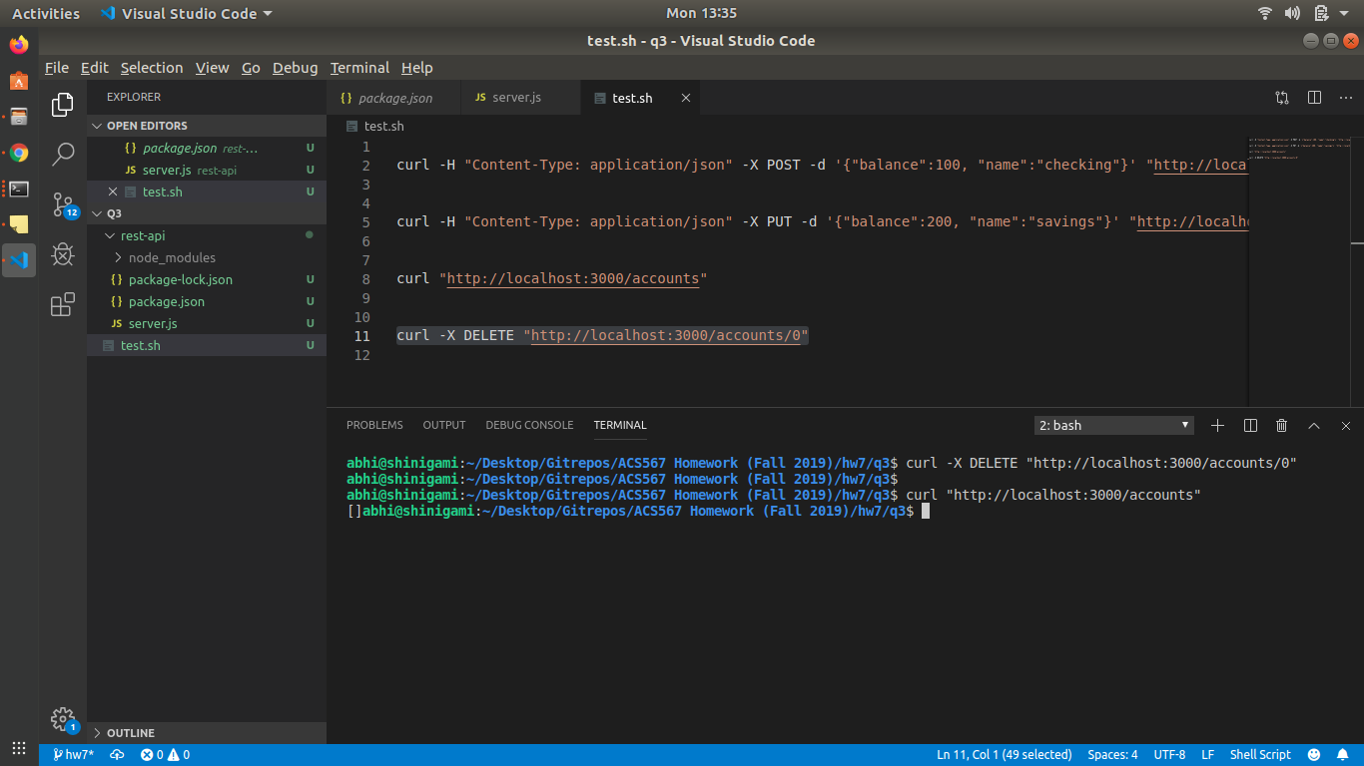

4)
