**How to use this website**

*Following are the points which help you to use this simplest student-guidence-portal website:*

1. *You can sign-up this website if you are new user*

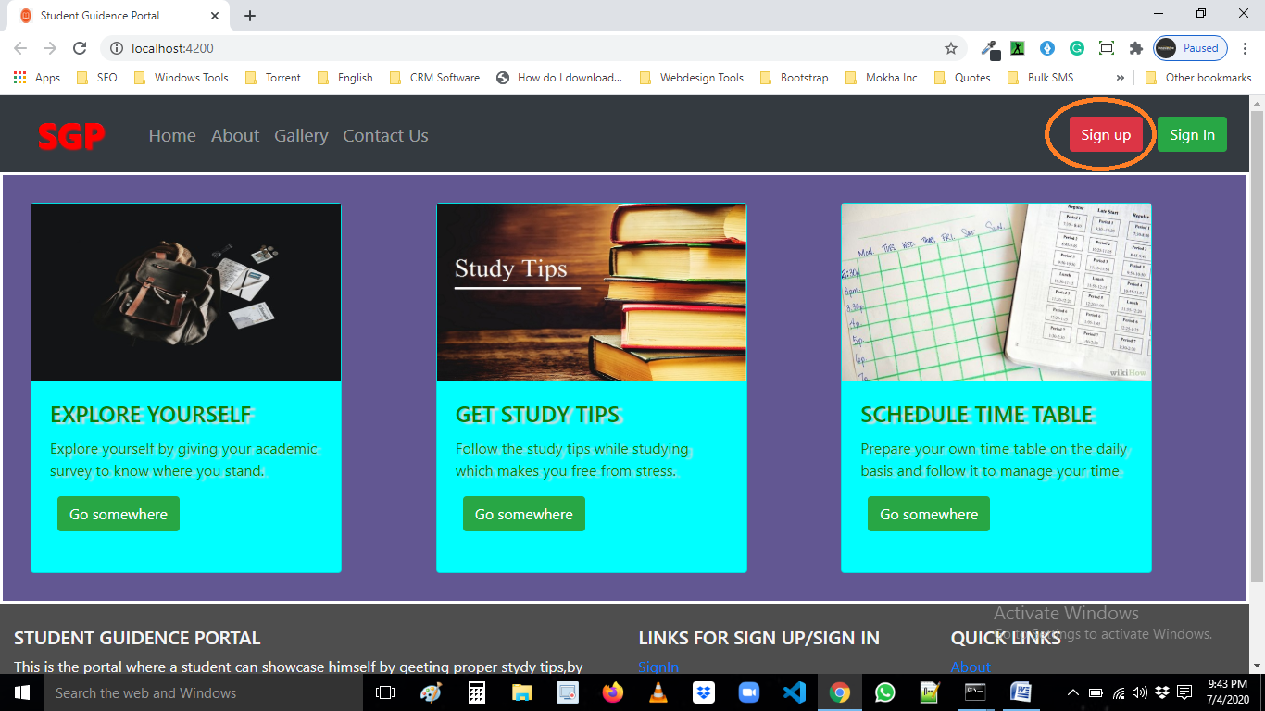

*Click here to “Sign-Up”…*

1. *If you are already registered then “Sign-In” to go on dashboard page were you get study tips*

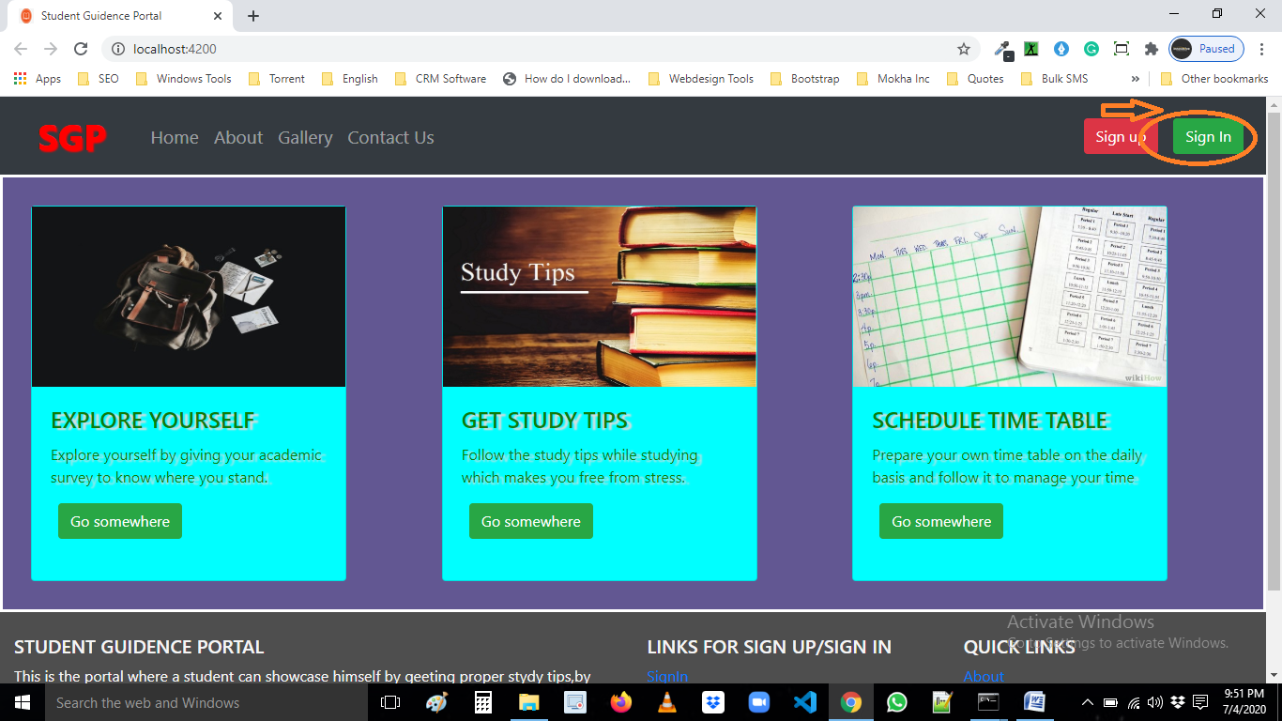

*Click here to “Sign-In”…*

1. *Explore Yourself by click here …*

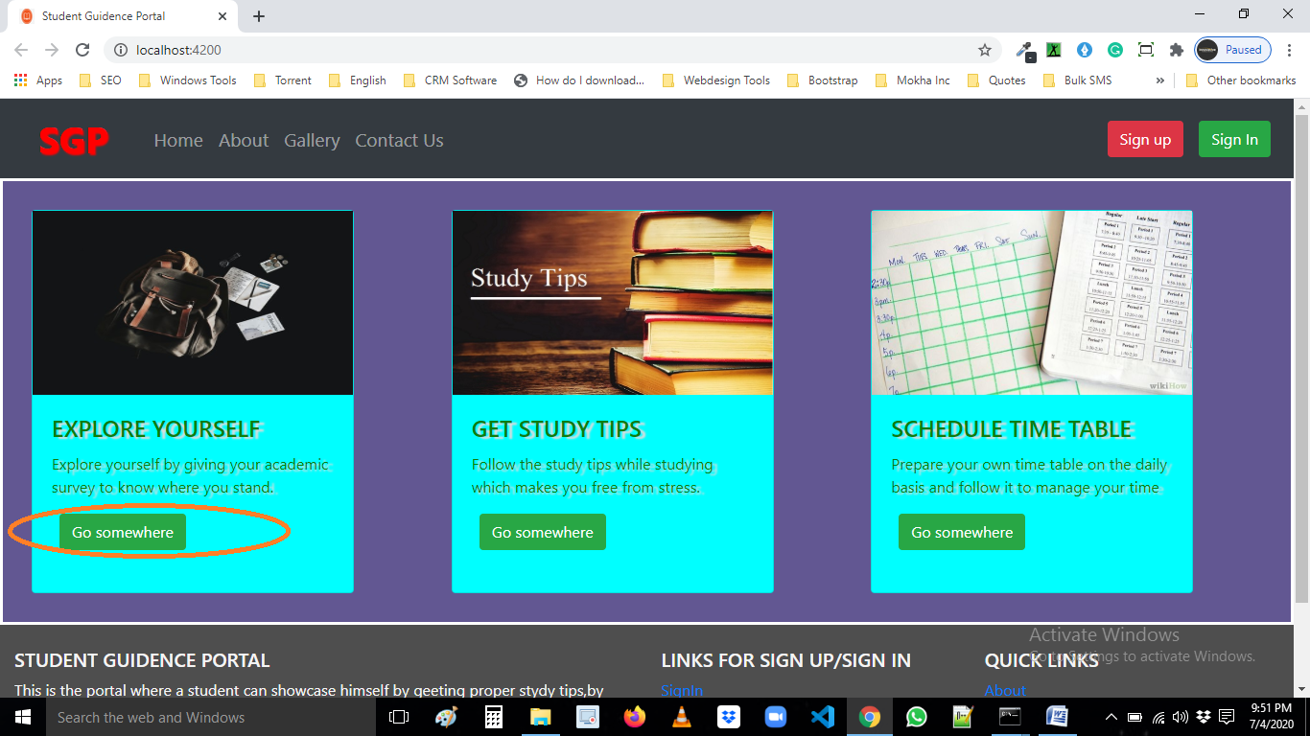

*4.Get study tips by click here …*

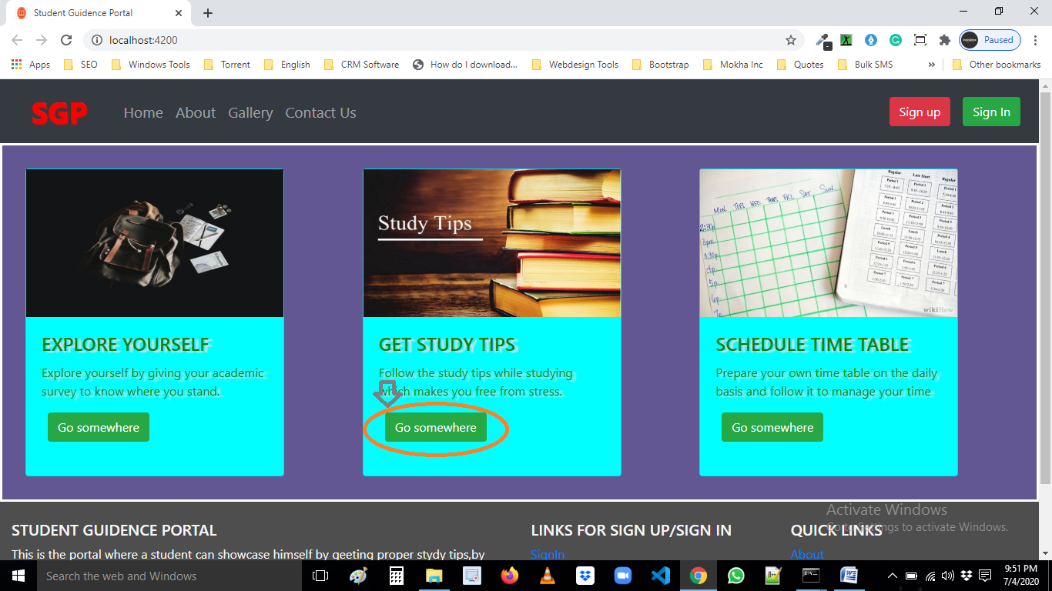

1. *Shedule your time table by click here...*

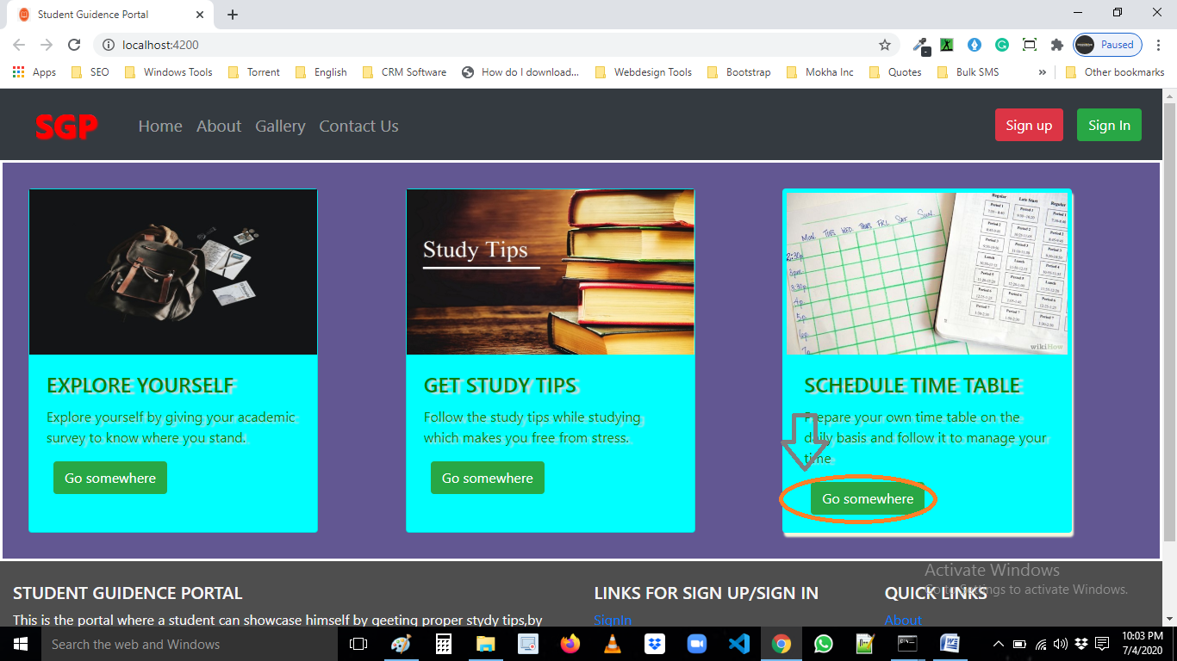

1. *You go on dashboard by sign in or you either click on “Go somewhere” there it will moves on sign-in page then you sign-in and switched to dashboard.*
2. *Now move on dashboard here you have 3 options :*
3. *Explore yourself*
4. *Get –study tips*
5. *Schedule your time table*

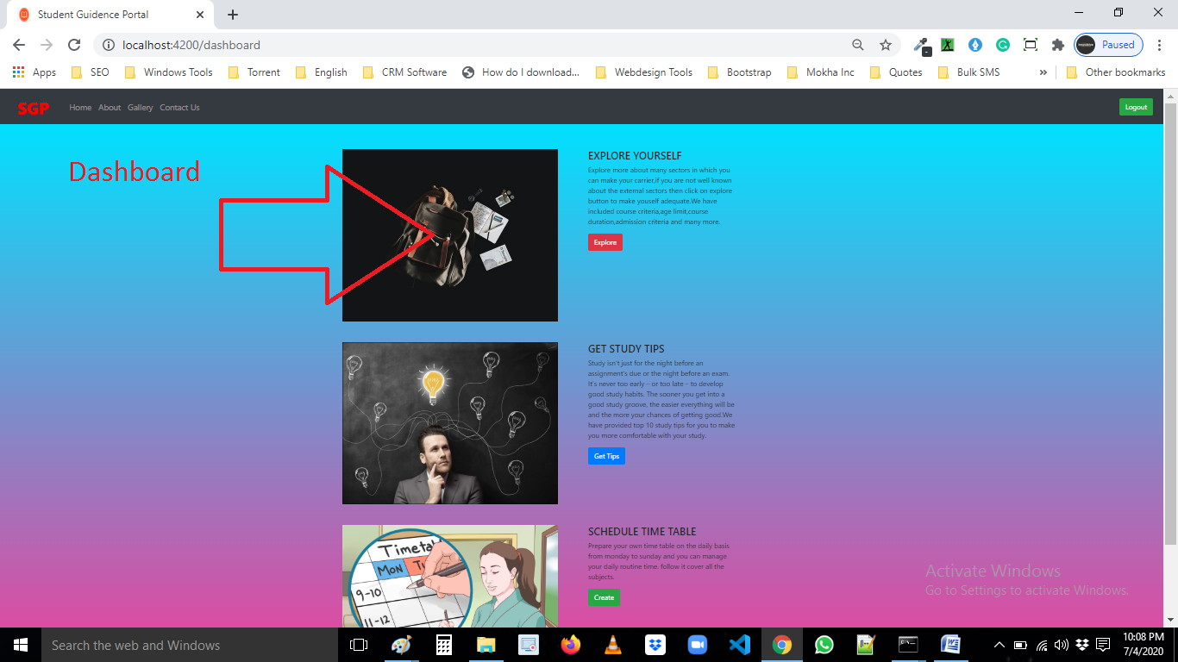

*8.In explore your self you have some choices select your favourite or interesting one.*

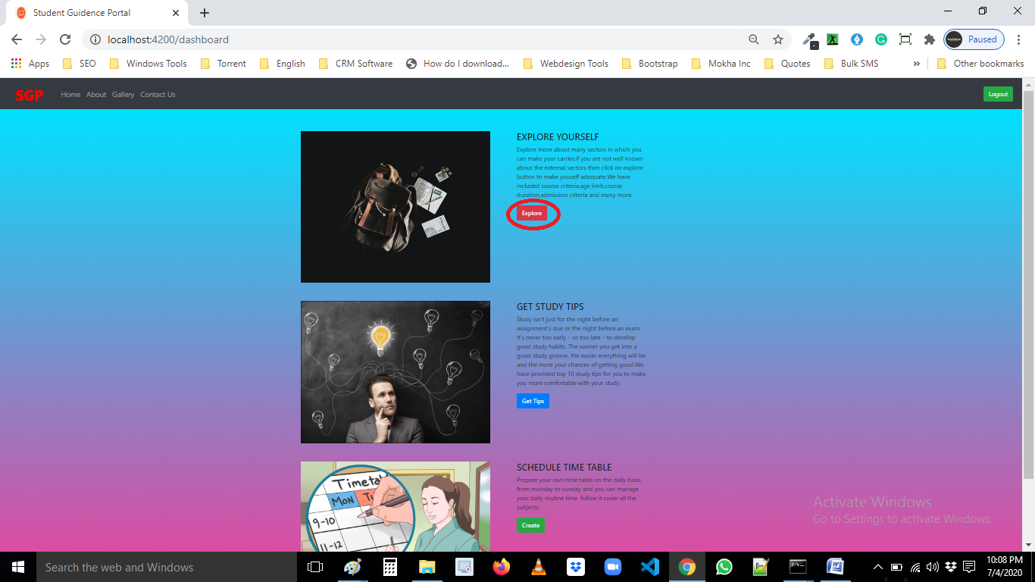

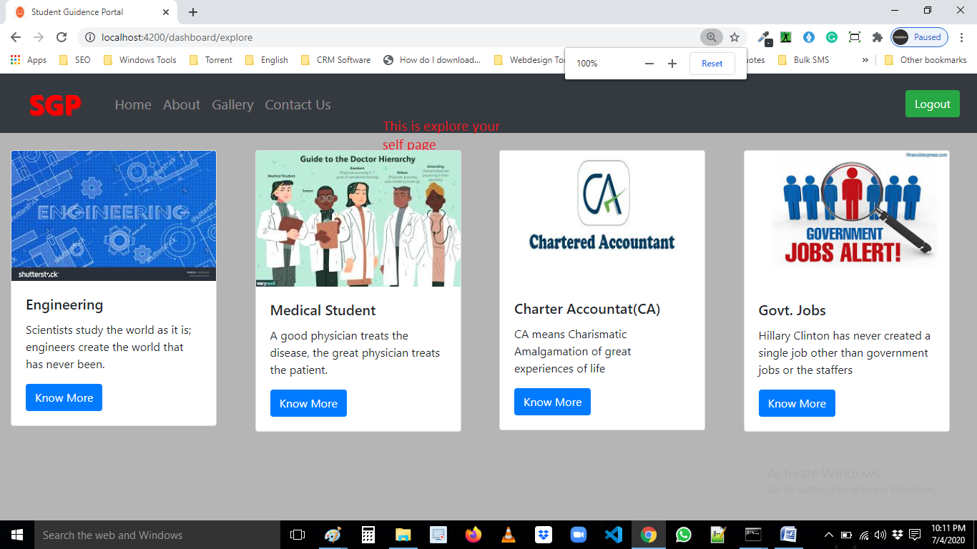

*9.In Get Study tips you can take tips that how to study like a topper.*

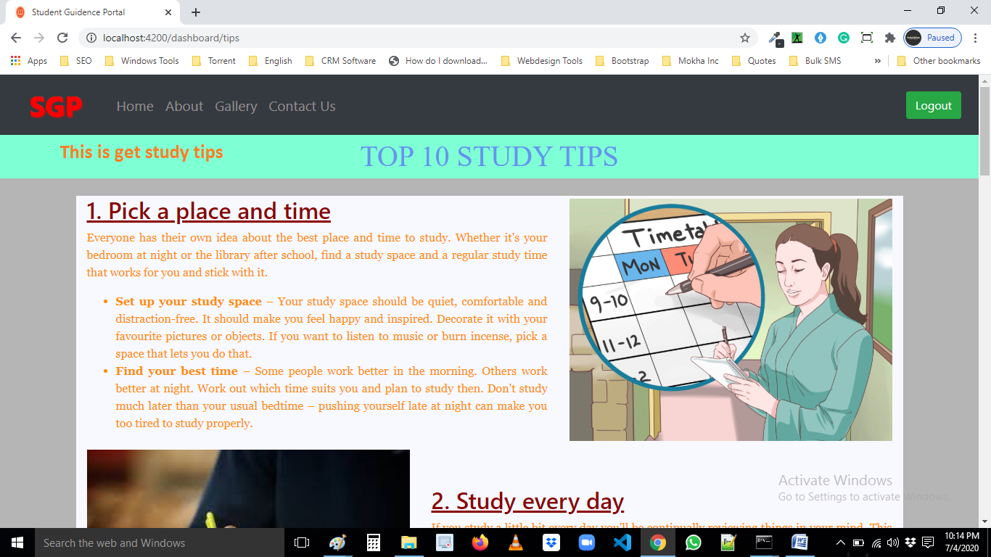

*10. Schedule your time table by click on “Create”*

*And make your own time table.*

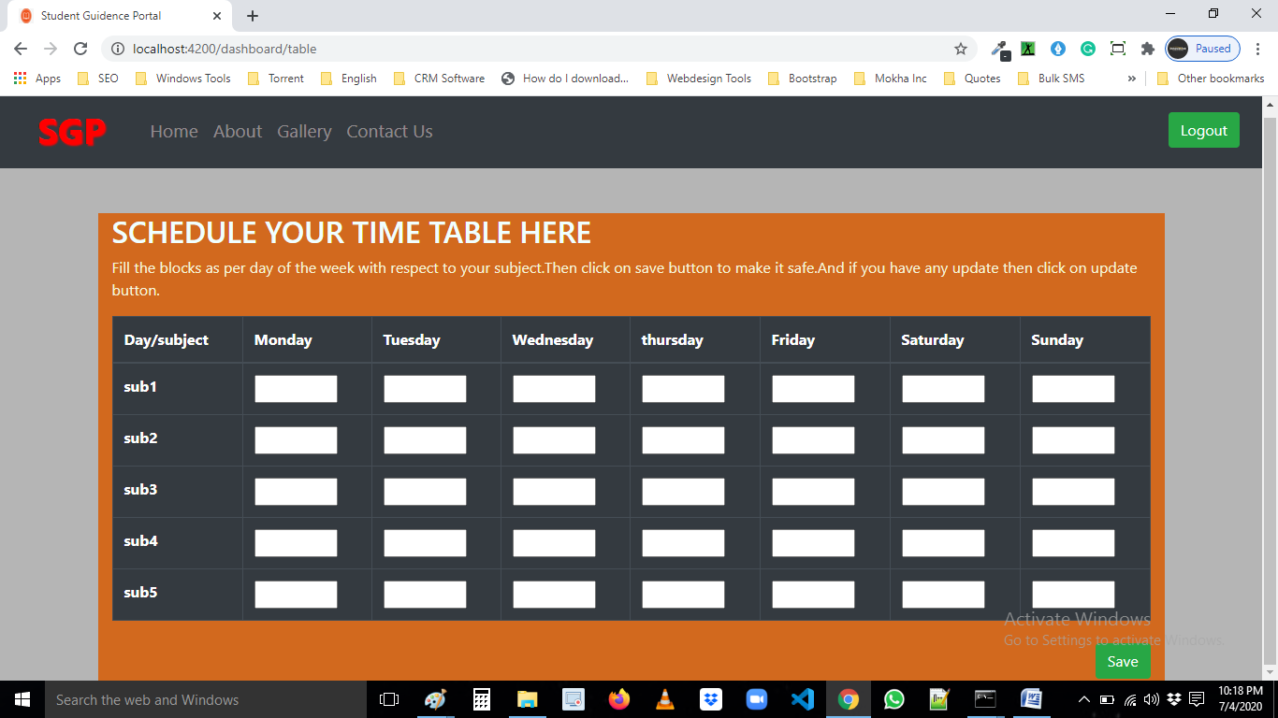

*11. You can see about us by click on “About” in top-bar.*

*12. You can see our gallery by click on “Gallery” in*

*Top-bar*

*13. You can contact us by click on “Contact Us” in top-bar*

