DESIGN

Here we are total use of 64 led for making 8*8 led matrix.

After connecting the led we found 8 negative ends and 8 positive ends.

After we connect all **negative** and **positive** parts of Led's to atmega328 and simulate on simullide .

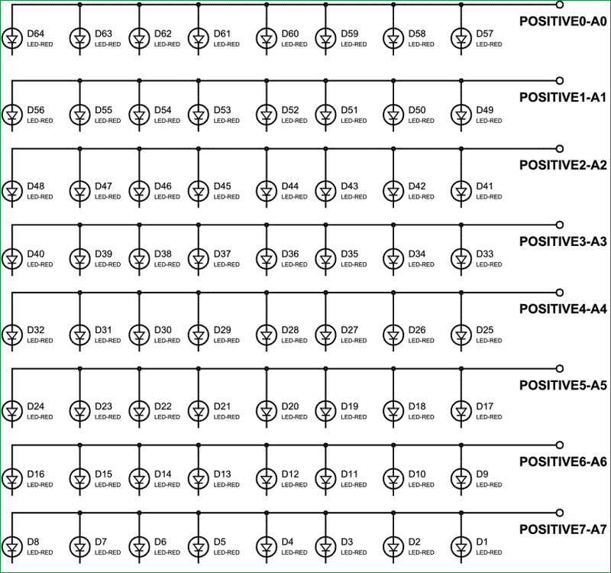

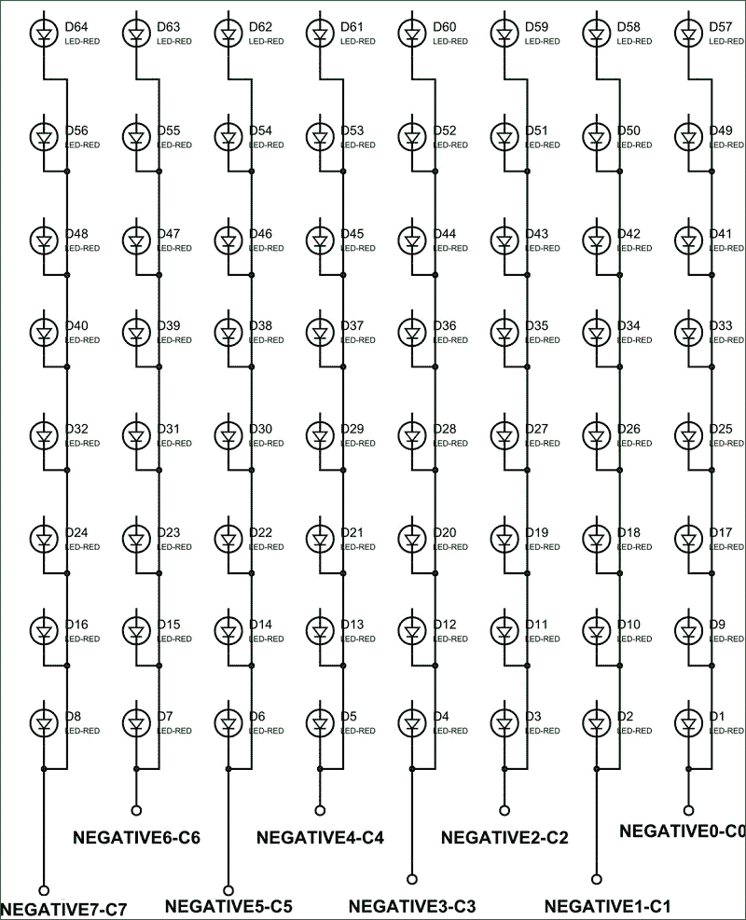

8*8 Led matrix pin in and pin out diagram:

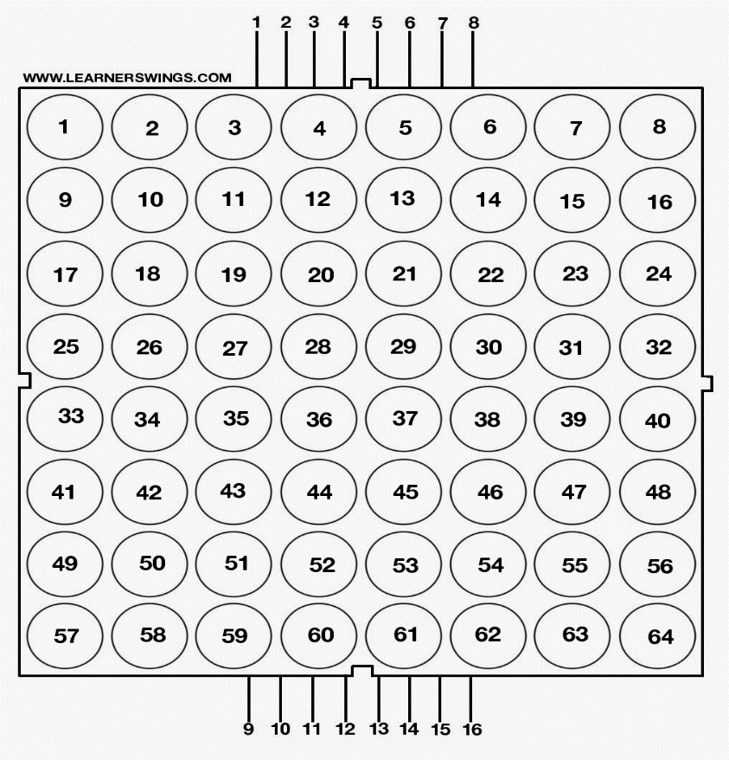

Circuit Diagram-

