ApexaIQ- ASSIGNMENTS | DATE: 10/02/2025

____________________________

**ApexaIQ Company Information:-**

SaaS – Software as a service based company

ApexaiQ is a private company specializing in IT asset management and cybersecurity solutions. Founded in **2021**, the company is headquartered at 100 Medway Road, Suite 403, Milford, Massachusetts, 01757, United States.

_____________________________________________________________________________________

**Key Features of ApexaiQ Data-Driven Approach**

1. **Continuous IT Asset Visibility**
   * ApexaiQ offers a real-time, agentless platform that continuously monitors IT environments, ensuring organizations have full visibility into their assets.
2. **Data Accuracy & Integrity**
   * The platform eliminates duplicate, outdated, or inaccurate asset information, ensuring that decision-making is based on clean, high-quality data.
3. **Automated Risk Remediation**
   * ApexaiQ automates the detection and remediation of vulnerabilities, reducing risk exposure and improving cybersecurity resilience.
4. **Actionable Insights & Compliance**
   * Organizations gain actionable intelligence on IT asset health, security risks, and compliance gaps, allowing them to proactively address threats.
5. **User-Friendly, Centralized Dashboard**
   * A single-pane-of-glass dashboard provides IT teams with a comprehensive, intuitive view of their asset environment.

_____________________________________________________________________________________

**How ApexaiQ Helps Organizations:**

✔ Reduces IT & Security Risks: By identifying and remediating vulnerabilities before they become threats.

✔ Enhances Operational Efficiency: Eliminates manual processes and reduces asset management workload.

✔ Strengthens Compliance: Ensures organizations meet industry regulations with up-to-date asset intelligence.

✔ Optimizes IT Investments: Helps businesses allocate resources effectively and avoid unnecessary spending on redundant assets.

_____________________________________________________________________________________

**Harness the power of clean, actionable data:-**

1. **HARDWARE**

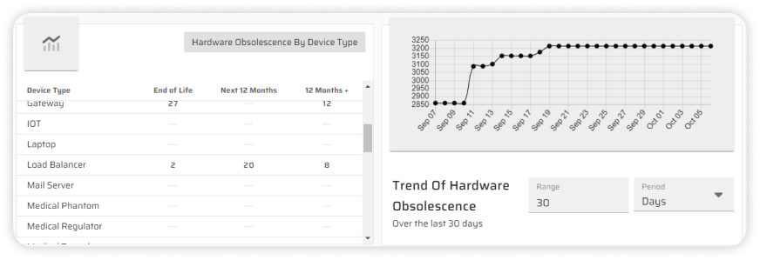

1. **SOFTWARE**

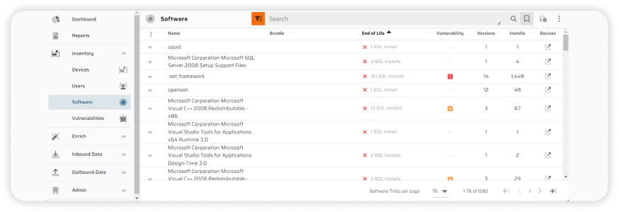

1. **FIRMWARE**

* **ROM (Read-Only Memory):-**

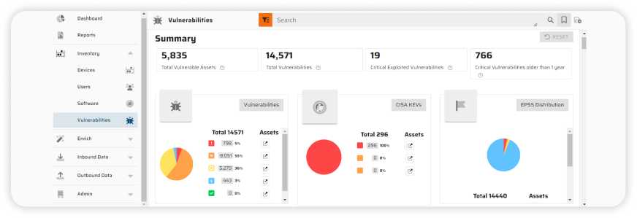

1. **ACCESS**

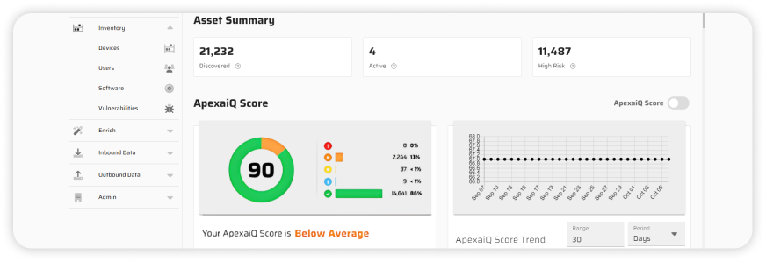

**ApexaiQ Platform Use Cases**

**ApexaiQ** SaaS-based, agentless platform is designed to provide organizations with continuous asset assurance, helping them manage IT environments efficiently, reduce cybersecurity risks, and maintain compliance. Below are the key ways organizations can leverage ApexaiQ platform:

**1. IT Asset Management & Visibility**

✔ Real-Time Asset Discovery: Provides a comprehensive inventory of all IT assets across on-premises, cloud, and hybrid environments.  
✔ Eliminates Data Silos: Aggregates IT asset data into a single, centralized dashboard, ensuring accuracy and consistency.  
✔ Lifecycle Management: Tracks assets from procurement to retirement, ensuring optimal utilization.

**2. Cybersecurity & Risk Mitigation**

✔ Continuous Security Posture Assessment: Identifies misconfigurations, outdated software, and potential security vulnerabilities.  
✔ Automated Risk Remediation: Prioritizes and automates security fixes to reduce attack surfaces.  
✔ Endpoint Protection: Monitors and secures endpoints without requiring agents.

**3. IT Compliance & Governance**

✔ Regulatory Compliance Monitoring: Ensures adherence to GDPR, HIPAA, SOC 2, ISO 27001, NIST, and other frameworks.  
✔ Audit-Ready Reporting: Generates detailed compliance reports to streamline audits.  
✔ Real-Time Alerts: Notifies IT teams about compliance gaps and potential risks.

**4. IT Operations & Cost Optimization**

✔ Eliminates Unused or Redundant Assets: Identifies underutilized software, servers, and licenses to cut unnecessary costs.  
✔ Capacity Planning & Forecasting: Uses AI-driven analytics to optimize IT investments.  
✔ Seamless Integration: Works with existing IT tools like ServiceNow, Splunk, and cloud platforms.

**5. Third-Party & Supply Chain Risk Management**

✔ Continuous Monitoring of External Vendors: Identifies risks related to third-party software and service providers.  
✔ Vendor Compliance Tracking: Ensures external partners meet security standards before integration.

**Industries That Benefit from ApexaiQ**

**🏦 Financial Services –** Enhances data security and regulatory compliance**.**

**🏥 Healthcare** – Ensures HIPAA compliance and protects patient data.

**🌍 Government & Public Sector –** Strengthens national security posture.

**🏢 Enterprise IT & SaaS –** Optimizes IT infrastructure for large organizations.

* **Differences between ApexaiQ and its key competitors in terms of services**

**And capabilities**

|  |  |  |  |  |  |  |
| --- | --- | --- | --- | --- | --- | --- |
| **Feature/Company** | **ApexaiQ** | **Quod Orbis** | **Vicarius** | **Bionic** | **BeyondRisk** | **Nanitor** |
| Core Focus | IT Asset Management & Cybersecurity | Continuous Controls Monitoring (CCM) | Vulnerability Management | Application Security Posture Management | Risk & Compliance Automation | Continuous Threat Exposure Management |
| Real-Time Asset Visibility | ✅ Yes | ❌ No | ❌ No | ❌ No | ❌ No | ❌ No |
| Continuous IT Risk Assessment | ✅ Yes | ✅ Yes | ✅ Yes | ✅ Yes | ✅ Yes | ✅ Yes |
| Automated Risk Remediation | ✅ Yes | ❌ No | ✅ Yes (Patching) | ✅ Yes | ✅ Yes | ✅ Yes |
| Vulnerability Management | ✅ Yes | ❌ No | ✅ Yes | ✅ Yes | ❌ No | ✅ Yes |
| Compliance Monitoring | ✅ Yes | ✅ Yes | ✅ Yes | ✅ Yes | ✅ Yes | ✅ Yes |
| Security Posture Assessment | ✅ Yes | ✅ Yes | ✅ Yes | ✅ Yes | ✅ Yes | ✅ Yes |
| Third-Party Risk Management | ✅ Yes | ❌ No | ❌ No | ✅ Yes | ✅ Yes | ✅ Yes |
| Threat Intelligence & Response | ✅ Yes | ✅ Yes | ✅ Yes | ✅ Yes | ✅ Yes | ✅ Yes |
| Automated Compliance Reporting | ✅ Yes | ✅ Yes | ✅ Yes | ✅ Yes | ✅ Yes | ✅ Yes |
| Agentless Deployment | ✅ Yes | ❌ No | ✅ Yes | ✅ Yes | ❌ No | ✅ Yes |

**CYBER SECURITY**

* **What is Cyber Security?**

**Cybersecurity** is the practice of **protecting systems, networks, and digital assets** from cyber threats such as unauthorized access, data breaches, malware, and cyberattacks. It encompasses a broad range of technologies, processes, and best practices aimed at ensuring the **confidentiality, integrity, and availability (CIA)** of information.

Cybersecurity is a **continuous process** that requires ongoing monitoring, updates, and improvements to stay ahead of evolving threats.

________________________________________________________________________

Cyber threats are evolving rapidly, requiring organizations to stay ahead with cutting-edge security measures .

**Top 10 cybersecurity trends 2024** shaping the industry:

**1. AI-Powered Cybersecurity & Threat Detection 🤖**

🔹 Artificial Intelligence (AI) and Machine Learning (ML) are revolutionizing cybersecurity by improving **threat detection, anomaly detection, and automated responses**.  
🔹 AI-driven tools analyse vast amounts of data to **identify patterns of cyberattacks** in real time.

💡 *Example:* AI-driven **Extended Detection & Response (XDR)** and **Security Information & Event Management (SIEM)** solutions.

**2. Zero Trust Architecture (ZTA) 🔐**

🔹 The **Zero Trust model** operates under the principle of “**never trust, always verify**.”  
🔹 Every user and device must continuously authenticate and be verified before accessing systems.

💡 *Example:* Multi-Factor Authentication (MFA), Identity & Access Management (IAM), and least privilege access controls.

**3. Rise in Ransomware Attacks 💰**

🔹 Ransomware is becoming **more sophisticated**, with attackers using AI and automation to exploit vulnerabilities.  
🔹 Organizations are investing in **backup strategies, endpoint security, and proactive monitoring** to mitigate ransomware risks.

💡 *Example:* **Ransomware-as-a-Service (RaaS)** is fueling cybercrime, making it easier for attackers to deploy ransomware.

**4. Cloud Security Challenges ☁️**

🔹 As organizations shift to cloud environments, cybercriminals target **cloud misconfigurations, APIs, and identity-based attacks**.  
🔹 Companies must implement **Cloud Security Posture Management (CSPM)** and **Secure Access Service Edge (SASE)** frameworks.

💡 *Example:* Securing multi-cloud and hybrid environments using **Zero Trust Network Access (ZTNA)**.

**5. Cybersecurity in IoT & Smart Devices 📡**

🔹 The rapid growth of **Internet of Things (IoT)** devices introduces new security risks, as many are **poorly secured** and vulnerable to attacks.  
🔹 Implementing **network segmentation, firmware updates, and strong authentication** is crucial.

💡 *Example:* **IoT botnets** like Mirai, which compromise insecure devices for large-scale attacks.

**6. Supply Chain Attacks & Third-Party Risks ⚠️**

🔹 Attackers exploit **weak links in supply chains** to infiltrate major companies.  
🔹 **Third-party risk management (TPRM)** and **continuous security monitoring** of vendors are becoming essential.

💡 *Example:* The **SolarWinds attack** that compromised thousands of organizations worldwide.

**7. Quantum Computing & Cybersecurity Risks ⚛️**

🔹 Quantum computing could **break traditional encryption methods**, posing a major cybersecurity challenge.  
🔹 Organizations are exploring **Post-Quantum Cryptography (PQC)** to stay ahead.

💡 *Example:* **Shor’s Algorithm** in quantum computing threatens RSA encryption.

**8. Social Engineering & Deepfake Cyber Threats 🎭**

🔹 Attackers use **AI-generated deepfake videos and voice manipulation** to launch scams and impersonate executives.  
🔹 Organizations must train employees to recognize **phishing, vishing (voice phishing), and social engineering tactics**.

💡 *Example:* **CEO fraud**, where attackers use deepfake voices to manipulate financial transactions.

**9. Cybersecurity Regulations & Compliance 📜**

🔹 Governments worldwide are enforcing stricter **cybersecurity laws and data privacy regulations**.  
🔹 Organizations must comply with frameworks like **GDPR, CCPA, HIPAA, NIST, and ISO 27001**.

💡 *Example:* **EU’s Digital Operational Resilience Act (DORA)** requires stronger security measures in financial services.

**10. Cybersecurity Workforce Shortage & Automation 📉**

🔹 There is a **huge demand for skilled cybersecurity professionals**, leading companies to **automate security processes**.  
🔹 **AI-driven security automation** helps **reduce workload** and **improve threat response times**.

💡 *Example:* **SOAR (Security Orchestration, Automation, and Response)** platforms improve security team efficiency.

**Key Aspects of Cybersecurity**

**A. Cybersecurity Principles (CIA Triad)**

1. **Confidentiality** – Ensuring that data is only accessible to authorized individuals.
2. **Integrity** – Protecting data from tampering, corruption, or unauthorized modifications.
3. **Availability** – Ensuring that data and systems are available when needed by authorized users.

________________________________________________________________________

**Types of Cybersecurity**

**1. Network Security**

🔹 Protects **network infrastructure** from unauthorized access, cyber threats, and attacks (e.g., **firewalls, intrusion detection systems, VPNs**).

**2. Information Security (InfoSec)**

🔹 Focuses on **data protection**, ensuring that sensitive information remains confidential and unaltered. (e.g., **encryption, access control, data masking**).

**3. Cloud Security**

🔹 Protects cloud-based infrastructure, applications, and data from cyber threats (e.g., **cloud firewalls, data encryption, identity & access management (IAM)**).

**4. Endpoint Security**

🔹 Secures **end-user devices** such as laptops, mobile phones, and IoT devices (e.g., **antivirus software, endpoint detection & response (EDR)**).

**5. Application Security**

🔹 Protects **software applications** from threats such as SQL injection, cross-site scripting (XSS), and malware (e.g., **secure coding, penetration testing, Web Application Firewalls (WAF)**).

**6. Operational Security (OpSec)**

🔹 Focuses on the **processes and policies** that protect IT infrastructure and digital assets.

**7. Identity & Access Management (IAM)**

🔹 Ensures that **only authorized users** can access specific systems and data (e.g., **multi-factor authentication (MFA), biometrics, role-based access control (RBAC)**).

**8. IoT Security**

🔹 Protects **Internet of Things (IoT) devices**, which are often vulnerable to cyber threats (e.g., **firmware updates, network segmentation**).

________________________________________________________________________

**Common Cyber Threats**

🔴 **Malware** – Viruses, worms, ransomware, and spyware that infect systems.  
🔴 **Phishing** – Fraudulent attempts to obtain sensitive information via email, messages, or fake websites.  
🔴 **Ransomware** – Malware that encrypts files and demands a ransom for decryption.  
🔴 **Denial of Service (DoS) / Distributed Denial of Service (DDoS) Attacks** – Overwhelming a system or network to make it unavailable.  
🔴 **SQL Injection** – Cyberattack that exploits vulnerabilities in databases.  
🔴 **Man-in-the-Middle (MitM) Attack** – Intercepting communication between two parties.  
🔴 **Zero-Day Exploits** – Attacks that target newly discovered vulnerabilities before a fix is available.

________________________________________________________________________

**SOLUTION ON ATTACK OR BEST PRACTICES OF CYBER SECURITY**

✅ Use Strong Passwords & Multi-Factor Authentication (MFA)  
✅ Regularly Update Software & Systems  
✅ Employ Firewalls & Antivirus Protection  
✅ Monitor & Analyse Network Traffic  
✅ Conduct Security Awareness Training for Employees  
✅ Regularly Backup Important Data  
✅ Implement Zero Trust Security Model

**Importance of Cybersecurity**

Cybersecurity is critical for:  
✔ Protecting Sensitive Data – Personal, financial, and business information.  
✔ Ensuring Business Continuity – Preventing disruptions due to cyberattacks.  
✔ Regulatory Compliance – Adhering to laws like GDPR, HIPAA, PCI-DSS.  
✔ Maintaining Trust – Enhancing customer confidence in digital platforms.

**IT MANAGEMENT**

IT Management (Information Technology Management) is the practice of overseeing all technology resources, systems, and processes in an organization to ensure smooth operations, security, and efficiency. It includes managing hardware, software, networks, cybersecurity, and IT teams to align technology with business goals.

**Key Components of IT Management:-**

**1. IT Infrastructure Management 🏢**

**🔹** Managing hardware, software, servers, networks, and cloud services.  
🔹 Ensuring system uptime, performance, and scalability.

💡 *Example:* Cloud infrastructure management in AWS, Azure, or Google Cloud.

**2. IT Asset Management (ITAM) 💻**

🔹 Tracking IT assets (hardware, software, licenses, cloud subscriptions).  
🔹 Ensuring efficient resource allocation, cost savings, and compliance.

💡 *Example:* Using ITAM tools like ServiceNow, ApexaiQ, or IBM Maximo to manage IT assets.

**3. Cybersecurity & Risk Management 🔐**

🔹 Protecting IT systems from cyber threats, data breaches, and malware.  
🔹 Implementing firewalls, intrusion detection, endpoint security, and encryption.

💡 *Example:* Zero Trust Security, Multi-Factor Authentication (MFA), SIEM tools.

**4. IT Service Management (ITSM) 🎯**

🔹 Managing IT services using structured frameworks like ITIL (Information Technology Infrastructure Library).  
🔹 Ensuring efficient incident management, problem resolution, and IT service delivery.

💡 *Example:* Helpdesk and ticketing tools like ServiceNow, Jira Service Management, BMC Remedy.

**5. Cloud Computing & Virtualization ☁️**

**🔹** Managing cloud-based IT services, SaaS applications, and virtual machines.  
🔹 Ensuring cloud security, cost optimization, and disaster recovery.

💡 *Example:* Hybrid Cloud Strategy, Cloud Security Posture Management (CSPM), Kubernetes management.

**6. IT Governance & Compliance 📜**

**🔹** Ensuring IT operations comply with industry standards like ISO 27001, GDPR, HIPAA, NIST, PCI-DSS.  
🔹 Implementing audit trails, access control policies, and compliance monitoring.

💡 *Example:* Automating compliance checks using Qualys, Splunk, or Tenable.

**7. Data Management & Analytics 📊**

🔹 Managing databases, big data analytics, and business intelligence (BI).  
🔹 Using AI-driven insights to improve IT operations.

💡 *Example:* Data warehouses, SQL databases, AI-powered IT analytics tools.

**Asset Management in Cybersecurity**

**What is Asset Management in Cybersecurity?**

* Asset management in cybersecurity refers to the process of identifying, tracking, monitoring, and securing an organization's digital and physical assets to prevent cyber threats. It ensures that all hardware, software, data, and network components are accounted for and protected against vulnerabilities.
* Asset management is a **critical component** of cybersecurity, helping organizations track and secure IT resources while minimizing cyber risks. Investing in **real-time asset monitoring, automation, and security compliance** can significantly improve cyber resilience.

Effective **cyber asset management** helps organizations:  
✔ Identify all IT assets (devices, applications, cloud services)

✔ Detect vulnerabilities and security gaps

✔ Maintain compliance with security policies

✔ Reduce risks of cyberattacks and data breaches

_______________________________________________________________________

**Types of Assets in Cybersecurity**

**1. Hardware Assets 🖥️**

🔹 Computers, servers, routers, firewalls, IoT devices, mobile devices, etc.  
🔹 Need **endpoint security, encryption, and access control** to prevent breaches.

**2. Software Assets 💾**

🔹 Operating systems (Windows, Linux, macOS), applications, cloud services.  
🔹 Must be **patched and updated** regularly to prevent vulnerabilities.

**3. Data Assets 📂**

🔹 Sensitive business data, customer information, financial records.  
🔹 Needs **encryption, access control, and backup strategies** to prevent data leaks.

**4. Network Assets 🌐**

🔹 Firewalls, VPNs, switches, wireless networks.  
🔹 Require **continuous monitoring and intrusion detection systems (IDS/IPS)**.

**5. Cloud Assets ☁️**

🔹 Cloud storage, SaaS applications, virtual machines, databases.  
🔹 Require **Cloud Security Posture Management (CSPM) and identity access management (IAM)**.

**Key Cybersecurity Asset Management Strategies**

**1. Asset Inventory & Visibility**

🔹 Maintain a comprehensive inventory of all IT assets.  
🔹 Use automated asset discovery tools to track new and existing assets.

**2. Risk-Based Prioritization**

🔹 Identify critical assets that need stronger security controls.  
🔹 Prioritize patching based on asset importance & vulnerability risk.

**3. Continuous Monitoring & Threat Detection**

🔹 Deploy SIEM (Security Information & Event Management) tools for real-time tracking.  
🔹 Use Endpoint Detection & Response (EDR) to detect unauthorized access.

**4. Patch Management & Software Updates**

🔹 Regularly patch and update software, operating systems, and firmware.  
🔹 Implement automated vulnerability scanning to detect outdated assets.

**5. Access Control & Identity Management**

🔹 Enforce least privilege access – only allow users to access necessary assets.  
🔹 Use Multi-Factor Authentication (MFA) and Zero Trust policies.

**6. Data Protection & Encryption**

🔹 Encrypt sensitive data at rest and in transit.  
🔹 Implement Data Loss Prevention (DLP) tools to prevent unauthorized data access.

**7. Incident Response & Asset Recovery**

🔹 Develop a cyber incident response plan to handle breaches involving assets.  
🔹 Implement automated asset quarantine for compromised devices.

**Top Tools for Cybersecurity Asset Management**

🔹 **ApexaiQ** – Real-time IT asset visibility and cybersecurity risk assessment  
🔹 **Qualys Asset Management** – Cloud-based asset tracking and vulnerability scanning  
🔹 **Tanium Asset** – Endpoint security and risk management  
🔹 **Axonius** – Automated cybersecurity asset inventory & compliance  
🔹 **Cisco SecureX** – Integrated security visibility and automation

**Similarities & Differences Between IT Asset Management (ITAM) and Cybersecurity Asset Management (CSAM)**

Both are focus on tracking and managing an organization assets.

|  |  |  |
| --- | --- | --- |
| **Feature** | **IT Asset Management (ITAM)** | **Cybersecurity Asset Management (CSAM)** |
| 1. **Primary Focus** | **Tracks ownership, lifecycle, and cost of IT assets** | **Tracks security risks, vulnerabilities, and threats to assets** |
| 1. **Key Purpose** | **Optimize IT resource allocation, cost savings, and efficiency** | **Enhance cybersecurity posture, risk assessment, and compliance** |
| 1. **Scope of Assets** | **Includes hardware, software, licenses, cloud services** | **Includes endpoints, networks, applications, databases, and IoT devices** |
| 1. **Security Risk Management** | **Not a primary focus, but helps identify outdated or non-compliant assets** | **Actively detects vulnerabilities, threats, and attack vectors** |
| 1. **Compliance Goals** | **Ensures software licensing, asset lifecycle management** | **Ensures security compliance (NIST, GDPR, HIPAA, SOC 2)** |
| 1. **Vulnerability Detection** | **Limited, mainly tracks software versions & updates** | **Continuously scans for vulnerabilities, misconfigurations, and threats** |
| 1. **Response & Remediation** | **Manages IT procurement, updates, and decommissioning** | **Automates security patching, quarantine, and incident response** |
| 1. **Visibility & Discovery** | **Uses CMDB (Configuration Management Database) for asset tracking** | **Uses SIEM, XDR, and security monitoring tools for threat detection** |

**_______________________________________________________________**

**Case Study**

* The SolarWinds Cyber Attack (2020)
* The SolarWinds cyber attack was one of the most sophisticated supply chain attacks in history. Hackers compromised SolarWinds Orion software, impacting over 18,000 organizations, including U.S. government agencies, Fortune 500 companies, and critical infrastructure.

**Background**

🔹 **Company:** SolarWinds (IT Management & Network Monitoring Software Provider)  
🔹 **Attack Discovered:** December 2020  
🔹 **Victims:** Microsoft, Cisco, Intel, U.S. Treasury, Homeland Security, NATO, and more  
🔹 **Suspected Attacker:** Russian-backed hacking group “APT29” (Cozy Bear)

**How the Attack Happened**

1. **Supply Chain Compromise**
   * Hackers infiltrated **SolarWinds’ software development environment** and inserted **malicious code** into the **Orion software update** (March–June 2020).
   * This **backdoor, named SUNBURST**, was distributed to **18,000 customers** via a legitimate software update.
2. **Stealthy Infiltration & Lateral Movement**
   * Once inside, attackers used **stolen credentials** to move laterally within networks.
   * They **disabled security monitoring tools** and created **hidden admin accounts**.
3. **Exfiltration of Sensitive Data**
   * The attackers **gathered sensitive data** over **months** without detection.
   * They **stayed hidden by mimicking normal network traffic** and using **legitimate credentials**.

**Impact of the Attack**

🚨 **Massive Data Breach** – Stolen government & corporate data  
🚨 **Economic Impact** – Billions in cybersecurity costs  
🚨 **Supply Chain Security Threat** – Exposed weaknesses in global IT supply chains  
🚨 **Geopolitical Tensions** – Increased concerns over state-sponsored cyber warfare

**Key Lessons Learned**

✅ **Zero Trust Security** – Organizations should **assume breach** and implement **least privilege access**.

✅ **Stronger Supply Chain Security** – Regular security audits and **code integrity verification** for third-party vendors.  
✅ **Advanced Threat Detection** – AI-driven **behavioural analytics & real-time threat hunting** can detect anomalies early.  
✅ **Multi-Factor Authentication (MFA)** – Reducing reliance on **password-based security** can limit lateral movement.  
✅ **Security Awareness & Incident Response** – Organizations need **stronger employee cybersecurity training & faster threat response**.

**Conclusion**

The **SolarWinds attack exposed critical cybersecurity vulnerabilities** in supply chains and **highlighted the need for Zero Trust frameworks**. Governments and enterprises are now **enhancing security monitoring, endpoint detection, and software integrity measures** to prevent similar attacks in the future.